Survey: Project Connect – South Melbourne Market

You can share your thoughts by completing this survey and returning it to the South Melbourne Market Office in Centre Aisle or a City of Port Phillip ASSIST counter by Sunday 29 November 2026.

Complete the survey for a chance to win one of 2 double passes for a guided foodie tour of South Melbourne Market.
Project Connect is a long-term investment in South Melbourne Market, delivering accessibility, infrastructure and public space improvements while protecting the Market’s role as a working market and being a loved and trusted community destination. In the coming years, the Market will be delivering a range of changes to the building and surrounding streets to make it safer and more accessible and improve the visitor experience.
The changes will include:
• More toilet facilities
• Better footpaths and aisle surface grading
• Improving accessibility to the rooftop carpark
• Improving and increasing public space outside the Market
• A new retail precinct on York Street.

Visiting the Market
- What is your connection with South Melbourne Market? ^{Required}
Tick all that apply(continues over page)

I have visited South Melbourne Market in the past 12 months
I used to visit South Melbourne Market but HAVEN’T in the past 12 months
I am a South Melbourne Market trader
I am a local business owner/trader (within a 5min walk of South Melbourne Market)
I live in or own a property within a 5min walk of South Melbourne Market
I work within a 5min walk of South Melbourne Market
I travel past South Melbourne Market
I have never visited South Melbourne Market, but I live in, work in or visit the City of Port Phillip
Other (please specify)

- If you HAVE visited South Melbourne Market in the past 12 months, how often do you usually visit South Melbourne Market?

More than once a week
Weekly
Fortnightly
Monthly
Every few months
1-2 times a year
- If you HAVE visited South Melbourne Market in the past 12 months, which days do you usually visit the Market?
Tick all that apply
Wednesday | Saturday
Friday | Sunday
- If you HAVE visited South Melbourne Market in the past 12 months, which times do you usually visit?
Tick all that apply
8am - 10am | 12pm - 2pm
10am - 12pm | 2pm - 4/5pm
- If you told us that you have NOT visited South Melbourne Market in the past 12 months, can you tell us more about why?
Tick all that apply (continues over page)
Can’t get there during opening hours
The Market is too busy
The Market doesn't offer what I am looking for
The Market isn't physically accessible enough for me
Other (please specify)

Improving the public space around the Market

Improvements are proposed for the public space along York Street and Coventry Street, to:
- Enhance the areas surrounding the Market
- Improve the visitor experience
- Support the Market’s long-term success.

These improvements include creating more public space along York and Coventry Streets, improving pedestrian access and movement, and strengthening connections between the Market and the surrounding precinct.

Coventry Street (between Cecil Street and the tram stop)

In 2023, our community told us that the following features were the most important priority on Coventry Street (between Cecil Street and the tram stop):
- Seating (69%)
- Use of natural materials (67%)
- Improved connection to the tram stop (64%)
- Public dining spaces (61%).

Take a look at the changes proposed for Coventry Street
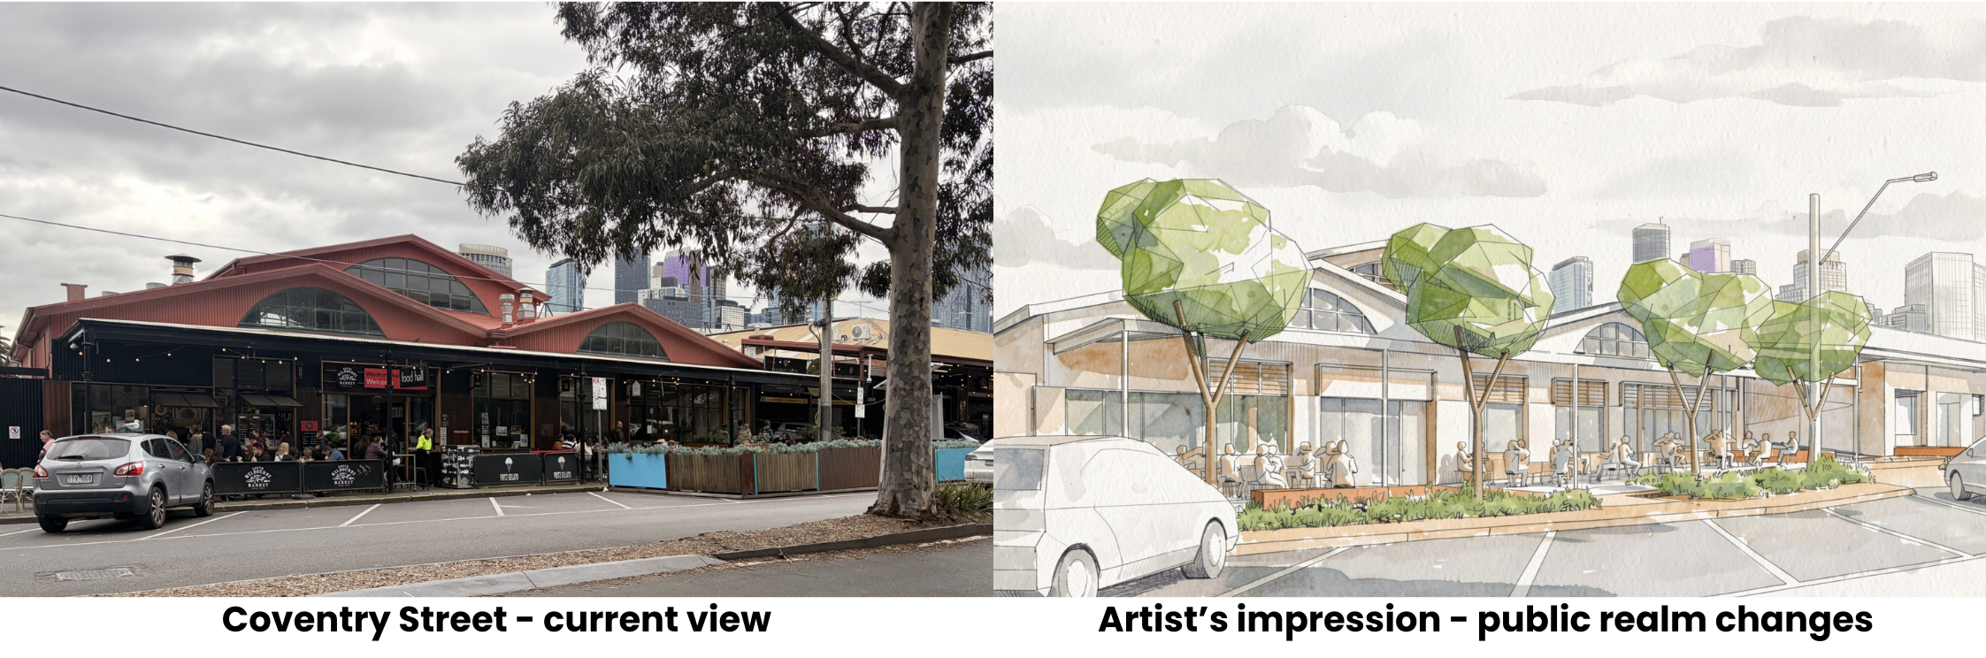
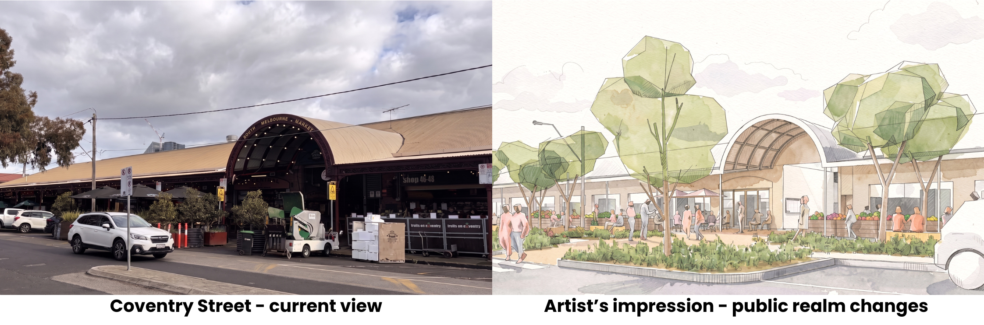
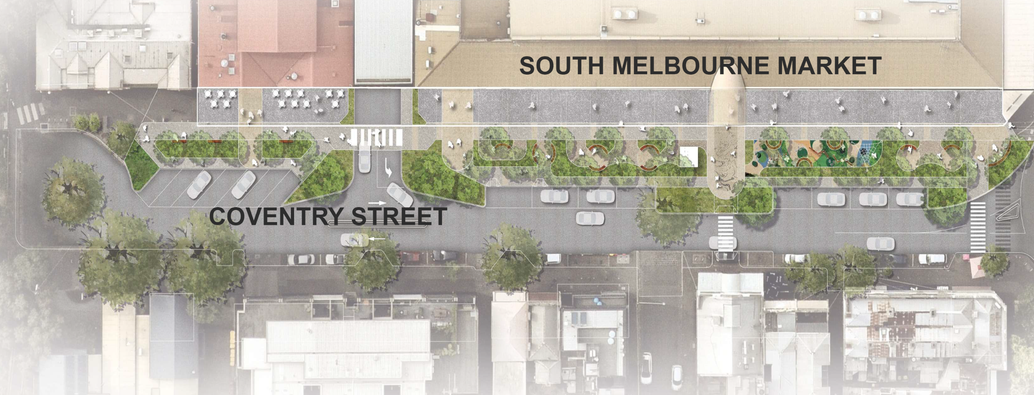
The draft concept for Coventry Street features:
- A new linear park with more trees, planting and shaded areas
- Nature-based play elements and outdoor spaces for community use
- Wider pedestrian pathways and improved access to and from the tram stop
- A proposed pedestrian crossing linking Centre Aisle with the surrounding precinct
- Additional seating, outdoor dining opportunities and public amenities
- Parallel parking along the Market edge, while retaining angular parking outside the Food Hall/Childcare Centre
- Safety improvements for pedestrians
- Improved stormwater management through rain gardens and landscaped areas.
- Do you think the changes proposed for Coventry Street reflect what we heard from our community in 2023?
Yes | No | Not sure

- If you would like to tell us more about your response, you can tell us here.
- Do you think the changes proposed for Coventry Street will help to connect the Market with the wider area, including local businesses?
Yes | No | Not sure

- If you would like to tell us more about your response, you can tell us here.

York Street (between Cecil and Ferrars Streets outside the Market)

In 2023, our community told us that the following features were the most important priority on York Street (between Cecil and Ferrars Streets outside the Market):
- Use of natural materials (70%)
- Seating (63%)
- Public dining spaces (64%).

Take a look at the changes proposed for York Street
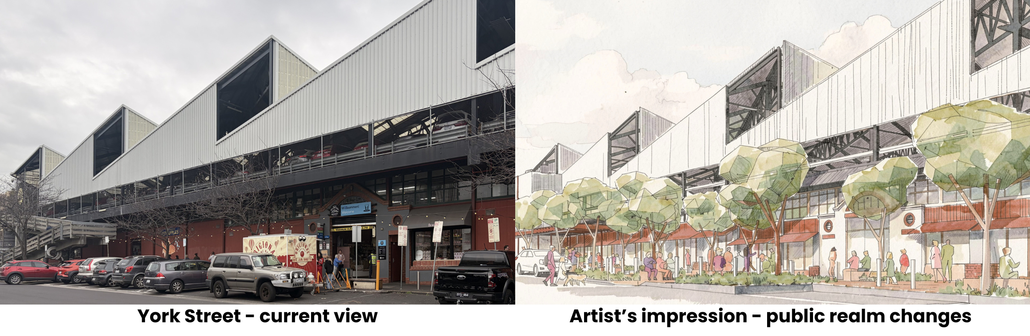
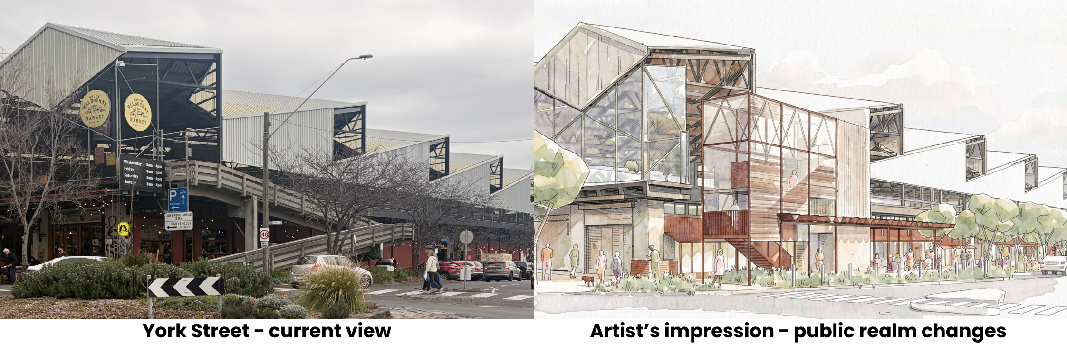
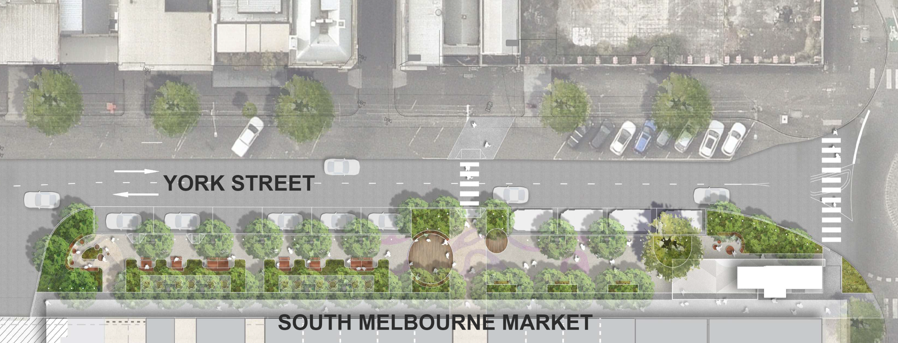
The draft concept for York Street features:
- New stair and lift access to the rooftop carpark
- More trees, planting and shaded areas
- Wider footpaths and improved pedestrian access
- A proposed pedestrian crossing linking Centre Aisle with the surrounding precinct
- Additional seating and public amenities
- Parallel parking along the Market edge
- Safety improvements for pedestrians
- More space for community activity and gathering
- Improved stormwater management through rain gardens and landscaped areas.
- Do you think the changes proposed for York Street reflect what we heard from our community in 2023?
Yes | No | Not sure

- If you would like to tell us more about your response, you can tell us here.
- Do you think the changes proposed for York Street will help to connect the Market with the wider area, including local businesses?
Yes | No | Not sure

- If you would like to tell us more about your response, you can tell us here.

New retail precinct on York Street

A new precinct will be created on York Street as a vibrant street-facing extension of the Market.

Our market research tells us that most shoppers come to the Market for fresh food and grocery shopping, particularly seafood, meat and poultry, fruit and vegetables, and deli products.

This new precinct would make some of these key fresh food categories more accessible and convenient, for more days per week and longer opening hours than the Market currently offers.

Alongside fresh food traders, the precinct may also include flowers, specialty foods, cafés, bakeries, bars, and grab-and-go food.

- If fresh market produce was accessible outside of current Market times, which of these additional days or times would you want to access it?
Tick all that apply
Monday | 10am - 12pm | 4pm - 6pm
Before 8am | 12pm - 2pm | 6pm - 8pm
8am - 10am | 2pm - 4pm | 8pm - late
Tuesday | 10am - 12pm | 4pm - 6pm
Before 8am | 12pm - 2pm | 6pm - 8pm
8am - 10am | 2pm - 4pm | 8pm - late
Wednesday | (current hours are 8am – 4pm) | 6pm - 8pm
Before 8am | 4pm - 6pm | 8pm - late
Thursday | 10am - 12pm | 4pm - 6pm
Before 8am | 12pm - 2pm | 6pm - 8pm
8am - 10am | 2pm - 4pm | 8pm - late
Friday | (current hours are 8am – 5pm) | 6pm - 8pm
Before 8am | 5pm - 6pm | 8pm - late
Saturday | (current hours are 8am – 4pm) | 6pm - 8pm
Before 8am | 4pm - 6pm | 8pm - late
Sunday | (current hours are 8am – 4pm) | 6pm - 8pm
Before 8am | 4pm - 6pm | 8pm - late
None of these, I'm happy with current days and times

- Which retail categories would you most like to see available on York Street?
Write a number from 1-10 in each box, with 1 being the highest priority and 10 being the lowest priority
Bakeries | Fruit and vegetables
Bars | Grab-and-go food
Cafés | Meat and poultry
Delicatessens | Seafood
Flowers | Speciality foods
- If there are any other shops, services or experiences you would like to see included in the York Street precinct, you can tell us here.

Using spaces at the Market

The new York Street precinct will include increased public space and amenities suitable for community events and activations.
- Which of these would you be interested in seeing at the Market?
Tick all that apply
Community spaces for hire (charities and community groups)
Cooking demonstrations and food sampling
Cultural celebrations
Live music
Nighttime events
Pop-up stalls
Sports-related events
None of these
Other (please specify)

Traffic on surrounding streets

While traffic and road changes are not part of this project, Council is committed to reviewing future opportunities to improve movement around the Market. Given the constraints of the surrounding local street network, there are difficult trade-offs between vehicle access, parking, deliveries, public transport, walking, cycling and public space.
- What do you think Council's top priorities should be when considering future traffic and access improvements around the Market?
Write a number from 1-8 in each box, with 1 being the highest priority and 10 being the lowest priority
Access for people with mobility needs | Public space and amenity
Cycling access | Public transport connections
Parking availability | Trader and delivery access
Pedestrian safety and comfort | Traffic flow
- If you would like to tell us more about your response, you can tell us here.

Long-term future of the Market
- If you think there is something important in planning for the long-term future of the Market that you feel we have not considered, you can tell us here.

About you
Please tell us a little bit about yourself so that we can understand who we're hearing from. To understand how your information is used, you can request a copy of Council’s Privacy Policy by calling ASSIST on (03) 9209 6777.

- Which gender do you identify with? ^{Required}
Female (woman or girl) | Non-binary
Male (man or boy) | I’d prefer not to say
I use a different term (please specify)

- What is your residential suburb? ^{Required}
Albert Park | South Melbourne
Balaclava | Southbank
Elwood | St Kilda
Melbourne | St Kilda East
Middle Park | St Kilda West
Port Melbourne | Windsor
Ripponlea | Prefer not to say
Other (please specify)

- Please indicate your age group. ^{Required}
5 – 11* | 35 - 49
12 – 14* | 50 - 59
15 - 17 | 60 - 69
18 - 24 | 70 - 84
25 - 34 | 85 and over
I'd prefer not to say
- *Since you told us that you’re under 15, a parent or guardian over 18 needs to agree for you to take this survey. ^{Required}
I’m a parent or guardian and I agree to let my child take part in this survey.
Yes
- Which of the following best describes your current household?
Tick one answer only
Couple with children | Other families
Couple without children | Group household
One-parent family | One-person household
Other (please specify)

- Please tick any of the statements that apply to you. ^{Required}
Tick all that apply
I am from an Aboriginal and/or Torres Strait Islander background
I speak a language other than English at home
I am a person with disability
I identify as LGBTIQA+
I'd prefer not to say
None of these apply to me
- Have you provided feedback on any other City of Port Phillip projects in the past 12 months? ^{Required}
Yes | No | Not sure

Would you like a chance to win one of 2 double passes for a guided foodie tour of South Melbourne Market? Enjoy exclusive access to some of the Market’s most iconic traders while discovering quality produce and artisan creations.

Winners will be drawn Friday 4 December and contacted via the email address or phone number provided. Terms and Conditions can be found at https://haveyoursay.portphillip.vic.gov.au/project-connect-foodie-tour-competition-terms-and-conditions
- Would you like to enter for a chance to win?
Yes – Provide your email address or phone number

- Would you like to sign up to the monthly South Melbourne Market e-newsletter?
Yes - Provide your email address

- If you would like your survey responses emailed to you, please provide an email or postal address.

Thank you for completing this survey. Please now return it to the South Melbourne Market Office in Centre Aisle or a City of Port Phillip ASSIST counter by Sunday 29 November 2026.

