We are Port Phillip
Council Plan 2017-27

Draft amendments for 2018/19
Council respectfully acknowledges the Yalukut Weelam Clan of the Boon Wurrung.
We pay our respects to their Elders, both past and present.
We acknowledge and uphold their continuing relationship to this land.
Contents
Contents 3
City of Port Phillip Councillors 5
Mayor’s message 6
Message from the CEO 8
About this plan 8
Partners to our plan 10
Section 1: Port Phillip Today and Tomorrow 11
Our city and our people 11
General statistics about the City of Port Phillip (Source: ABS Census 2016 unless otherwise indicated) 12
Our health and wellbeing 12
Our challenges 17
Our vision 22
Our strategic directions 22
How this plan responds to our community 22
How the community helped shape this plan 25
Strategic direction 1: We embrace difference, and people belong. 29
Strategic direction 2: We are connected and it’s easy to move around. 46
Strategic direction 3: We have smart solutions for a sustainable future. 56
Strategic direction 4: We are growing and keeping our character. 68
Strategic direction 5: We thrive by harnessing creativity. 81
Strategic direction 6: Our commitment to you. 91
Delivering our strategic directions 104
Our financial strategy 105
Financial summary 110
Section 2: Our neighbourhoods 119
Our neighbourhoods at a glance 119
We are Elwood / Ripponlea 120
We are Balaclava / St Kilda East 123
We are St Kilda / St Kilda West 125
We are St Kilda Road 128
We are Albert Park / Middle Park 130
We are South Melbourne 133
We are Port Melbourne 137
We are Montague 140
We are Sandridge / Wirraway 142
Section 3: Finances and performance 144
Our 10-Year Financial Plan 144
Financial statements 158
Measuring performance 193
Linking our initiatives to strategies and plans 198
Rates and charges 221
Fees and charges 229
Glossary 282

City of Port Phillip Councillors
The City of Port Phillip has three wards, each represented by three elected councillors.
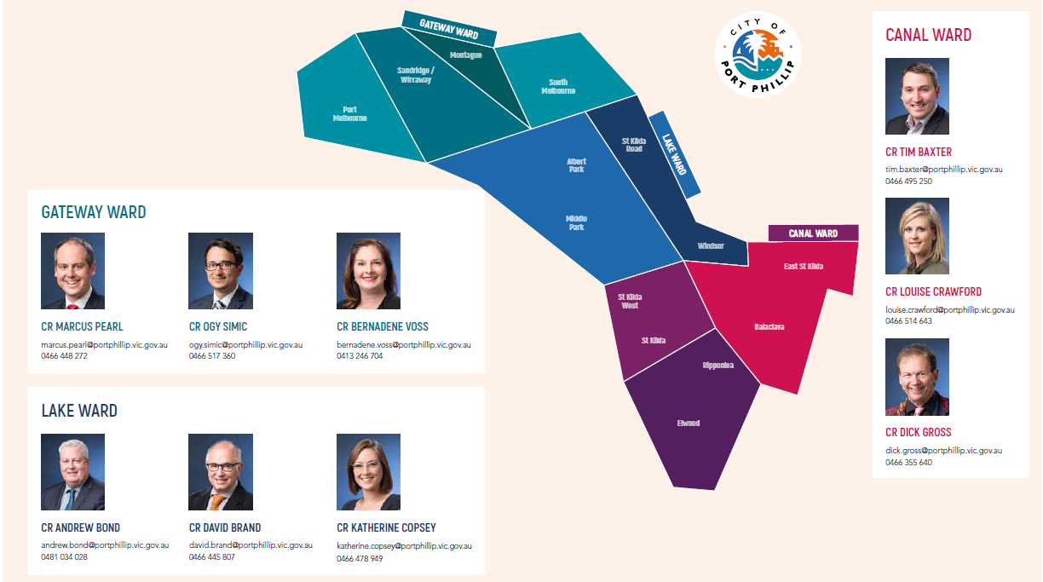
The Councillors were elected to the City of Port Phillip for a four-year term on 22 October 2016. The Mayor, Councillor Bernadene Voss, was elected by the Councillors on 10 November 2016.
Councillors are responsible for setting the strategic direction for the City, representing the local community in their decision making, developing policy, setting service standards, and monitoring performance.

Mayor’s message
The Councillors and I are pleased to release the proposed amendments to the City of Port Phillip Council Plan 2017-2027 for the 2018/19 year for public feedback.
We adopted the Council Plan 2017-27 in June 2017. This plan was the first of its kind for Port Phillip, as it sets out our long-term vision for the City and the outcomes we want to see between 2017-27. It links all Council activities and spending with the outcomes we seek for a liveable, inviting and caring City for our residents, businesses and visitors.
It makes a long-term commitment to improve and protect the health and wellbeing of our people and our places. It delivers for today and sets us up to effectively address the challenges to come.
I am proud of our significant work over the last year. Among many accomplishments, highlights include:
- On 30 January 2018, South Melbourne Primary school opened, which includes Council’s multi-purpose rooms and Barring Dijnang Kindergarten, with the maternal child health service opening in February 2018
- Upgrading the Beach Street Queuing lane to reduce traffic delays associated with cruise ship arrivals
- Commencing construction of Montague Community Park (interim name) and lodging our submission on the draft Fishermans Bend Framework to the Victorian Government
- Starting construction works to upgrade Linden Gallery, redevelop the South Melbourne Life Saving Club and the facilities at Peanut Farm Pavilion for our community to enjoy
- Renewing our buildings and assets including flooring upgrades to Betty Day and Alma Road community centres and Elwood Croquet Club and decking access ramp at Elwood St Kilda Neighbourhood Learning Centre.
- Launching the online Port Phillip City Art and Heritage Collection platform enabling people to view and search pieces in the collection
- Recording our highest monthly attendance at South Melbourne Market with over 530,000 visitors in December 2017.

Each year we review the plan to reflect where we have made progress, any new challenges or opportunities that have emerged and the work that lays ahead. Most of the plan remains the same, however, we identified several opportunities to adjust the plan to improve how we deliver the outcomes and monitor progress.
The development of key strategies has helped us find better ways of responding to the key challenges identified in the Plan, including climate change, population growth, transport and parking, urbanisation, a changing legislative environment and evolving economic conditions and technology changes. We are seeking community feedback on two of these key strategies at the same time as the Council Plan and Budget.
We remain committed to pursuing ways of improving the way we manage waste and investing in water management. We will continue to work closely with our community to reduce greenhouse gas emissions and adapt to the ever-present impacts of a changing climate.
The proposed changes to the Plan also explain how we can leverage the creativity and prosperity of our city through investment and relationships.
Building partnerships is key to improving our services and ensuring they meet the needs and demands of our diverse communities. An example of this is our partnership with the Victorian Government to ensure Fishermans Bend is a unique, liveable and welcoming part of the City.
When preparing this Plan, we carefully considered the evidence and benefits before committing to spending to ensure value for money and a sustainable long-term financial outlook.
Careful planning, while still investing in the things that matter, means we can keep the 2018/19 rate increase at 2.25 per cent, in line with the Victorian Government rate cap. Our proposed cash surplus of $2 million will provide a buffer to respond to financial risks.
Taking this prudent approach to our Budget means we are able to invest in improving existing core services and assets for residents such as keeping our streets and villages clean, maintaining our trees and parks and ensuring community and recreation facilities are fit for purpose and can be used by more people, more often.
A great relationship with the community is important to us. Your feedback matters and I encourage you to tell us your thoughts and ideas during the consultation period.
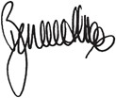
Bernadene Voss
Mayor

Message from the CEO
We are Port Phillip, Council Plan 2017-2027 is an exciting new chapter in the City of Port Phillip’s history.
It sets out an ambitious program to invest in services and projects that ensure Port Phillip remains the bold, liveable, caring and beautiful place residents and visitors love. The integrated approach ensures everything we do – our projects, services, people and expenditure – is delivering on Council’s vision and plan for the municipality.
We operate in an environment that is rapidly changing and there are some significant challenges ahead. The proposed amendments to the plan represent an evidence-based and financially disciplined response to risks and opportunities that are emerging. Examples include public safety, changes in the recycling industries and disrupting service models.
Through the development of the plan we have worked closely with the Councillors to prudently budget over the long term and prioritise significant investment in initiatives that will enable us to be more responsive to our communities, keep pace with the needs of our rapidly growing community and deliver on Council’s vision for the City.
The proposed budget 2018/19 commits us to a significant delivery program. Along with delivering on our transformations, this includes investing $9 million to transform our technology systems to provide a better customer and digital experience for people when they interact with us and allocating $17.5 million to jointly purchase land for inner metropolitan sustainability hub. We have been able to achieve this level of investment within the rate cap and without reducing service levels by delivering ongoing organisational efficiencies ($9 million in savings identified over the past four budgets) and careful prioritisation.
As an organisation, we are committed to being easy to work with, efficient and responsive to the needs of our community.
I encourage and look forward to your feedback on the plan and draft budget.
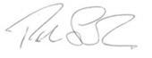
Peter Smith
Chief Executive Officer

About this plan
This plan sets out what we want to achieve for the City of Port Phillip by 2027, and how we will support the current and future health and wellbeing of the City and our people.
This plan delivers on our Victorian local government planning obligations under the Local Government Act 1989 and the Public Health and Wellbeing Act 2008. These obligations determine how we plan for community needs and aspirations over the long, medium and short term, and hold ourselves accountable.
This single, integrated plan delivers our council plan, municipal public health and wellbeing plan, strategic resource plan, 10-year financial outlook, and annual budget.
This plan is supported by the Port Phillip Planning Scheme and detailed strategies and delivery plans that will help deliver our vision and the outcomes we are committed to. Within the organisation, department and individual employee plans are also aligned to support the delivery of the Council Plan.
Figure 1: Integrated planning and delivery framework
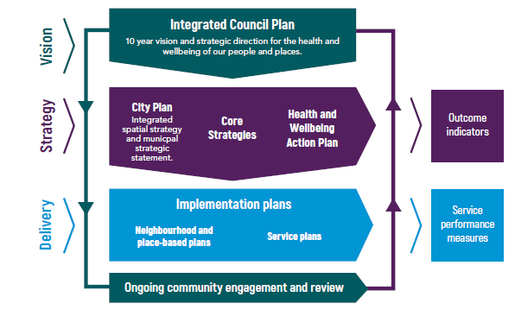
We are committed to a continuous cycle of planning, implementing, reporting and review to ensure we deliver the best outcomes for the community. This plan will be reviewed, updated and improved every year. In particular, we will improve over time the way we measure our performance and how we plan, report and engage at the neighbourhood level.
We will regularly report on our progress towards achieving the outcomes of this plan, our financial performance and project delivery. These reports, and our annual reports, are available online at www.portphillip.vic.gov.au.
Figure 2: Engaging and reporting on the Council Plan
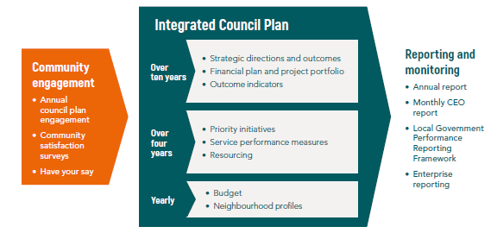

Partners to our plan
Local government plays a key role in protecting and enhancing liveability and the wellbeing of our current and future communities. We are well positioned to directly influence vital factors like transport and land use planning, housing, protection of the natural environment and mitigating impacts of climate change, fostering local connections, social development and safety.
This plan sets out how we, and agencies working in Port Phillip, will work together to improve community outcomes.
We will partner with other levels of government, community, not-for-profit and business organisations, service providers and residents, to develop, implement and evaluate projects, programs and policies that deliver our vision and improve the health and wellbeing of our people and places.

Section 1: Port Phillip Today and Tomorrow

Our city and our people
The Yalukut Weelam clan of the Boon Wurrung are the first people of the City of Port Phillip, with a continued strong connection to the land. Yalukut Weelam means ‘river home’ or ‘people of the river’ reflecting the original prevalence of wetlands between the Yarra River and the foreshore – a landscape that has altered vastly since European settlement.
Port Phillip is one of the oldest areas of European settlement in Melbourne, known and treasured by many for its urban village feel and artistic expression. It is a city of neighbourhoods, each with its own character, defined by heritage buildings, strip shopping precincts and tree-lined streets.
Port Phillip is one of the smallest municipalities in Victoria, only 21 square kilometres, and the most densely populated with more than twice the population density of the metropolitan Melbourne average.
Port Phillip is a popular inner city area of Melbourne, attracting more than 2.8 million visitors each year (Source: Tourism Research Australia Data (March 2016). Note: Excludes local (Melbourne) visitors.), making it one of the most visited places in metropolitan Melbourne, second only to the central business district. The foreshore that stretches over 11 kilometres, and vast public open spaces, make the City highly desirable to residents and visitors.
As we look to 2050, we know that the world will be different. Our physical environment will be more volatile and hostile, technology will continue to rapidly evolve and our urban environment will be more dynamic as information becomes more readily available at all times. Our public places and spaces will significantly change and evolve as residential and mixed use development continues and density increases. Significant population growth is expected over the next 40 years, particularly in the Fishermans Bend renewal area on the northern edge of the City, and in established neighbourhoods like St Kilda Road and South Melbourne.
This plan is shaped by our desire to celebrate our history, protect our character, and encourage inclusion and creativity, while planning for the future of a dynamic and evolving City.

General statistics about the City of Port Phillip

Population (forecast 2018) is 113,512 people (Source: Forecast.id)
Age profile:
13% are aged between 0 and 17 years
35% are aged between 18 and 34 years
45% are aged between 35 and 69 years
7% are aged 70 years or more
Household type:
41% are singles
27% are couples without children
21% are families with children
11% are other household types
Country of birth:
31% were born overseas:
6% in the United Kingdom
3% in New Zealand
2% in India
Language spoken at home:
21% of residents speak a language other than English
Top 3 languages spoken at home:
2.6% of residents speak Greek
2.2% of residents speak Mandarin
1.4% of residents speak Italian
Transport:
27% of residents use public transport to get to work
72% of residents own one or more cars
Housing:
49% of households rent
38% of households own their own home
5% of households live in social or public housing
Income:
30% of households have a total weekly household income of greater than $2,500.
(Source: ABS Census 2016 unless otherwise indicated)

Our health and wellbeing
Integrating health and wellbeing into the Council Plan
Working at the interface with community, local government is well-positioned to directly influence conditions that enable positive health and wellbeing. We have a legislative responsibility under the Victorian Public Health and Wellbeing Act 2008 to prepare a Municipal Public Health and Wellbeing Plan every four years.
To recognise the important role Council plays in supporting health and wellbeing, we have integrated the planning, implementation and evaluation requirements of the Municipal Public Health and Wellbeing Plan into this Council Plan. Integrating our plans in this way ensures we are working to protect, improve and promote public health and wellbeing in everything we do.
Socio-economic factors, and the natural and built environment impact on health. By working collaboratively with other levels of government, service providers, business and community we can reduce inequalities and optimise the conditions in which people can be healthy. In this way, we hope to provide coordinated, robust and appropriate responses, including:
- supporting the delivery of an integrated transport network that connects people and places
- designing infrastructure that creates a greener, cooler and more liveable city
- advocating for and facilitating partnerships to support delivery of diverse, affordable housing
- developing policies and programs that strengthen the community to prevent crime, injury and ill-health, and foster positive social and health change.
The six strategic directions of this plan have been informed and guided by analysing population health data, community consultation and stakeholder feedback, reviewing international, national, state and local research and policy, and the Victorian Public Health and Wellbeing Plan 2015-2019. This ensures we play our role in achieving the State vision of “a Victoria free of the avoidable burden of disease and injury, so that all Victorians can enjoy the highest attainable standards of health, wellbeing, and participation at every age”.
Understanding health
We have embedded the World Health Organisation definition of health in this plan. That is, “a state of complete physical, mental and social wellbeing and not merely the absence of disease or infirmity”.
To support this holistic view of health and wellbeing we need to understand what influences health outcomes. Influences include biological factors and the conditions in which people are born, grow, live, work, play and age – known as the social determinants of health. The Social Model of Health diagram shows this best, with individuals at the centre. This model guides our efforts and those of our partners to promote conditions that support people to be healthy.
We know that there will always be differences in health status in our community. These differences do not happen by chance. They follow social patterns and a trajectory by which an individual's overall health tends to improve at each step up the economic and social hierarchy. That is why we have a role in working to reduce health and wellbeing inequalities, by committing to prevention and early intervention across the life course and by embedding health equity and social justice principles in everything we do.
Understanding health
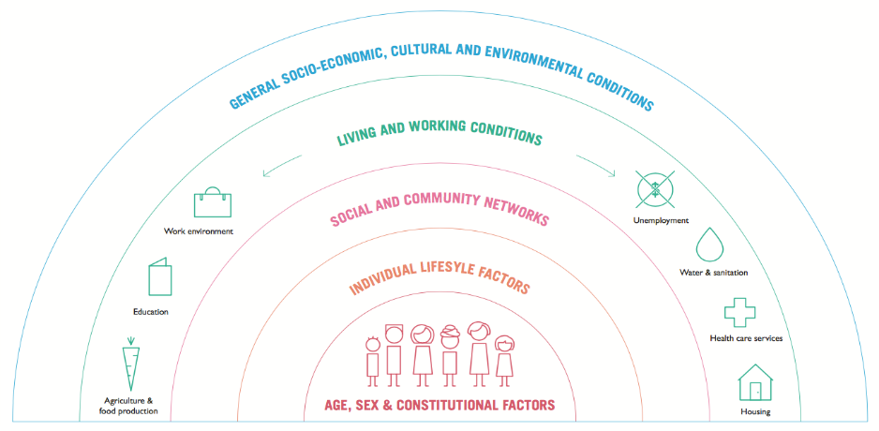 | Inside circle  - Age  - Gender  - Ethnicity  - Ability  Individual Lifestyle Factors  - Diet  - Exercise  - Smoking  - Alcohol  - Illicit substances  Social and Community Networks  - Social participation  - Family  - Friendships  Living and Working Conditions  - Income  - Education  - Housing  - Health services  - Safety  - Transport  - Agriculture and food production  - Water and sanitation  General Socio-Economic, Cultural and Environmental Conditions  - Political landscape  - Built environment  - Social justice  - Health equity
Port Phillip’s health profile
- 7% currently smoke
- 6% eat enough fruit and vegetables
- 59% get enough physical activity
- 38% are pre-obese or obese
- 53% have at least one chronic disease
- rate of sexually transmissible infections is higher than the state average
- each person spends $50 per week on alcohol and $297 on pokies annually
- 44% at risk of alcohol-related harm each month and 69% lifetime risk
- rate of criminal offences is nearly 1.5 times state average
- 96% feel safe walking alone during the day and 65% at night
- 1,032 family violence incidents per 100,000 people
- 31% experienced anxiety or depression in their lifetime
- 43% excellent/very good health status (self-reported)
Victorians’ health and wellbeing is high by international standards and significant gains have been made in recent years. The health and wellbeing of the Port Phillip community is similarly relatively high.
Available data shows that we are similar to the Victorian average in terms of general wellbeing, life satisfaction, day time safety, resilience, levels of psychological distress, participation in health screening activities (for example, blood pressure check), neighbourhood cohesion, social trust, willingness to intervene in a situation of family violence, and fruit, vegetable and water consumption.
Our community has some more favourable outcomes than the Victorian average, such as levels of physical activity and obesity, smoking rates, income and socioeconomic indicators, and some chronic diseases. Port Phillip also has higher than average levels of gender equity awareness, which contributes to lower rates of family violence. Our efforts in these aspects of health and wellbeing must continue to maintain these positive outcomes.
However, we also experience less favourable outcomes. Areas of concern include use of alcohol and illicit drugs, crime, sedentary work behaviours, housing affordability, people experiencing homelessness, and sexually transmissible infections.
This plan seeks to understand the complexities of these outcomes, and identify how we can work together with our partners to improve our health and wellbeing.
Favourable health outcomes | Unfavourable health outcomes
- Almost two-thirds of Port Phillip residents feel safe walking alone in their local area after dark, which is higher than the state average.  - The percentage of people who do not meet physical activity guidelines is the lowest in the state.  - Port Phillip residents eat significantly more serves of vegetables per day than the state average.  - The rate of reported obesity is the lowest in the state.  - Significantly lower smoking rate than the state average.  - The percentage of people who believe multiculturalism makes life better is among the highest in the state.  - The median household income is among the highest in the state and the percentage of people with income less than $400 per week is the lowest in the state.  - The percentages of households with mortgage stress and rental stress are among the lowest in the state.  - The percentage of social housing is among the highest in the state.  - Use of public transport to get to work is one of the highest in the state.  - The percentage of people reporting arthritis is the lowest in the state, and the percentages reporting type two diabetes and high blood pressure are among the lowest.  - Infant breastfeeding rates are among the highest in the state.  - The percentage of children with speech or language problems at school entry is among the lowest in the state. | - The rate of criminal offences is among the highest in the state.  - Significantly higher levels of time spent sitting on a usual work day than state average.  - Significantly greater number of residents identified as being at risk of short-term harm from alcohol, and the number of people identified as being at very high risk of short-term harm is the highest in state.  - Significantly greater number of residents who agree that getting drunk every now and then is okay.  - Significantly higher rates of alcohol related ambulance attendances, hospitalisation, emergency department presentations and assault, including the highest rate of male alcohol-related hospitalisations in the state.  - Significantly higher rate of pharmaceutical related ambulance attendances.  - Significantly higher rates of illicit drug related ambulance attendances (in particular for amphetamines, meth-amphetamines and ecstasy) and the highest hospitalisation rate in the state.  - The percentage of people who feel they are able to get help from neighbours is among the lowest in the state.  - The median weekly rent for a three-bedroom home is the highest in the state and the median house price is among the highest in the state.  - The estimated rate of homeless people per 1,000 population is the third highest in the state.  - Higher rates of sexually transmissible infections.

Our challenges
We have identified seven significant, long-term challenges facing our City, that we have considered when developing this long-term plan:
- Climate Change
- Population growth
- Urbanisation
- Transport and parking
- Legislative and policy influence
- Changing economic conditions
- Rapid evolution of technology.
How we respond to these challenges impacts the liveability of our City, and the health of our community and has shaped this plan and the services we provide.

Climate change
Port Phillip is already experiencing the impacts of climate change, including temperature increases (of between 1.2 and 1.4 degrees since 1950), lower than average rainfall (a decrease of between 100 and 200 millimetres since 1950), more flooding, sea level rise (of between 0.08 to 0.20 metres above the 1986-2005 level), and a notable increase in the number of days over 35 degrees. (Source: Climate Ready Victoria: Greater Melbourne, November 2015, State of Victoria Department of Environment, Land, Water and Planning)
Our City is Melbourne’s playground. The beach lifestyle and coastal activities are very attractive and important to the health and enjoyment of residents and visitors. However, Port Phillip is built on reclaimed land to the south and north. Much of the City is only one to three metres above sea level and coastal areas are exposed to the impacts of climate change, especially flooding and erosion. Port Phillip is located at the bottom of the Elster Creek and Yarra River catchments, requiring a regional ‘whole-of catchment’ partnership approach to enable both proactive and emergency flood management responses.
We can expect increased flooding of coastal properties and public amenities, storm damage to infrastructure, beach erosion, decreased water quality and security of water supply, reduced summer outdoor activities and hotter urban spaces. Changing environmental conditions may challenge some members of our community to stay healthy and safe. For example, those experiencing health or housing crises will be more vulnerable to periods of extreme heat or cold.
This will have an impact on Council services. Assets may be unable to provide the same level of service to the community. In particular, drainage (currently beyond capacity) and Council facilities may become cost-prohibitive to operate if they are not developed to the required sustainable design standards.
Greenhouse gas emissions reduction is one important way to address climate change and avoid dangerous temperature increases. Ninety-nine per cent of Port Phillip emissions are community generated, and these are increasing as our City grows and reliance on car travel continues.

Population growth (Source: Forecast.id unless otherwise stated)
Port Phillip’s population is expected to grow to more than 168,549 people by 2041, a significant 52 per cent increase from the 2017 estimate of 110,942 people. Over the life of this plan, our population is expected to grow by 23 per cent to 136,140.
Our worker population will also rise dramatically. Fishermans Bend is expected to cater for 80,000 jobs by 2050, with just over half of these jobs (34,000) projected to be within Port Phillip. Adjacent municipalities are also expected to grow significantly. The population of the City of Melbourne is projected to double over the next 30 years. (Source: Fishermans Bend: Population & Demographics, September 2016, State of Victoria Department of Environment, Land, Water and Planning)
Growth will not be uniform across our City. The St Kilda Road, Sandridge / Wirraway and Montague neighbourhoods are projected to grow significantly. Other established neighbourhoods will experience lower population growth.
In 2041, the population will continue to be highly mobile and dominated by 25-39 year olds, but with an increasing number of older people. The forecast median age for the Fishermans Bend suburbs (Montague, Sandridge / Wirraway) is 32 and 29 years of age respectively. Our community will likely be more diverse, as the number of people born overseas grows. More than two-thirds of our households will be single person or couples without children.
Population growth and associated demographic and socio-economic shifts will increase demand for all Council services and amenities. Health inequities and wealth disparity may be exacerbated if people find it difficult to access programs, services and amenities that support health and wellbeing. Coupled with the increasing cost of providing services, increasing demand will stretch services and infrastructure. Achieving a balance between the economic benefits of tourism and thriving entertainment and shopping precincts, and minimising social harm and protecting residential amenity may become more challenging.

Transport and parking
Integrated transport infrastructure and services support healthy behaviours including safe walking, bike riding and use of public transport, and enjoyment of entertainment precincts, parks and open spaces.
Road network congestion and overcrowding on public transport will continue to be an issue as our population grows. The road network for cars is at capacity and cannot be increased. The Victorian Government is prioritising more efficient and sustainable modes like trams, walking and bike riding. So, we can expect that, in real terms, road network capacity for private cars is likely to remain static or decrease over time.
Managing on-street car parking for different users – residents, workers and visitors – is also an ongoing challenge. In many parts of the City, demand for parking outstrips supply, and decisions will need to be made about how to best manage the use of this shrinking resource.
Managing congestion as our City grows will only be possible by enabling people to travel by non-car modes. This will require increased investment in walking and bike riding infrastructure, behaviour change initiatives, and partnerships with the Victorian Government to deliver ‘place and movement’ projects that invest in our public spaces and increase public transport service levels, capacity and accessibility.
Traffic and parking congestion has a significant impact on our environment and health, and compromises the liveability of our City. Without safe and accessible transport, some people will be constrained in their ability to stay connected and participate in important aspects of community life, like work, exercise, visiting friends and family, and accessing services and programs.
Increases in car trips cannot easily be accommodated, especially during peak travel times. It is expected that in response there will need to be a real boost in bike riding alongside a continuing shift to public transport and walking travel, where these alternatives are safe, direct and convenient.
It will be important to ensure our public spaces are places for people, accessible by walking and riding a bike, and offer opportunities to be healthy. Learning from European cities, early planning for high capacity bike parking across the City will be required, with the new Domain station presenting a significant opportunity.

Urbanisation
Population growth will drive an increase in urban density. Fishermans Bend will make a significant contribution to housing growth, with new high density neighbourhoods. The density of established areas across the City will also increase, with the St Kilda/St Kilda West and St Kilda Road neighbourhoods accounting for more than half of the projected housing growth outside Fishermans Bend over the next 20 years. We will see more medium to high density residential development and continued pressure to convert commercial areas to residential use. If not carefully managed, this could pose a threat to neighbourhood character and heritage.
Compact cities enable more people to be connected to the things they need to be healthy, like public transport, employment, education and services. However, urban environments increase exposure to pollution and traffic accidents, and reduce access to nature and green open spaces. Maintaining liveability in a higher density city will take concerted effort.
Demand for inner city housing increases price, and can constrain socio-economic and demographic diversity. Higher density, mixed use development means that we are fast becoming a 24-hour city. The ever-growing night time economy, and social issues like drug and alcohol abuse and family violence, become more visible and intensified in urban areas.
With increasing density and vertical living, more people will use our parks, villages, roads and footpaths, beaches and public transport. Improving travel choices and access to high frequency public transport will ensure liveability for residents, workers and visitors. Our public spaces and waterfront will need to be welcoming to all and cater for different and increased use as they become residents’ ‘backyards’.
Our neighbourhoods will need to be safe and walkable, with good access to shops and flexible community spaces, and have a balance of residential and business use so we can reap the benefits of a vibrant ‘mixed use’ city and support healthy, active and connected communities.
Housing affordability will continue to be a concern. Housing costs in Port Phillip are twice the Melbourne average and most low and moderate income households find buying a home and private rentals increasingly unaffordable.

Rapid evolution of technology
The world is becoming more connected. People, businesses and governments are increasingly moving online to connect, deliver and access services, obtain information and perform activities like shopping and working. Technology is also changing the way our residents work. Around one in every 18 employed persons works from home.
We can expect increasing demand for council services to be delivered online, and for engagement through social media and other digital means. We will need to respond to this demand and think about how we operate and support people to connect with Council, particularly those who have limited online access and/or digital literacy. The digital shift will reshape how we deliver services and engage our community in decision making.
Technological advances also present opportunities for Council to consider new methods of service delivery, such as electronic parking management, that have the potential to offer efficiencies and improved community outcomes. New technologies will enable our workforce to be more mobile and deliver services that support community health and wellbeing where, when and how they want them.

Legislative and policy influence
All Victorian councils operate in a complex legislative and policy environment that includes many Acts of Parliament and Regulations. The key Act (the Local Government Act 1989) is under review.
Government funding is being reduced or withdrawn from several sectors, placing additional expectation on local government to fill the gap. This trend of government cost shifting, along with increased compliance, will likely continue. Large-scale sector reforms will exacerbate this challenge, requiring service model changes that may impact on those in our community with the most complex needs.
In addition, the cap on rate increases means local government’s ability to control revenue is constrained. As a result, we are experiencing increased strain on our financial sustainability. The cap on rate increases is forecast to impact our bottom line by $14 million over the next 10 years if we don’t make changes to the way we operate. Difficult decisions will need to be made about our services, investments and assets to ensure the health and wellbeing of our people and places within these fiscal constraints.

Changing economic conditions (Source Economy.id)
Port Phillip’s economy was close to $12 billion in 2015, contributing 4.2 per cent of the greater Melbourne economy. Our economy grew significantly in the early 2000s, and slowed over the last 10 years, but we experienced 2.9 per cent growth in Gross Regional Product, which is the market value of all final goods and services, between 2013 and 2015.
In recent years, we have experienced some growth in the number of businesses and jobs - particularly in construction, manufacturing and some services. We have a higher than average proportion of professional, scientific and technical services (23.6 per cent compared to 9.1 per cent in Victoria), arts and recreation services (2.8 per cent compared to 1.6 per cent) and information media and telecommunications (4 per cent compared to 2.2 per cent). The South Melbourne precinct has one of the highest concentrations of creative industries in Australia. Despite this, 75 per cent of our working population leave the area for work.
The Port Phillip neighbourhoods of Fishermans Bend are currently home to over 750 businesses and approximately 12,000 workers. The transition of Fishermans Bend to a mixed-use community will have a significant impact on the number and type of businesses and jobs in that area.
Our people can expect to spend more time travelling to work outside of the City. We may also continue to experience a change in the nature of our business community as high rental prices put pressure on smaller businesses.
Socio-economic factors have a significant impact on health and wellbeing. The spectrum of people considered vulnerable is widening due to increased costs of living, rental and property costs, social exclusion and health inequity. More than 8,000 residents are living in housing stress and 2,500 residents are on the public housing waiting list (excluding local community housing waiting lists). In the last two years, we have seen an increase of 104 per cent in the number of calls received about people sleeping rough in public places. We expect to observe ever-increasing vulnerability in our community.

Our vision
We are beautiful, liveable, caring, inviting, bold and real

Our strategic directions
We will deliver the vision for Port Phillip through six directions. The plan is structured around these directions and the outcomes for the health and wellbeing of our people and places that we want to see by 2027.

How this plan responds to our community
The table that follows shows how this plan responds to our identified emerging health issues and the Victorian Public Health and Wellbeing Plan 2015-19.
There are four emerging health issues for Port Phillip. We determined these by analysing population health data and identifying priorities, and then assessing what impact we can have on the issue.
- Housing and homelessness.
- Social inclusion and diversity.
Including social network and mental health (prevalence of and lifestyle risk factors).
- Safety.
Including crime, alcohol, illicit and pharmaceutical drugs and family violence.
- Access to information and services.
Including health services, maternal and child health, sexual and reproductive health, preventative action, health status, and prevalence of illness and disease.
Outcomes by 2027 | Emerging health issues that will be addressed | State health priorities that will be addressed
Strategic direction 1: We embrace difference, and people belong
- A safe and active community with strong social connections | Social inclusion and diversity  Safety | Reducing harmful alcohol and drug use  Preventing violence and injury
- An increase in affordable housing | Housing and homelessness | Improving mental health
- Access to services that support the health and wellbeing of our growing community | Access to information and services | All
- Community diversity is valued and celebrated | Social inclusion and diversity | Improving mental health
Strategic direction 2: We are connected and it’s easy to move around
- An integrated transport network that connects people and places  - Demand for parking and car travel is moderated as our City grows  - Our streets and places are designed for people | Access to information and services  Social inclusion and diversity  Safety | Healthier eating and active living  Preventing violence and injury
Strategic direction 3: We have smart solutions for a sustainable future
- A greener, cooler and more liveable City  - A City with lower carbon emissions  - A City that is adapting and resilient to climate change  - A water sensitive City  - A sustained reduction in waste | Access to information and services  Housing and homelessness | Healthier eating and active living  Improving mental health
Strategic direction 4: We are growing and keeping our character
- Liveability in a high-density City  - A City of diverse and distinctive neighbourhoods and places | Housing and homelessness  Access to information and services  Social inclusion and diversity  Safety | Healthier eating and active living  Improving mental health  Reducing harmful alcohol and drug use
Strategic direction 5: We thrive by harnessing creativity
- A City of dynamic and distinctive retail precincts  - A prosperous City that connects and grows business  - A City where arts, culture and creative expression is part of everyday life | Access to information and services  Safety  Social inclusion and diversity | Reducing harmful alcohol and drug use  Preventing violence and injury  Improving mental health
Strategic direction 6: Our commitment to you
6.1 A financially sustainable, high performing, well governed organisation that puts the community first | Social inclusion and diversity  Access to information and services | All

How the community helped shape this plan
Your views and aspirations for the City continue to be important contributions to this plan and we welcome your feedback on the proposed adjustments to this plan.
Our plan was developed in early 2017 and was informed by a comprehensive community engagement program asking for your feedback on how to tackle some of the challenges we face and what you value most about the City.
Community engagement was widely promoted through a range of channels, including Council and library websites, social media, advertisements in local newspapers, and email updates to community networks. Postcards were distributed in town halls, libraries, shopping precincts, markets, childcare centres, community centres and other sites across the City. Community ideas and feedback was captured through:
- community surveys
- an avatar survey identifying community personas
- pop-up conversations between the community and Councillors
- targeted focus groups
- stakeholder meetings
- online discussion forums
- special focus workshops to explore particularly significant challenges like transport, parking and managing waste.
Tailored conversations and activities ensured that a range of groups were involved (including some that are typically harder to reach), such as Indigenous, culturally and linguistically diverse, older people, faith-based communities, youth and children. We used several methods, including facilitated focus group conversations, interpreters to assist with completing the community surveys, and translated feedback forms in Greek, Polish and Russian. A large print survey was provided to community members on request, to ensure the engagement was accessible and everyone had an opportunity to contribute their ideas.
We engaged community researchers to conduct surveys that were inclusive of all members of our community, to extend our reach to people who do not typically engage with Council. Community researchers are graduates of the Voices of the South Side program that provides public speaking, advocacy, research, communication and teamwork skills to people who live in social and public housing in Port Phillip.
Survey questions and prompts emphasised the central role that local government plays in creating communities and environments in which people can thrive. We know we have influence over some of the most powerful contributors to health and wellbeing, like employment, social support, land-use planning, transport and access to cultural activities, so we are ideally placed to have a profound impact on the quality of life of our community.
We received more than 2,000 pieces of feedback, and reached 450 people through the tailored engagement with harder to reach groups in our community. 125 groups and individuals made a submission to the draft Plan when it was released in April.
Since the plan was adopted in June 2017 we have continued to have ongoing conversations about how to tackle the challenges and opportunities facing our city and how to support the health and wellbeing of our community. We are committed to monitoring change and participating in research to understand emerging trends based on evidence, working with community and other partners to innovate and advocating to meet community needs. Over the last twelve months we have engaged deeply on our transport challenges and opportunities and engaged with our key partners and communities on how we can tackle the challenges associated with the impacts of climate change and enhance our creative and prosperous city. We also hosted a series of pop-up conversations in February at local markets and venues to listen to community concerns and provide information on opportunities and challenges facing our city.
The table that follows shows the key themes from our community engagement and consultation. This plan responds by reinforcing the attributes of our City that our community values most and planning for the City they want to see in 10 years’ time.
What our communities value | How this plan responds
Supportive City for all  There is a desire to support all people in the community, including those who are most vulnerable and from diverse backgrounds, and to invest in supporting healthy living and community wellbeing for people of all ages, abilities and life stages. Council’s role in developing community capacity was emphasised. | We embrace difference, and people belong (Direction 1)  The plan identifies priorities that will deliver:  An active and well connected community, with access to services that enhance health and wellbeing. An increase in affordable housing, services targeted at supporting community members experiencing vulnerability, and programs and events that celebrate and are inclusive of our diverse cultural communities.  Highlights of the plan include:  Major upgrades to sporting and community facilities, investing in delivering new affordable housing projects by partnering with housing organisations, and ensuring our services meet the needs of our rapidly growing community.
Transport choice and parking management  Improving transport, traffic management and parking management is one of the City’s greatest challenges. Our community wants a city that makes it easier and more enjoyable to walk, bike ride or use public transport. There are wide ranging views about how to manage parking. | We are connected and it’s easy to move around (Direction 2)  The plan identifies priorities that will deliver:  A transport network offering real travel choices, an improved framework for managing our limited parking supply, and streets that are designed for healthy people, not cars.  Highlights of the plan include:  Developing an Integrated Transport Strategy, investing in improving pedestrian safety and the continuity of our bike routes, and advocacy to address gaps in the public transport network, including a high frequency tram connection to Fishermans Bend.
Creating a sustainable city and managing climate change  Reducing greenhouse gas emissions and managing a changing climate are considered key challenges. Ensuring an environmentally sustainable City is considered important. | We have smart solutions for a sustainable future (Direction 3)  The plan identifies priorities that will deliver:  A cooler city through greening our buildings and streets. A city that has reduced waste going to landfill and increased the use of renewable energy sources. A city and community that has adapted for climate change and reduced the risk of flooding.  Highlights of the plan include:  Developing a Sustainable City Community Action Plan and a new Sustainability Strategy Beyond 2020. Investing in stormwater harvesting, solar energy, waste service innovation and the EcoCentre.
Sense of place and community  Our communities value the places where they live, including beaches, parks and gardens. Clean, safe, and inviting streets, spaces and amenities are important to our community now and in the future. Protecting heritage and iconic buildings is also considered important.  Developing our neighbourhoods in a balanced way  How our neighbourhoods can provide for growth, and maintain character is considered a challenge for the City. | We are growing and keeping our character (Direction 4)  The plan identifies priorities that will deliver:  Liveability as the City grows and urban density increases, by ensuring high quality buildings contribute to safe, lively streets, and enhanced public spaces to cater for increased demand. Protection of the City’s valued heritage places and 10-minute neighbourhoods to reinforce the sense of place.  Highlights of the plan include:  Reviewing planning policy to effectively manage urban growth, strengthening heritage controls and developing a new Public Spaces Strategy. Working in partnership with the Victorian Government to develop a robust planning framework and precinct plans for Fishermans Bend to ensure a world class renewal area.
Creativity and diversity of the City  The culture and vibrancy of Port Phillip is highly regarded and considered part of what makes the City unique.  Balancing activation with protecting local amenity  Supporting businesses and activating shopping strips is seen as an opportunity. Events, festivals and attractions that bring people to the City need to be managed in a way that protects local amenity. | We thrive by harnessing creativity (Direction 5)  The plan identifies priorities that will deliver:  A city where arts, culture and creative expression is part of everyday life, our creative industries cluster has grown, and thriving retail centres are a focal point for local communities and business.  Highlights of the plan include:  Investing in retail precincts to improve accessibility and facilitating renewal. Developing a Creative and Prosperous City Strategy and transforming our libraries as creative and learning spaces.
A full summary of the feedback received is available at www.portphillip.vic.gov.au/haveyoursay.

Strategic direction 1: We embrace difference, and people belong.

What we want to see by 2027
- A safe and active community with strong social connections
- An increase in affordable housing
- Access to services that support the health and wellbeing of our growing community
- Community diversity is valued and celebrated

How we will measure progress
Outcome indicators | 2014/15 result | 2015/16 result | 2016/17  result | 2018/19 target | 2020/21 target | 2026/27 target
Residents that agree Port Phillip is a welcoming and supportive community for everyone | 96% | 93% | 94% | >95% | >95% | >95%
Social housing as a percentage of housing stock (Average 92 new dwellings per year required to maintain performance) | 7.2% | 7.2% | NA | 7.2% | 7.2% | 7.2%
Wellbeing index (VicHealth Indicators Survey self-reported index, available every four years) | n/a | 77.5 | NA | n/a | >77.5 | >77.5

By 2027 we want to see:
1.1 A safe and active community with strong social connections
We will work towards this outcome by: | Our priorities for the next four years:
- Providing access to flexible, multi-purpose facilities that support participation in community life through sport, recreation and life-long learning.  - Supporting programs that create social connections and strengthen community networks.  - Building community capacity by harnessing the knowledge, expertise and spirit within our community. | - Plan and deliver a long-term program of sports field and pavilion upgrades to enhance capacity and broaden community participation in sport and recreation.  - Redevelop the South Melbourne Life Saving Club to provide contemporary clubhouse facilities and public amenities.  - Invest in a long-term program of community facility upgrades to ensure they are fit for purpose and meet current and future community needs.  - Establish outdoor gyms and fitness stations in open space and continue to upgrade recreation reserves and skate parks to facilitate an active, healthy community.  - Deliver community strengthening programs that harness community knowledge and expertise to support leadership, learning and volunteering, improve safety and foster positive social and health outcomes.  - Implement a whole of Council and community approach to preventing and responding to family violence.  - Collaborate with partners to understand and minimise the harms associated with alcohol and drug use.  - Provide funding to groups and organisations that support local networks, encourage community participation and support access and inclusion.
1.2 An increase in affordable housing
We will work towards this outcome by: | Our priorities for the next four years:
- Pursuing new, sustainable funding streams to significantly increase the supply of social housing.  - Establishing and facilitating partnerships to support diverse and innovative new affordable housing projects, and reduce the risk of homelessness. | - Implement In Our Backyard – Growing Affordable Housing in Port Phillip 2015-2025 to increase the supply and diversity of affordable housing aligned to priority local needs – low income families, older people, key workers, and single people at greatest risk of homelessness.  - Review and implement the Homelessness Action Strategy 2015-2020, and provide support for people experiencing homelessness to access suitable housing.  - Use Council property assets (land and air space contributions) and cash contributions to facilitate delivery of new community housing units by local housing organisations, including progressing development of 46-58 Marlborough Street, Balaclava.  - Work with the Victorian Government and local community housing organisations to optimise benefits from existing social housing sites, through increased yield, quality and housing type, aligned to local needs.  - Facilitate partnerships between the community housing, private and philanthropic sectors that fund and deliver new housing projects, including in Fishermans Bend.
1.3 Access to services that support the health and wellbeing of our growing community
We will work towards this outcome by: | Our priorities for the next four years:
- Facilitating access to relevant services that cater for all ages and life stages.  - Supporting co-located and integrated services, and shared use arrangements, to improve access for all.  - Exploring partnerships and innovative ways of delivering services.  - Pursuing universal accessibility for people with disabilities, children and older people. | - Deliver new community spaces as part of the integrated Ferrars Street Education and Community Precinct at Fishermans Bend – Completed in 2018  - Implement outcomes from reviewing Council’s role in aged care and disability support services, in the context of national sector reforms and with the aim of facilitating continued access to relevant, quality services.  - Complete the review of children’s services to determine Council’s future role in early childhood education and care.  - Explore new models of providing services and advocate to ensure the right mix and level of services to improve access and health equity for our communities.  - Implement improvements to maternal and child health services and family support services that respond to growing and changing demands.  - Investigate the feasibility of a dedicated youth space, including through potential partnership arrangements.  - Collaborate with partners and service providers to undertake neighbourhood planning and delivery of community infrastructure, services, programs and outreach that promote health and social inclusion and are aligned to community needs.  - Review and implement the City of Port Phillip Access Plan to support universal access, and implement accessibility improvements to council buildings, streets and public spaces, including the beach.  - Provide funding to community organisations and service providers to ensure access to relevant services and programs.
1.4 Community diversity is valued and celebrated
We will work towards this outcome by: | Our priorities for the next four years:
- Supporting programs and events that engage, honour and are inclusive of our diverse social and cultural communities.  - Targeting services and building community capacity to support vulnerable members of our community, emphasising prevention and early intervention.  - Protecting and promoting Aboriginal culture and heritage, and continuing reconciliation with our Indigenous community. | - Establish the Pride Centre in St Kilda.  - Work with the Port Phillip Health and Wellbeing Alliance, Youth Advisory Committee, Older Persons Consultative Committee, Access Network, Multicultural Forum and Multifaith Network to develop policy, services and infrastructure that best meet diverse community needs.  - Ongoing delivery of programs and events that celebrate our diverse communities, including multicultural and multifaith events, senior events, and the Pride March.  - Review the Port Phillip Social Justice Charter.  - Retain Council’s Access and Ageing Department Rainbow Tick accreditation to ensure LGBTIQ inclusive service delivery – Completed in 2017  - Implement our second Reconciliation Action Plan 2017-2019, including the Aboriginal and Torres Strait Islander employment policy, and update the Aboriginal and Torres Strait Islander Arts Plan.

This direction is supported by:
Instrument | Description
Advocacy priorities | Advocate to the Victorian Government:  - for an affordable housing target in Fishermans Bend  - to introduce ‘Inclusionary Zoning’ to deliver affordable and social housing through private sector development  - for improved public and social housing, and better standards for boarding and rooming houses, to improve safety, amenity and privacy of residents  - to improve access to education and additional schools in Port Phillip.  Advocate to the Federal Government for funded support and tax reform that addresses housing affordability.
Engagement and partnership priorities | Ongoing collaboration with partners to the Health and Wellbeing Alliance.  Suai Covalima Timor Leste Partnership.  Work in partnership with Victoria Police, the community and local service agencies to improve community safety.  Work with new and current partners to monitor and respond to health and social change through research and evidence-based policy.  Work with academic partners to undertake place-based evaluations of health outcomes.  Work with inner Melbourne councils to collaborate on regional sport and recreational planning and delivery.
Strategies / plans. These are mapped to the direction they primarily contribute to. Some strategies, plans and policies will contribute to multiple directions. | Access Plan 2013-18  Childcare Policy 2018 (Interim Policy)  Disability Policy 2011  Family, Youth and Children Collaborative Practice Framework 2016  Family, Youth and Children Strategy 2014-2019  Friends of Suai Strategic Plan 2010-2020  Health and Wellbeing Implementation Plan  Homelessness Action Strategy 2015-2020  In Our Backyard – Growing Affordable Housing in Port Phillip 2015-2025  Middle Years Commitment and Action Plan 2014-2019  Protocol for Assisting People Who Sleep Rough 2012  Reconciliation Action Plan 2017  Social Justice Charter 2011  Sport and Recreation Strategy and Implementation Plan 2015-2024  Youth Commitment and Action Plan 2014-2019

Key projects that will be underway by 2027:
Service | Project | Cost (4-year projection) | Council’s role | 2017/18 | 2018/19 | 2019/20 | 2020/21 | 2021-27
Affordable housing and homelessness | In Our Backyard Strategy Implementation. This is a major initiative that will be reported on in Council’s Annual Report, pursuant to section 131 of the Local Government Act 1989. | $535,600 | Partner | Ongoing | Ongoing | Ongoing | Ongoing | Finish
Ageing and accessibility | Aged Care Transition Service Review | $859,880 | Deliver | Start | Ongoing | Ongoing | Finish | n/a
Children | Children’s Centres Improvement Program | $2,800,000 | Deliver | Deferred | Start | Ongoing | Ongoing | Ongoing
Children | Bubup Nairm Non-Compliance Works | $927,000 | Deliver | Finish | n/a | n/a | n/a | n/a
Children | Children’s Services Review Implementation | $810,000 | Deliver | Start | Ongoing | Ongoing | Finish | n/a
Community programs and facilities | Health and Wellbeing Strategy Implementation | $362,000 | Deliver/  Partner | n/a | Start | Ongoing | Ongoing | Finish
Community programs and facilities | Ferrars Street Education and Community Precinct Community Facilities and Netball Courts. This is a major initiative that will be reported on in Council’s Annual Report, pursuant to section 131 of the Local Government Act 1989. | $2,995,000 | Fund | Finish | n/a | n/a | n/a | n/a
Community programs and facilities | Liardet Street Community Centre | $560,000 | Deliver | Finish | n/a | n/a | n/a | n/a
Community programs and facilities | South Melbourne Community Centre | $767,000 | Deliver | Start | Finish | n/a | n/a | n/a
Community programs and facilities | Pride Centre Implementation | $20,000 | Partner | Start | Ongoing | Finish | n/a | n/a
Families and young people | Adventure Playgrounds Upgrade | $1,226,000 | Deliver | n/a | Start | Ongoing | Ongoing | Finish
Recreation | JL Murphy Reserve Pavilion Upgrade. This is a major initiative that will be reported on in Council’s Annual Report, pursuant to section 131 of the Local Government Act 1989. | $3,947,000 | Deliver | Start | Ongoing | Finish | n/a | n/a
Recreation | Peanut Farm Reserve Sports Pavilion Upgrade. This is a major initiative that will be reported on in Council’s Annual Report, pursuant to section 131 of the Local Government Act 1989. | $3,002,000 | Deliver | Ongoing | Finish | n/a | n/a | n/a
Recreation | South Melbourne Life Saving Club Redevelopment. This is a major initiative that will be reported on in Council’s Annual Report, pursuant to section 131 of the Local Government Act 1989. | $6,350,000 | Deliver | Start | Ongoing | Finish | n/a | n/a
Recreation | North Port Oval Upgrade | $2,950,000 | Deliver | n/a | Start | Ongoing | Finish | n/a
Recreation | Sports Playing Field Renewal Program | $800,000 | Deliver | Ongoing | Ongoing | Ongoing | Ongoing | Ongoing
Recreation | Julier Reserve Pavilion Upgrade | $240,000 | Deliver | n/a | n/a | Start | Ongoing | Finish
Recreation | Lagoon Reserve Sport Field Upgrade | $100,000 | Deliver | n/a | n/a | n/a | Start | Finish
Recreation | Recreation Reserves Facilities Renewals Program | $840,000 | Deliver | Ongoing | Ongoing | Ongoing | Ongoing | Ongoing

Services that contribute to this direction
Service category and description | Expenditure type | 2018/19 | 2019/20 | 2020/21 | 2021/22
Affordable housing and homelessness - support people at risk of or experiencing homelessness through direct services and facilitating an increasing supply of affordable housing through research and advocacy, contributing property and funding for community housing projects, and facilitating affordable housing developments by the public, private and community sectors. | Operating  Capital | $1,635,363  $0 | $1,493,891  $0 | $1,547,220  $0 | $1,547,981  $0
Ageing and accessibility – facilitate independence and promote social connectedness for older people and those with a disability by providing in-home support services, social inclusion programs, funding for community groups and service providers, assessing clients to determine their needs, and consulting with community committees and networks.  Note: this service may change over the next four years in response to national sector reforms. | Operating  Capital | $8,910,797  $0 | $9,091,686  $0 | $9,443,211  $0 | $9,396,491  $0
Children – help families achieve their full potential by providing, funding and advocating for high quality, affordable early childhood education and care, maternal and child health services, playgroups and toy libraries.  Note: this service may change over the next four years to reflect changing demand and service models. | Operating  Capital | $17,783,215  $400,000 | $18,306,901  $1,200,000 | $20,050,599  $1,200,000 | $19,124,527  $1,200,000
Community programs and facilities – support inclusion for all people in our diverse community regardless of age, ethnicity, gender identity, sexuality, faith or socio-economic status, by working with community organisations, multicultural and multifaith networks, and through planning, programs, grants and facilities.  The operating expenditure figure for 2017/18 includes one-off funding for the Ferrars Street Education and Community Precinct and Pride Centre. | Operating  Capital | $4,019,278  $754,000 | $4,061,323  $0 | $4,285,101  $0 | $4,319,308  $0
Families and young people – support for families and young people through case management services for vulnerable families, middle years services and programs for young people aged 8 to 11 years, and programs and projects for young people aged 12 to 25 years who live, work, study or recreate in Port Phillip. | Operating  Capital | $3,111,232  $215,000 | $3,108,363  $205,000 | $3,125,273  $806,000 | $3,488,250  $806,000
Recreation – support our community to remain active and healthy through programs, support and funding for local sports and recreation clubs and providers, providing quality sports facilities, and partnering with other organisations to facilitate health and wellbeing outcomes. | Operating  Capital | $1,995,668  $8,566,500 | $2,310,207  $6,170,500 | $2,409,636  $1,951,500 | $2,329,686  $4,505,000

Performance measures
Service | Measure | Result 2014/15 | Result 2015/16 | Result 2016/17 | Target 2018/19 | Target 2020/21
Affordable housing and homelessness | Council facilitated units on Council land | Data unavailable | 645 (total baseline) | Data unavailable | No score | No score
Ageing and accessibility | Resident satisfaction with services that support older people and people with disabilities | 94% | 93% | 94% | >94% | 95%
Children / Families and young people | Proportion of state regulated, Council provided family, youth and children’s services that meet or exceed national quality and accreditation standards | 100% | 100% | 100% | 100% | 100%
Children / Families and young people | Participation in first maternal and child health home visit. This measure is required under the Local Government Performance Reporting Framework.  The greater than 100 per cent result is due to a greater number of visits than birth notifications, because some babies born late in the financial year received their first visit in the next financial year. | 104.4% | 103.9% | 103.3% | 100% | 100%
Children / Families and young people | Infant enrolment in maternal and child health services. This measure is required under the Local Government Performance Reporting Framework. | 99.8% | 99.8% | 100% | 100% | 100%
Children / Families and young people | Cost of maternal and child health service. This measure is required under the Local Government Performance Reporting Framework. | $72.65 | $73.37 | $71.80 | $82 | $85
Children / Families and young people | Participation in maternal and child health services. This measure is required under the Local Government Performance Reporting Framework. | 83.6% | 84.2% | 82.9% | >85% | >85%
Children / Families and young people | Participation by Aboriginal children in maternal and child health services. This measure is required under the Local Government Performance Reporting Framework. | 69.1% | 87.2% | 84.8% | >85% | >85%
Children / Families and young people | Resident satisfaction with services that support families, youth and children | 95% | 97% | 94% | >95% | >95%
Community programs and facilities | Resident perception regarding whether City of Port Phillip services contribute to the overall health and wellbeing of the community | Data unavailable | 66% (result is from November 2016) | 64% | 67% | 68%
Recreation | Community rating of Council’s recreational facility performance (index) | Data unavailable | 76 | 73 | >75 | >80
Recreation | Participation per capita in sport and recreation across formal activities | Data unavailable | Data unavailable | 19% | 1% increase on baseline | 5% increase on baseline

Service information
The following statistics highlight some of the services we provided during 2016/17 compared to previous years.
Statistic | 2014/15 | 2015/16 | 2016/17 | Trend
Maternal and child health services
Birth notifications received | 1,255 | 1,362 | 1,344 | Decrease
Community immunisation sessions held | 79 | 80 | 78 | Stable
Infants and children attending immunisation sessions | 2,784 | 2,952 | 2,801 | Decrease
Childcare
Total places across the City | 1,530 | 1,620 | 1,728 | Increase
Council managed places | 318 | 318 | 318 | Stable
- Bubup Nairm Family and Children’s Centre | 116 | 116 | 116 | Stable
- Clark Street Children’s Centre | 65 | 65 | 65 | Stable
- Coventry Children’s Centre | 60 | 60 | 60 | Stable
- North St Kilda Children’s Centre | 77 | 77 | 77 | Stable
Community managed places | 446 | 483 | 568 | Increase
Commercial managed places | 766 | 819 | 842 | Increase
Family support
Received in government grants | $238,372 | $250,208 | $253,000 | Increase
Target hours provided | 2,565 | 2,729 | 2,327 | Decrease
Young people
Young people (8-11 years old) accessing programs that are run or funded by Council | NA | 21,187 | 33,369 | Increase
Young people (12-25 years old) accessing programs that are run or funded by Council | 8,178 | 26,359 | 21,946 | Decrease
Aged and disability services
Home care
Active home care clients | 1,991 | 1,973 | 1,710 | Decrease
Hours of general home care | 26,758 | 27,902 | 19,865 | Decrease
Hours of meal preparation | 432 | 284 | 219 | Decrease
Hours of personal care | 6,788 | 6,556 | 6,239 | Decrease
Hours of home maintenance service | 4,003 | 3,413 | 2,450 | Decrease
Hours of respite care | 8,647 | 7,356 | 6,435 | Decrease
Hours of shopping services | 9,051 | 8,373 | 8,137 | Decrease
Hours of core social support | 7,958 | 9,204 | 9,919 | Increase
Hours of high priority social support | 10,270 | 9,183 | 8,564 | Decrease
Community meals
Meals delivered | 33,321 | 31,321 | 27,688 | Decrease
Meals provided at centres | 4,467 | 3,798 | 2,949 | Decrease
Meals subsidised | 80,679 | 80,037 | 82,848 | Increase
Community transport
Community bus trips | 3,380 | 1,352 | 1,981 | Increase
Passengers who used the service | 32,845 | 33,150 | 33,048 | Decrease
Volunteers
Community access volunteers | 23 | 15 | 15 | Stable
Sports facilities
Bookings across 15 sporting reserves | 4,487 | 3,871 | 4,387 | Increase
Community centres
Visits | 194,295 | 172,590 | 184,140 | Increase
Bookings | 11,721 | 11,506 | 12,276 | Increase
Casual hires | 1,232 | 1,071 | 1,131 | Increase

Assets
Asset type | Result
Maternal and child health centres | 7
Council and community managed childcare centres | 12
Community centres | 12
Sports club buildings | 20

Major contracts (annualised value of $150,000 or more)
Contract type | Annualised value 2018/19
Sports field maintenance | $502,000

Major financial contributions (annual value of $30,000 or more)
Organisation or financial contribution type | Value
Childcare subsidies (community managed centres) | $780,000
Port Phillip Community Group | $570,000
Childcare subsidies (council managed centres) | $531,000
Community housing contribution | $500,000
Community and neighbourhood grants | $303,000
Food services and social support grants | $222,000
Youth services | $149,000
Kindergarten grants | $129,000
Town hall hire subsidy | $110,000
Port Melbourne Neighbourhood House | $136,000
Star Health | $115,000
South Port Legal Service | $59,000
Friends of Suai | $48,000
South Port Day Links | $48,000
Sacred Heart Mission | $23,000
New Hope Foundation | $33,000

Major leases on council assets
Lessee | Physical address | Market rental (Estimate. Unless otherwise noted, market rent is the rating valuation calculated as five per cent of the Capital Improvement Value of the property.) | Rent per year (excluding GST)
Ada A’Beckett Childrens Centre | 2 Batman Road, Port Melbourne | $340,000 | $104
Albert Park Kindergarten | 18 Dundas Place, Albert Park | $102,500 | $104
Bubup Womindjeka Family and Childrens Centre | 85 Liardet Street, Port Melbourne | $385,000 | $104
Clarendon Childrens Centre | 404-412 Clarendon Street, South Melbourne | $105,000 | $104
Eildon Road Childrens Centre | 17 Eildon Road, St Kilda | $127,500 | $104
Lady Forster Kindergarten | 63B Ormond Esplanade, Elwood | $185,000 | $104
Lillian Cannam Kindergarten | 97 Eastern Road, South Melbourne | $155,000 | $104
Napier Street Aged Care | 179 Napier Street, South Melbourne | $483,000  (market rent determined by valuation report) | $0
Poets Grove Family and Childrens Centre | 18 Poets Grove, Elwood | $185,000 | $104
Port Melbourne Football Club North Port |  | $210,000  (market rent determined by valuation report) | $14,642  (includes seasonal fee and gym lease
South Melbourne Child Care | 5-11 Carter Street, Albert Park | $125,000 | $104
South Port Community Residential Home | 18-30 Richardson Street, Albert Park | $100,000  (ground rent only at market rates) | $1
St Kilda Life Saving Club |  | $420,000  (market rent determined by valuation report) | $1,000
The Elwood Childrens Centre | 446 Tennyson Street, Elwood | $100,000 | $104

Total budget for 2018/19
$47,391,054

How is it spent?
Operating - $37,455,554
Capital - $9,935,500

How is it funded?
Rates - $14,731,193 (31%)
Fees and charges including parking - $20,390,946 (43%)
Other income - $12,268,916 (26%)

Strategic direction 2: We are connected and it’s easy to move around.

What we want to see by 2027
- An integrated transport network that connects people and places
- Demand for parking and car travel is moderated as our City grows
- Our streets and places are designed for people

How we will measure progress
Outcome indicators | 2014/15 result | 2015/16 result | 2016/17 result | 2018/19 target | 2020/21 target | 2027 target
Residents reporting choosing sustainable transport options to travel to work | 57% | 57% | 64% | 58% | 60% | 65%
Number of fatal and serious traffic collisions involving all road users | 93 | 97 | 78 | <127 | <119 | To be developed through the Integrated Transport Strategy
Number of schools participating in Ride 2 School Month and Walk to School Day | 8 | 10 | 11 | 12 | 14 | 16
Note: It is anticipated that the Integrated Transport Strategy will be released for a period of consultation in mid-2018.

By 2027 we want to see:
2.1 An integrated transport network that connects people and places
We will work towards this outcome by: | Our priorities for the next four years:
- Improving the connectivity, safety and amenity of walking and bike riding networks.  - Advocating for investment in public transport to address network gaps, increase capacity, and improve connections between modes.  - Influencing truck movements to facilitate business and manage local amenity impacts. | - Develop and deliver an Integrated Transport Strategy, including network plans for all modes and intermodal connections  - Implement walking projects that create safe, high amenity walking routes and reduce barriers to people walking across arterial roads.  - Improve the attractiveness of bike riding as part of delivering Council’s bike network.  - Deliver the Beach Street separated queuing lane to reduce traffic delays associated with cruise ship arrivals – completed in 2017  - Plan for and deliver Kerferd Road safety and streetscape improvements to enhance walking and bike riding (subject to State funding).  - Work with Public Transport Victoria and Yarra Trams to deliver a pipeline of tram projects that will improve place and movement.  - Ongoing program of renewals and improvements to laneways, roads, footpaths and street signage.
2.2 Demand for parking and car travel is moderated as our City grows
We will work towards this outcome by: | Our priorities for the next four years:
- Engaging with the community using a neighbourhood based approach, to encourage active and sustainable travel.  - Reducing reliance on cars, by directing housing and employment growth to areas with the best access to public transport and shops.  - Managing parking demand through technology, policy and pricing. | - Develop a Parking Management Plan as part of the Integrated Transport Strategy –  - Develop new policies for paid parking, on-street permits and parking provision rates for new development.  - Investigate Council’s car parks for future development opportunities that deliver increased community benefit.  - Implement clever parking initiatives that help manage parking supply and turnover, and improve customer experience.  - Expand the on-street network of car share vehicles, and encourage provision in new developments.  - Integrate land use and transport planning through a review of the Municipal Strategic Statement.
2.3 Our streets and places are designed for people
We will work towards this outcome by: | Our priorities for the next four years:
- Prioritising walking, bike riding and public transport when designing roads and allocating resources. | - Implement blackspot safety improvements at high collision locations (subject to external funding).  - Work with partners on the St Kilda Junction safety upgrade and St Kilda Road safety improvement study to facilitate walking, bike riding and use of public transport.  - Complete the streetscape and intersection upgrade of Wellington Street to improve safety and amenity.  - Improve local community travel choices, especially by schools, by investing in infrastructure and behaviour change programs.  - Progressively review and upgrade disabled parking spaces in commercial areas to meet updated Australian Standards.  - Review Council’s design and technical standards for streets and public spaces.

This direction is supported by:
Instrument | Description
Advocacy priorities | Advocate to the Victorian Government:  - to maximise community benefit from Melbourne Metro public transport and precinct works including the Park Street tram link and all associated tram stop upgrades  - to maximise community benefit from Public Transport Victoria’s tram stop upgrade program  - for the Shrine to Bay Boulevard, landscape and bike network connection  - to expedite funding and delivery of the St Kilda Road safety improvement project to provide for convenient, safe and continuous walking and bike riding  - for early implementation of strategic cycling corridors (continuous buffered and protected bike lanes), light rail and smart bus routes to and around Fishermans Bend  - for Balaclava Walk (Nightingale Street to Ripponlea Station).  Advocate to VicRoads to confine truck travel to select routes through the City, including an extension of the truck curfew on Beaconsfield Parade and Beach Street.
Engagement and partnership priorities | Lead collaboration with inner Melbourne councils to secure funding for the inner metro strategic cycling corridor network.  Partner with inner city councils to advocate for a consistent wayfinding strategy for pedestrians and public transport users.
Strategies / plans. These are mapped to the direction they primarily contribute to. Some strategies, plans and policies will contribute to multiple directions. | Bike Plan: Pedal Power 2011-2020  Car Share Policy 2016-2021  Parking Permit Policy 2001  Public Transport Advocacy Statement 2009  Road Management Plan 2013  Safer Streets 2013-2020: The Road User Safety Strategy  Sustainable Transport and Parking Rates Policy 2007 (scheduled for review)  Sustainable Transport Precinct Plans  Sustainable Transport Strategy: A Connected and Liveable City 2014  Walk Plan 2011-2020

Key projects that will be underway by 2027
Service | Project | Cost (4-year projection) | Council’s role | 2017/18 | 2018/19 | 2019/20 | 2020/21 | 2021-27
Transport and parking management | Integrated Transport Strategy Development and Implementation. A draft strategy will be released for public consultation in 2018. This includes a budget allocation to deliver on the strategy. This is a major initiative that will contribute to Transforming Transport and Parking. Major initiatives will be reported on in Council’s Annual Report, pursuant to section 131 of the Local Government Act 1989. | $968,000 | Deliver | Start | Ongoing | Ongoing | Ongoing | Ongoing
Transport and parking management | Domain Precinct and Melbourne Metro Tunnel Project Management | $2,781,000 | Partner | Start | Ongoing | Ongoing | Finish | n/a
Transport and parking management | Kerferd Road Safety and Streetscape Improvements (subject to external funding). This is a major initiative that will contribute to Transforming Transport and Parking. Major initiatives will be reported on in Council’s Annual Report, pursuant to section 131 of the Local Government Act 1989. | $2,060,000 | Deliver | Start | Ongoing | Ongoing | Finish | n/a
Transport and parking management | Wellington Street Upgrade – Intersection Improvements | $450,000 | Deliver | n/a | Start & Finish | n/a | n/a | n/a
Transport and parking management | Blackspot Safety Improvements (subject to external funding) | $2,185,000 | Deliver | Ongoing | Ongoing | Ongoing | Ongoing | Ongoing
Transport and parking management | Parking Technology Renewal and Upgrade Program. | $1,765,000 | Deliver | Start | n/a (see Parking Technology Enhancements) | Ongoing | Ongoing | Ongoing
Transport and parking management | Parking Technology Enhancements. This is a major initiative that will contribute to Transforming Transport and Parking. Major initiatives will be reported on in Council’s Annual Report, pursuant to section 131 of the Local Government Act 1989. | $1,222,000 | Deliver | Start | Finish | n/a | n/a | n/a
Transport and parking management | Walk Plan and Bike Plan Implementation. This is a major initiative that will contribute to Transforming Transport and Parking. Major initiatives will be reported on in Council’s Annual Report, pursuant to section 131 of the Local Government Act 1989. | $6,250,000 | Deliver | Ongoing | Ongoing | Ongoing | Ongoing | Ongoing
Transport and parking management | St Kilda Junction Safety Upgrade | $500,000 | Deliver | n/a | Start | Finish | n/a | n/a
Transport and parking management | Street Signage and Furniture Renewal Program | $1,440,000 | Deliver | Ongoing | Ongoing | Ongoing | Ongoing | Ongoing
Transport and parking management | Footpath Renewal Program | $2,899,000 | Deliver | Ongoing | Ongoing | Ongoing | Ongoing | Ongoing
Transport and parking management | Kerb and Gutter Renewal Program | $2,050,000 | Deliver | Ongoing | Ongoing | Ongoing | Ongoing | Ongoing
Transport and parking management | Laneway Renewal and Upgrade Program | $1,970,000 | Deliver | Ongoing | Ongoing | Ongoing | Ongoing | Ongoing
Transport and parking management | Public Space Accessibility Improvement Program | $1,400,000 | Deliver | Ongoing | Ongoing | Ongoing | Ongoing | Ongoing
Transport and parking management | Road Renewal Program | $11,830,000 | Deliver | Ongoing | Ongoing | Ongoing | Ongoing | Ongoing

Services that contribute to this direction
Service category and description | Expenditure type | 2018/19 | 2019/20 | 2020/21 | 2021/22
Transport and parking management – provide and maintain a safe transport network, develop transport and road safety strategy and policy, measure the impact of education programs, improve the range of travel modes, and manage parking policy, on-street parking controls and enforcement. | Operating  Capital | $23,199,395  $9,845,000 | $23,487,652  $8,810,000 | $24,726,282  $8,480,000 | $23,763,393  $9,620,000

Performance measures
Service | Measure | Result 2014/15 | Result 2015/16 | Result 2016/17 | Target 2018/19 | Target 2020/21
Transport and parking management | Resident satisfaction with transport planning policy, safety and design. | - | 91% (result is from November 2016) | 88% | >90% | >90%
Transport and parking management | Resident satisfaction with parking management | 77% | 79% | 81% | 80% | 80%
Transport and parking management | Resident satisfaction with resident parking permits | - | 74% (result is from November 2016) | 80% | >75% | >75%
Transport and parking management | Sealed local road requests. This measure is required under the Local Government Performance Reporting Framework. | 59 | 52 | 65 | 70 | 70
Transport and parking management | Satisfaction with sealed local roads | 73 | 70 | 70 | >70 | >70
Transport and parking management | Cost of sealed local road reconstruction. This measure is required under the Local Government Performance Reporting Framework. | $170.70 | $156.51 | $190.87 | NA | NA
Transport and parking management | Cost of sealed local road resealing. This measure is required under the Local Government Performance Reporting Framework. | $40.27 | $43.03 | $49.90 | $50 | $60
Transport and parking management | Sealed local roads below the intervention level. This measure is required under the Local Government Performance Reporting Framework. | 97% | 97% | 97% | 97% | 97%

Service information
The following statistics highlight some of the services we provided during 2016/17 compared to previous years.
Measure | 2014/15 | 2015/16 | 2016/17 | Trend
Parking management
Abandoned vehicles | 1,476 | 1,489 | 1,679 | Increase
Disabled parking permit issued - Blue | 1,179 | 1,236 | 1,257 | Increase
Disabled parking permit issued - Green | 217 | 120 | 102 | Decrease
Resident parking permits issued | 6,710 | 7,646 | 6,465 | Decrease
Foreshore permits issued | 2,567 | 2,527 | 2,266 | Decrease
Combined permits issued | 7,068 | 7,016 | 5,842 | Decrease
Community service permits issued | 1,133 | 1,301 | 1,038 | Decrease
Visitor parking permits issued | 10,724 | 11,486 | 10,193 | Decrease
Parking enforcement infringements issued | 147,647 | 158,376 | 162,852 | Increase
Parking complaints (officer) | 33 | 17 | 28 | Increase
Number of parking permits issued per year | 18,830 | 32,986 | 28,548 | Decrease

Assets
Asset type | Result
Bike network (lanes and paths) | 59km
Roads | 265km
Footpaths | 414km
Parking machines | 489

Major contracts (annualised value of $150,000 or more)
Contract type | Annualised value 2018/19
Civil infrastructure and maintenance | $3,000,000
Parking administration services | $2,123,000
Parking machine maintenance | $725,000
Street lighting electricity | $1,240,000
Vehicle towing | $668,000

Total budget for 2018/19
$33,044,395

How is it spent?
Operating - $23,199,395
Capital - $9,845,000

How is it funded?
Rates - $25,199,864 (76%)
Fees and charges including parking - $5,994,392 (18%)
Other income - $1,850,139 (6%)

Strategic direction 3: We have smart solutions for a sustainable future.

What we want to see by 2027
- A greener, cooler and more liveable City
- A City with lower carbon emissions
- A City that is adapting and resilient to climate change
- A water sensitive City
- A sustained reduction in waste

How we will measure progress
Outcome indicators | 2014/15 result | 2015/16 result | 2016/17 result | 2018/19 target | 2020/21 target | 2026/27 target
Total canopy cover | Data unavailable | 19% | No score | No score | No score | 21%
Council’s greenhouse gas emissions | 43% reduction (On 1996/97 emissions, which was 16,333 tonnes) | 60% reduction | 60% reduction | 71% reduction | Zero net emissions | Zero net emissions
Council’s potable water use (ML) | 209 | 258 | 238 | 244 | 257 | 203
Kerbside collection waste diverted from landfill. This measure is required under the Local Government Performance Reporting Framework. | 35% | 34% | 33% | 35% | >35% | 80%
Municipal-wide greenhouse gas emissions | n/a | n/a | 1,704,000 | No score | No score- | No score-
Notes:
- The Kerbside collection waste diverted from landfill targets is a proposed aspirational target that is subject to further analysis through the development of the Waste and Resource Recovery Strategy in mid-2018.

By 2027 we want to see:
3.1 A greener, cooler and more liveable City
We will work towards this outcome by: | Our priorities for the next four years:
- Increasing canopy cover and diversity of tree species across our streets and open spaces.  - Facilitating the greening of our built environment, through green roofs, walls and facades. | - Promote green buildings by applying environmentally sustainable design planning policy and guidelines.  - Develop a heat management plan to help cool the City and reduce the impact on health.  - Implement and review progress on the Greening Port Phillip Plan – An Urban Forest Approach, including implementing the street tree planting program 2017-2022 and ongoing investment in park trees and streetscape improvements, including in Fishermans Bend.  - Investigate opportunities to protect vegetation and increase canopy cover on private property.
3.2 A City with lower carbon emissions
We will work towards this outcome by: | Our priorities for the next four years:
- Reducing Council energy consumption and greenhouse gas emissions.  - Facilitating a reduction in community greenhouse gas emissions by partnering with the community and private sector.  - Promoting sustainable and low energy precinct infrastructure, including in Fishermans Bend. | - Develop a sustainability strategy for beyond 2020, including considering United Nations sustainability goals and targets and baselining municipal-wide greenhouse gas emissions – Planned for completion in 2018.  - Invest in renewable energy and energy efficiency measures in Council buildings and street lighting and in the Melbourne Renewable Energy Project, a group purchasing model to drive investment in renewable energy.  - Embed sustainability into Council’s procurement, fleet and investment policies and practices and investigate opportunities to install electric car charging stations.  - Implement guidelines that enable increased uptake of environmentally sustainable design features, including roof top solar, in heritage areas.
3.3 A City that is adapting to climate change
We will work towards this outcome by: | Our priorities for the next four years:
- Increasing community resilience to the impacts of climate change.  - Requiring development to adapt to and positively influence the local climate.  - Managing and reducing the impacts of flooding and sea level rise. | - Deliver behaviour change and education programs through the Sustainable City Community Action Plan and support environmental education programs in schools.  - Develop tools to help the community understand and adapt to the impacts of climate change.  - Examine the effectiveness of establishing a Port Phillip energy foundation, or partnering with an existing foundation, to undertake advocacy, research, advisory and community engagement initiatives.  - Work with partners to develop a bay-wide coastal hazard assessment and advocate for a planning scheme tool to identify and manage coastal inundation.  - Contribute to the EcoCentre redevelopment and continue to invest in EcoCentre programs that support an environmentally aware community.  - Work with partners to develop a long-term action plan for the Elster Creek catchment to mitigate flooding.  - Develop and implement a framework to increase Council asset resilience to the impacts of climate change.
3.4 A water sensitive City
We will work towards this outcome by: | Our priorities for the next four years:
- Reducing potable water consumption by encouraging more efficient water use and establishing alternative water sources.  - Improving the quality of water entering Port Phillip Bay and increasing ground permeability. | - Undertake integrated water management planning, including partnering with Melbourne Water and others to review and implement relevant plans.  - Plan and deliver water sensitive urban design interventions to reduce contaminants in water entering Port Phillip Bay.  - Investigate and implement (subject to viability) stormwater harvesting and flood mitigation works at key locations.  - Implement irrigation upgrades at key sports fields and parks to optimise water use.  - Increase the permeability of ground surfaces across public streets and spaces, and work with the community to achieve greater permeability on private property.  - Develop a Stormwater Asset Management Plan and continue to invest in drainage improvements.  - Develop a Stormwater Management Policy and Guidelines to require onsite stormwater detention for new developments.
3.5 A sustained reduction in waste
We will work towards this outcome by: | Our priorities for the next four years:
- Reducing waste and maximising recycling and diversion from landfill through service innovation and facilitating community action.  - Managing waste collection to improve amenity and achieve cleaner streets, public spaces and foreshore areas. | - Develop and implement a new municipal Waste and Resource Recovery Strategy including an implementation plan to divert organic waste from landfill.  - Increase investment in street cleaning, litter bins and equipment to improve amenity and responsiveness and investigate opportunities for further improvements to service delivery.  - Work with the Metropolitan Waste and Resource Recovery Group to establish an inner metropolitan sustainability hub.  - Pursue waste innovations in Fishermans Bend.  - Update waste management guidelines for apartment developments and deliver focused recycling program to increase waste diversion from landfill.

This direction is supported by:
Instrument | Description
Advocacy priorities | Advocate for and promote reduced use of balloons, plastic bags and single use plastics.  Advocate to the Victorian Government for sustainability targets in Fishermans Bend.  Advocate for innovative sustainable infrastructure solutions for water reuse, energy and climate resilience, and partner to deliver advanced waste treatment and resource recovery.
Engagement and partnership priorities | Collaborate with the South East Councils Climate Change Alliance and the Council Alliance for Sustainable and Built Environment.  Work with partners to improve catchment management.  Collaborate with the Cooperative Research Centre for Water Sensitive Cities  Work with the Association of Bayside Municipalities to coordinate, cooperate and advocate to ensure sustainable management and health of Port Phillip Bay.  Work with inner Melbourne councils on an Urban Forest and Biodiversity Strategy for the inner region.  Work with inner Melbourne councils on an innovative waste management strategy for the inner region.  Work with Parks Victoria and City of Melbourne to determine the viability of stormwater harvesting at Albert Park Lake.
Strategies / plans. These are mapped to the direction they primarily contribute to. Some strategies, plans and policies will contribute to multiple directions. | Draft A Sustainable Future – our Sustainable Environment Strategy 2018-28  Climate Adaptation Plan 2010 (Revise in 2018)  Foreshore and Hinterland Vegetation Management Plan 2015  Greenhouse Plan 2011 (Revise in 2018) Greening Port Phillip, An Urban Forest Approach 2010  Graffiti Management Plan 2013-2018  Public Toilet Plan 2013-2023  Stormwater Management Plan 2010  Sustainable Design Strategy 2013  Sustainable Public Lighting Strategy for Streets and Open Space 2011-2016  Water Plan 2010 (Revise in 2018)  Water Sensitive Urban Design Guidelines 2009

Key projects that will be underway by 2027
Service | Project | Cost (4-year projection) | Council’s role | 2017/18 | 2018/19 | 2019/20 | 2020/21 | 2021-27
Amenity | Stormwater Management Program. This is a major initiative that will contribute to Transforming Water Management. Major initiatives will be reported on in Council’s Annual Report, pursuant to section 131 of the Local Government Act 1989. | $4,250,000 | Deliver | Ongoing | Ongoing | Ongoing | Ongoing | Ongoing
Amenity | Plant and Equipment (Depot) Renewal Program | $700,000 | Deliver | n/a | n/a | Start | Ongoing | Ongoing
Amenity | Clean Streets Service Review | $150,000 | Deliver | n/a | Start and Finish | n/a | n/a | n/a
Sustainability | A Sustainable Future Strategy Development and Implementation. This is a major initiative that will contribute to Transforming Water Management and Waste Management. Major initiatives will be reported on in Council’s Annual Report, pursuant to section 131 of the Local Government Act 1989. | $1,430,000 | Deliver | Start | Ongoing | Ongoing | Ongoing | Ongoing
Sustainability | Energy Efficient Street Lighting Upgrade | $1,900,000 | Partner | n/a | n/a | Start | Finish | n/a
Sustainability | Electric Vehicle Charging Feasibility and Infrastructure | $290,000 | Deliver | n/a | Start | Ongoing | Ongoing | Ongoing
Sustainability | Water Sensitive Urban Design Program. This is a major initiative that will contribute to Transforming Water Management. Major initiatives will be reported on in Council’s Annual Report, pursuant to section 131 of the Local Government Act 1989. | $1,800,000 | Deliver | Ongoing | Ongoing | Ongoing | Ongoing | Ongoing
Sustainability | Albert Park Stormwater Harvesting Development (subject to confirming viability). This is a major initiative that will contribute to Transforming Water Management. Major initiatives will be reported on in Council’s Annual Report, pursuant to section 131 of the Local Government Act 1989. | $3,318,000 | Partner | Start | Ongoing | Ongoing | Ongoing | Finish
Sustainability | Alma Park Stormwater Harvesting Development. This is a major initiative that will contribute to Transforming Water Management. Major initiatives will be reported on in Council’s Annual Report, pursuant to section 131 of the Local Government Act 1989. | $1,662,000 | Deliver | Start | Ongoing | Finish | n/a | n/a
Sustainability | Sustainable City Community Action Plan Implementation | $1,200,000 | Deliver | Start | Ongoing | Ongoing | Finish | n/a
Sustainability | South Melbourne Market Solar Installation | $690,000 | Deliver | Start | Finish | n/a | n/a | n/a
Sustainability | Energy Efficiency and Solar Program. This is a major initiative that will be reported on in Council’s Annual Report, pursuant to section 131 of the Local Government Act 1989. | $2,040,000 | Deliver | Ongoing | Ongoing | Ongoing | Ongoing | Ongoing
Sustainability | Street and Park Tree Improvements Program | $2,160,000 | Deliver | Ongoing | Ongoing | Ongoing | Ongoing | Ongoing
Sustainability | EcoCentre Redevelopment (subject to funding) | $2,600,000 | Partner | n/a | n/a | Start | Ongoing | Finish
Waste reduction | Waste and Resource Recovery Strategy Development and Implementation. A draft strategy will be released for public consultation in 2018. This includes a budget placeholder for delivering on the strategy. This is a major initiative that will contribute to Transforming Waste Management. Major initiatives will be reported on in Council’s Annual Report, pursuant to section 131 of the Local Government Act 1989. | $2,605,000 | Deliver | Start | Ongoing | Ongoing | Finish | n/a
Waste reduction | Sustainability Hub land acquisition and business case | $19,095,000 | Partner/ Deliver | Start | Ongoing | Ongoing | Finish | n/a
Waste reduction | Litter Bin Renewal and Expansion Program | $1,424,000 | Deliver | Ongoing | Ongoing | Ongoing | Ongoing | Ongoing

Services that contribute to this direction
Service category and description | Expenditure type | 2018/19 | 2019/20 | 2020/21 | 2021/22
Amenity – manage waste collection, clean streets, beaches, foreshore, roads, footpaths, medians, trade commercial areas, public toilets and barbecues, maintain Council buildings and assets, respond to graffiti complaints and remove graffiti. | Operating  Capital | $17,035,575  $1,920,000 | $17,160,168  $2,780,000 | $18,096,500  $2,780,000 | $17,870,551  $2,780,000
Sustainability – reduce Council and community impact on the environment and coordinate long-term approaches to climate adaptation through policy and tools to achieve environmental sustainability outcomes, behaviour change programs, community outreach, advice and support, partnership programs, advocacy, and by embedding sustainability into Council operations and projects. | Operating  Capital | $3,879,463  $3,140,000 | $5,782,207  $2,240,000 | $4,641,791  $5,382,000 | $3,381,974  $2,400,000
Waste reduction – reduce waste going to landfill through kerbside and public place recycling, hard waste and green waste collection, operating the Resource Recovery Centre, waste and environment education, and support for the EcoCentre. | Operating  Capital | $6,377,333  $17,500,000 | $6,080,549  $0 | $5,899,062  $0 | $5,106,702  $0

Performance measures
Service | Measure | Result 2014/15 | Result 2015/16 | Result 2016/17 | Target 2018/19 | Target 2020/21
Amenity | Resident satisfaction with street cleaning | 89% | 89% | 88% | >90% | >90%
Amenity | Street cleaning audit compliance | 85% | 95% | 94% | >95% | >95%
Sustainability | New trees planted per year | 1,305 | 1,466 | 1,117 | 1,055 | 1,055
Sustainability | Resident satisfaction with making Port Phillip more environmentally sustainable | 91% | 91% | 91% | >90% | >90%
Sustainability | Mega litres of water use from alternative sources | Data unavailable | 1.68 | 10.51 | 15 | 40
Sustainability | Total suspended solids removed from stormwater (tonnes) | Data unavailable | 38.9 | 44.1 | 47.3 | 109.43
Sustainability | Investments in fossil-free institutions | 28% | 49% | 66% | 60-80% | 60-80%
Waste | Council waste production (tonnes) | 62.2 | 53.4 | 50.4 | 50 | 10.64
Waste | Resident satisfaction with waste and recycling collections | 95% | 92% | 93% | 90% | 90%
Waste | Kerbside bin collections missed. This measure is required under the Local Government Performance Reporting Framework. | 5.6 | 2.7 | 1.7 | <2.5 | <2.5
Waste | Direct cost of kerbside garbage bin collection service. This measure is required under the Local Government Performance Reporting Framework. | $75.10 | $72.89 | $69.65 | $50* | Under development
Waste | Direct cost of kerbside recycling collection. This measure is required under the Local Government Performance Reporting Framework. | $32.00 | $33.93 | $36.07 | $50* | Under development*
Waste | Kerbside garbage requests (per 1,000 households). This measure is required under the Local Government Performance Reporting Framework. | 48.64 | 33.57 | 26.18 | <35 | <35
Note: The direct cost of kerbside garbage bin collection service targets are subject to change.

Service information
The following statistics highlight some of the services we provided during 2016/17 compared to previous years.
Measure | 2014/15 | 2015/16 | 2016/17 | Trend
Waste reduction
Waste bins collected each week | 38,582 | 38,749 | 38,909 | Increase
Recycling bins collected each week | 34,355 | 34,626 | 34,962 | Increase
Hard and green waste collections | 15,102 | 15,682 | 17,217 | Increase
Sustainability
Participants in Council-run sustainability programs | 7,573 | 8,274 | 8,308 | Increase
Additional trees planted | 1,305 | 1,466 | 1,117 | Decrease

Assets
Asset type | Result
Drain pipes | 11,900 km
Drainage pits | 10,400
Street and park litter bins | 1,212
Street trees | 31,042
Park trees | 12,852

Major financial contributions (annual value of $30,000 or more)
Organisation or financial contribution type | Value 2018/19
EcoCentre contribution and funding for education programs | $200,000

Major contracts (annualised value of $150,000 or more)
Contract type | Annualised value 2018/19
Regional landfill | $3,675,000
Residential kerbside waste collection | $2,843,000
Residential kerbside recycling collection | $3,675,000
Hard waste and dumped rubbish collection | $850,000
Drainage maintenance | $679,000
Graffiti removal | $207,000
Mobile waste and recycling bins | $174,000

Total budget for 2018/19
$49,852,371

How is it spent?
Operating - $27,292,371
Capital - $22,560,000

How is it funded?
Rates - $38,805,490 (78%)
Fees and charges including parking - $8,025,549 (16%)
Other income - $3,021,332 (6%)

Strategic direction 4: We are growing and keeping our character.

What we want to see by 2027
- Liveability in a high-density City
- A City of diverse and distinctive neighbourhoods and places

How we will measure progress
Outcome indicators | 2014/15 result | 2015/16 result | 2016/17 result | 2018/19 target | 2020/21 target | 2027 target
Residents who feel a sense of safety and security in Port Phillip | 85% | 85% | 85% | 85% | >85% | >85%
Residents who are proud of, connected to and enjoy living in their neighbourhood | 97% | 96% | 97% | 95% | >95% | >95%
Residents who agree the local area is vibrant, accessible and engaging | 97% | 96% | 97% | 95% | >95% | >95%
Planning decisions upheld by VCAT. This measure is required under the Local Government Performance Reporting Framework. | 71% | 71% | 70% | >70% | >70% | >70%

By 2027 we want to see:
4.1 Liveability in a high-density City
We will work towards this outcome by: | Our priorities for the next four years:
- Requiring well-designed buildings that contribute to safe, lively, high amenity places.  - Designing and activating well managed, safe and liveable public spaces for people to enjoy.  - Extending, connecting and diversifying our open space network to cater for increased demand. | - Partner with the Victorian Government to ensure the Fishermans Bend Framework and precinct plans maximise outcomes for current and future Port Phillip residents, including employment, housing choice, quality public space and community facilities, and early delivery of fast, frequent public transport.  - Deliver open space and streetscape works in Fishermans Bend, particularly in the Montague Precinct and at the Ferrars Street Education and Community Precinct.  - Work with the Victorian Government to effectively manage soil contamination and management on open space sites, including at Gasworks Arts Park.  - Review and update the Port Phillip Planning Scheme and Municipal Strategic Statement to ensure an effective framework of local policy and controls to manage growth and support healthy communities.  - Implement planning scheme amendments to strengthen design and development controls in areas undergoing significant change.  - Develop a new public space strategy.  - Deliver the Design and Development Awards, to showcase and promote design excellence in Port Phillip – Completed in 2018  - Invest in improving parks, playgrounds and street and public space lighting.  - Continue to improve community safety by evaluating CCTV, undertaking safety audits and implementing crime prevention measures such as environmental design.  - Continue to maintain a high standard of amenity, ensure compliance with planning requirements and local laws, and support public health and safety through service improvements and mobile technology.  - Review Council’s local law to manage and improve community amenity - Completed in 2018.  - Review and monitor our emergency management guidelines and protocols to support state-wide policy and good practice.  - Work with the Victorian Government to improve the safety of buildings in our municipality  - Implement Council’s Domestic Animal Management Plan, which promotes animal welfare and responsible pet ownership.
4.2 A City of diverse and distinctive neighbourhoods and places
We will work towards this outcome by: | Our priorities for the next four years:
- Planning for 10-minute walking neighbourhoods that give locals access to shops, community spaces and a strong sense of place.  - Protecting heritage places that represent our historic, social, cultural and architectural identity.  - Ensuring new development integrates with, respects and contributes to the unique heritage, character and beauty of our neighbourhoods.  - Enhancing the environmental and recreational qualities of the foreshore. | - Effectively manage the St Kilda Marina including process for new lease and developing design guidelines through stakeholder and community engagement.  - Advocate for and partner to develop a vision and plan for St Kilda Junction.  - Develop an urban design framework for the St Kilda Road North - Anzac Station precinct and surrounds.  - Develop a strategic plan for the St Kilda precinct, including a strategy to revitalise Fitzroy Street.  - Implement a program to strengthen heritage controls including assessing sites of cultural and social significance and implementing the review of Heritage Overlay 6 (East St Kilda) through the planning scheme.  - Review the Housing Strategy to ensure new residential development is well located and respects the character and heritage of established neighbourhoods.  - Review the Heritage Policy in the Planning Scheme to improve guidance on retention and adaptive reuse of the City’s heritage fabric.  - Reflect and interpret the City’s history by installing plaques, memorials and monuments.  - Upgrade the foreshore including vegetation projects and maritime infrastructure renewals.

This direction is supported by:
Instrument | Description
Advocacy priorities | Advocate to the Victorian Government for:  - measures to mitigate the amenity impact of Melbourne Metro construction, including minimising the loss of trees  - early delivery of high frequency public transport links to Fishermans Bend  - a sustainable funding and financing strategy to fund the timely delivery of local infrastructure at Fisherman Bend  - community consultation for a replacement recreational structure that meets safety obligations, to recognise the cultural and heritage significance of Brookes Jetty  - the redevelopment of St Kilda Pier.
Engagement and partnership priorities | Engage with our communities and advocate for positive planning outcomes for Fishermans Bend, including walkability.  Work with Parks Victoria on key projects, including use of Port Phillip Bay and Albert Park.
Strategies / plans. These are mapped to the direction they primarily contribute to. Some strategies, plans and policies will contribute to multiple directions. | Activating Laneways Strategy 2011  City of Port Phillip Housing Strategy 2007-2017  City of Port Phillip Activity Centre Strategy 2006  Domestic Animal Management Plan 2017-2016  Fishermans Bend Planning and Economic Development Strategy  Foreshore Management Plan 2012  Inner Melbourne Action Plan 2015-2025  Management plans for: Catani Gardens and Southern Foreshore, Elwood Foreshore and Recreation reserves, JL Murphy Reserve, and Marina Reserve  Masterplans for: Albert Park College Precinct, Balaclava Station, Emerald Hill Precinct, St Kilda Triangle  Monuments and Memorials Guidelines  Municipal Emergency Management Plan  Open Space Strategy and Implementation Plan Framework 2009  Open Space Water Management Plan 2010  Playspace Strategy 2011  Port Melbourne Waterfront Activation Plan  Port Phillip Heritage Review 2000 (Version 18)  Port Phillip Local Law No.1 (Community Amenity) 2013  Port Phillip Planning Scheme  Precinct structure plans and urban design frameworks for: activity centres (Bay Street, Carlisle Street, South Melbourne Central and Ormond Road, Elwood) and growth precincts (Montague Precinct, St Kilda Road South, St Kilda Road North, St Kilda Foreshore and Port Melbourne Waterfront)  Port Phillip City Collection Policy 2017  Soil Contamination Management Policy  St Kilda Botanical Gardens Future Directions Plan 2009

Key projects that will be underway by 2027
Service | Project | Cost (4-year projection) | Council’s role | 2017/18 | 2018/19 | 2019/20 | 2020/21 | 2021-27
City planning and urban design | Fishermans Bend Program. This is a major initiative that will contribute to Transforming Fishermans Bend. Major initiatives will be reported on in Council’s Annual Report, pursuant to section 131 of the Local Government Act 1989. | $1,160,000 | Partner | Ongoing | Ongoing | Ongoing | Ongoing | Ongoing
City planning and urban design | Planning Scheme Amendments Program | $1,100,000 | Deliver | Ongoing | Ongoing | Ongoing | Ongoing | Ongoing
Development approvals and compliance | Statutory Planning Service Review | $100,000 | Deliver | Finish
Public space | Public Spaces Strategy Development. This is a major initiative that will be reported on in Council’s Annual Report, pursuant to section 131 of the Local Government Act 1989. | $190,000 | Deliver | Start | Ongoing | Finish | n/a | n/a
Public space | Ferrars Street Education and Community Precinct – Construction of Montague Park. This is a major initiative that will contribute to Transforming Fishermans Bend. Major initiatives will be reported on in Council’s Annual Report, pursuant to section 131 of the Local Government Act 1989. | $7,490,000 | Deliver | Start | Ongoing | Ongoing | Finish | n/a
Public space | Ferrars Street Education and Community Precinct – Streetscape Upgrade. This is a major initiative that will contribute to Transforming Fishermans Bend. Major initiatives will be reported on in Council’s Annual Report, pursuant to section 131 of the Local Government Act 1989. | $3,268,000 | Partner | Ongoing | Finish | n/a | n/a | n/a
Public space | Gasworks Arts Park Contamination Management Plan and Reinstatement. This is a major initiative that will be reported on in Council’s Annual Report, pursuant to section 131 of the Local Government Act 1989. | $4,535,000 | Partner | Start | Ongoing | Ongoing | Finish | n/a
Public space | St Kilda Marina. This is a major initiative that will be reported on in Council’s Annual Report, pursuant to section 131 of the Local Government Act 1989. | $1,075,000 | Deliver | Start | Ongoing | Ongoing | Finish | n/a
Public space | Foreshore Assets Renewal and Upgrade Program | $1,530,000 | Deliver | Ongoing | Ongoing | Ongoing | Ongoing | Ongoing
Public space | Maritime Infrastructure Renewal Program | $3,400,000 | Deliver | Ongoing | Ongoing | Ongoing | Ongoing | Ongoing
Public space | Parks and Playground Renewal and Upgrade Program | $4,310,000 | Deliver | Ongoing | Ongoing | Ongoing | Ongoing | Ongoing
Public space | Parks Furniture and Pathway Renewal Program | $1,400,000 | Deliver | Ongoing | Ongoing | Ongoing | Ongoing | Ongoing
Public space | Public Space Lighting Renewal and Upgrade Program | $1,850,000 | Deliver | Ongoing | Ongoing | Ongoing | Ongoing | Ongoing
Public space | Public Space Lighting Expansion Program | $450,000 | Deliver | Ongoing | n/a | Ongoing | Ongoing | Ongoing

Services that contribute to this direction
Service category and description | Expenditure type |  | 2018/19 |  | 2019/20 |  | 2020/21 |  | 2021/22
City planning and urban design - direct and manage changes in land use, the built environment and the public realm to maximise community benefit through place-based urban strategy and projects, land-use policies, reviewing and amending the Port Phillip Planning Scheme and Municipal Strategic Statement, precinct management to coordinate development in key areas, working to enhance the public realm and protect buildings of architectural, cultural or historical interest through urban design and heritage advice, and contributing to state planning policy and regulation. | Operating  Capital | $4,666,952  $370,000 |  | $4,240,581  $0 |  | $4,372,830  $0 |  | $4,313,963  $0
Development approvals and compliance - regulate how land is developed, used and occupied safely by providing advice and education, processing planning applications and supporting community participation in the planning process, issuing and enforcing permits for activity in and around building sites, investigating and enforcing land use and development issues, protecting our assets, roads and footpaths, carrying out building and site inspections and assessments. | Operating  Capital | $8,621,316  $0 |  | $8,872,905  $0 |  | $9,187,149  $0 |  | $9,384,880  $0
Health services - support public health by monitoring registered food premises, accommodation properties, registered hairdressers, tattooists, beauty parlours, and water quality in public swimming pools and spas, providing for immunisation and syringe disposal, and investigating public health nuisance complaints. | Operating  Capital | $1,785,593  $0 |  | $1,838,489  $0 |  | $1,906,353  $0 |  | $1,945,545  $0
Local laws and animal management – ensure community safety by enforcing local laws (use, occupation and behaviour on Council land, commercial activities, illegal advertising, dumped rubbish and illegal camping), monitoring building site activity and protecting Council assets, responding to complaints about breaches of the Domestic Animals Act 1995, and encouraging responsible pet ownership through education and registration. | Operating  Capital | $2,166,602  $0 |  | $2,179,375  $0 |  | $2,259,826  $0 |  | $2,306,554  $0
Municipal emergency management – ensure our community is safe in the event of an emergency, and supported to recover from such events. | Operating  Capital | $636,363  $0 |  | $655,711  $0 |  | $680,505  $0 |  | $695,387  $0
Public space – improve our network of accessible parks and open spaces including foreshore, playgrounds, gardens, reserves, sports fields and streetscapes by planning and delivering improvements, ongoing maintenance and management, and activation through permitted recreation, cultural and community activities and events. | Operating  Capital | $15,961,022  $7,679,000 |  | $16,004,572  $6,775,000 |  | $16,902,071  $10,475,000 |  | $16,053,144  $3,240,000
Note: These services ensure we deliver on our responsibilities under the Planning and Environment Act 1978, Building Act 2006, Domestic Animals Act 1995, Emergency Management Act 1986, State Food Act 1984, Public Health and Wellbeing Act 2008, Tobacco Act 1987 and Council’s local law.

Performance measures
Service | Measure | Result 2014/15 | Result 2015/16 | Result 2016/17 | Target 2018/19 | Target 2020/21
Development approvals and compliance | Days taken to decide planning applications. This measure is required under the Local Government Performance Reporting Framework. | 67 | 75 | 78 | <75 | <75
Development approvals and compliance | Planning applications decided within 60 days. This measure is required under the Local Government Performance Reporting Framework. | 63% | 58% | 60% | >60% | >60%
Development approvals and compliance | Cost of statutory planning service. This measure is required under the Local Government Performance Reporting Framework. | $1,734 | $2,104 | $2,555 | <$2,500 | <$2,900
Development approvals and compliance | Resident satisfaction with Council’s planning services | 77% | 79% | 78% | >80% | >80%
Health services | All critical and most major non-compliance notifications about food premises followed up on the due date. This measure is required under the Local Government Performance Reporting Framework. | 96% | 99% | 99% | 95% | 95%
Health services | Days between receipt and first response actions for all food complaints. This measure is required under the Local Government Performance Reporting Framework. | 1.8 | 1.8 | 1.7 | <2 days | <2 days
Health services | Food premises receiving annual assessment or audit. This measure is required under the Local Government Performance Reporting Framework. |  | 100% | 100% | 100% | 100%
Health services | Cost of food safety service | $690 | $548 | $521 | <$640 | <$680
Local laws and animal management | Animal management prosecutions. This measure is required under the Local Government Performance Reporting Framework. | 4 | 5 | 2 | <10 | <10
Local laws and animal management | Days between receipt and first response actions for all animal management requests. This measure is required under the Local Government Performance Reporting Framework. | 1 | 1 | 1 | <2 | <2
Local laws and animal management | Animals reclaimed. This measure is required under the Local Government Performance Reporting Framework. | 55% | 59% | 48% | >55% | >55%
Local laws and animal management | Cost of animal management service. This measure is required under the Local Government Performance Reporting Framework. | $74.30 | $75.10 | $61.36 | <$76 | <$80
Public space | Resident satisfaction with parks and open space | 96% | 94% | 96% | >90% | >90%
Public space | Resident satisfaction with beach cleaning | 94% | 92% | 95% | >90% | >90%
Public space | Contract delivered to standard for parks and open space | 99% | 95% | 99% | >95% | >95%
Public space | Public space community requests resolved on time | 76% | 86% | 88% | >85% | >90%

Service information
The following statistics highlight some of the services we provided during 2016/17 compared to previous years.
Measure | 2014/15 | 2015/16 | 2016/17 | Trend
Events
Weddings held in our parks and open spaces | 103 | 88 | 79 | Decrease
Community events held in our parks and open spaces | 38 | 20 | 29 | Increase
Community events in Council halls | 48 | 69 | 81 | Increase
Food safety
Inspections of registered premises | 2,822 | 2,734 | 2,680 | Decrease
Food premises complaints | 185 | 217 | 185 | Decrease
Food samples analysed | 268 | 218 | 265 | Increase
Health services
Prescribed accommodation inspections conducted | 97 | 91 | 134 | Increase
Hairdresser, tattooist and beauty parlour inspections conducted | 268 | 132 | 106 | Decrease
Syringes collected and discarded through syringe disposal containers and the Community Clean-up program | 19,584 | 22,021 | 20,749 | Decrease
Public health nuisances reviewed | 239 | 275 | 234 | Decrease
Animal management
Animal registrations | 8,072 | 8,279 | 9,678 | Increase
Dogs impounded | 129 | 142 | 129 | Decrease
Cats impounded | 120 | 132 | 150 | Increase
Reported cases of stray cats (feral or trespassing) | 111 | 97 | 106 | Increase
Reported cases of stray dogs (wandering at large) | 88 | 73 | 78 | Increase
Reported cases of dog attacks | 72 | 99 | 86 | Decrease
Reported cases of barking dogs | 285 | 278 | 332 | Increase
Local laws
Litter investigation requests | 867 | 550 | 588 | Increase
Unsightly property complaints | 152 | 122 | 149 | Increase
Local law infringement notices issued | 389 | 487 | 484 | Decrease
Parks and open space
Ovals mowed (hectares per week) | 14 ha | 14 ha | 14 ha | Stable
Reserves and gardens maintained (hectares per week) | 177.6 ha | 177.6 ha | 177.6 ha | Stable
Playground inspections conducted | 3,007 | 3,692 | 3,380 | Decrease
Additional trees planted | 1,305 | 1,466 | 1,117 | Decrease
Planning applications
Received | 1,602 | 1,529 | 1,423 | Decrease
Decisions made | 1,438 | 1,624 | 1,380 | Decrease

Assets
Asset type | Result
Historical and heritage sites | 31
Playgrounds and sports fields | 75
Immunisation centres | 6
Reserves and gardens | 176 ha

Major financial contributions (annual value of $30,000 or more)
Organisation or financial contribution type | Value
Inner Melbourne Action Plan | $95,000

Major contracts (annualised value of $150,000 or more)
Contract type | Annualised value 2018/19
Parks and open space maintenance | $4,500,000
Tree maintenance | $3,500,000
Cleaning public facilities | $1,680,000
Street furniture | $670,000
Natural heritage area maintenance | $212,000

Total budget for 2018/19
$41,886,849

How is it spent?
Operating - $33,837,849
Capital - $8,049,000

How is it funded?
Rates - $16,860,566 (40%)
Fees and charges including parking - $15,689,535 (37%)
Other income - $9,336,759 (23%)

Strategic direction 5: We thrive by harnessing creativity.

What we want to see by 2027
- A City of dynamic and distinctive retail precincts
- A prosperous City that connects and grows business
- A City where arts, culture and creative expression is part of everyday life

How we will measure progress
Outcome indicators | 2014/15 result | 2015/16 result | 2016/17 result | 2018/19 target | 2020/21 target | 2027 target
People employed in the Top 5 industries as a proportion of total employment in the municipality | 54% | No score | NA | >54% | 56% | 60%
Visitors to the City of Port Phillip (includes overnight stays, day trips, local visitor and people attending festivals | Not available | 3.4 million | NA | 3.5 million | 3.6 million | No score
Residents who agree they have the opportunity to participate in affordable local community events and activities | 92% | 90% | 95% | 92% | 95% | >95%
Residents who agree Port Phillip has a culture of creativity | 95% | 90% | 94% | 95% | >95% | >95%

By 2027 we want to see:
5.1 A City of dynamic and distinctive precincts
We will work towards this outcome by: | Our priorities for the next four years:
- Enhancing the prosperity of our shopping precincts and the South Melbourne Market by working with traders and land owners by adopting a place-based approach.  - Collaborating to ensure our entertainment and local economies thrive, while ensuring safe, enjoyable places for everyone. | - Trial an approach that brings together residents, property owners, businesses and place users to agree a future vision and new place identity for our shopping precincts.  - Leverage opportunities to improve the Carlisle Street retail precinct, including tram stop upgrade, Marlborough Street redevelopment and planning for redevelopment of the supermarket precinct to enhance the retail offer and surrounding street spaces.  - Review footpath trading policies to promote street activity and accessibility.  - Continue to collect special rates to support traders and fund the promotion, marketing and development of retail precincts.  - Develop a strategic vision and business case for the South Melbourne Market to shape the future direction and investment, and plan for and deliver renewal works.  - Work with inner Melbourne councils to develop approaches to better manage licenced premises and entertainment precincts.  - Develop a process to require developers to work with Council to commission art on hoardings
5.2 A prosperous City that connects and grows business
We will work towards this outcome by: | Our priorities for the next four years:
- Fostering the knowledge economy and creative industry clusters.  - Facilitating innovation and investment that enables businesses to start-up, connect and grow.  - Partnering to promote Port Phillip as a visitor destination in a way that respects local amenity. | - Develop a Creative and Prosperous City Strategy that features all elements of our City’s economy – Planned for completion in 2018  - Map the innovation and creative ecosystem of the City to understand and prioritise options to address issues of affordability and availability of space  - Work with inner city councils and Victorian Government to protect, promote and grow the local creative and innovation economy.  - Develop and implement a marketing plan to promote the local environment, attractions and events to locals and visitors.  - Connect local industry associations, including visitor and volunteer groups like the Port Melbourne Waterfront Welcomers with the broader visitor economy.
5.3 A City where arts, culture and creative expression are part of everyday life
We will work towards this outcome by: | Our priorities for the next four years:
- Promoting and celebrating community creativity and participation in art, music, culture, heritage and festivals.  - Activating our public spaces and streets through local cultural events and urban art.  - Transforming our library services and spaces to support inclusive, creative opportunities and learning outcomes. | - Support the community to plan and produce festivals that celebrate local culture and talent.  - Implement a new, competitive multi-year grant program for arts and cultural organisations  - Optimise our investment in our key arts and culture venues, including running an Expression of Interest process for the management and operation of Gasworks Arts Park and Linden Gallery in 2019/20.  - Implement the Events Strategy through event attraction and communications.  - Deliver improvements to library branches and the library collection, including preparing a Library Action Plan and planning for redeveloping the St Kilda Library.  - Protect and develop the Port Phillip City collection by acquiring, preserving and exhibiting artworks.  - Develop and implement a Live Music Action Plan to better support, facilitate and grow a dynamic live music scene.

This direction is supported by:
Instrument | Description
Advocacy priorities | Advocate for Victorian Government funding to support City of Port Phillip festivals.  Advocate to Creative Victoria to resource and support the reinvention of libraries to help increase the impact of creative industries at a local level.
Engagement and partnership priorities | Working with creative practitioners to create opportunities for industry experience, collaboration and innovation.
Strategies / plans. These are mapped to the direction they primarily contribute to. Some strategies, plans and policies will contribute to multiple directions. | Aboriginal and Torres Islander Arts Strategy 2014-2017  Community Hubs Policy  Community Grants Subsidies and Donations Policy 2014-2017  Draft Creative and Prosperous City Strategy 2018-2022  Events Strategy 2018  Outdoor Events Policy 2014  Port Phillip City Collection Policy 2017  South Melbourne Market Strategic Plan 2015-2020  St Kilda Esplanade Market Strategic Plan 2016-2020  St Kilda Festival Strategy and Multi-Year Operational Plan 2016-2018

Key projects that will be underway by 2027
Service | Project | Cost (4-year projection) | Council’s role | 2017/18 | 2018/19 | 2019/20 | 2020/21 | 2021-27
Arts, culture and heritage | Creative and Prosperous City Strategy Development and Implementation. This is a major initiative that will be reported on in Council’s Annual Report, pursuant to section 131 of the Local Government Act 1989. | $1,540,000 | Deliver | Start | Ongoing | Ongoing | Ongoing | Finish
Arts, culture and heritage | Placemaking Program. This is a major initiative that will be reported on in Council’s Annual Report, pursuant to section 131 of the Local Government Act 1989. | $1,250,000 | Deliver | n/a | Start | Ongoing | Ongoing | Finish
Arts, culture and heritage | Linden Gallery Upgrade. This is a major initiative that will be reported on in Council’s Annual Report, pursuant to section 131 of the Local Government Act 1989. | $1,805,000 | Deliver | Ongoing | Finish | n/a | n/a | n/a
Libraries | St Kilda Library Redevelopment Strategy | No funding allocated in the next four years | Deliver | n/a | n/a | n/a | n/a | Start
Libraries | Library Purchases | $3,290,000 | Deliver | Ongoing | Ongoing | Ongoing | Ongoing | Ongoing
Markets | South Melbourne Market Building Compliance | $1,938,000 | Deliver | Ongoing | Ongoing | Ongoing | Finish | n/a
Markets | South Melbourne Market Renewal Program | $800,000 | Deliver | Ongoing | Ongoing | Ongoing | Ongoing | Ongoing
Markets | South Melbourne Market Strategic Business Case | $290,000 | Deliver | Start | Finish | n/a | n/a | n/a

Services that contribute to this direction
Service category and description | Expenditure type | 2018/19 | 2019/20 | 2020/21 | 2021/22
Arts, culture and heritage - promote community participation and engagement in arts, culture and heritage and foster development of the City’s creative people and culture through programs, services, spaces and funding for artists and arts organisations. | Operating  Capital | $3,523,129  $1,635,000 | $3,383,975  $745,000 | $3,567,657  $30,000 | $3,440,980  $30,000
Economic development and tourism - support our business community to be successful by developing economic strategies, supporting economic activity centres and villages, collaborating with businesses and associations, facilitating training and development for business owners, facilitating special rate schemes for trader groups and attracting investment in growth sectors and urban renewal areas. | Operating  Capital | $1,846,540  $0 | $1,771,405  $0 | $1,708,561  $0 | $1,730,513  $0
Festivals - deliver accessible and inclusive festivals that celebrate creativity, provide opportunities for artists, traders and business, and meet the needs and aspirations of the community. | Operating  Capital | $4,620,955  $0 | $4,764,389  $0 | $5,016,561  $0 | $5,010,621  $0
Libraries - provide branch-based, online and in-home library and information services, including access to technology, flexible, safe and welcoming community spaces, literacy and life-long learning programs and events. | Operating  Capital | $4,803,243  $925,000 | $4,942,926  $1,065,000 | $5,117,836  $835,000 | $5,226,517  $3,335,000
Markets – operate and promote the South Melbourne and St Kilda Esplanade markets, and support and permit local markets (for example, Gasworks, Veg Out, Hank Marvin). | Operating  Capital | $6,434,993  $1,088,000 | $6,130,611  $825,000 | $6,445,017  $825,000 | $6,453,951  $325,000

Performance measures
Outcome | Measure | Result 2014/15 | Result 2015/16 | Result 2016/17 | Target 2017/18 | Target 2020/21
Arts, culture and heritage / Festivals | Resident satisfaction with delivering arts and festivals | 95% | 97% | 96% | 90% | 90%
Economic development and tourism | Residents who agree their local area has a good range of business services and local conveniences | 94% | 94% | 95% | 90% | 90%
Economic development and tourism | Resident satisfaction with visitor management | n/a | 92% (result is from November 2016) | 94% | >90% | >90%
Libraries | Active library members in the community. This measure is required under the Local Government Performance Reporting Framework. | 20% | 19.4% | 19.1% | 20% | 21%
Libraries | Number of collection items purchased in the last five years (standard of library collection). This measure is required under the Local Government Performance Reporting Framework. | 46% | 47% | 51% | 48% | 50%
Libraries | Cost per capita of library service. This measure is required under the Local Government Performance Reporting Framework. | $5.76 | $6.13 | $6.17 | <$7 | <$8
Libraries | Visits to library per capita | 6.5 | 6.5 | 6.4 | 6.5 | 7.0
Libraries | Rate of turnover for physical items (loans per item). This measure is required under the Local Government Performance Reporting Framework. | 4.8 | 4.8 | 4.5 | >4.5 | >4.5
Markets | Residents who agree South Melbourne Market is a significant benefit to residents | 98% | 99% | 98% | >90% | >90%

Service information
The following statistics highlight some of the services we provided during 2016/17 compared to previous years.
Measure | 2014/15 | 2015/16 | 2016/17 | Trend
Libraries
Loans made at our five library branches | 795,928 | 748,524 | 716,561 | Decrease
Inter-library loans | 5,526 | 4,082 | 4,976 | Increase
Total library visits | 677,194 | 670,179 | 687,565 | Increase
Programs run | 530 | 442 | 478 | Increase
Attendees at our programs | 43,769 | 35,619 | 33,922 | Decrease
New books added to the collection | 19,732 | 19,866 | 21,462 | Increase
Arts and Festivals
Filming permits issued | 252 | 290 | 228 | Decrease
Attendance at St Kilda Festival | 420,000 | 450,000 | 400,000 | Decrease
South Melbourne Market
Visitors to the South Melbourne Market during the year | 4,644,521 | 4,724,196 | 5,001,932 | Increase

Assets
Asset type | Result
Library branches | 5
Library books | 206,749
Value of Council-owned art works | $16.8 million
Arts facilities | 4
Value of South Melbourne Market | $20.2 million

Major contracts (annualised value of $150,000 or more)
Contract type | Annualised value 2018/19
St Kilda Festival | $1,800,000
South Melbourne Market cleaning | $973,000

Major financial contributions (annual value of $30,000 or more)
Organisation or financial contribution type | Value 2018/19
Gasworks Arts Park management and programming | $590,000
St Kilda Film Festival | $198,000
Linden Gallery management and programming | $297,000
Cultural Development Fund (grants) | $137,000
Local Festivals Fund (grants) | $135,000
Indigenous Arts | $117,000
Live N Local | $66,000
Pride March | $65,000

Major leases on council assets
Lessee | Physical address | Market rental (Estimate determined by valuation report) | Rent per year (excluding GST)
ANAM | South Melbourne Town Hall (proposed) | $450,000 | $1,000  (In addition, ANAM contributes $120,000 per annum as a capital contribution to renewing the building)
Gasworks Arts Inc | Gasworks Arts Park | $566,000 | $104
Linden New Art | 26 Acland Street, St Kilda | $220,000 | $104

Total budget for 2018/19
$24,876,861

How is it spent?
Operating - $21,228,861
Capital - $3,648,000

How is it funded?
Rates - $10,920,763 (44%)
Fees and charges including parking - $5,380,989 (22%)
Other income - $8,575,109 (34%)

Strategic direction 6: Our commitment to you.

What we want to see by 2027
- A financially sustainable, high performing, well governed organisation that puts the community first

How we will measure progress
Outcome indicators | 2014/15 result | 2015/16 result | 2016/17 result | 2018/19 target | 2020/21 target | 2027 target
Satisfaction with community consultation and engagement (index). This measure is required under the Local Government Performance Reporting Framework. | 61 | 62 | 60 | >60 | >65 | >70
Proportion of residents who have participated in community engagement activities. This is a new measure. Baseline will be set in 2017/18. | No data | No data | To be updated | To be updated | To be updated | To be updated
Satisfaction with the overall performance of Council (index) | 68 | 64 | 67 | >65 | >70 | >70
Overall financial sustainability risk rating (as measured against the VAGO Financial Sustainability Risk Framework) | Low | Low | Low | Low | Low | Low
Efficiency savings as a percentage of operating expense (excluding depreciation) | 1.2% | 1.8% | 1.2% | 1% | 1.5% | 1.5%

By 2027 we want to see:
  - A financially sustainable, high performing, well-governed organisation that puts the community first
We will work towards this outcome by: | Our priorities for the next four years:
- Improving customer experience and technology and being more innovative.  - Improving community engagement, advocacy, transparency and governance.  - Inspiring leadership, a capable workforce and culture of high performance and safety.  - Ensuring sustainable financial and asset management and effective project delivery. | - Implement our Customer Experience Improvement Plan and Information and Communications Technology Strategy to streamline processes, improve systems, improve workforce mobility and transition to digital service delivery.  - Be the partner of choice for other councils and organisations to work with, to enable improved customer experience, productivity and innovation.  - Be catalysts for greater community action, including by opening up more of our data to the public  - Develop and implement a Community Engagement Policy.  - Develop and implement an advocacy strategy to advance Council and community priorities.  - Improve our enterprise planning, performance, risk and compliance frameworks.  - Deliver the Council Election 2020.  - Improve record-keeping, including digitising historical records.  - Implement the outcomes from the review of the Local Government Act.  - Upgrade the organisation’s financial and asset management systems, processes and practices.  - Invest in improving the condition, functionality, capacity and sustainability of council assets.  - Continue to build organisational capability and maturity in project management.  - Review our rating strategy, property policy and investment policy.  - Review the organisation’s People and Culture Strategy and develop a workforce plan.  - Improve the organisation’s health and safety practices.  - Embed environmental and social responsibility into the way we work including monitoring measures of gender equity.

This direction is supported by:
Instrument | Description
Advocacy priorities | Advocate to the Victorian Government for access to Fishermans Bend development contributions to support delivery of community infrastructure.
Engagement and partnership priorities | Work with the Municipal Association of Victoria (MAV) to advocate for a cost-shift index to be applied to the Victorian Government cap on rates increases.  Work with other councils, the MAV, and organisations on opportunities to drive efficiency and service improvements through collaborative procurement, process and system improvement, and where relevant, service delivery.
Strategies / plans. These are mapped to the direction they primarily contribute to. Some strategies, plans and policies will contribute to multiple directions. | Asset management plans  Asset Management Policy 2017 and Strategy (under development)  Civic Recognition and Support Strategy  Councillor Code of Conduct (including Councillor Support and Expense Reimbursement Policy 2016)  Employee Code of Conduct  Organisational Strategy 2017-21  Property Policy 2009 (under review)  Risk Management Policy 2017

Key projects that will be underway by 2027
Service | Project | Cost (4-year projection) | Council’s role | 2017/18 | 2018/19 | 2019/20 | 2020/21 | 2021-27
Asset management | South Melbourne Town Hall Lifts Upgrade | $1,400,000 | Deliver | Start | Finish | n/a | n/a | n/a
Asset management | Building Renewal and Upgrade Program. This is a major initiative that will be reported on in Council’s Annual Report, pursuant to section 131 of the Local Government Act 1989. | $12,360,000 | Deliver | Ongoing | Ongoing | Ongoing | Ongoing | Ongoing
Asset management | Building Safety and Accessibility Program | $7,860,000 | Deliver | Ongoing | Ongoing | Ongoing | Ongoing | Ongoing
Asset management | Staff Accommodation Plan Development | $300,000 | Deliver | Start | Finish | n/a | n/a | n/a
Asset management | Council Fleet Renewal Program | $4,781,000 | Deliver | Ongoing | Ongoing | Ongoing | Ongoing | Ongoing
Governance and engagement | Council Plan and Budget Community Engagement | $298,500 | Deliver | Ongoing | Ongoing | Ongoing | Ongoing | Ongoing
Technology, transformation and customer experience | Business Enablement and Innovation Fund | $777,000 | Deliver | Ongoing | Ongoing | Ongoing | Ongoing | Ongoing
Technology, transformation and customer experience | Customer Experience Program. This is a major initiative that will be reported on in Council’s Annual Report, pursuant to section 131 of the Local Government Act 1989. | $22,226,500 | Deliver | Start | Ongoing | Ongoing | Finish | n/a
Technology, transformation and customer experience | Core IT Infrastructure Renewal and Upgrade Program. This is a major initiative that will be reported on in Council’s Annual Report, pursuant to section 131 of the Local Government Act 1989. | 4,267,000 | Deliver | Ongoing | Ongoing | Ongoing | Ongoing | Ongoing

Services that contribute to this direction
Service category and description | Expenditure type | 2018/19 | 2019/20 | 2020/21 | 2021/22
Asset management – ensure effective management of our assets and property. | Operating  Capital | $11,295,124  $6,340,000 | $11,429,043  $5,250,000 | $12,043,639  $5,350,000 | $11,979,837  $4,850,000
Finance and project management – maintain financial sustainability by ensuring effective management and control of our financial resources and ensuring Council’s projects deliver best value. | Operating  Capital | $5,942,632  $1,089,000 | $6,108,765  $1,325,000 | $6,363,882  $1,309,000 | $6,408,082  $829,000
Governance and engagement – enable good governance by supporting Councillors to make well-informed decisions, managing freedom of information, maintaining records, ensuring robust planning, reporting and risk management, and facilitating inclusive engagement with our community to support decision making. | Operating  Capital | $6,579,883  $0 | $6,792,257  $0 | $7,220,043  $0 | $7,175,146  $0
People, culture and capability – ensure our employees are supported to deliver our services, have access to development opportunities, and work in a safe and healthy environment. | Operating  Capital | $4,236,683  $0 | $4,141,941  $0 | $4,292,067  $0 | $4,397,557  $0
Technology, transformation and customer experience – enable efficient and effective service delivery to our community through best practice information and communication technologies, clever information management, continuous improvement of the community’s experience of Council, and ensuring our community are informed about available services and their queries and requests are responded to. | Operating  Capital | $14,620,397  $1,000,000 | $12,176,117  $400,000 | $11,095,659  $445,000 | $7,786,366  $475,000
Note: These services ensure Council delivers on its requirements under the Local Government Act 1989, the Local Government Performance Reporting Framework, and employment and occupational health and safety regulations.

Performance measures
Outcome | Measure | Result 2014/15 | Result 2015/16 | Result 2016/17 | Target 2018/19 | Target 2020/21
Asset management | Asset management maturity | 883 | 883 | 815 | 952 | >1,000
Asset management | Asset renewal as a percentage of depreciation. This measure is required under the Local Government Performance Reporting Framework. Council uses VAGO asset renewal / upgrade to depreciation as a key measure of financial sustainability. | 73% | 72% | 92% | 78.7% | 75.8%
Finance and project management | Rates collection rate | 98% | 98% | 98% | 98% | 98%
Finance and project management | Rates collection rate | 98% | 98% | 98% | 98% | 98%
Finance and project management | Return on financial investments | 2.86% | 2.88% | 2.67% | 2.4% | 50 basis points above the 90 day BBSW swap rate
Finance and project management | Percentage of priority projects on track | 77% | 68% | 93% | 80% | 80%
Finance and project management | Project management maturity score | 16.8 | 18.1 | 19.3 | 21 | 21
Governance and engagement | Council decisions closed to public. This measure is required under the Local Government Performance Reporting Framework. | 2% | 7% | 7% | <10% | <10%
Governance and engagement | Councillor attendance rate at Council meetings. This measure is required under the Local Government Performance Reporting Framework. | 92% | 92% | 96% | >90% | >90%
Governance and engagement | Direct cost of delivering Council’s governance service per Councillor. This measure is required under the Local Government Performance Reporting Framework. | $55,333 | $59,459 | $48,688 | $62,000 | $65,000
Governance and engagement | Material legislative breaches | 4 | 9 | 4 | 0 | 0
Governance and engagement | Audit actions completed on time | 73% | 93% | 92% | >90% | >90%
Governance and engagement | Community satisfaction with advocacy (index) | 59 | 59 | 57 | 60 | 62
Governance and engagement | Community satisfaction with Council decisions (index) | 60 | 59 | 57 | 60 | 62
People, culture and capability | Staff engagement score (Methodology subject to change in 2018) | 71% | 74% | 73% | >74% | >74%
People, culture and capability | Staff alignment score (Methodology subject to change in 2018) | 52% | 59% | 57% | >59% | >59%
People, culture and capability | Staff turnover. This measure is required under the Local Government Performance Reporting Framework. | 10% | 10.4% | 11.4% | 10% | 10%
Technology, transformation and customer experience | Community time saved (days) | 3,685 | 19,054 | 72,258 | 10,000 | 12,000
Technology, transformation and customer experience | Staff time saved (hours) | 1,242 | 3,401 | 4,430 | 5,000 | 3,000
Technology, transformation and customer experience | Community satisfaction with customer service (index) | 73 | 71 | 72 | >70 | >70
Technology, transformation and customer experience | Calls answered within 30 seconds | 75% | 78% | 83% | >80% | >80%
Technology, transformation and customer experience | Requests resolved within agreed timeframe | 89% | 91% | 94% | >90% | >90%
Technology, transformation and customer experience | Percentage of residents that agree the website is easy to use and navigate through the sections you want | 92% | 87% | 88% | 90% | >90%

Service information
The following statistics highlight some of the services we provided during 2016/17 compared to previous years.
Measure |  | 2014/15 |  | 2015/16 |  | 2016/17 |  | Trend
Communications and engagement
Number of projects that we engaged the community on |  | 30 |  | 30 |  | 30 |  | Stable
Number of pieces of feedback on the Council Plan and Budget |  | 400 |  | 1,000 |  | 2,000 |  | Increase
Number of twitter followers |  | - |  | 5,450 |  | 6,979 |  | Increase
ASSIST customer service
Number of customer interactions |  | 206,802 |  | 206,465 |  | 203,579 |  | Decrease
Face to face interactions at Council service centres |  | 43,967 |  | 40,217 |  | 37,622 |  | Decrease
Phone calls answered by ASSIST |  | 111,561 |  | 112,913 |  | 107,163 |  | Decrease
Administration tasks handled by ASSIST |  | 55,696 |  | 53,335 |  | 58,794 |  | Increase
Percentage of ASSIST phone calls answered within 30 seconds |  | 76.33 |  | 77.65 |  | 83.34 |  | Increase
Culture and capability
Staff alignment score |  | 52% |  | 59% |  | 57% |  | Decrease
Staff engagement score |  | 71% |  | 74% |  | 73% |  | Decrease
Total recordable injury frequency rate (injuries per million work hours) |  | 22.22 |  | 19.43 |  | 15.73 |  | Decrease
Service and business improvement
Lean Practitioners | 20 |  | 40 |  | 54 |  | Increase
Staff time saved | 1,242  hours |  | 2,059  hours |  | 4,430  hours |  | Increase
Community wait days saved | 3,685  days |  | 19,054 days |  | 72,258 days |  | Increase
Governance
Legislative breaches |  | 4 |  | 9 |  | 4 |  | Decrease
Property management
Leases and licences managed by Council |  | 132 |  | 170 |  | 172 |  | Increase
Building maintenance requests processed |  | 4,942 |  | 5,106 |  | 5,313 |  | Increase

Assets
Asset type | Result
Council corporate fleet cars | 123
Computers | 826
Mobile phones | 614

Major financial contributions (annual value of $30,000 or more)
Organisation or financial contribution type | Value
Councillor committee donations and neighbourhood contributions | $35,000

Major contracts (annualised value of $150,000 or more)
Major contract type | Annualised value 2018/19
Insurance services  Note: actual expenditure is allocated to relevant services | $1,068,000
Recruitment services | $310,000
Electricity | $1,133,000
Valuation services | $652,000
Security services  Note: actual expenditure is allocated to relevant services | $963,000
Microsoft licensing agreements | $630,000
Banking and bill payment services | $600,000
Printing services  Note: actual expenditure is allocated to relevant services | $273,000
Internet network services | $510,000
Stationery and associated services | $407,000
Internal audit and core assurance services | $227,000
Mechanical maintenance services | $260,000
Divercity newsletter | $201,000

Major leases on council assets
Major leases on council assets |  | Market rental (Estimate, unless otherwise stated determined by the valuation report) | Rent per year (excluding GST)
Access Arts Victoria | 222 Bank Street, South Melbourne | $235,000 | $59,702
Brewsters | Ground floor, 147 Liardet Street, Port Melbourne | $220,474 | Equals market rental estimate
Café Watersedge | 11 Waterfront Place, Port Melbourne | $309,000  (Market rent is Net Annual Value – a rating calculation for market rent undertaken every two years for rating purposes and used where a valuation report is not available) | $62,536
Palais Theatre Live Nation | 14 Lower Esplanade, St Kilda | $875,000  (this will increase by the March quarter CPI – currently not known) | Equals market rental estimate
Redside | 9 Waterfront Place, Port Melbourne | $371,500  (Market rent is Net Annual Value – a rating calculation for market rent undertaken every two years for rating purposes and used where a valuation report is not available) | $38,905
Sails on the Bay | 15 Elwood Foreshore, Elwood | $215,411 | Equals market rental estimate
Schiavello Group | 13 Waterfront Place, Port Melbourne | $422,500  (Market rent is Net Annual Value – a rating calculation for market rent undertaken every two years for rating purposes and used where a valuation report is not available) | $63,098
Shorething Donovans | 36 Jacka Boulevard, St Kilda | $300,235 | Equals market rental estimate
St Kilda Sea Baths Car Park | 8 Jacka Boulevard, St Kilda | $225,000  (This is the current rental. Rental undergoing market review process) | Equals market rental estimate
St Kilda Marina | 42A Marine Parade, St Kilda | $1,152,000  (Market rent is Net Annual Value – a rating calculation for market rent undertaken every two years for rating purposes and used where a valuation report is not available) | $157,310
Stokegroup | 30 Jacka Boulevard, St Kilda | $490,000 | $461,491  (The Stokehouse lease allows for initial discounts related to the fire reinstatement and business re-establishment reflecting direct investment by the Stokehouse operators)
The Vineyard | 71A Acland Street, St Kilda | $229,175 | Equals market rental estimate
West Beach Bathing Pavilion | 330 Beaconsfield Parade, St Kilda West | $358,000 | $0  (Percentage of turnover above threshold amount is currently under review)

Total budget for 2018/19
$51,103,719

How is it spent?
Operating - $42,674,719
Capital - $8,429,000

How is it funded?
Rates - $18,812,659 (37%)
Fees and charges including parking - $7,519,966 (15%)
Other income - $24,771,094 (48%)

Delivering our strategic directions

Four-year budget at a glance
Strategic direction | Total spend 2017-2021 ($m) | Value per $100 of rates
We embrace difference, and people belong | Operating - 156,895,283  Capital - $27,979,500 | $12
We are connected and it’s easy to move around | Operating - 95,177,031  Capital - $36,755,000 | $21
We have smart solutions for a sustainable future | Operating - 111,312,281  Capital - $40,922,000 | $24
We are growing and keeping our character | Operating - 137,638,019  Capital - $28,539,000 | $13
We thrive by harnessing creativity | Operating - 85,940,541  Capital - $11,663,000 | $8
Our commitment to you | Operating - 162,085,320  Capital - $28,662,000 | $22
Note: our commitment includes funding for some major capital works that contribute to all directions and cannot be readily allocated.

Our financial strategy
Our financial strategy provides clear direction on the allocation, management and use of financial resources. It aims to ensure that Council stays financially sustainable while maintaining assets and services, responding to growth, and delivering on our priorities.
The financial strategy is embedded in our 10-year Financial Plan and throughout this plan. It sets the parameters within which Council agrees to operate to maintain acceptable financial outcomes over the short, medium and long term.
The 10-year Financial Plan is in Section 3.

Addressing our financial challenges
Over the next 10 years, we will face many challenges that require strong financial leadership and creative solutions to overcome them. Key amount these challenges will be rates capping, which takes away our ability to control 56% of our revenue source. Without action, the Financial Plan forecasts a cumulative $14 million funding gap due to rate capping.
The impact of population growth, which is projected to increase by over 50% by 2041 largely driven by Fishermans Bend and some other pockets in our city, will drive an increase in urban density. Our road network for cars, which is at capacity and cannot be increased, will see increased congestion as our population grows. We will invest over $35 million over the 10-year period to implement the Integrated Transport Strategy.
Whilst our population is growing, it is also changing. We are fast becoming a 24-hour city. Around one in every 12 workers works from home. We can expect increasing demand for council services to be delivered online, and greater engagement through social media and other digital means. We will need to respond to this demand and consider the opportunities that technological advances offer for new methods of service delivery that have the potential to offer efficiencies and improved community outcomes. The digital shift will reshape how we deliver services and engage our community in decision making, which sees council investing $30 million over the 10-year period.
The City of Port Phillip has always been a bold, liveable, caring and beautiful place. Our history and heritage remind us we have long been Melbourne’s creative playground. Arts, creativity and innovation are in our DNA. Our diversity and inclusiveness is our future. However, we face both challenges and opportunities from urban development and growth which mean we need to be more considered and proactive to ensure the social, cultural and economic wellbeing of our community, and to think differently about how best to support accessibility and diversity. Some of the important challenges we face include those of densification which can create tension between competing land uses, and we see this acutely when managing the local impacts of festivals, events and live music. Gentrification, escalating land values and the rising cost of rent also present a challenge for creative practitioners, entrepreneurs and small businesses. The changing retail environment, rise of the sharing economy and flexible employment models are driving an evolution of our places and the experiences people have in our city.
We propose to invest over $12 million over the 10-year period to harness the creativity of the City of Port Phillip and will seek to achieve this by creating a city of dynamic and distinctive places and precincts; building a prosperous city that connects and grows business as well as bringing arts, culture and creative expression to everyday life and contributing to Melbourne’s liveability
Our city needs to be environmentally sustainable and minimise our waste output. We are already experiencing the impacts of climate change, and we can expect increased flooding of coastal properties and public amenities, storm damage to infrastructure, beach erosion, decreased water quality and security of water supply, reduced summer outdoor activities and hotter urban spaces. Changing environmental conditions may challenge some members of our community to stay healthy and safe, and this will have an impact on Council services. We will invest over $68 million to ensure a sustainable future for the city by creating a city that is greener, cooler and more liveable; a city with lower carbon emissions, a city that is adapting and resilient to climate change; a city that is water sensitive with a sustained reduction in waste.
We closely monitor the affordability of services, and recognise ongoing community concerns about the financial impost of rates and the cost of other essential services. As such, we are not planning to apply for a rate increase above the rates cap over the life of the Financial Plan.
We plan to balance the budget, manage the impact of rates capping and transform our City by adjusting the following strategic levers.

Delivering efficiency and cost savings
The community’s expectations for better value service delivery are of primary concern to Council. We have identified permanent operational savings of $2.0 million in Budget 2018/19. This adds to the $9.0 million of savings delivered in the last four budgets.
Over the period of the financial plan, we will target the delivery of efficiency savings equivalent to one per cent of operating expenditure (less depreciation) per annum for the first two years and 1.5 per cent per annum thereafter to 2026/27. This is expected to reduce our cost base by a cumulative $22.5 million over the 10-year period.
Key initiatives to deliver these savings include a service review program to better define service requirements and target support, a commitment to better practice procurement and asset management, the sale of surplus properties, and investment in business process and system improvement.
Over the next three years, over $23 million will be invested in our outdated technology to ensure our services remain relevant, convenient and responsive to our ratepayers as we move into the digital age whilst maintaining our face to face service delivery. We expect to see a more efficient organisation which addresses the issues associated with ageing legacy systems (limited integration, system inflexibility to cater for fast-changing business needs, data quality and duplication issues). The efficiency and financial benefits will outweigh the initial investment, which have been embedded into the 10-year period.

Appropriate use of borrowings and reserves
We will consider borrowings for property acquisitions, large capital works or operating projects that provide intergenerational community benefit, and initiatives that deliver sufficient revenue streams to service the debt. Borrowings will not be used to fund ongoing operations.
The financial plan includes refinancing a $7.5 million loan due to mature in 2021/22 on interest only terms. It is expected that this will release $5.3 million in cash over the 10-year period while maintaining very low debt levels.
We maintain general reserves at levels sufficient to ensure operational liquidity. Reserves may be built up over time to part-fund large capital works or appropriate operating projects where this is considered more efficient than the use of debt.
The financial plan includes using general reserves as an internal source of borrowing for projects that will benefit future generations such as the Ferrars Street Education and Community Precinct works ($9.8 million). We will continue to use open space contributions for investment in parks and foreshore open space assets.
The financial plan also includes a progressive build-up of the Palais Theatre Reserve funded from significantly increased rental returns following the successful leasing process last year to ensure funds are available to maintain the theatre over the long term.
Our investment in a Sustainability Hub which will replace our current transfer station and depot and includes a new Advanced Waste Treatment facility. This will be part funded from the Strategic Property Reserve (built up from sale of surplus assets) and general reserves to be replenished over the life of the asset. It is expected the financial benefit of using general reserves rather than to finance it from borrowing will save Council $5.1 million in interest costs.

Careful management and prioritisation of expenditure
We undertake a rigorous and robust budget setting process each year, including a line by line review of operating budgets and proposed projects to ensure alignment with strategic priorities and best value. Performance is monitored closely throughout the year with forecasts updated monthly.
In addition to the disciplined budget setting and expenditure monitoring, the strategy in the financial plan provides $4.2 million per annum for operating projects (excluding cloud-based technology which will be recognised as operating expenditure as we will not own any assets). This represents a minor reduction compared to historical expenditure levels, resulting in cumulative savings of $2.0 million over the 10-year period.
Our focus on improved asset management sees investment prioritised on assets most in need of intervention rather than those in relatively good condition. This translates to an increase in spending on buildings, drainage and technology over the 10-year period of the plan, partially offset by reducing road and footpath renewal budgets.

Setting fair and appropriate user charges
The annual budget process includes a thorough review of user charges to ensure they remain affordable, fair, and appropriate. We believe that those who directly benefit from and/or cause expenditure should make an appropriate contribution to the service balanced by the capacity of people to pay.
The financial plan links increases in Council user charges to inflation plus 0.25 percentage points from 2018/19. This is forecast to contribute a cumulative $1.7 million of additional income to council lowers our dependency on rates revenue. The application and impact of this policy setting will be reviewed annually to ensure affordability and fairness.

Rates assistance
We recognise the impact municipal rates and other charges have on the financially disadvantaged groups of the community. In addition to our commitment to keeping rates affordable, we offer assistance packages:
- A pensioner rebate that will increase by 3.1 per cent to $165 in 2018/19. The City of Port Phillip is one of very few councils that offer this scheme.
- An option for self-funded retirees to defer their rates indefinitely at half the official penalty interest rate set by the Victorian Government (five per cent for the 2017/18 financial year, 2018/19 financial year has not been released).
- Providing a 50 per cent waiver of the general rate for housing accommodation that provides reduced rentals for elderly persons of limited means.
- Support for residents and ratepayers experiencing hardship through rate deferments and payment arrangements.

Financial risks
- The financial plan assumes rates capping based on inflation. Since its introduction, the Minister for Local Government has prescribed rate increases based on inflation, which has been lower than ESC’s recommendation. Every 0.1 per cent lower than the ESC methodology equates to a $0.12 million reduction per annum in revenue.
- The financial plan achieves financial sustainability over the next 10 years. Beyond this period, sustainability will be tested particularly if other financial risks materialise.
- A more subdued property development market may result in rates revenue growing at a lower rate than the 1.3 per cent per annum financial plan assumption. Every 0.1 per cent reduction in growth equates to a $0.12 million reduction in revenue.
- Parking revenue, which is our second largest revenue source, is historically volatile and can be impacted by the macro-economic environment. A 1.0 per cent reduction in revenue from parking fees and fines equates to a $0.38 million per annum reduction in revenue.
- Pending community consultation, parking fees proposed for Fishermans Bend may vary to better manage demand. Income therefore may be impacted.
- There may be a large funding gap between the infrastructure desired in Fishermans Bend and what is able to be funded. A failure to appropriately budget for the costs of running and looking after new assets in Fishermans Bend is also a risk.
- The Minister of Planning has put permits on hold at Fishermans Bend until new planning controls are established, which has created uncertainty in property valuations and projected rate revenue until planning controls are in place.
- Recent changes to the Recycling Sector due to policy changes imposed by China will have a permanent negative impact to Local Government.
- The possibility of a future unfunded defined benefits superannuation call.
- Future reductions in funding from other levels of Government or increases in cost shifting.
- A major, unexpected, asset renewal/upgrade challenge.
- The recent announcement by the Victorian Government to require registration of all household pools and spas and for local councils to enforce inspections every three years.
Notwithstanding these risks, our sound financial position with low levels of borrowing and healthy reserves balance enable us to respond to these financial risks in the 10-year period if they arise. If necessary, we can also apply to the ESC for an above rates cap increase.

Monitoring our financial sustainability
We use the Victorian Auditor General’s (VAGO) financial sustainability indicators to monitor our financial sustainability. Our financial strategy is designed to ensure an overall low risk rating over the period of the plan unless we can demonstrate it is prudent not to (for example, one-off abnormal transactions that do not have an enduring impact). We are forecasting that we will achieve an overall risk rating of low throughout the 10-year period, as shown in the table below.
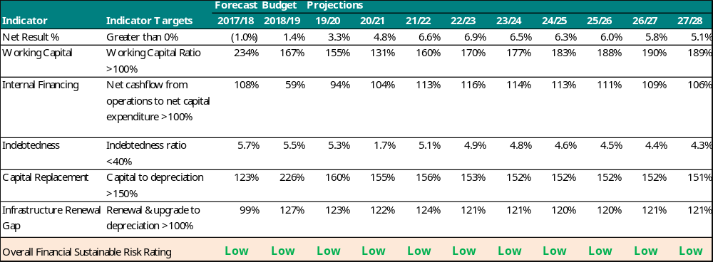

Financial summary

Operating result
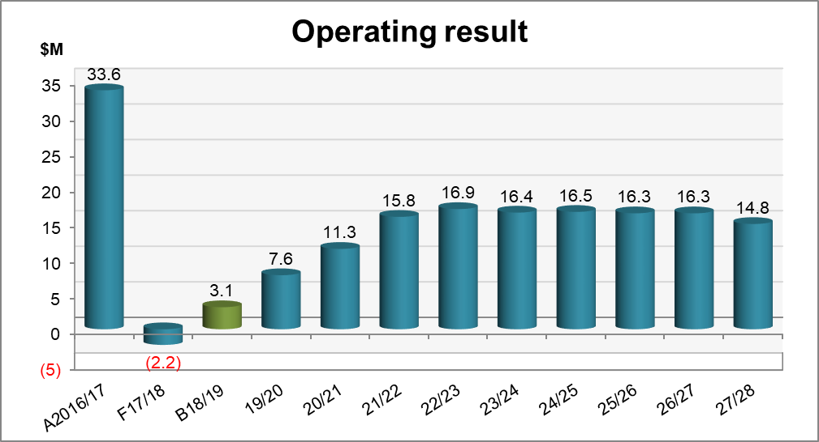
Achieving an operating surplus is a key component of our financial strategy. It provides capacity to renew our $2.9 billion portfolio of community assets, meet debt repayment obligations, manage the impact of financial risks materialising, and invest in transformative strategies.
The forecast for 2017/18 shows an operating deficit of $2.2 million. This is mainly due to three significant one-off items totalling $19.4 million, including Victorian Pride Centre contributions, Ferrars Street precinct works, and relinquishing a Committee of Management property of crown land.
For the financial years 2018-2021, operating surpluses of $3.1 million, $7.6 million and $11.3 million respectively are due to the $23 million investment in the Customer Experience program. The technology shift to Cloud-based managed services means a significant amount of expenditure budget for technology will be reclassified in the operating expenditure budget rather than capital investment.

Underlying result
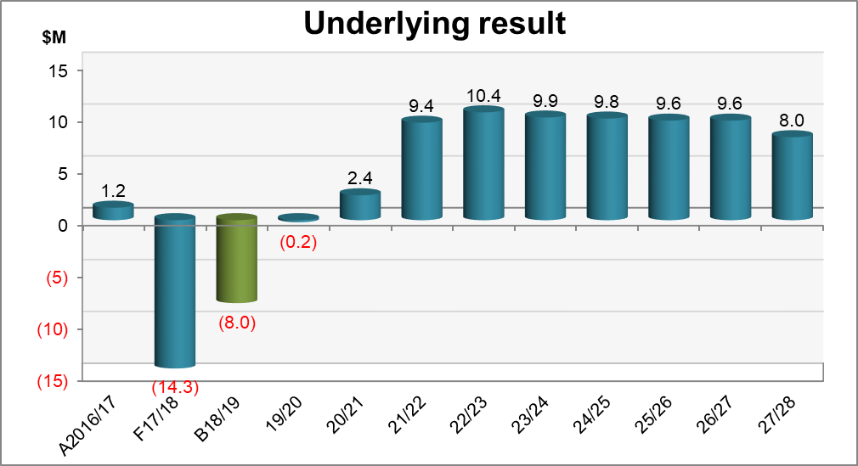
The adjusted underlying result excludes capital related revenue (grants and open space contributions). Reasons for the movement in the underlying result are consistent with the operating result.

Rates percentage increase
The draft Budget 2018/19, which funds a $62.5 million capital program and maintains existing service levels, includes a 2.25 per cent rates increase, consistent with the Victorian Government cap. This has been achieved through a continued strong focus on prudent financial management, careful prioritisation and commitment to productivity and efficiency ($11 million in savings identified over the last five budgets). Future rates increases are based on forward projections of inflation consistent with past decisions made by Minister of Local Government for setting the rates cap.
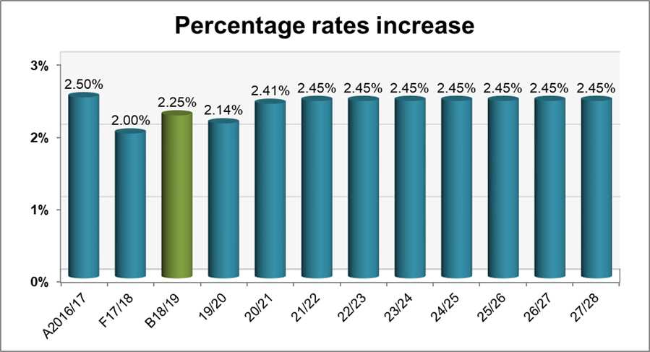

Operating expenditure
The forecast 2017/18 operating expenditure increase of $21.2 million has been impacted by increases in non-cash depreciation expenses, Ferrars Street Education and Community Precinct works, one-off cash and property contributions for the Victorian Pride Centre, and a non-cash asset write-off for the relinquished Committee of Management property of crown land.
Draft Budget 2018/19 operating expenditure totals $221 million which includes $9 million for the Customer Experience program ($23 million over the next three years). We expect productivity and efficiency savings from this program which will reduce our underlying operating expenditure base by 1.7 per cent in the 2024/25 financial year.
The small but steady growth in operating expenditure in future years is largely driven by inflation (around 2 to 2.5 per cent per annum), service demand increases associated with population growth (around 1.3 per cent per annum), and the operating expenditure impact of new and improved assets (for example depreciation increase of 3.8 per cent per annum). This is partially offset by our commitment to efficiency and cost savings (1.0-1.5 per cent per annum).

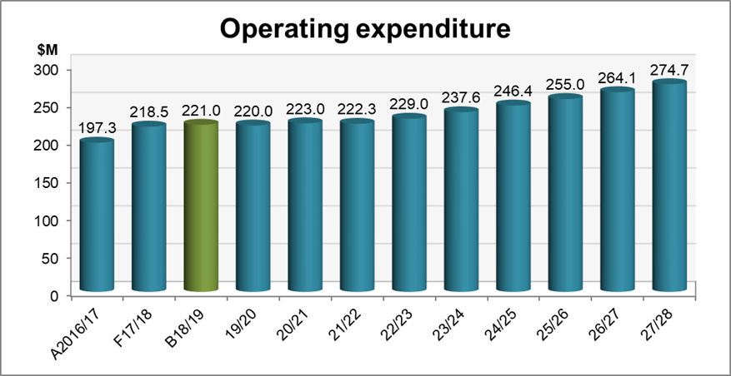

Infrastructure renewal gap
This graph shows the asset renewal and upgrade budget over the financial plan compared to depreciation.
The forecast in in 2017/18 shows a ratio of 99%, which is marginally below 100 percent. This is due to works in progress for large and complex building projects such as Peanut Farm Pavilion and South Melbourne Community Centre. The funds have been deferred to Budget 2018/19, which projects a ratio of 127%.
Over the period of the financial plan, we intend to stay above 100 per cent, which shows our commitment to not only maintaining but upgrading our existing assets.
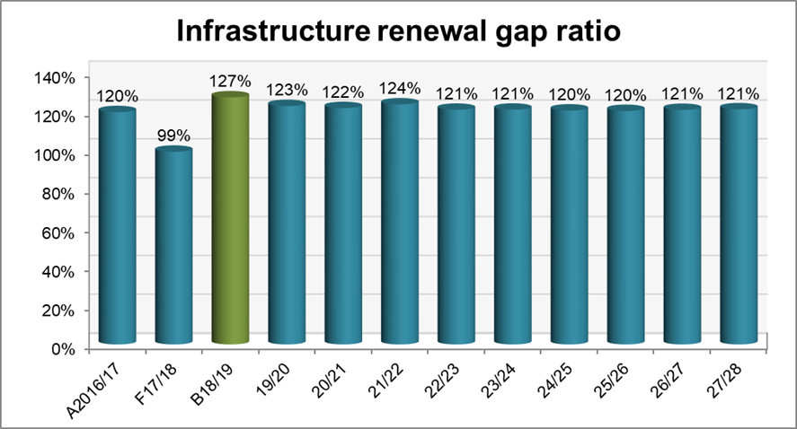

Capital expenditure
Capital works expenditure in 2018/19 is expected to be $57.3 million, out of a total $62.5 million capital program. The $5.2 million gap represents the component of the capital program budget expected to be treated as operating expenditure, such as community engagement and feasibility studies.
The 2018/19 capital program includes $17.5 million to purchase land for a Sustainability Hub. Excluding this exceptional investment, our capital expenditure budget is $39.8 million
Over the period of the financial plan, we provide for appropriate levels of capital expenditure to ensure existing assets are maintained and improved, while investing in growth driven assets. Over the 10-year period, we plan for our total capital expenditure to be greater than 150 per cent of depreciation expenditure.
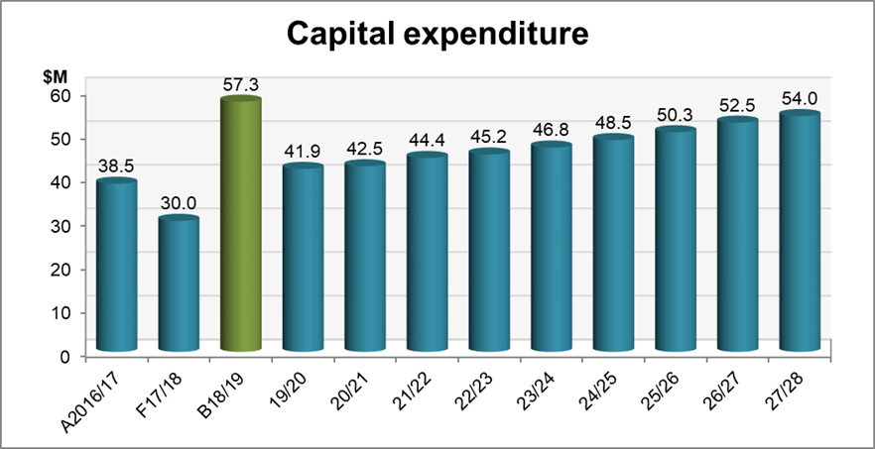

Council staff
Council employees are our most essential resource, enabling the delivery of a broad range of services. We are proposing an increase of 22 FTE based on 39 new positions partially offset through the disestablishment of 17 existing FTE positions. The key drivers for this increase include:
- 12.7 FTE to support delivery of the project portfolio and transformation strategies including 3 FTE to implement the Waste Resource & Recovery Strategy and 3.4 FTE (1-year term) for Fishermans Bend
- 5.1 FTE to support increased service levels including Graffiti Management and Summer Management of Glass and Alcohol restrictions
- 4.6 FTE of in-sourcing rather than outsourcing to improve service outcomes and reduce overall cost to the community including VCAT appeals planner and Waste Management Plan Review Officer
- 5.3 FTE to support risk mitigation and legislative compliance including ensuring municipal buildings are safe (claddings audits)
- 11.3 FTE in response to population and resultant service growth including 3.1 FTE for the new Barring Djinang Kindergarten at Fishermans Bend.

Over the life of the financial plan, we expect the growth in FTEs to increase by 1.3 per cent in line with projected population growth. This is offset by our investment in technology (Customer Experience program) which is expected to achieve productivity and efficiencies which will see the shift of back office roles re-directed to service delivery/ community facing roles.
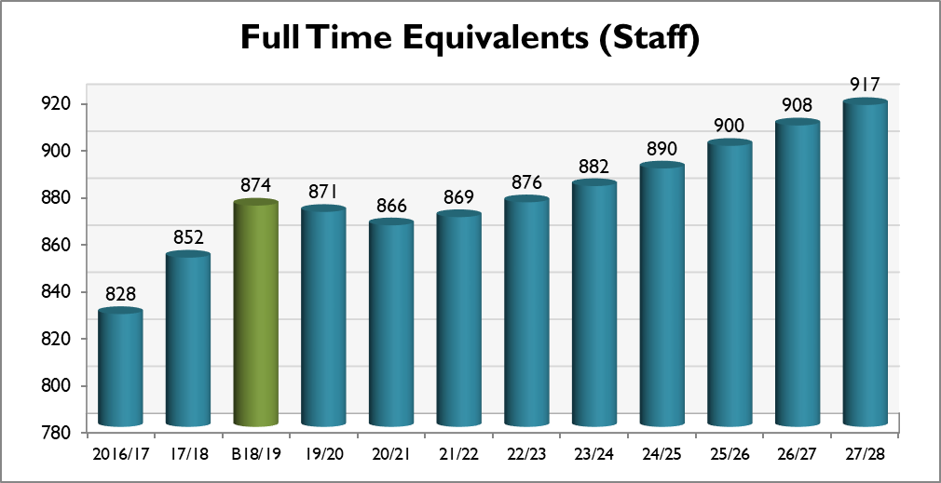

Rates expenditure allocation
This chart shows how rates revenue is spent across our services, for every $100 we spend.
Service category | Proportion of rates spent on service  (for every $100 we spend)
Transport and parking management | $19.30
Amenity | $11.90
Public space | $9.50
Asset management | $8.20
Technology, transformation and customer experience | $6.70
Waste reduction | $5.90
Sustainability | $4.80
Recreation | $4.50
Governance and engagement | $4.30
Libraries | $3.50
City planning and urban design | $2.80
People, culture and capability | $2.60
Community programs and facilities | $2.40
Festivals | $2.30
Arts, culture and heritage | $2.20
Ageing and accessibility | $2.20
Children | $2.00
Families and young people | $1.40
Economic development and tourism | $1.10
Affordable housing and homelessness | $1.00
Local laws and animal management | $0.90
Health services | $0.60
Municipal emergency management | $0.40
Development approvals and compliance | $0.20
Markets | ($0.30)
Finance and project management | ($0.40)
Total | $100.00
Note: some services receive substantial funding from other sources, such as government grants, fees and charges.

Section 2: Our neighbourhoods

Our neighbourhoods at a glance
People who live in Port Phillip tend to experience the City at a neighbourhood level. Strong communities of interest exist in local areas, and people relate closely with the distinctive characteristics of their own neighbourhood.
We have nine defined neighbourhoods, each with distinct character and attributes. Two of these are emerging neighbourhoods in Fishermans Bend.
We deliver services and projects in our each of our neighbourhoods, and each place is home to community infrastructure that enables us to provide services locally, city-wide and regionally.
Neighbourhood | Forecast population in 2018 | Forecast population in 2027 | Change
Elwood / Ripponlea | 16,657 | 17,180 | 3.1%
Balaclava / St Kilda East | 17,763 | 18,527 | 4.3%
St Kilda / St Kilda West | 25,777 | 28,891 | 12%
St Kilda Road | 12,582 | 17,309 | 38%
Albert Park / Middle Park | 12,300 | 12,197 | -0.8%
South Melbourne | 9,718 | 11,403 | 17%
Port Melbourne | 17,544 | 18,062 | 3.0%
Sandridge / Wirraway | 521 | 5,508 | 957%
Montague | 651 | 7,064 | 985%
Port Phillip | 113,513 | 136,141 | 20%
Note: Neighbourhood boundaries do not correspond directly with suburb boundaries. All population estimates and forecasts are sourced from Forecast.id (based on the 2016 Census), updated in December 2017.

We are Elwood / Ripponlea
Encompassing the suburb of Ripponlea and most of the suburb of Elwood, the neighbourhood is known for its leafy streets and suburban character. Visitors and locals are drawn to the beach and the cafés and restaurants in local shopping strips. Ripponlea Station offers good accessibility to central Melbourne.

Pull out fact
- 41.1 per cent of households are families.

Our people
- 16,657 people are estimated to live here in 2018. By 2027, the population is forecast to grow by 3.1 per cent to 17,180.
- There is a higher proportion of young people (0-17 years) and 35-49 year olds than the City average, reflecting the greater proportion of family households. There is a smaller proportion of older people.
- While most people live in medium and high-density housing, a greater proportion live in separate housing (14.3 per cent) than the City of Port Phillip average (8.4 per cent).
- 13.6 per cent of people speak a language other than English at home, compared with the City average of 20.6 per cent, with Greek, Italian and Russian the most common.

History
Point Ormond was an important source of seafood for the Boon Wurrung people, with evidence of an Aboriginal shell midden found in 1974. The original red, brown and yellow sandstone of this area is likely to have been a source of ochre for body paint used in performance. In 1894, a Ngargee was witnessed at the site that is now Ripponlea mansion.
Development of the area dates from the 1850s. Substantial growth started in the early 1900s, continuing into the interwar period. Significant development occurred during the post-war years. The population was relatively stable during the 1990s and then increased slightly from 2001, largely a result of new apartment developments in the area. Elwood was originally swampland until the development of Elwood Canal, which enabled residential development.

Servicing the community
The Elwood / Ripponlea neighbourhood is home to a range of amenities and facilities.

- Ripponlea neighbourhood activity centre
- Elwood neighbourhood activity centre (Glen Huntly / Ormond roads)
- Tennyson Street neighbourhood activity centre
- Lady Forster Kindergarten
- Poets Grove Family and Children’s Centre
- Burnett Gray Centre (Elwood playgroups)
- Elwood Angling Club
- Elwood Life Saving Club
- Elwood St Kilda Neighbourhood Learning centre (including Poets Grove community garden and toy library)
- Elwood Park
- Elwood Beach
- Point Ormond
- Elwood Canal
- Clarke Reserve
- Moran Reserve

Investment in Elwood / Ripponlea this year (2018/19)

- Building renewals
  - Sails on the Bay
- Elster Creek catchment governance and advocacy
- Footpath renewals
- Brighton Road
- Foam Street
- Goldsmith Street
- Lyndon Street
- Meredith Street
- Ruskin Street
- Shelley Street
- Kerb and channel renewals:
  - Los Angeles Court
  - Monkstadt Avenue
- Laneway renewals and upgrades:
  - R1693 (Clarke Street)
  - R1627 (Coleridge Street)
  - R1795 and R3351 (Dickens Street)
  - R1551 (Ormond Road)
  - R1545 (Victoria Avenue)
- Outdoor Fitness Station installation at Elwood Park
- Parks and Playground renewals and upgrades:
- Elwood Playspace (complete construction)
- Parks and Playground renewals and upgrades:
- Elwood Playspace (complete construction)
- Recreation reserves facilities renewals:
- Elwood Reserve (coaches boxes)
- Road renewals:
  - May Street
  - Ruskin Street (design)
  - Shelley Street (design)
- Stormwater management:
  - Byrne Avenue and Ormond Road (pipe replacement)
  - Clarke Reserve (design, underground water retention system and pipe installation)
  - Goldsmith Street (design, raingarden and pipe diversion)
  - Meredith and Barkly Street (pipe replacement)

We are Balaclava / St Kilda East
Encompassing the suburb of Balaclava and part of St Kilda East and St Kilda, this neighbourhood has diverse housing types and population. Primarily a residential neighbourhood, the Carlisle Street activity centre, Balaclava station and Alma Park are key features. The cafes and restaurants on Carlisle Street are popular with locals and visitors.

Pull out fact
- 42.3% of residents are aged 25-39 years.

Our people
- 17,763 people are estimated to live here in 2018. By 2027 the population is projected to grow by 4.3 per cent to 18,527.
- There is a prominent Jewish community in the neighbourhood.
- There is a high proportion of young workers and smaller proportions of parents, young families and older people compared to the rest of the City.
- Most people live in medium and high-density housing (87.7 per cent).
- 21 per cent of people speak a language other than English at home (slightly higher than the City average).
- Russian (2.0 per cent), Greek (1.8 per cent) and Spanish (1.5 per cent) are the most common languages spoken at home other than English.

History
Houses in Balaclava / St Kilda East includes larger houses and cottages from the Victorian, Edwardian and interwar eras, and a significant number of flats from the 1960s and 1970s, and more recent contemporary apartments.
Balaclava was named after the battlefield in the Crimean War (1853-1856) and has related street names like Nightingale, Inkerman, Raglan and Sebastopol.

Servicing the community
The Balaclava / St Kilda East neighbourhood is home to a range of amenities and facilities.

- Carlisle Street activity centre
- Inkerman Street local activity centre
- St Kilda Town Hall
- Bubup Nairm Family and Children’s Centre
- The Avenue Children’s Centre
- St Kilda and Balaclava Kindergarten
- St Kilda Library
- Alma Road Community House (including maternal child health services and Te Arai community garden)
- St Kilda community garden
- Alma Park Reserve
- Hewison Reserve
- Te Arai Reserve
- William Street Reserve
- Pakington Street Reserve

Investment in Balaclava / St Kilda East this year (2018/19)

- Alma Park stormwater harvesting development
- Building safety and accessibility:
  - Bubup Nairm Child Care Centre cladding rectification works
  - St Kilda Town Hall security improvements
- Carlisle Street tram stop upgrade (with PTV)
- Footpath renewals:
  - Charles Street
  - Glen Eira Avenue
  - The Avenue
  - Woodstock Street
- Kerb and channel renewals:
  - Sunhill Court
- Laneway renewals and upgrades:
  - R3767 and R3769 (Balston Street)
  - R3793 (Blenheim Street)
  - R3803 (Chusan Street)
  - R1475 (Gourlay Street)
  - R3765, R3771, R3773 and R3781
  - R1497 (William Street)
- Recreation reserves facilities renewals:
  - Alma Park (cricket nets, synthetic cricket pitch and surrounding apron, and new soccer goal posts). This may be partially funded with an SRV grant.

We are St Kilda / St Kilda West
Encompassing the suburbs of St Kilda West (east of Cowderoy Street), most of St Kilda and a small part of Elwood, the neighbourhood is attractive to residents and visitors for its iconic retail strips, significant open spaces and the foreshore.
St Kilda attracts millions of visitors every year, as it is home to many of Melbourne’s famous attractions including Luna Park, the Palais Theatre and St Kilda Beach. It also hosts large events including the St Kilda Festival and Pride March.

Pull out fact
- 54 per cent of households rent their home.

Our people
- 25,777 people are estimated to live here in 2018. By 2027, the population is projected to grow by 12 per cent to 28,891.
- There is a smaller proportion of young people (under 17 years) when compared to the City average but a higher proportion of people aged 18 to 34 years, reflecting the prominence of singles and group households.
- Most people live in medium to high-density housing (90.4 per cent).
- Over half the dwellings are being rented (higher than the City average) and almost two out of every five residents live alone.
- 18 per cent of people speak a language other than English at home, with Spanish and Mandarin the most common.

History
Albert Park Reserve was once a rich willam or camp for the Yalukut Weelam, with miams (huts) built alongside today’s Albert Park Lake. The Ngargee (Corroboree) Tree located in the south-east corner of Albert Park is the last remaining corroboree tree in Melbourne, and also the site of the ceremonial dance circle and Ngargee grasslands that are a current day focus for cultural and reconciliation activities.
European development dates from the 1840s, spurred by the opening of the railway line. St Kilda grew in the late 1880s, continuing into the early 1900s. Expansion continued during the interwar period and the 1940s, including the construction of many flats and apartments. Significant development occurred during the 1950s and 1960s, due mainly to high-density development.

Servicing the community
The St Kilda / St Kilda West neighbourhood is home to a range of amenities, facilities and significant events.

- Fitzroy Street activity centre
- Acland Street activity centre
- St Kilda Road South precinct
- St Kilda Triangle
- Betty Day Community Centre
- Cora Graves Community Centre
- Peanut Farm Reserve Pavilion
- St Kilda Adventure Playground
- Shakespeare Grove and Veg Out
- St Kilda Life Saving Club
- Port Phillip EcoCentre
- Eildon Road Children’s Centre
- North St Kilda Children’s Centre
- Elwood Children’s Centre
- St Kilda Festival
- St Kilda Film Festival
- Esplanade Market
- Linden New Art
- Theatreworks
- Shakespeare Grove Artist Studios
- Palais Theatre
- Luna Park (asset not owned / managed by council)
- Astor Theatre (asset not owned / managed by council)
- National Theatre (asset not owned / managed by council)
- St Kilda Sea Baths (asset not owned / managed by council)
- St Kilda Botanical Gardens
- Catani Gardens
- St Kilda Marina
- O’Donnell Gardens
- Church Street Reserve
- Crimea Street Reserve
- Cummings Reserve
- H R Johnson Reserve
- Jacoby Reserve
- Jim Duggan Reserve
- Renfrey Reserve
- Talbot Reserve
- Waterloo Reserve

Investment in St Kilda / St Kilda West this year (2018/19)

- Blackspot safety improvements:
  - Inkerman Street/Chapel Street intersection
  - Alma Road/Chapel Street intersection
  - Fitzroy Street/Park Street intersection
- EcoCentre redevelopment opportunities (dependent on Victorian Government funding)
- Fitzroy Street streetscape upgrade from Grey Street to Lakeside Drive (with PTV)
- Footpath renewals:
  - Barkly Street
  - Blessington Street
  - Cintra Avenue
  - Clyde Street
  - Cowper Street
  - Dalgety Lane
  - Fitzroy Street
  - Herbert Street
  - Inkerman Grove
- Foreshore assets renewal and upgrade:
  - landscape design of Missing links section of the foreshore and St Kilda Pier Promenade and Road (to be confirmed in Business Case)
- Kerb and channel renewals:
  - Crimea Street
  - Tennyson Street
- Laneway renewals and upgrades:
  - R4023 (Barkly Street)
  - R3591 (Charles Street)
  - R3483 (Clyde Street)
  - R3385 (Mozart Street)
  - R3377 (Spenser Street)
- Open Space Irrigation renewal and upgrade:
  - St Kilda Botanical Gardens pond pump replacement
  - Rotary Playground/ Stokehouse Reserve
- Palais Theatre renewal and upgrade
- Park Street bike link between St Kilda Road and Moray Street connecting the St Kilda Road bike lane to the north and Moray Street bike link to the south
- Parks and Playground renewals and upgrades:
- Chipton Reserve (complete construction)
- Newton Court Reserve (design and complete construction) (matched Victorian Government grant funding)
- Parks, furniture and pathway renewals:
  - St Kilda Botanical Gardens (upgrade of fences along Blessington, Dickens and Tennyson streets)
- Peanut Farm Reserve sports pavilion upgrade
- Road renewals:
  - Chapel Street (resurface)
  - Charles Street (resurface)
  - Enfield Street (resurface)
  - Irymple Avenue (design)
  - Princes Street (resurface)
- Sports fields lighting expansion:
  - Peanut Farm, including remediation works
- St Kilda Adventure Playground upgrade (feasibility in 2018/19)
- St Kilda Junction safety upgrade to implement pedestrian safety and landscape works (design in 2018/19)
- St Kilda Marina
- Stormwater management:
  - Beaconsfield Parade (renew outlet to address pooling)
- Walk Plan and Bike Plan implementation:
  - Fitzroy Street and Park Street signalisation
- Wellington Street/ Dandenong Road and Dandenong Road/ Chapel Street intersection improvements

We are St Kilda Road
Encompassing parts of the suburbs of Melbourne and Windsor, and parts of Albert Park and South Melbourne, the St Kilda Road neighbourhood is unique in the City because of its mix of offices and high-rise residential development. It is our fastest growing neighbourhood.
St Kilda Road is a significant employment area with over 20,000 people working in the neighbourhood. The planned Domain Station for the Melbourne Metro will enhance access to the area. The neighbourhood includes and adjoins significant open spaces and recreational facilities.

Pull out fact
- Population is forecast to grow by 38 per cent by 2027.

Our people
- 12,582 people are estimated to live here in 2018, growing to 17,309 in 2027.
- There are a higher proportion of people aged between 18 to 34 years than the City average and a much smaller proportion of parents and young families.
- Over 97 per cent of residents live in high density housing, with over half being private renters.
- Significantly more people were born overseas (47.4 per cent) than the City average (31.4 per cent), with origins including China, the United Kingdom, India and New Zealand.
- 34 per cent of people speak a language other than English at home, with Mandarin and Cantonese the most common.

History
St Kilda Road is regarded as Melbourne’s iconic ‘urban boulevard’. Development of the area dates from the 1860s, with several heritage mansions remaining. Rapid residential apartment development has taken place from the early 1990s, replacing former office space.
The population more than doubled between 1991 and 2001 and growth continues, with development of residential apartment towers now focused in the area north of Albert Road.

Servicing the community
The St Kilda Road neighbourhood is home to a range of amenities and facilities.
- St Kilda Road North precinct
- Domain interchange
- Bowen Crescent Reserve
- Albert Road Reserve
- Albert Park, Golf Course and Lake (asset not owned / managed by council)
- Albert Reserve tennis, lacrosse and cricket facilities (asset not owned / managed by council)

Investment in St Kilda Road this year (2018/19)

- Footpath renewals:
  - Park Street
  - Queens Lane
  - Queens Road
  - St Kilda Road
- Road renewals:
  - Queens Lane (resurface)
  - R1809 (Punt Road) (resurface)
- Stormwater management:
  - Queens Road (design to address capacity)
- Work with Victorian Government on the Melbourne Metro Tunnel Project / Domain Station

We are Albert Park / Middle Park
Encompassing the suburb of Middle Park, part of the suburb of Albert Park and part of St Kilda West, this neighbourhood is one of the oldest parts of the City with significant heritage areas featuring wide tree-lined streets and houses from the Victorian and Edwardian eras. Primarily a residential area, visitors are also drawn to the beach, local shopping strips and recreational facilities in Albert Park.

Pull out fact
- 16 per cent of people speak a language other than English at home.

Our people
- 12,300 people are estimated to live here in 2018. The population is forecast to decline to 12,197 by 2027 due to limited housing growth and a reduction in household size (as families mature).
- There are a higher proportion of pre-schoolers and people at post-retirement age than the City average and a significantly smaller proportion of young people starting out in the workforce.
- While more than half of residents live in medium density housing, a significantly higher proportion live in separate housing (15.2 per cent) than the City average of 8.4 per cent.
- Greek and Italian are the most common languages other than English that are spoken at home.

History
The coastline of Port Phillip Bay was a focal point for the Boon Wurrung, who travelled annually down the coast returning to Port Phillip in warmer weather. The Canterbury Road Urban Forest still retains surviving plants of the woodlands and wetlands of the former Albert Park Lagoon, which was the traditional home to the Yalukut Weelam clan.
European development dates from the 1850s, spurred by the opening of the railway line. Expansion continued during the interwar period and the 1940s, and significant development occurred during the 1960s. The population was relatively stable between 1991 and 2006, and increased slightly between 2006 and 2011.

Servicing the community
The Albert Park / Middle Park neighbourhood is home to a range of amenities and facilities.

- Bridport Street / Victoria Avenue neighbourhood activity centre
- Armstrong Street neighbourhood activity centre
- Albert Park Preschool and Maternal Child Health
- Middle Park Kindergarten
- South Melbourne Childcare Cooperative
- Albert Park Library
- Mary Kehoe Community Centre (including Mary and Basil community garden)
- Middle Park Community Centre (including library, toy library, maternal and child health and civic kindergarten)
- South Melbourne Life Saving Club
- Albert Park Yachting and Angling Club
- Albert Park and Middle Park beaches
- Albert Park Reserve (asset not owned / managed by council)
- Ashworth Street Reserve
- Danks Street Playspace
- Gasworks Arts Park
- Frank and Mary Crean Reserve
- Little Finlay Reserve
- Little Page Reserve
- Neville Street Reserve
- Moubray Street Pop Up Park

Investment in Albert Park / Middle Park this year (2018/19)

- Albert Park stormwater harvesting opportunities (with Parks Victoria)
- Footpath renewals:
  - Ferrars Street
  - Merton Street
  - Moubray Street
  - Moubray Street
  - St Vincent Place South
  - Danks Street
  - Page Street
- Gasworks Arts Park reinstatement (design in 2018/19)
- Gasworks Theatre seats replacement
- Kerb and channel renewals:
  - Danks Street
- Laneway renewals and upgrades:
  - R2605 (Draper Street)
- Litter bin renewals:
  - St Vincent Gardens Albert Park (five 240 litre bins)
- Maritime infrastructure renewals:
  - Albert Park Angling Club wave deflection wall
- Parks and Playground renewals and upgrades:
- St Vincent Gardens (design in 2018/19, construct in 2019/20)
- Road renewals:
  - Cardigan Place (road resurface)
  - Kerferd Road (road resurface)
- Safer street infrastructure improvement
  - Bridport Street/ Richardson Street intersection
- South Melbourne Life Saving Club redevelopment

- Stormwater management:
  - Dundas Place (design, raingarden and pipe diversion)
  - Lane R1035, near Mills St (replace pipe)
  - Langridge Street (pipe replacement)
  - Wright Street (replace pipe)
- Water Sensitive Urban Design implementation:
  - Foote Street / Reed Street
  - Hambleton and Mills Street
  - Danks Street / Withers Street
  - Moubray Street / Bridport Street West

We are South Melbourne
Encompassing most of the suburb of South Melbourne and part of Albert Park, the neighbourhood is one of Melbourne’s original suburbs. The South Melbourne activity centre, including Clarendon Street and the South Melbourne Market, attracts local and regional visitors. Significant established business precincts, predominantly east of Clarendon Street, offer a location for small and medium size firms close to central Melbourne.

Pull out fact
- 16.3 per cent of people live in social housing.

Our people
9,718 people are estimated to live here in 2018. The population will grow by 17 per cent to 11,403 by 2027.
Compared to the City average, there is a higher proportion of people aged over 70 years, and a lower proportion of residents aged between 18 and 34 years.
Residents live in a mix of medium density (56.5 per cent), separate house (8.5 per cent) and high-density (33.4 per cent) housing, with a higher than average proportion of family households.
Greek and Russian are the most common languages other than English that are spoken at home.

History
South Melbourne, or Nerre nerre minum, was home to the Yalukut Weelam clan of the Boon Wurrung. The higher ground of Emerald Hill (now the site of the South Melbourne Town Hall) was used as a place to engage in ceremonies.
Development dates from the 1850s, following establishment of a tent city for gold seekers. There was rapid growth in the 1870s and 1880s, and significant development occurred a century later, including construction of high-rise public housing estates. The population has increased gradually from the early 1990s, a result of contemporary apartment developments.

Servicing the community
The South Melbourne neighbourhood is home to a range of amenities and facilities.

- South Melbourne Central activity centre (Clarendon Street, South Melbourne Market and surrounding business precincts)
- South Melbourne Town Hall and Community Hub
- South Melbourne Market
- Emerald Hill Library and Heritage Centre
- South Melbourne Community Centre/Trugo Club
- South Melbourne Hellenic RSL
- Melbourne Sports and Aquatic Centre (asset not owned / managed by council)
- Napier Street Aged Care (asset not owned / managed by council)
- CASPA Care Residential Care
- Clarendon Children’s Centre
- Clarendon Family Centre (including maternal and child health and toy library)
- Coventry Children’s Centre
- Lillian Cannam Kindergarten
- Pickles Street Learning (Youth Education) Centre
- Skinners Adventure Playground
- Sol Green Community Centre
- St Vincent Gardens
- Sol Green Reserve
- Lyell / Iffla Reserve
- Eastern Reserve
- Ludwig Stamer Reserve
- Emerald Hill Place
- Howe Crescent Reserve

Investment in South Melbourne this year (2018/19)

- Footpath renewals:
  - Bank Street
  - Chessell Street
  - Dorcas Lane
  - Kings Way
  - Gladstone Grove
  - Kerr Street
  - Kings Way
  - Law Street
  - Montague Street
  - Nolan Court
  - Smith Street
  - Tope Street
Kerb and channel renewals:
  - Henderson Street
- Kerferd Road safety and streetscape improvements planning (subject to funding)
- Laneway renewals and upgrades:
  - R2965 (Eville Street)
  - R3163 (Gladstone Place)
  - R2581 (Nelson Place)
  - R2597 (Smith Street)
  - R3173 and R3185 (Thistlethwaite Street)
- Road renewals:
  - Banks Street (road resurface)
  - Kings Way (design)
  - Northumberland Street (design)
  - Bike Path (near Victrack Depot)
- Skinners Adventure Playground upgrade (feasibility in 2018/19)
- South Melbourne Community Centre upgrade
- South Melbourne Market building compliance:
  - Install a compliant roof car park sprinkler system
  - Address accompanying access and egress issues
- South Melbourne Market renewals:
  - External Food Hall upgrade
  - Lighting enhancements
  - Security camera replacements
  - Food Halls seating installation
- South Melbourne Market solar installation
- South Melbourne Market stall changeover refit works
- South Melbourne Market strategic business case
- South Melbourne Town Hall ANAM lease works
- South Melbourne Town Hall lift upgrade
- Stormwater management:
  - Cobden Street (pipe replacement and redirection)
  - Chessell Street (pipe replacement)
  - Cecil and Park streets (pipe relining)
  - Gladstone Lane (address water pooling)
  - Heather and Park streets (address capacity)
  - South Melbourne Market (pipe relining)

We are Port Melbourne
Encompassing most of the suburb of Port Melbourne, this neighbourhood is a gateway to Melbourne via Station Pier. The Waterfront precinct brings a large number of visitors to the neighbourhood and beyond, attracted to the foreshore and beaches and the retail and commercial strip along Bay Street. Traditional residential heritage precincts contrast with the distinctive areas of Garden City, Beacon Cove and contemporary apartment development in the Port Melbourne mixed use area. The neighbourhood is also home to the Port Phillip Specialist School for children with disabilities.

Pull out fact
- Almost 5 per cent of residents speak Greek at home.

Our people
- 17,544 people are estimated to live here in 2018, growing to 18,062 (3.0 per cent) by 2027.
- Compared to the City average, there is a larger proportion of families with young children and people at retirement age (60+ years), and significantly smaller proportion of residents aged between 18 to 34.
- There is a smaller proportion of renters than the City average (42.7 per cent compared with 49.2 per cent)
- There is a larger proportion of people living in social housing (7.3 per cent compared to the City average of 4.7 per cent).

History
The Port Melbourne lagoon was an original feature of this neighbourhood and a well-known Aboriginal site. The lagoon was filled in from the 1890s to create Lagoon Reserve and Edwards Park.
Port Melbourne is one of the oldest neighbourhoods in the City, with housing dating from the Victorian and Edwardian eras. Major exceptions are the historic Garden City estates developed in the 1930s and 1940s, and the more recent Beacon Cove development adjacent to Station Pier. Beacon Cove and significant redevelopment of former industrial sites for residential apartments (southern end of Bay Street) have seen the population double over the last few decades.

Servicing the community
The Port Melbourne neighbourhood is home to a range of amenities and facilities.

- Bay Street major activity centre
- Garden City neighbourhood activity centre
- Port Melbourne Waterfront precinct
- Ada Mary A’Beckett Children’s Centre
- Clark Street Children’s Centre
- Bubup Womindjeka Family and Children’s Centre
- Port Melbourne Library
- Fishermans Bend Community Centre (and community garden)
- Liardet Street Community Centre
- Port Melbourne Community Centre / Trugo Club
- Port Melbourne Community Room
- Port Melbourne Cricket Ground
- Port Melbourne Tennis Club
- Port Melbourne Life Saving Club
- Port Melbourne Bowls Club
- Port Melbourne Yacht Club
- Sandridge Community Centre / Trugo Club
- Sandridge Life Saving Club
- Buckingham Reserve
- Crichton Reserve
- Cyril Letts Reserve
- Edwards Park
- Fred Jackson Reserve
- Lagoon Reserve
- Garden City Reserve
- Morris Reserve
- R F Julier Reserve
- Sangster Reserve
- Walter Reserve
- Perce White Reserve (asset not owned / managed by council)
- Port Melbourne Town Hall (including toy library)

Investment in Port Melbourne this year (2018/19)
- Bike Network implementation:
  - Beacon Cove shared path upgrade
  - Garden City Reserve shared path upgrade
- Footpath renewals:
  - Bay Street
  - Florence Place
  - Munro Street
  - Nott Street
  - Ozone Street
  - Spring Street East
  - Swallow Street
  - Williamstown Road
  - Woodruff Street
- Graham Street skate park upgrade
- Kerb and channel renewals:
  - Farrell Street
  - Leith Crescent
  - Spring Street East
  - Station Street
- Litter bin renewals:
  - Sandridge, Beacon Cove and Port Melbourne beaches (Fifty 240 litre bin)
- Maritime infrastructure renewals:
  - Beacon Cove
- Open Space Irrigation renewal and upgrade:
  - Beacon Cove
- Parks and Playground renewals and upgrades:
- Buckingham Reserve (design in 2018/19, construct in 2019/20)
- Parking technology enhancements:
  - Introduction of appropriate time based controls South of Williamstown Rd
- Public space lighting renewals and upgrades:
  - Station Pier (commence replacement of lighting infrastructure – completion by 2021/22)
- Port Melbourne Waterfront Place Precinct Design Guidelines – completion
- Recreation reserves facilities renewals:
  - Julier Reserve (cricket pitch consultation, soil test and design. This is subject to a successful application for SRV grant funding for Alma Park nets
- Road renewals:
  - Griffin Crescent (road resurface)
  - Melville Street
  - R2320 (Esplanade East) (road resurface)
- Safer street infrastructure improvement
  - Liardet Street/ Esplanade West intersection
- Stormwater management:
  - Esplanade East (address pooling)
  - Park Street and St Vincent Place North (address pooling)
  - Garden City Reserve (design, underground water retention system and pipe installation)
  - Liardet Street (address pooling and reconstruction of drainage system)
  - Beach Street (install rain garden and pipe replacement)

We are Montague
Montague is an emerging neighbourhood in Fishermans Bend. Montague is bound by the West Gate Freeway to the north, the St Kilda Light Rail Line (Route 96) to the east, City Road to the south, and Boundary Street to the west.
As part of Fishermans Bend, Montague is envisaged to feature high-density tower development to the north, and finer grain lower-rise development to the south that will respect heritage buildings and adjoining established neighbourhoods.

The area
- Montague is currently a significant employment area featuring a range of businesses, including cafes and a major cluster of creative industries. It is also home to significant cultural and built heritage that further contribute to the neighbourhood’s distinct character.
- 651 people are estimated to live here in 2018, up from 92 in 2017. By 2027, it is projected that 7,064 people will reside in Montague and 14,106 residents by 2041.
- The Montague Continuing Education Centre provides services to young persons with mild intellectual disabilities. Montague has strong links to the CBD with established light rail routes.

History
Montague contains a mix of nineteenth and early twentieth century low scale residential, commercial and industrial buildings, including some early historic sites related to the growth of Melbourne’s port and earliest worker suburbs. Examples include ‘corner’ hotels such as Wayside Inn, Talbot Inn, Golden Fleece Hotel, Victorian shops and dwellings along City Road and Montague Street, and notable industrial buildings like the former Dunlop factory and Laycock & Sons Woollen Mills.

Servicing the community
The Montague neighbourhood will be home amenities and facilities currently under development.
- Ferrars Street Education and Community Precinct (under construction)
- Community hub (proposed community hub co-located at the Montague Continuing Education Centre)
- Montague Park (soon to be developed at the corner of Buckhurst and Ferrars Street)

Investment in Montague this year (2018/19)

- Ferrars Street Education and Community precinct – remediation of Montague Park site
- Ferrars Street Education and Community precinct – delivery of streetscape (Railway Place) as an integrated space to the school and other key projects including changes to intersections and tram stop works (Route 109 and 96)
- Parking technology enhancements:
  - Installation of 55 new paid parking ticket machines in Fishermans Bend and introduction of time based controls between Boundary Street and Bridge Street

We are Sandridge / Wirraway
Sandridge / Wirraway will transform over the next 30 years as the Fishermans Bend renewal area develops.
Sandridge / Wirraway is bound by the West Gate Freeway to the north, Williamstown Road to the south, Todd Road to the west and Johnson Street to the east.
By 2051, it is anticipated the neighbourhood will host more than 20,000 jobs, primarily in the Sandridge suburb, as a result of its premium office and commercial location and proposed transport connections with the CBD across the Yarra River. The suburb of Wirraway is envisaged as a family friendly inner city neighbourhood offering a diverse choice of housing.

The area
- 521 people are estimated to live here in 2018, up from 307 in 2017. By 2027, it is projected that 5,508 people will reside in Sandridge / Wirraway and 23,021 residents by 2041.
- This neighbourhood adjoins the Fisherman Bend employment precinct (within the City of Melbourne), which is home to 12,500 existing jobs. North Port Oval and its historic grandstand is an anchor for the local community. JL Murphy Reserve is a major green space in Fishermans Bend, with a focus on active recreation, organised sports and leisure activities.

History
The Sandridge area, named after the high ridges of sand created by wind, originally contained extensive wetlands that were rich hunting and gathering grounds for the Boon Wurrung people.
Formerly part of the neighbourhood of Port Melbourne, this primarily industrial area has been home to several prominent historical Australian aircraft design and automotive manufacturing companies, including the former Rootes/Chrysler factory. ‘The Block’ residential development at 164 Ingles Street is an example of retention and reuse of an important heritage building that will convey the place’s history to the future Fishermans Bend community. The building was the office of John Kitchen and Sons P/L, the largest soap making firm in Australia. The building also has architectural significance as an exceptionally imposing commercial building in the Classical Revival style from the interwar period.

Servicing the community
The Sandridge / Wirraway neighbourhood is home to a range of amenities and facilities.
- North Port Oval Reserve and Pavilion
- JL Murphy Reserve (including Dig-In Community Garden)
- Council Depot and Resource Recovery Centre

Investment in Sandridge / Wirraway this year (2018/19)

- JL Murphy Reserve pavilion upgrade
- JL Murphy Playspace upgrade
- Northport Oval upgrade (design in 2018/19)
- Recreation reserves facilities renewals:
  - JL Murphy Reserve (feasibility and design lighting for the baseball field)
  - Woodruff and Aaneson ovals (new goal posts)
- Parking technology enhancements:
  - Installation of 55 new paid parking ticket machines in Fishermans Bend and introduction of time based controls between Boundary Street and Bridge Street

Section 3: Finances and performance

Our 10-Year Financial Plan

Overview and context
Financial sustainability is a key objective for Council, as a sound financial base is required to continue to deliver valued services to the community. The 10-Year Financial Plan supports Council to achieve financial sustainability, particularly in the face of the significant challenge posed by rates capping. The financial plan also provides the context within which the Council formulates the Council Plan, including our Strategic Resource Plan and Budget and enables the Council to plan for the financial impacts of growth.
The Financial Plan demonstrates the long-term financial implications of Council’s revenue and expenditure projections. The Financial Plan is prepared and revised annually to reflect our changing operating environment, including considering information gathered internally and the significant external factors that impact on Council at any point in time.

Key outcomes of the financial plan:

Identifying the impact of rates capping
We recognise the community concern about the affordability of Council services, with rates and other essential services forming an increasing share of average household expenditure. The community’s expectation for better value in service delivery has been reflected in our decision making. We continue to implement initiatives to ensure that our services are delivered in the most efficient and effective manner possible. This includes a successful drive for efficiency savings. Permanent operational savings of $2 million for Budget 2018/19 have been identified, in addition to the $9 million of savings identified for in Budgets 2014/15 to 2017/18.
The Victorian Government has also responded to community affordability concerns by capping rate increases from 2016/17. This plan demonstrates the significant impact that rate capping will have on our financial position and the use of financial levers to ensure financial sustainability.
The level of the rates cap in 2018/19 and beyond is still highly uncertain. The Essential Services Commission (ESC), Victoria’s independent economic regulator, recommended that the rates cap be set a level that reflects movements in the consumer price index (CPI) and the wage price index (WPI), as wages form a significant proportion of council’s costs.
In the two years since rate capping was introduced, the Minister has linked the cap to inflation instead of the ESC recommendation. It is likely that future rate caps could be lower than CPI, which poses a risk to our financial sustainability.
The Financial Plan assumes a rate cap based on inflation. The impact of rates capping is quantified as an accumulated challenge of $14 million over ten years. This represents a major challenge for us (and the sector as a whole) that will require fundamental changes to the way we operate. Our approach to managing this challenge is outlined below.

Rates capping challenge
Rates cap based on forecast inflation | 2018/19 | 2019/20 | 2020/21 | 2021/22 | 2027/28
Rate increase | 2.00% | 2.20% | 2.39% | 2.62% | 2.13%
Accumulated rates capping challenge ($m) | ($0.0) | ($1.0) | ($2.3) | ($3.8) | ($14.3)
Initiatives to improve our efficiency and effectiveness will position us favourably to manage this challenge. However, the medium to long-term magnitude of rate capping will require fundamental review of the sustainability of our operations.
A ‘business as usual’ approach will not be sufficient to meet the rates capping challenge. We will need to consider:
- opportunities to further reduce our cost base without impacting service levels (such as efficiencies identified through process, procurement, and project planning and delivery improvements)
- ensuring that user fees and charges reflect the benefit that individual community members receive (that is, rates funding is not unreasonably subsidising services that provide private benefit)
- service delivery options, including changes to the way services are targeted and delivered and consideration of service level reductions in areas of lower strategic priority
- applying to the ESC for rate increases above CPI, where those increases are justifiable to the community
- a prudent and fiscally responsible approach towards the use of new debt for strategic property acquisitions, funding community capital works or operating projects that will provide intergenerational community benefit, and initiatives that deliver revenue streams to repay debt
- using reserves where appropriate to invest in one-off new or improved assets where this is considered more efficient than the use of debt.
Other aspects of the financial plan, such as expenditure and other revenue are currently based on business as usual planning. See the Financial statements section for details.

Growth in Port Phillip
We are facing a period of significant growth, much of which through development in Fishermans Bend. Current planning projections provide for a possible population increase of 120,000 people in the next 40 years, over 100 per cent of our current population. We are continuing to invest in planning for growth in the municipality, including Fishermans Bend, to ensure that service outcomes meet the expectations of current and future generations.
We are working closely with the Victorian Government to deliver a package of work in the Montague precinct of Fishermans Bend, where development is occurring first. This plan includes financial outcomes from works agreed with the Victorian Government and known proposals only.
The Victorian Government is currently preparing a Developer Contributions Plan for Fishermans Bend that will outline future investment needs and funding sources. Due to the uncertainty of the future investment profile, no further investment has been incorporated in this plan, beyond the immediate proposal for the Montague Precinct. We will update our financial planning for Fishermans Bend as new information becomes available.
Population growth in our city will drive an increase in urban density. Our road network for cars, which is at capacity and cannot be increased, will see increased congestion as our population grows. We will invest over $35 mill over the 10-year period to implement our Integrated Transport Strategy.

Climate change and renewing community assets
We own and control a wide range of assets from land and buildings to roads, drains, footpaths and open space. The total value of our fixed assets is $2.6 billion and is largely the product of investment by prior generations of residents. Consistent with the trend across the local government sector, we are facing escalating costs to maintain and renew our ageing asset base.
Much of the City is only one to three metres above sea level and therefore vulnerable to the impacts of climate change. Flooding of coastal properties and public amenities, storm damage to infrastructure and beach erosion are examples of climate change impacts. To mitigate against the impacts of climate change, upgrades and renewal of assets will need to be designed and built to suit. This means additional costs. This plan reflects increasing renewals expenditure due to an expanding asset base, and cost escalation for delivering renewals and mitigating against the impacts of climate change.
A major focus is continued improvements to our asset planning and management capability. Insufficient investment in asset renewal will result in assets deteriorating much faster than necessary, adding cost in the long run and potentially compromising service levels.
Our city needs to be environmentally sustainable and minimise our waste output. We are already experiencing the impacts of climate change, and we can expect increased flooding of coastal properties and public amenities, storm damage to infrastructure, beach erosion, decreased water quality and security of water supply, reduced summer outdoor activities and hotter urban spaces. Changing environmental conditions may challenge some members of our community to stay healthy and safe, and this will have an impact on Council services. We will invest over $68 million to ensure a sustainable future for the city by creating a city that is greener, cooler and more liveable; a city with lower carbon emissions, a city that is adapting and resilient to climate change; a city that is water sensitive with a sustained reduction in waste.

Impacts of State, Commonwealth Government and International legislation and policy
The transfer of responsibilities and costs from other levels of government has been well documented and continues to be a significant issue. Types of ‘cost shifting’ and additional taxes include:
- direct removal of funding, such as the freeze in indexation of grants commission funding and the cessation of $250,000 funding for adventure playgrounds
- indirect impact of government policies that formally or informally transfer service responsibility, for example we currently allocate resources to support social housing ($500,000), a public policy area that in many respects should be the responsibility of State and Commonwealth governments
- introduction of the congestion levy, which is being partly funded by a contribution of rates revenue to mitigate the significant negative impact on visitation and trade in the areas where the levy applies (in addition to an increase in parking fees)
- additional capital expenditure required to ensure our buildings are compliant with the Disability Discrimination Act and Building Code.
Significant changes in the recycling sector with China placing more stringent conditions on their import of recyclable materials from other countries including Australia. The result of this policy change means we will no longer receive rebates for household recyclable materials. Instead, we will have to pay for the processing of them. The negative impact to our recurrent cost base is $1.1 million per annum.

Financial outcomes
Our decision-making reflects principles of sound financial management, to ensure our finances remain prudent and sustainable.
This plan assesses our financial performance using key financial indicators. See the Measuring performance section for details.
Cash surplus/deficit – This is a measure of the cash inflows from all sources of revenue and the cash outflows for all expenditure (capital and operating expenditure). The Financial Plan presents a balanced budget over the 10-year planning horizon. However, it is important to note that we will have to make significant financial savings to meet the rate capping challenge (quantified as $14 million over 10 years).
Borrowings – No further investment is included in this plan beyond the immediate proposal for the Montague precinct, due to the uncertainty of the future investment profile. It is likely that investing for growth will require the prudent use of borrowing. We have the capacity to borrow up to $68 million and still achieve a low risk rating in accordance with VAGO’s financial sustainability risk assessment. The Financial Plan assumes refinancing of existing loans $7.5 million in 2021/22 for a further 10-year interest only terms.
Working capital – This is a measure of current assets to current liabilities in determining our ability to pay existing liabilities that fall within the next 12 months. The Financial Plan expects this measure to stay above 100 per cent, peaking at 190 per cent and dipping to a low of 130 per cent.
Infrastructure renewal gap – This measures spending on existing assets through renewal and upgrade compared to depreciation. A ratio of 100 per cent or higher indicates that spending on existing assets is moving at a faster rate than the rate of asset deterioration. The Financial Plan forecasts for significant investment in existing assets over the next 10 years, achieving a renewal gap ratio between 120 per cent and 127 per cent. This recognises that in the past two years, we have been below 100 per cent and the need for upgrades driven by safety (The Building Code of Australia under the Building Act 1975) and accessibility (Disability Discrimination Act 1992).

Financial sustainability
Despite being in a relatively strong financial position, rates capping presents a significant threat to our financial sustainability. To manage this challenge, we continue to consider the principles of sound financial management prescribed in the Local Government Act 1989:
- prudently manage financial risks related to debt, assets and liabilities
- provide reasonable stability in the level of the rates burden
- consider the financial impacts of Council decisions on future generations
- provide full, accurate and timely disclosure of financial information.
We use the Victorian Auditor General Office (VAGO) financial indicators to measure financial sustainability risk. Our strategy is to ensure we achieve an overall low risk rating. As demonstrated below, the VAGO financial indicators over the financial plan show we are financially sustainable.
We also use our own principles to support financial sustainability, which aim to ensure continued operating viability, sustainable funding of assets and the ability to absorb the impact of unexpected budget shocks.
Financial principle | Measures
1. Council will have fair, affordable and stable revenue and financing mechanisms. | - Funding is prioritised towards achieving Council strategies and priorities and in accordance with key policies.
 | - The distribution of costs and revenues to be fair and reasonable with a level of consistency in treatment.
 | - The capacity of people to pay will be considered in determining the appropriate mix of funding mechanisms.
 | - Where benefits from an investment are to be enjoyed by future generations, those future generations should contribute to the cost.
 | - Those who directly benefit from or cause expenditure will make a contribution towards funding it.
 | - Funding mechanisms will be transparent, practical to implement and not involve unreasonable transaction costs.
 | - Growth in universal services will be funded through growth in rates and the broader revenue base associated with growth.
 | - Rate revenue will remain at a stable percentage of total underlying revenue (target between 60 per cent and 65 per cent of total underlying revenue) and other revenue will be strengthened over the medium term to reduce reliance on rate revenue.
2. Council will have an ongoing sustainable and balanced budget, and ideally a small cash surplus. | - Expenditure on operating activities will be in line with, or lower than, income from operating activities, producing a surplus. Any surplus achieved will be used to repay debt or carried over to subsequent years.
 | - Net cash outflow from operational, capital and financing activities will be in line with, or lower than, cash inflow from operational activities, producing a cash surplus. A positive cash surplus balance any budgeted year is targeted.
 | - Net cash flow from operations is to generate sufficient cash to fund capital works over the long term. Internal financing ratio to be greater than 100 per cent.
3. Council’s asset base will be maintained, enhanced and expanded. | - The total pool of assets will increase in value each year – excluding the effect of any revaluation adjustments and sale of assets of lower strategic value.
 | - Capital expenditure compared to depreciation is to be greater or equal to 150 per cent over a medium to long term planning horizon.
 | - Assets will be managed in accordance with community need, optimum utilisation and long-term efficiency.
 | - Capital expenditure on existing assets (asset renewals and upgrades) will be higher than depreciation over a medium to long term planning horizon.
4. Capital will be managed in the most efficient manner possible. | - General reserves will be maintained at levels sufficient to ensure operational liquidity. Working Capital Liquidity Ratio (current assets compared to current liabilities) is to be at least 100 per cent.
 | - Council will consider borrowings for property acquisitions, large capital works or operating projects that provide inter-generational community benefit, and initiatives that deliver sufficient revenue streams to service the debt.
- Prudent use of debt shall be subject to achieving:
  - indebtedness ratio (Non-current liabilities compared to own source revenue) below 40 per cent
  - loans and borrowings compared to rates below 70 per cent
  - loans and borrowing repayments compared to rates below 20 per cent.
 | - Reserves may be built up over time to enable part funding of periodic large capital expenditure items where this is considered more efficient than the use of debt.
5. Council will proactively develop and lead an efficient and effective organisational culture. | - In order to deliver better value to our growing community, we will support developing policy and practice in the workplace to increase organisational innovation, effectiveness and efficiency.
 | - The organisation will target delivery of productivity and efficiency savings of greater than one per cent of operating expenditure less depreciation per annum.
In addition to our principles of sound financial management, financial decision-making is guided by key strategies.

Use of rate revenue
Our main revenue source is assessment rates on properties in the municipality. Our rating strategy is supported by the following principles:
- Local government rates are levied in accordance with a ratepayer’s capacity to pay as measured by the Net Annual Value (NAV) of property owned within the municipality. Rates levied are therefore directly proportional to the NAV of individual properties. Other measures such as concessions, deferral of rate payments and other discounts to fees and charges will be applied to address equity and access issues.
- Universal services are funded from the broadest forms of income - rates and parking revenue.
- Fees for subsidised services provided by Council in a market, such as childcare and aged care, will be based on a clearly articulated policy position. To achieve equitable outcomes, these services will be funded through a mix of user charges, government grants and rates.
- Specific individual regulatory services such as, but not limited to, animal licences, parking permits and planning permits will be funded, where possible, through user charges (some may be set by statute) and otherwise through rates.
- Special rates are levied against retail tenants in various shopping precincts and this rate income is then distributed to centralised trader associations to spend on improving the shopping strip for the benefit of all traders.
- Rate concessions are available for recreational land and pensioners. We are one of only a few councils that provide a pensioner rate rebate in addition to the Victorian Government pensioner rate rebate.
- Self-funded retirees are entitled to request a deferral of their rates indefinitely at a discounted interest rate. Persons experiencing financial hardship may also, subject to application and financial assessment, access this benefit.

Use of borrowings
Our borrowings strategy is supported by the following principles:
- Borrowings will not be used to fund ongoing operations.
- A prudent and fiscally responsible approach will be applied in considering any proposals for new debt to deliver our objectives.
- Where debt is increased, the servicing costs ideally need to be funded from future revenue streams or cost savings that can be expected from the investment of the funds raised.
- Borrowings are also appropriate for the purpose of funding large non-recurrent capital works or operating projects that can be expected to provide benefits to future generations.
- Debt will be managed as part of an efficient capital management policy and repaid when it is prudent to do so.

Infrastructure and asset management
Our infrastructure and asset management strategy is supported by the following principles:
- We are committed to spending what is required to renew and enhance our asset base to ensure ongoing fitness for use. The capital budget takes into account expected asset deterioration, increased asset utilisation (capacity requirements) and technology development.
- Renewal of existing assets is generally funded from the depreciation expense that is provided each year. This needs to be applied to the different asset portfolios (drainage, roads, buildings and land improvements) to ensure consistency across the entire network of assets that we manage.
- Maintaining capital expenditure at levels that will replenish existing assets is a higher priority than reducing debt and investing in new assets, as asset funding shortfalls will transfer the liability to future generations.
- Asset acquisitions and capital works projects are funded from rate revenue, reserves, sale of existing assets, government grants or external borrowings.
- Our investment and asset management strategies, purchasing arrangements and other financial tools should encourage environmental responsibility.

Financial resource planning assumptions and risks

Financial assumptions
- The Financial Plan is updated annually following a review of internal financial results and changes in the external environment. Following this, scenario analysis is performed to test key assumptions and to prepare a ten-year forecast that best represents our expected financial performance given those assumptions.
- The financial information used for 2018/19 (the base year) is based on the February 2018 forecast. The revenue and expenditure associated with growth has been separated from all other activities for the purposes of this Financial Plan. The assumptions associated with growth are included in the Planning for growth section.
- A detailed explanation of planning assumptions is provided below.
Item | 2018/19 | 2019/20 | 2020/21 | 2021/22 | 2027/28
Consumer Price Index (CPI) | 2.25% | 2.14% | 2.41% | 2.45% | 2.45%
Based on the most recent forecast from the Deloitte Access Economic Business Outlook for the Victorian Consumer Price Index.
Rates cap – base case  (ESC recommended methodology) | 2.25% | 2.21% | 2.41% | 2.46% | 2.16%
There remains some uncertainty as to the level of the rates cap in future years.
For the purposes of the financial plan, Council has used forecasts from the Deloitte Access Economic Business Outlook for the Consumer Price Index and Wage Price Index.
Growth in the rate base | 1.3% per annum based on latest population growth data from Profile ID and Fisherman’s Bend Taskforce.
Parking revenue | Parking fees is linked to the CPI plus 0.25 percentage points per annum from 2018/19 and fines by 2.0% per annum.
User fees and charges | User fees and charges is linked to the CPI plus 0.25 percentage points per annum from 2018/19.
Open space contributions | Remains constant at $4.1 million per annum plus forecast contributions from Fisherman’s Bend.
Government grants | Operating grants increased by CPI. Capital grants are based on identified funding. The out-years set at $1.3 million.
Interest received | 2.40% | 2.80% | 3.30% | 3.60% | 3.60%
Based on the Deloitte Access Economic Business Outlook forecast for the 90-day bank bill rate plus 50 basis points.
Employee costs | 2.00% | 2.14% | 2.41% | 2.45% | 2.45%
Employee benefits to increase as per latest EBA 2.0% for 2018/19. The out-years are linked to CPI.
Contract services, professional services, materials and other expenditure | Increased by CPI or contractual agreements. Additional costs of $1.1 million per annum for processing of household recycling materials due to China’s policy change on recycling materials.
Utility costs | Based on forecasts from Australian Energy Market Operators, utility costs are expected to be higher than CPI at 3.28% per annum.
Service growth | The cost of service growth is equivalent to the increase in rates revenue attributable to increase in the rates base (that is, it is assumed that the benefit of new assessments is wholly offset by the cost to service them).
Depreciation | Depreciation has been increased as a product of new assets being created consistent with the planned capital program.
Operating projects | Total operating projects to be capped to $5.2 million from 2022/23 (including $1 million of Cloud-based expenditure) and increases by annual CPI.
Capital projects | Capital projects consistent with the detailed planned over the Strategic Resource Plan. Annual capital project budgets will target renewal gap ratio greater than 100% and capital replacement ratio greater than 150%.
Borrowings | Assumes refinancing of $7.5 million due to mature in 2021/22 for a further 10-year interest only terms. We will review borrowings when reviewing and developing the Council Plan and Budget. The prudent use of borrowing is to be consistent with our principles of smoothing out major financial shocks, inter-generational significant projects and for growth related capital projects.
Reserves | The use of reserves remains consistent with past practice. This includes the following assumptions:  - open space receipts and out-goings are equivalent (each year)  - sustainable transport reserve receipts and out-goings are equivalent (each year)  - a debt repayment reserve is used to accumulate the capital necessary to retire council debt.

Financial risks
Our most significant financial risk is the impact of rates capping. The Financial Plan assumes rate capping based inflation. Since its introduction, the Minister for Local Government has prescribed rates lower than the ESC recommendation. Every 0.1 per cent lower than the ESC methodology equates to a $0.12 million reduction per annum in revenue. Our approach for managing this risk is outlined above.
Other financial risks include:
- More subdued property development, which may result in the rates revenue base growing at a lower rate than the current 1.3 per cent growth assumption, (every 0.1 per cent reduction in growth equates to a $0.12 million revenue loss).
- Lower than expected parking revenue, our second largest revenue source. Parking revenue is historically volatile and is impacted by the macro-economic environment (a 1.0 per cent reduction in revenue from parking fees and fines equates to a $0.38 million revenue loss).
- Pending community consultation, proposed parking fees for Fishermans Bend may vary to better manage demand. Parking income may therefore be impacted.
- Uncertainty regarding Fishermans Bend. There may be a large funding gap between the infrastructure desired and that able to be funded. A failure to appropriately budget for the costs of running and looking after new assets in Fishermans Bend is also a risk.
- The Minister of Planning has put permits on hold at Fishermans Bend until new planning controls are established which has created uncertainty.
- Recent changes to the Recycling Sector due to policy changes imposed by China will have a permanent negative impact to Local Government.
- The possibility of a future unfunded defined benefits superannuation call occurring.
- Future reductions in funding from other levels of government or increases in cost shifting.
- A major, unexpected, asset renewal issue.
Our sound financial position with low levels of borrowing and healthy reserves balance, enable us to respond to these financial risks in the ten-year period. If necessary, we can also apply to the ESC for an above rates cap increase.

Planning for growth
In November 2014, the State Government’s Metropolitan Planning Authority prepared a Draft Fishermans Bend Urban Renewal Area Developer Contributions Plan (DCP) which outlines approximately $376 million of local infrastructure and open space investment (in 2013 dollar terms). Infrastructure investment in Fishermans Bend will be funded through revenue associated with the DCP Levy, open space contributions, and direct State and local government funding.
Development in Fishermans Bend will create unprecedented financial challenges as we manage making significant investment ahead of future revenue streams. Work is underway to model the financial impact on Council, but uncertainty remains regarding the timing and extent of infrastructure funding that we will provide.
We are working closely with the Victorian Government to deliver works in the Montague precinct, including:
- streetscape works to make the Ferrars Street school safe and accessible
- remediation and improvement works for the acquired land to make it fit for open space use.
Further proposed capital investment includes:
- a Sustainability Hub which replace our current depot and transfer station, and a new Advanced Waste Treatment Plant.

Non-financial resources

Council culture
To strengthen the delivery of the Council Plan, we have developed a Delivering on Our Commitments organisational strategy. All activities are viewed through the community’s eyes, ensuring delivery of the best possible services, projects and outcomes for the community.

Council staff
Our employees are a valuable resource. We have a diverse workforce of committed individuals with an extensive range of skills and experience. We aspire to be an employer of choice and to operate collectively as one organisation focused on achieving the Council Plan objectives. To enable this, we are committed to professional development, mentoring, open communication and maintaining a safe and respectful working environment.
In response to the financial challenges we face, a significant investment has been made in building the capability of staff, including to:
- manage and prioritise projects with the support of new processes and systems
- focus on identify and realise efficiency savings
- achieve better service and financial outcomes through continuous process improvement initiatives
- perform detailed service reviews with an objective of improving overall value
- make more informed asset management decisions
- leverage technology to improve customer service
- undertake long-term planning and performance measurement.

Financial statements
This section presents our Financial Statements and Statement of Human Resources. Budget information for 2018/19 to 2021/22 has been extracted from the Strategic Resource Plan.
This section includes the following budgeted financial statements in accordance with the Local Government Act 1989 and the Local Government Model Financial Report:
- Comprehensive income statement
- Income statement converted to cash
- Balance sheet
- Statement of changes in equity
- Statement of cash flows
- Statement of capital works
- Capital projects 2018/19
- Summary of capital works expenditure 2018-22
- 2018-28 capital program
- 2018-22 operating projects
- Schedule of reserve movements
- Statement of human resources
- Summary of planned human resources
- Grants – operating
- Grants – capital
- Statement of borrowings

Comprehensive income statement
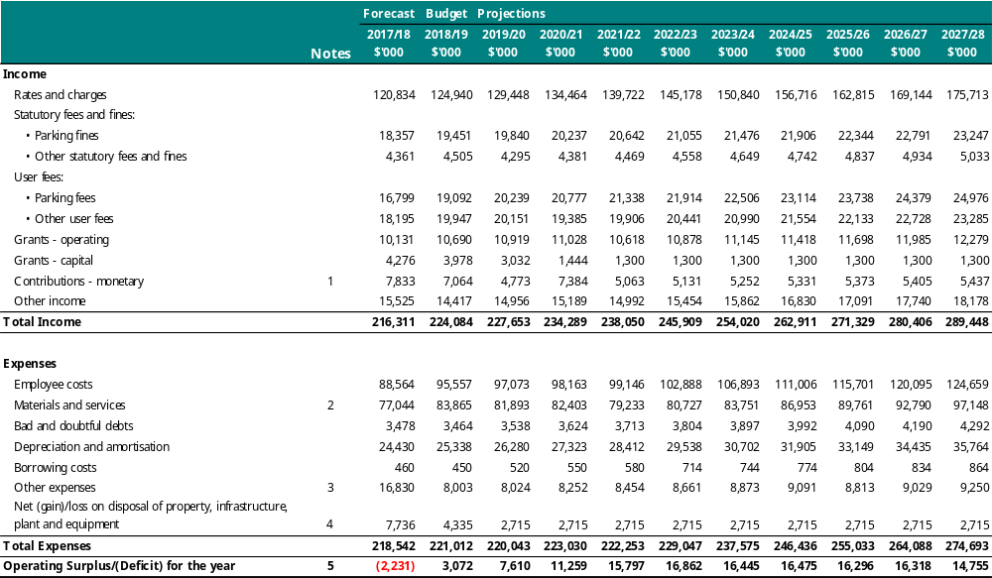
Notes
- Contributions – monetary – The Budget 2018/19 includes $3.0million from the Development Contribution Plan (DCP) for Fishermans Bend Ferrars Street Precinct works. We also expect to receive $2.5 million in 2020/21. Due to the uncertainty of planned works in Fishermans Bend, no further DCP are included in future years.
- Materials and services – The Budget 2018/19 includes $9.0 million of expenditure due to the technology shift to Cloud-based managed services which will reclassify to operating expenditure rather than capital investment. A total $23 million is planned over three financial years 2018/19 to 2020/21.
- Other expenses – The forecast for 2017/18 includes a one-off $8.95 million Council cash contribution for the Victoria Pride Centre to be situated in St Kilda.
- Net loss from disposal of property, infrastructure, plant and equipment – The forecast for 2017/18 includes a property transfer as a part of Council’s contribution to the Victoria Pride Centre ($1.56 million) and a Committee of Management property to be relinquished ($3.56 million).
- Operating Surplus for the year – An operating surplus is expected in Budget 2018/19 impact by the item identified in note 2. Excluding this item would result in an operating surplus of $12.1 million.

Income statement converted to cash
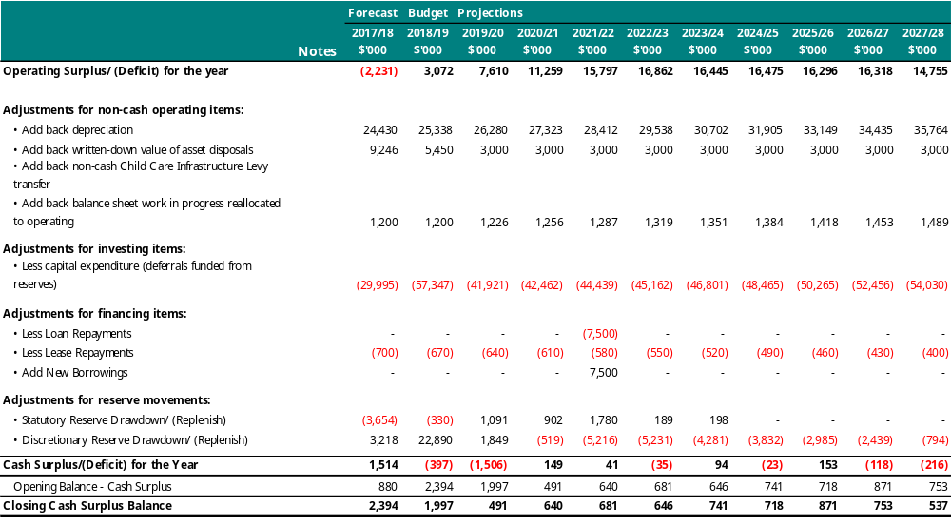

Balance sheet
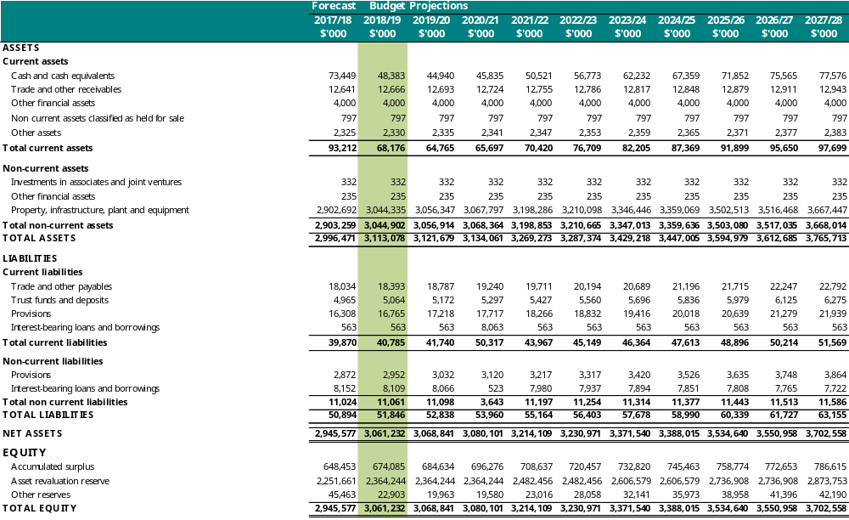

Statement of changes in equity
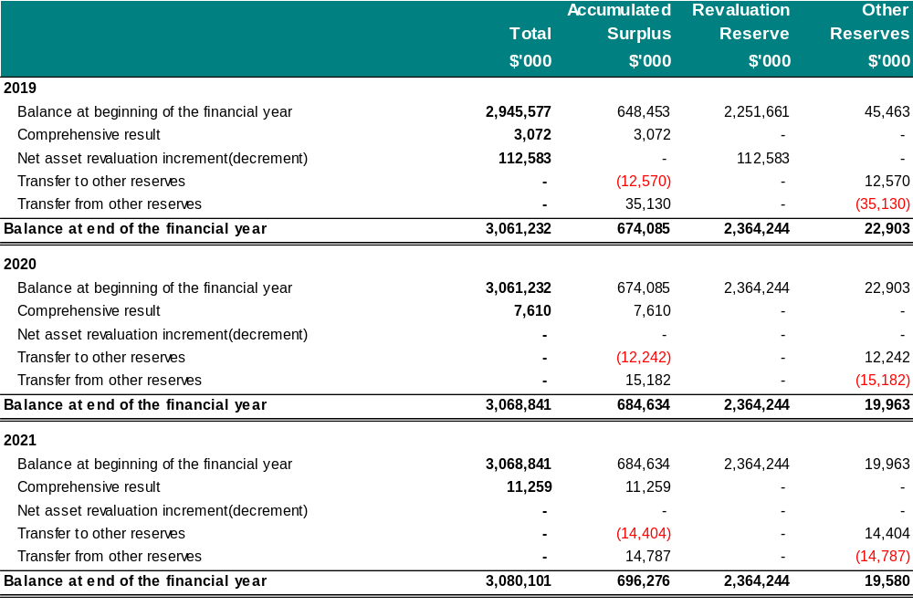
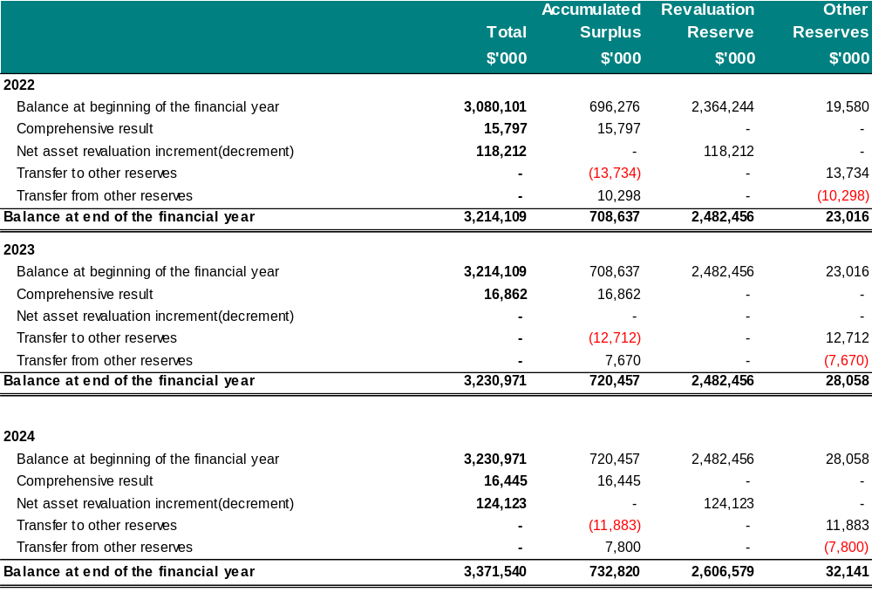
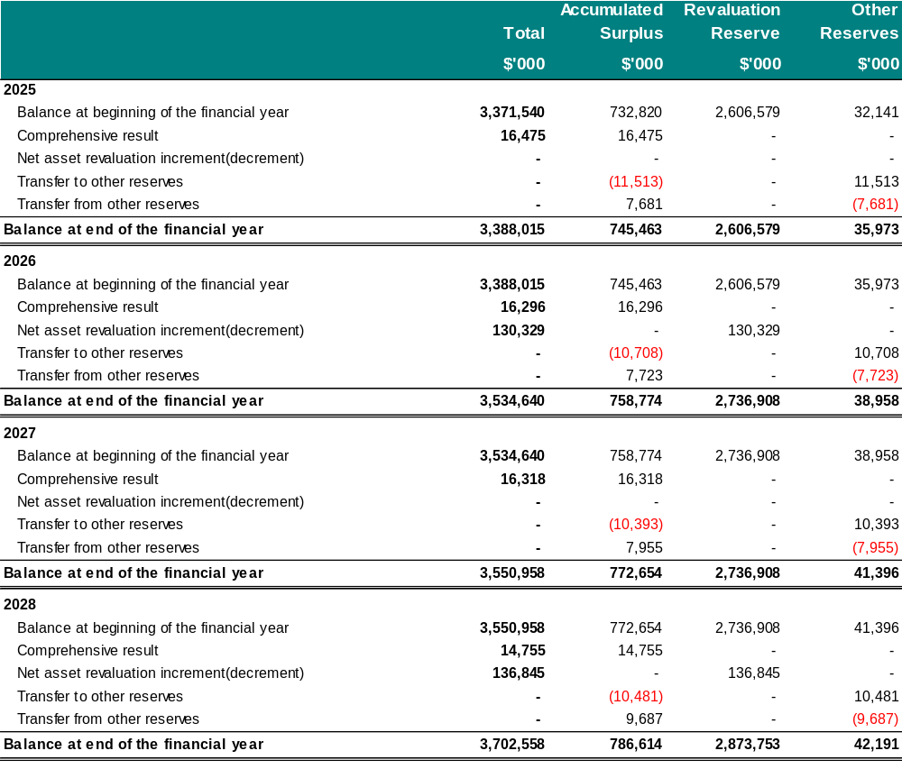

Statement of cash flows
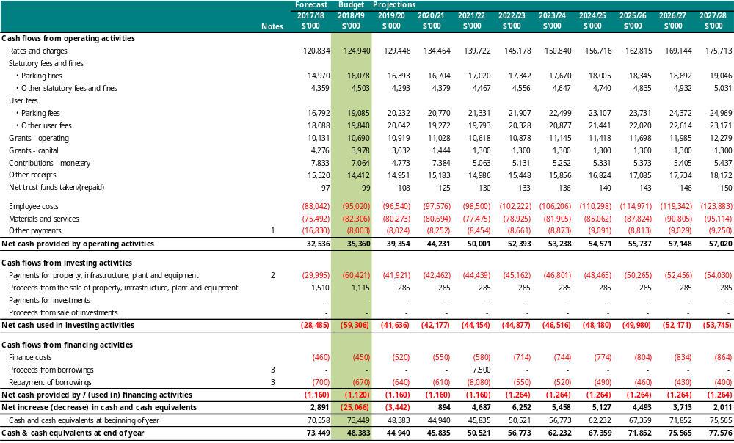
Notes to Statement of Cash Flows:
- Other payments – Budget 2017/18 includes a one-off $8.95 million Council cash contribution for the Victoria Pride Centre to be situated in St Kilda.
- Payments for property, infrastructure, plant and equipment – Budget 2018/19 includes $17.5 million to purchase land for a Sustainability Hub.
- Proceeds from borrowings and repayment of borrowings – Council has $7.5 million of borrowing which is expected to mature in 2021/22 financial year. Council plans to refinance this loan for a further 10 years on interest only terms.

Statement of capital works
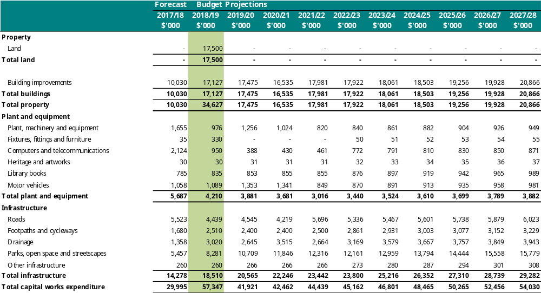
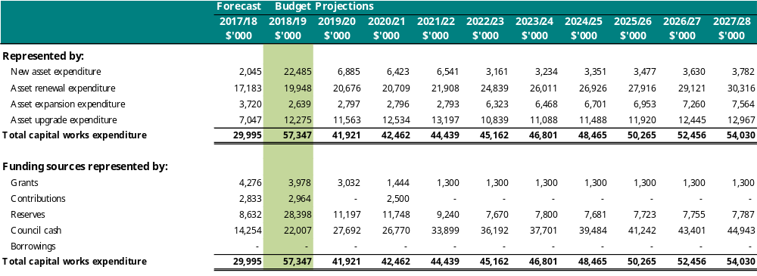

Budget 2018/19 Capital Projects
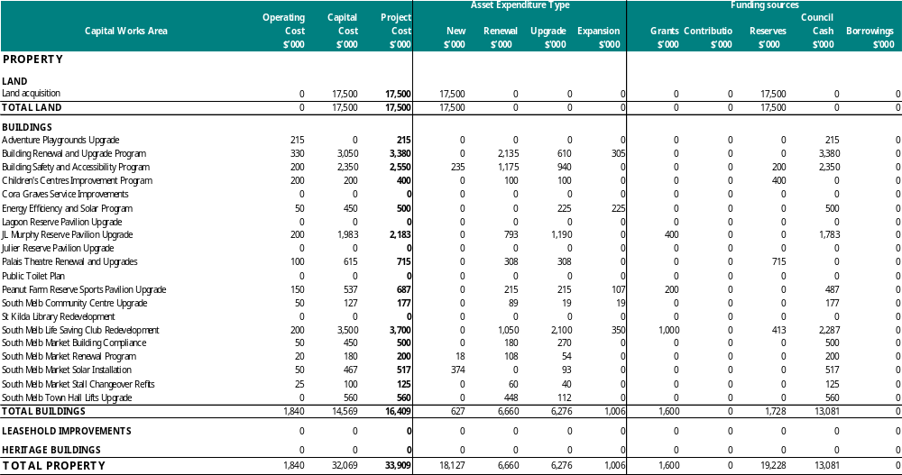
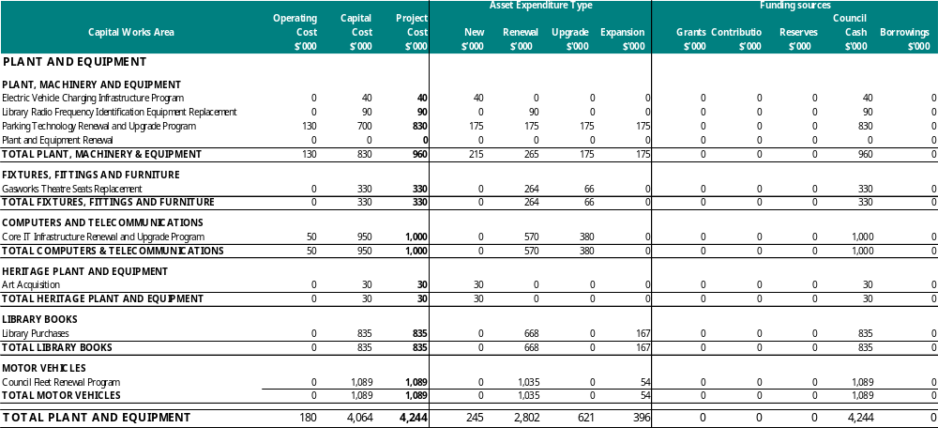
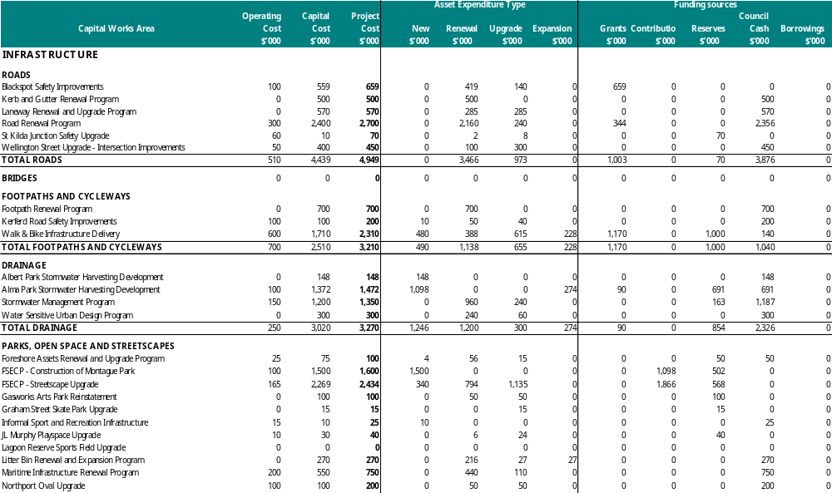
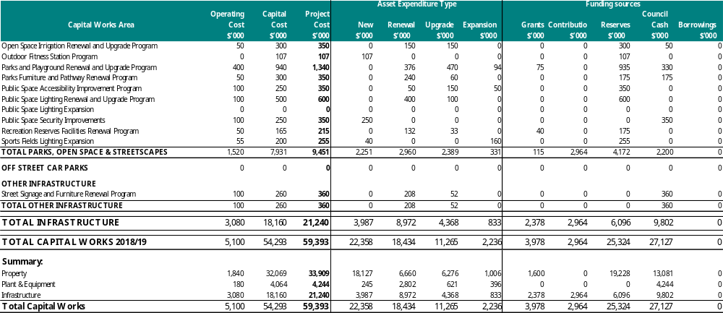

Works Deferred From 2017/18
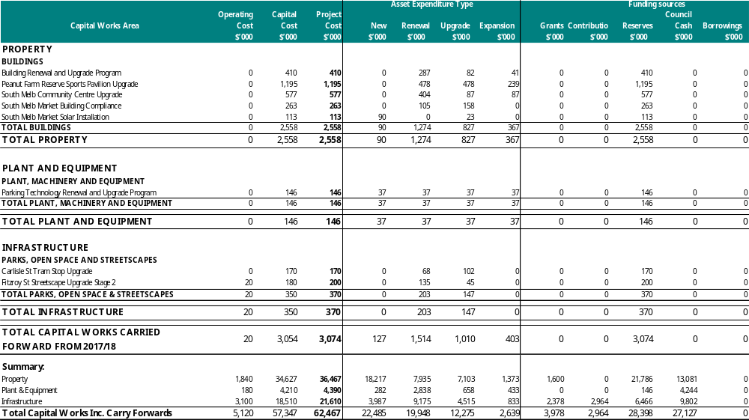

Summary of Capital Works Expenditure 2018-22
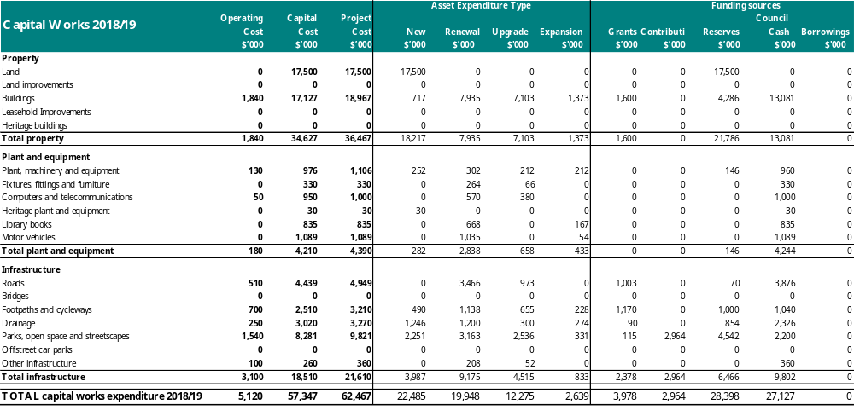
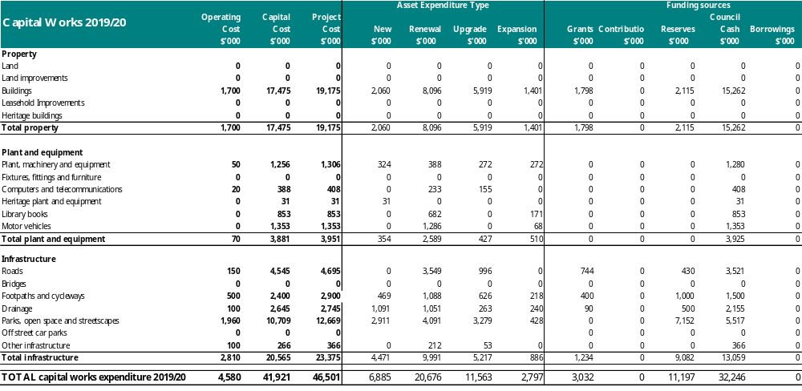
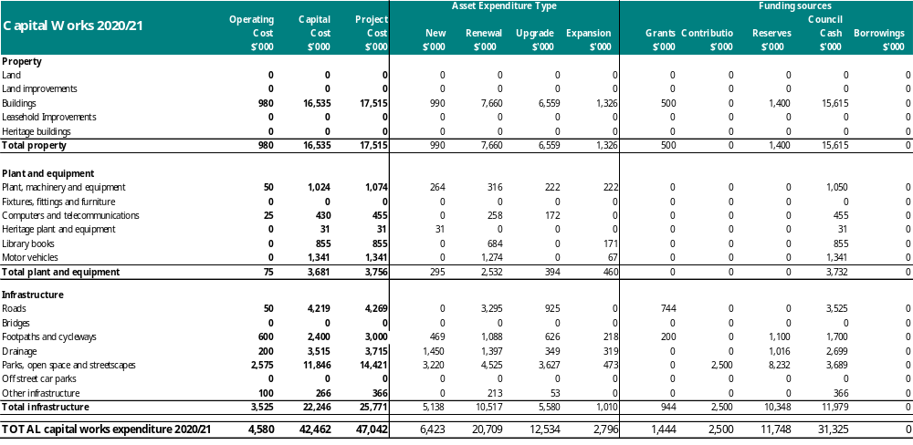
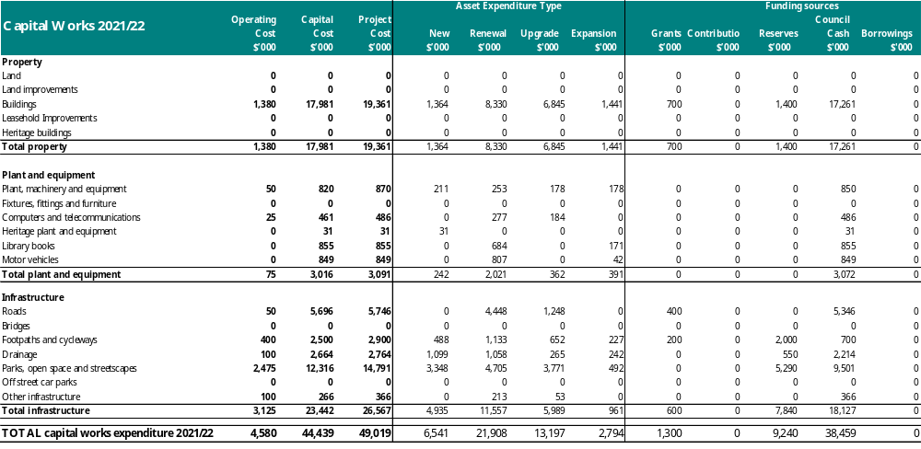

2018-28 capital program
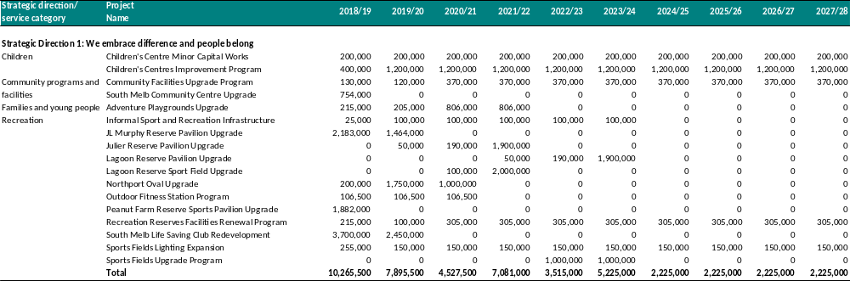
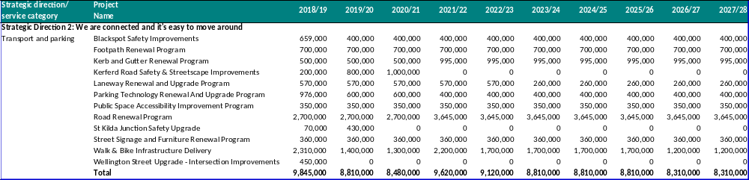
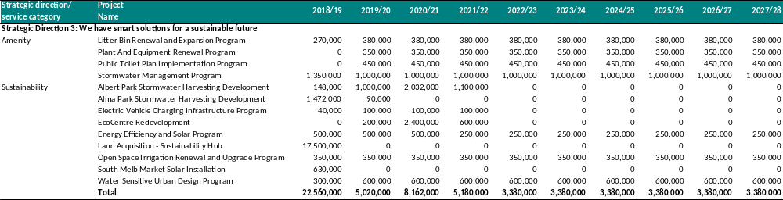
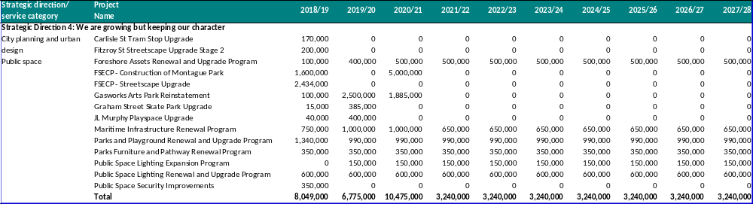
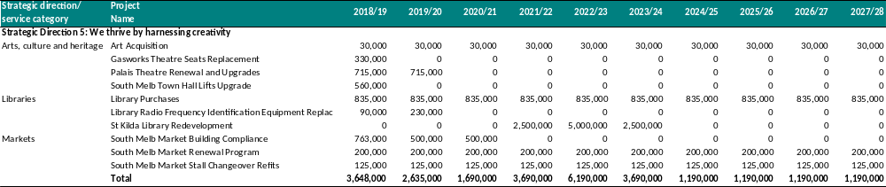
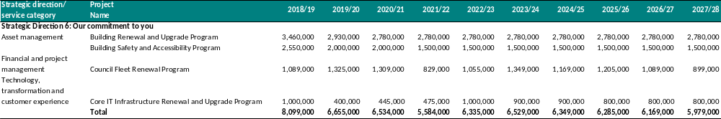

2018-22 operating projects
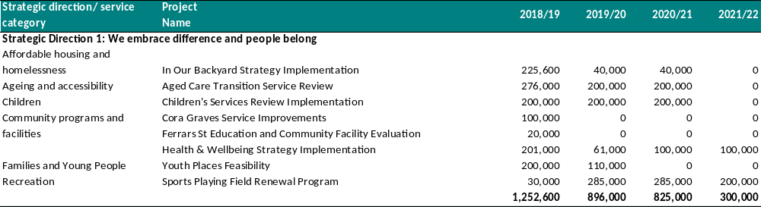
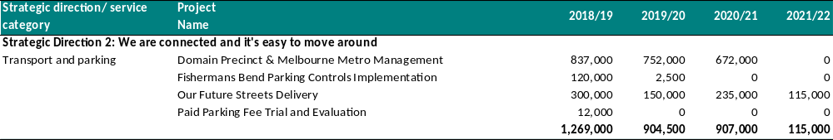
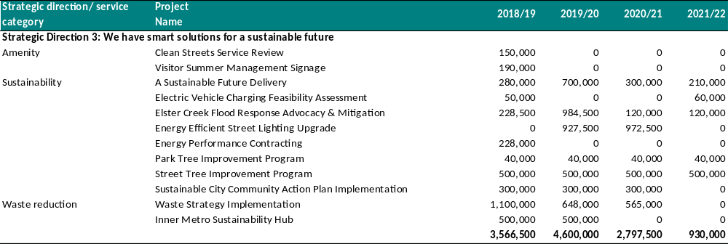
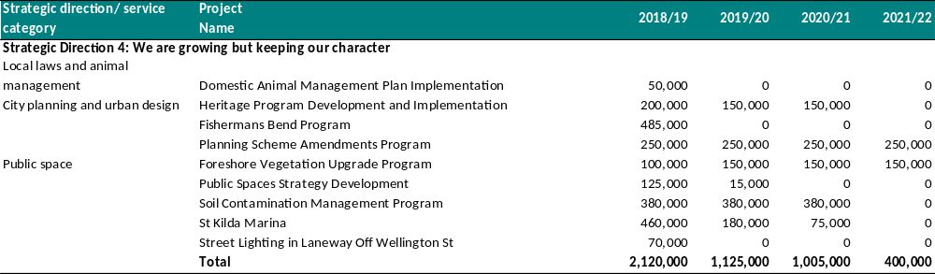
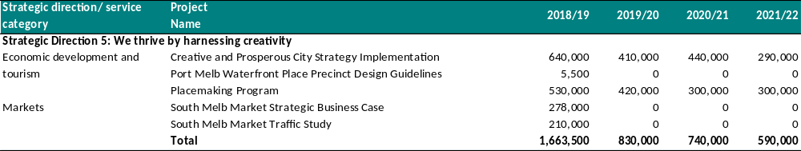
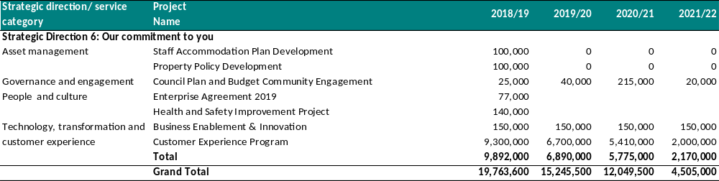

Schedule of cash-backed reserve movements
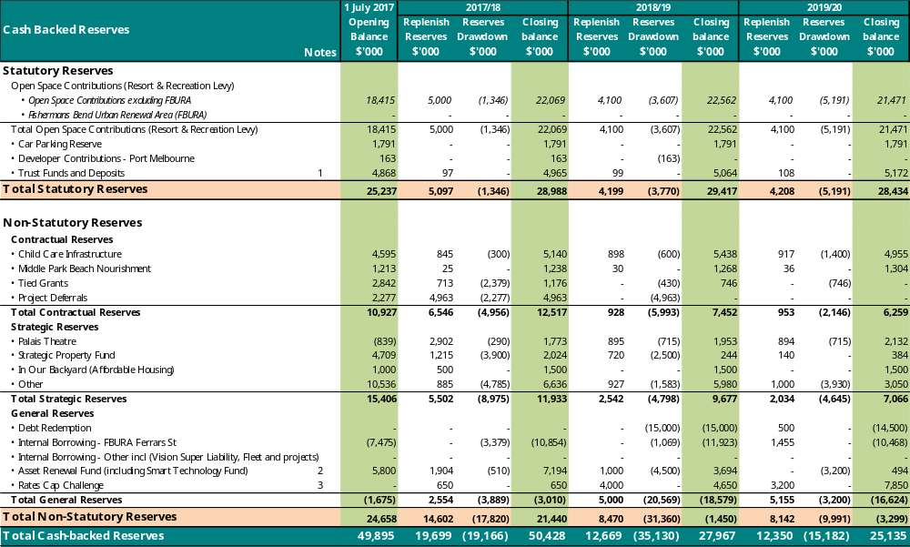
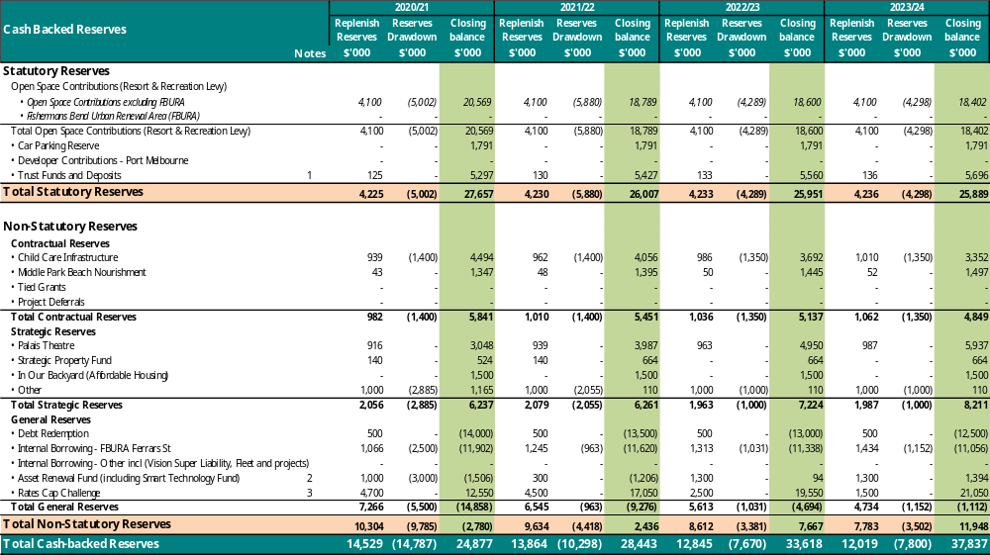
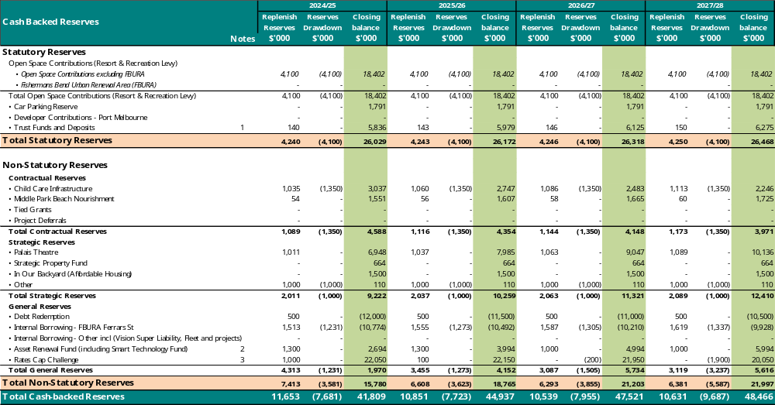
Notes to Reserves:
- Trust Funds and Deposits – Deposits and contract retentions are held in trust by Council as a form of surety for transactions with Council. These are also represented as liabilities in the balance sheet.
- Asset Renewal Fund (including Smart Technology Fund) – For funding of future asset renewals and projects related to Smart Technology.
- Rates Cap Challenge – Over the life of the 10-year financial plan, Council is expected to face a rates cap challenge as outline in the financial strategy. This reserve serves to quarantine the cash surpluses in the former years to fund the cash deficits in the latter years of the Financial Plan.

Statement of human resources
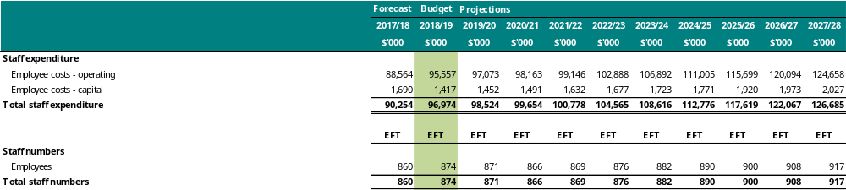

Summary of planned human resources
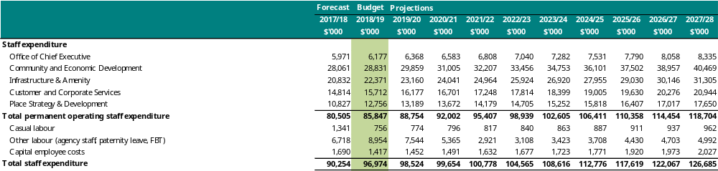
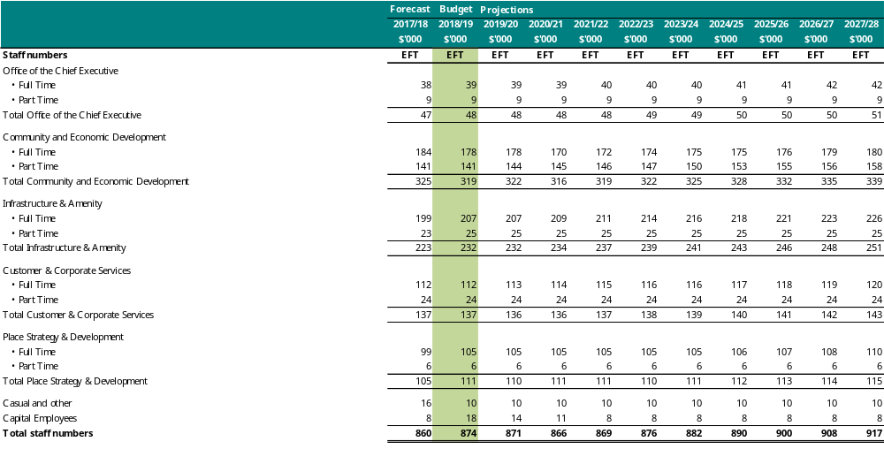

Grants – operating
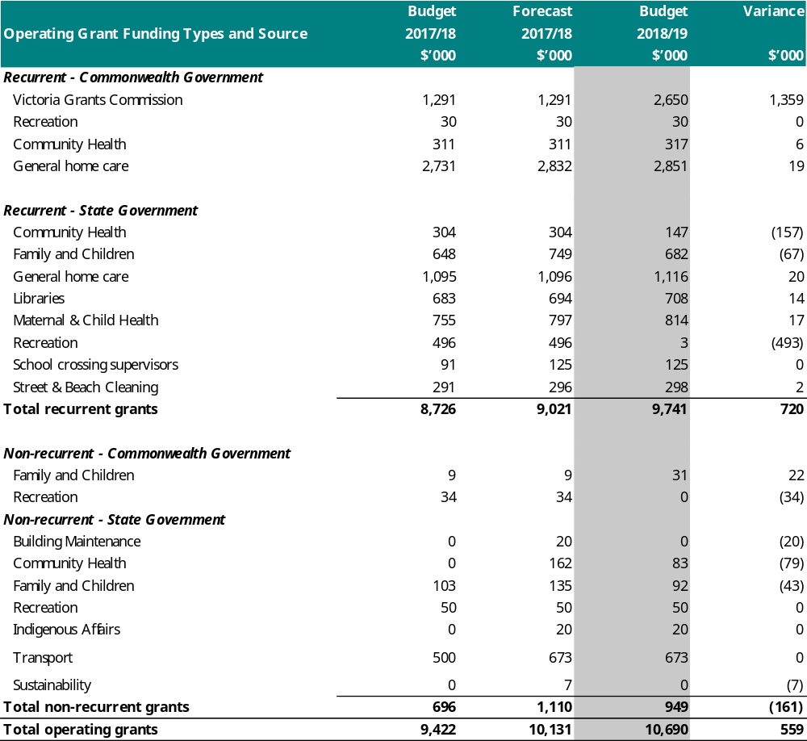

Grants – capital
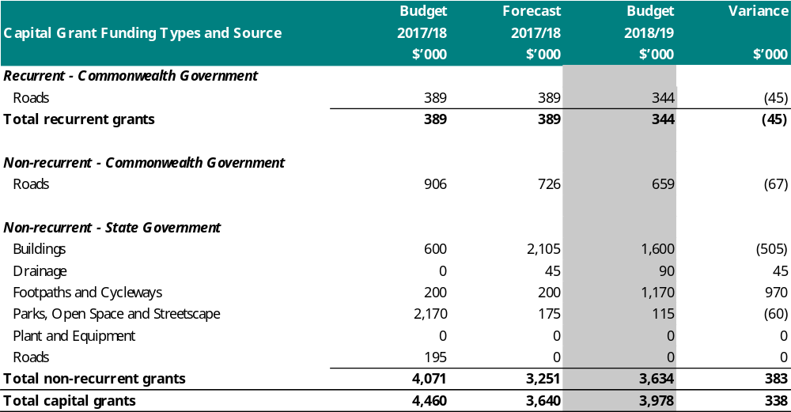

Statement of borrowings
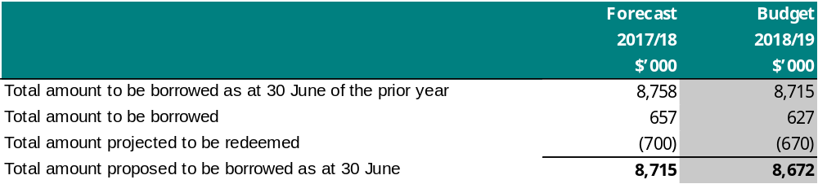

Measuring performance
Our directions in this Council Plan outline outcome and service measures to monitor progress. Under the Local Government Act 1989 and Local Government (Planning and Reporting) Regulations 2014 there are prescribed indicators for local government in Victoria. The prescribed service performance indicators are reflected in Section 2: Our future focus. Additionally, there are prescribed sustainable capacity and financial performance indicators. These measures provide insight into the effectiveness of our financial management and our capacity to meet the needs of our community in the future.

Sustainable capacity indicators
The prescribed sustainable capacity indicators provide information that highlights our capacity to meet the needs of our communities and absorb foreseeable changes and unexpected shocks into the future.
Indicator / measure |  | Results  2014/15 | Results  2015/16 | Results  2016/17 | Budget  2018/19 | Projection  2020/21
 | Population
Expenses per head of municipal population  [Total expenses / Municipal population] |  | $1,701.51 | $1,737.12 | $1,818.52 | $1901.05 | $1,869.69
Infrastructure per head of municipal population  [Value of infrastructure / Municipal population] |  | $5,516.95 | $5,528.54 | $5,5739.61 | $5,626.96 | $5,761.06
Population density per length of Road  [Municipal population / Kilometres of local Roads] |  | 364.05 | 396.77 | 401.75 | 430.54 | 441.80
 | Own-source revenue
Own-source revenue per head of municipal population  [Own-source revenue / Municipal population] |  | $1,573.38 | $1,668.41 | $1,730.46 | $1,740.58 | $1,797.62
 | Recurrent grants
Recurrent grants per head of municipal population  [Recurrent grants / Municipal population] |  | $111.46 | $85.52 | $110.68 | $91.96 | $92.45
 | Disadvantage
Relative Socio-Economic Disadvantage  [Index of Relative Socio-Economic Disadvantage by decile] |  | 10.00 | 10.00 | 10.00 | 10.00 | 10.00

Definitions
- “adjusted underlying revenue” means total income other than:
  - non-recurrent grants used to fund capital expenditure; and
  - non-monetary asset contributions; and
- contributions to fund capital expenditure from sources other than those referred to above
- “infrastructure” means non-current property, plant and equipment excluding land
- “local Road” means a sealed or unsealed Road for which the council is the responsible Road authority under the Road Management Act 2004
- “population” means the resident population estimated by council
- “own-source revenue” means adjusted underlying revenue other than revenue that is not under the control of council (including government grants)
- “relative socio-economic disadvantage”, in relation to a municipality, means the relative socio-economic disadvantage, expressed as a decile for the relevant financial year, of the area in which the municipality is located according to the Index of Relative Socio-Economic Disadvantage (Catalogue Number 2033.0.55.001) of SEIFA
- “SEIFA” means the Socio-Economic Indexes for Areas published from time to time by the Australian Bureau of Statistics on its Internet website
- “unrestricted cash” means all cash and cash equivalents other than restricted cash.

Service performance indicators
All service performance measures and indicators are included under Section 2: Our future focus.

Financial performance indicators
The prescribed financial performance indicators provide information that help monitor the effectiveness of our financial management.
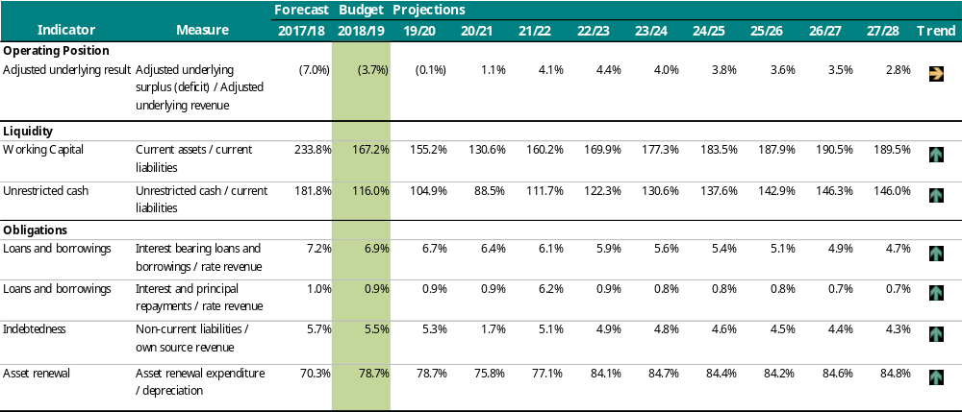

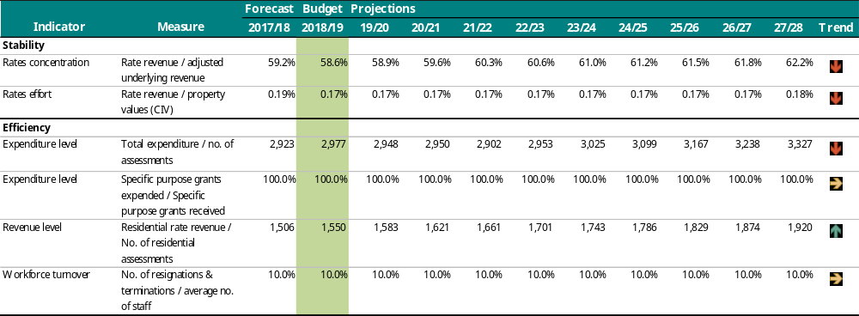
Key to Forecast Trends:
Forecast improvement in Council’s financial performance/ financial position indicator
Forecasts that Council’s financial performance/ financial position will be steady
 Forecast deterioration in Council’s financial performance/ financial position indicator
Notes to indicators:
- Adjusted underlying result – An indicator of the sustainable operating result required to enable Council to continue to provide core services and meet its objectives. Deterioration in financial performance is expected over the period primarily impacted by the projected 3.8% per annum increase in depreciation expense as a result of Council’s commitment to invest in capital assets for service delivery.
- Working Capital – The proportion of current liabilities represented by current assets. Working capital is forecast to remain steady or slightly improve at an acceptable level over the period.
- Debt compared to rates – Trend indicates Council’s reducing reliance on debt against its annual rate revenue. Council has the capacity to use debt to respond to financial risks over the period.
- Asset renewal – This percentage indicates the extent of Council’s renewals against its depreciation charge (an indication of the decline in value of its existing capital assets). A percentage greater than 100 indicates Council is maintaining its existing assets, while a percentage less than 100 means its assets are deteriorating faster than they are being renewed and future capital expenditure will be required to renew assets.
- Rates concentration – Reflects extent of reliance on rate revenues to fund all of Council’s on-going services. Trend indicates Council will become more reliant on rate revenue to all other sources.

Linking our initiatives to strategies and plans
This Council Plan is our primary planning document. It outlines the priorities that guide decision-making and the initiatives that will achieve our strategic objectives. Council has also adopted plans and strategies to support the delivery of the Council Plan, by providing detail about how specific policy objectives will be achieved.
The Local Government Act 1989 stipulates that the Strategic Resource Plan ‘must take into account services and initiatives contained in any plan adopted by the Council’. We undertake a disciplined annual budget process to ensure that future organisational resources are allocated in a way that best delivers on the Council Plan. All resource allocation decisions are made with reference to Council Plan priorities and objectives.
The table below shows the significant strategies, policies, plans and guidelines, the specific projects and initiatives that are linked to those documents, and the amount funded in this Council Plan. The figures show projects identified to take place between 2017/18 and 2020/21 and support for other agencies through grants or funding deeds. The allocation of resources is often guided by multiple Council Plan objectives and/or strategies. The resources identified below are cash allocations (that is, both capital and operating, project and recurrent investments) and may be funded from multiple sources, including external sources such as grants.
Some strategies, policies and plans do not have specific project funding attached. Rather, activity to achieve the objectives of those strategies, policies and plans is funded through service budgets and equivalent full-time staff (EFT). Service budgets and EFT information is provided in section 1 of this plan.
Consistent with legislative obligations and best practice, we review our Council Plan priorities and resource allocation annually. Estimates for 2018/19 and beyond represent current planning assumptions and should be considered provisional. These investments will be subject to evaluation and prioritisation in the relevant budget year.
Planning instrument, description and specific resources allocated for the following four years
Strategic Direction 1: We embrace difference, and people belong
Childcare Policy (interim 2018) | Ensures Council’s commitment to funding childcare with short and long-term strategies to retain and increase childcare places and financial support for low to middle income families.  Funding is for subsidies to third parties to provide childcare services.
Funding year and amount | 2018/19  $1,271,674 | 2019/20  $1,298,888 | 2020/21  $1,330,191 | 2021/22  $1,362,781
Disability Policy | Describes Council’s commitment to people with a disability and provides a leadership platform on which to base decisions regarding actions and advocacy that at times may reach beyond its legislative requirements.  This policy is delivered primarily through the budget and activity of the Ageing and accessibility service. Funding for asset upgrades to meet Disability Discrimination Act requirements also contribute to meeting the objectives of this policy.
Family, Youth and Children Collaborative Practice Framework | Outlines how collaborative practices will be supported, enhanced and embedded into service culture and delivery to achieve the desired goals.  Funding is for a third party to provide family, youth and children services.
Funding year and amount | 2018/19  $114,862 | 2019/20  $117,320 | 2020/21  $120,147 | 2021/22  $123,091
Family Youth and Children Strategy 2014–2019 | Guides development and implementation of policies and plans and drives service delivery and planning for children, middle years, youth and families.  Funding is for building upgrade works at children centres, implementation of the Children’s Services Review and investigation into a Youth Places centre.
Funding year and amount | 2018/19  $820,000 | 2019/20  $1,510,000 | 2020/21  $1,400,000 | 2021/22  $1,200,000
Friends of Suai Strategic Plan 2010–2020 | Strengthens capability and involvement in the Covalima community, practices good governance and management in our Friendship, and builds community awareness and our knowledge of Friendship between our Communities.  Funding is for our contribution to Friends of Suai.
Funding year and amount | 2018/19  $48,000 | 2019/20  $48,000 | 2020/21  $48,000 | 2021/22  $48,000
Health and Wellbeing Plan 2017-21 | Is integrated with the Council Plan and sets the broad mission, goals and priorities to enable people living in the municipality to achieve maximum health and wellbeing.  Funding is to implement a range of initiatives including development of a multi-agency public drinking strategic response, undertaking a community safety audit and evaluating the Homelessness Action Strategy.
Funding year and amount | 2018/19  $201,000 | 2019/20  $61,000 | 2020/21  $100,000 | 2021/22  $100,000
Homelessness Action Strategy 2015–2020 | Seeks to reduce the risks associated with homelessness through the development of agreed actions, continuing council’s role as a leader, advocate, planner, facilitator and service provider.  This strategy is delivered primarily through the budgets and activities of the Affordable housing and homelessness and Community programs and facilities services.
In Our Backyard – Growing Affordable Housing in Port Phillip 2015–2025 | Sets out a broad vision for housing and residential development in Port Phillip and makes recommendations regarding the future management of housing and residential development in the City.  Funding is for an annual cash contribution to an affordable housing reserve to support new projects and an expression of interest for making Council land in Marlborough Street ready for release to the community housing development market.
Funding year and amount | 2018/19  $725,000 | 2019/20  $540,000 | 2020/21  $540,000 | 2021/22  $500,000
Middle Years Commitment and Action Plan 2014–2019 | Provides a framework for Council, the community and our key partners to enable middle years young people to be happy, healthy and have their voices heard.  Funding is for upgrading council-owned Adventure Playgrounds.
Funding year and amount | 2018/19  $215,000 | 2019/20  $205,000 | 2020/21  $806,000 | 2021/22  $806,000
Protocol for Assisting People Who Sleep Rough 2012 | Helps ensure that people experiencing primary homelessness are treated appropriately and are offered relevant support services.  This protocol is delivered primarily through the budget and activity of the Affordable housing and homelessness service.
Reconciliation Action Plan 2017 | Explores employment opportunities, builds awareness and understanding and enhances cultural and economic development for local Aborigines and Torres Strait Islanders.  This plan is delivered primarily through the budget and activity of the Community programs and facilities service.
Social Justice Charter 2011(including Social Justice Action Plan) | The Charter sets a goal for the community to work together in pursuit of the common good, while protecting and promoting the rights of all members of the community.  Funding is for funding third parties to provide access and ageing services. The Social Justice Charter is also delivered through the budget and activity of the Community programs and facilities service.
Funding year and amount | 2018/19  $828,259 | 2019/20  $845,984 | 2020/21  $866,372 | 2021/22  $887,598
Sport and Recreation Strategy 2015–2024 | Supports the planning and provision of recreation and sport facilities and services to the local community.  Funding is for redeveloping the South Melbourne Life Saving Club, upgrading Peanut Farm and JL Murphy pavilions, renewing and upgrading sports playing fields and lighting.
Funding year and amount | 2018/19  $8,596,500 | 2019/20  $6,455,500 | 2020/21  $2,236,500 | 2021/22  $4,705,000
Youth Commitment and Action Plan 2014–2019 | Outlines how Council will bring our vision to fruition and meet our commitments.  Funding is for funding deeds to third parties to provide youth services.
Funding year and amount | 2018/19  $111,081 | 2019/20  $113,458 | 2020/21  $116,192 | 2021/22  $119,039
Other initiatives not specifically aligned to a strategy | Funding is for upgrading the South Melbourne Community Centre and reviewing Council’s role in aged care and disability support services.
Funding year and amount | 2018/19  $1,130,000 | 2019/20  $200,000 | 2020/21  $200,000 | 2021/22  $0,000
Strategic Direction 2: We are connected and it’s easy to move around
Access Plan 2013–2018 | Represents a ‘whole of organisation’ approach to addressing access and inclusion. It reflects the need for all areas of Council to work together in a coordinated manner to improve access for all.  Funding is for public space accessibility improvements.
Funding year and amount | 2018/19  $350,000 | 2019/20  $350,000 | 2020/21  $350,000 | 2021/22  $350,000
Bike Plan: Pedal Power 2011-2020 | Makes Port Phillip better for bike riding by carefully planning our infrastructure so riding is convenient, safe, efficient and enjoyable.  Funding is for implementing the Bike Plan.
Funding year and amount | 2018/19  $1,500,000 | 2019/20  $700,000 | 2020/21  $600,000 | 2021/22  $1,500,000
Car Share Policy 2016-2021 | Defines the benefits of car share to members, the local community and Council and encourages the expansion of car share across the municipality.  This policy is delivered primarily through the budget and activity of the Transport and parking management service.
Parking Permit Policy 2001 | Provides guidelines for residents, visitors, members of community service organisations, disabled residents, trade persons and businesses for eligibility of parking permits.  This policy is delivered primarily through the budget and activity of the Transport and parking management service.
Public Transport Advocacy Statement 2009 | Provides guidance on those matters that Council will advocate regarding bus, tram and train travel.  This commitment is delivered primarily through the budget and activity of the Transport and parking management service.
Road Management Plan | Outlines our road management responsibilities, lists the road assets and details the standards of service, maintenance and construction for roads within the City.  Funding is for renewing roads and kerbs, footpaths and laneways.
Funding year and amount | 2018/19  $4,470,000 | 2019/20  $4,470,000 | 2020/21  $4,470,000 | 2021/22  $5,910,000
Safer Streets 2013-2020: The Road User Safety Strategy and Walk Plan 2011-2020 | Makes Port Phillip better for walking by carefully planning our infrastructure so walking is convenient, safe, efficient and enjoyable. Also sets out the goals for eliminating fatalities and reducing the risk of injury on our roads so that people of all ages and abilities can travel on our road network safely and that vulnerable road users have confidence to travel freely in the City.  Funding is for implementing blackspot safety improvements at high collision locations, plan for and deliver Kerferd Road safety improvements to enhance walking and bike riding, St Kilda Junction safety upgrade, Wellington Street intersection upgrade, and for implementing the Walk Plan.
Funding year and amount | 2018/19  $2,189,000 | 2019/20  $2,330,000 | 2020/21  $2,100,000 | 2021/22  $1,100,000
Sustainable Transport Strategy: A Connected and Liveable City | Supports our vision for a connected and liveable city where residents, visitors and workers can live and travel car free by improving the convenience, safety, accessibility and range of sustainable travel choices across the municipality.  Funding is to maximise community benefit from Melbourne Metro public transport and precinct works including the Park Street tram link and all associated tram stop upgrades implement and Implement clever parking initiatives that help manage parking supply and turnover, and improve customer experience.
Funding year and amount | 2018/19  $1,945,000 | 2019/20  $1,354,000 | 2020/21  $1,272,000 | 2021/22  $400,000
Other initiatives not specifically aligned to a strategy | A placeholder has been included in the Budget 2018/19 and subsequent years for completion and implementation of the Integrated Transport Strategy. A draft strategy including an action plan will be released in 2018 for community consultation.
Funding year and amount | 2018/19  $300,000 | 2019/20  $150,000 | 2020/21  $235,000 | 2021/22  $115,000
Strategic Direction 3: We have smart solutions for a sustainable future
A Sustainable Future 2018-28 (in development) | Outlines the cultural change and collaborative actions required over the next ten years across a range of council services including: city planning and urban design, waste and water management, community outreach and behaviour change programs. It also embeds sustainability into Council operations and projects to ensure the City of Port Phillip has a sustainable future.  Funding is for planning and delivering water sensitive urban design interventions, supporting uptake of electric vehicles, maintain heat mapping, education programs and redevelopment of the EcoCentre (subject to partner funding). It also includes funding for land acquisition for a sustainability hub, replacement of our litter bins and a review of our Street Cleaning service. A draft Waste and Resource Recovery Strategy, which will establish a framework for how we will manage waste, recycling and litter services over the next eight years is in development, will be released in 2018 for community consultation.
Funding year and amount | 2018/19  $20,300,000 | 2019/20  $3,578,000 | 2020/21  $4,795,000 | 2021/22  $1,830,000
Climate Adaptation Plan 2010 | Targets Council operations and policy in the areas of built form, public space, coastal management and protection, drainage and flooding management, managing heat stress and heat island effects, and supporting local emergency management. It is a key plan to guide change in some vital Council operational areas, in order to progressively develop a more climate adept city.  Funding is to implement a Sustainable City Community Action Plan and respond to progress Council's efforts to reduce the impact of flooding, and improve water quality in the Elster Creek Catchment.
Funding year and amount | 2018/19  $528,500 | 2019/20  $1,284,500 | 2020/21  $420,000 | 2021/22  $120,000
Foreshore and Hinterland Vegetation Management Plan 2015 | Provides guidance for the future use, development and management of the Port Phillip foreshore.  Funding is for ongoing investment in upgrading the foreshore including vegetation projects.
Funding year and amount | 2018/19  $100,000 | 2019/20  $150,000 | 2020/21  $150,000 | 2021/22  $150,000
Graffiti Management Plan 2013-2018 | Provides direction for the removal and management of graffiti across the city, implementation community focussed programs that contribute to minimising graffiti, and provision of opportunities for people to participate in more legitimate forms of public art.  This plan is delivered through the budget and activity of the Amenity service.
Greenhouse Plan 2011 | Assists Council to address emissions reduction actions in greenhouse gas emissions, urban design and development, transport, zero waste, purchasing and procurement, and climate change.  Funding is for investing in energy efficiency measures (for example, solar implementation at South Melbourne Market) in Council buildings, upgrading our street lighting with energy efficient lights.
Funding year and amount | 2018/19  $1,448,000 | 2019/20  $1,527,500 | 2020/21  $1,572,500 | 2021/22  $410,000
Greening Port Phillip, An Urban Forest Approach 2010 | Supports a healthy and diverse urban forest that uses innovative greening solutions to enhance the community’s daily experience, ensuring environmental, economic, cultural and social sustainability for future generations.  Funding is for street tree and park tree improvement programs.
Funding year and amount | 2018/19  $540,000 | 2019/20  $540,000 | 2020/21  $540,000 | 2021/22  $540,000
Open Space Water Management Plan | Reflects the principles of the Water Plan 2010 and creates an implementation framework from which actions can be developed and prioritised.  Funding is for implementing irrigation upgrades to key sports fields and parks to optimise water use.
Funding year and amount | 2018/19  $350,000 | 2019/20  $350,000 | 2020/21  $350,000 | 2021/22  $350,000
Public Toilet Plan 2013–2023 | Supports clean, safe, accessible public toilets to all local residents and visitors to the municipality.  Funding is for improving safety and amenity of public toilets. Funding for the upgrade of the South Melbourne Life Saving Club in 2018/19 includes the toilet facilities and is located under the Sport and Recreation Strategy.
Funding year and amount | 2018/19  $0 | 2019/20  $450,000 | 2020/21  $450,000 | 2021/22  $450,000
Storm Water Management Plan | Provides direction for the environmental management of stormwater and presents an integrated approach to stormwater management, which maintains the traditional function of preventing adverse flooding, but also places emphasis on improving water quality and environmental amenity of stormwater systems.  Funding is for renewing and upgrading our drains and stormwater assets.
Funding year and amount | 2018/19  $1,350,000 | 2019/20  $1,000,000 | 2020/21  $1,000,000 | 2021/22  $1,000,000
Sustainable Design Strategy 2013 | Sets out how Council will achieve sustainable design outcomes through the planning scheme and incorporates best practice sustainability design standards for Council buildings, provides an assessment framework that directly supports the proposed Amendment C97 Environmentally Efficient Design (EED) Local Planning Policy.  This strategy is delivered primarily through the budgets and activity of the City planning and urban design and Sustainability services.
Sustainable Public Lighting Strategy for Streets and Open Space 2011–2016 | Provides the framework for achieving our zero net Council emissions by 2020 goal by providing direction for improvement where it is needed.  Funding is for renewal, upgrade and expansion of public space lighting.
Funding year and amount | 2018/19  $670,000 | 2019/20  $750,000 | 2020/21  $750,000 | 2021/22  $750,000
Water Plan 2010 | Identifies different water sources that can be used to make the city more liveable.  Funding is for working with third parties on the viability of stormwater harvesting at Albert Park Lake and Alma Park.
Funding year and amount | 2018/19  $1,620,000 | 2019/20  $1,090,000 | 2020/21  $2,032,000 | 2021/22  $1,100,000
Strategic Direction 4: We are growing but keeping our character
Activating Laneways Strategy | Identifies a selection of lanes within and/or close to key areas such as Activity Centres, regionally significant open spaces and public transport networks, and provides a framework to promote future activity within them.  This strategy is delivered through the Laneway Renewal and Upgrade Program (see Road Management Plan 2013),
City of Port Phillip Housing Strategy 2007-2017 | Sets out a broad vision for housing and residential development in Port Phillip and makes recommendations regarding the future management of housing and residential development in the City.  This strategy is delivered primarily through the budgets and activity of the City planning and urban design and Affordable housing and homelessness services.
City of Port Phillip Activity Centre Strategy 2006 | Provide a holistic understanding of the complex role and function of activity centres and the contribution that they can make to creating sustainable local communities and is in response to Melbourne 2030: Planning for Sustainable Growth  This strategy is delivered primarily through the budget and activity of the City planning and urban design service.
Domestic Animal Management Plan 2017-2021 | Aims to provide harmonious and responsible pet ownership across the City of Port Phillip focusing on the registration of pets, effective control of dogs within public areas, pet residential management, pet microchipping and de-sexing and the encouragement of owners to pick up dog poo.  This plan is delivered primarily through the budget and activity of the Local laws and animal management service and includes an initiative to implement year 1 actions identified in the recently adopted Plan.
Funding year and amount | 2018/19  $50,000 | 2019/20  $0 | 2020/21  $0 | 2021/22  $0
Fishermans Bend Planning & Economic Development Strategy | Guides the continued transition of Fishermans Bend from a traditional industrial area into a diverse, inner city business and employment precinct.  Funding is for the Ferrars Street Education and Community Precinct Montague Park and streetscape upgrade projects.
Funding year and amount | 2018/19  $4,519,000 | 2019/20  $0 | 2020/21  $5,000,000 | 2021/22  $0
Foreshore Management Plan 2012 | Guides how to protect, maintain and manage the City’s coastline. It provides strategic directions to address unsustainable impacts on the Port Phillip coast and community.  Funding is for renewing foreshore and maritime assets.
Funding year and amount | 2018/19  $850,000 | 2019/20  $1,400,000 | 2020/21  $1,500,000 | 2021/22  $1,150,000
Inner Melbourne Action Plan | Sets out 11 regional strategies and 57 actions to make the Inner Melbourne Region more liveable.  Funding is for our contribution to the Inner Melbourne Action Plan.
Funding year and amount | 2018/19  $95,000 | 2019/20  $95,000 | 2020/21  $95,000 | 2021/22  $95,000
Management plans for: Catani Gardens and Southern Foreshore, Elwood Foreshore and Recreation reserves, JL Murphy Reserve, and Marina Reserve | These plans are delivered primarily through the budget and activity of the City planning and urban design service.
Masterplans for: Albert Park College Precinct, Balaclava Station, Emerald Hill Precinct, St Kilda Triangle | Funding is for working with Public Transport Victoria on upgrading the Balaclava Station interchange on Carlisle Street.
Funding year and amount | 2018/19  $170,000 | 2019/20  $0 | 2020/21  $0 | 2021/22  $0
Memorials and Monuments Policy | Guides management of existing memorials and decision-making for new memorials.  Funding is for the memorials and monuments renewal program and heritage plaques.
Funding year and amount | 2018/19  $70,000 | 2019/20  $70,000 | 2020/21  $70,000 | 2021/22  $70,000
Municipal Emergency Management Plan | Outlines how the Port Phillip City Council will Implement measures to prevent (or reduce) the causes (or effects) of emergencies, manage the use of municipal resources in response to emergencies, manage support (that may be provided) to or from adjoining municipalities, assist the affected community to recover following an emergency and complement other local, regional and state planning arrangements.  This plan is delivered primarily through the budget and activity of the Municipal emergency management service.
Open Space Strategy and Implementation Plan Framework 2009 | Guides delivery of a city where public open spaces define the City’s character and respond to its people’s need for places to rest, recreate and be inspired.  Funding is to renew park and street furniture and signage.
Funding year and amount | 2018/19  $710,000 | 2019/20  $710,000 | 2020/21  $710,000 | 2021/22  $, 710,000
Playspace Strategy 2011 | Sets the vision, policy context and framework for future development of play spaces and prioritises play spaces for upgrade and renewal.  Funding is to renew and upgrade parks and playgrounds, including the playspace at JL Murphy and Graham Street Skate Park.
Funding year and amount | 2018/19  $1,395,000 | 2019/20  $1,775,000 | 2020/21  $990,000 | 2021/22  $990,000
Port Melbourne Waterfront Activation Plan | Defines short term actions and identifies longer term strategies and is guide for the delivery of them by Council, business and the community to activate the Port Melbourne Waterfront.  This plan is delivered primarily through the budget and activity of the City planning and urban design service.
Port Phillip Heritage Review 2000 (Version 18) | Includes completion of additional assessments of places and areas of heritage significance since the gazetting of the original review in 2000.  Funding is developing and implementing the Heritage Program.
Funding year and amount | 2018/19  $200,000 | 2019/20  $150,000 | 2020/21  $150,000 | 2021/22  $0
Port Phillip Local Law No.1 (Community Amenity) 2013 | Manages the uses and activities on roads and Council land, and manages, regulates and controls certain uses and activities.  The local law is delivered primarily through the budgets and activity of the Health services and Local laws and animal management services.
Port Phillip Planning Scheme | Provides a clear and consistent framework within which decisions about the use and development of land can be made.  Expresses state, regional, local and community expectations for areas and land uses.  Provides for the implementation of State, regional and local policies affecting land use and development.  Funding is for implementing planning scheme amendments that strengthen design and development controls in areas undergoing significant change.
Funding year and amount | 2018/19  $250,000 | 2019/20  $250,000 | 2020/21  $250,000 | 2021/22  $250,000
Precinct structure plans and urban design frameworks for: activity centres (Bay Street, Carlisle Street, South Melbourne Central and Ormond Road Elwood) and growth precincts (Montague Precinct, St Kilda Road South, St Kilda Road North, St Kilda Foreshore and Port Melbourne Waterfront) | Funding is to work with PTV on upgraded the streetscape in Fitzroy St from Grey Street to Lakeside Drive and to secure a new lease for the St Kilda Marina.
Funding year and amount | 2018/19  $660,000 | 2019/20  $180,000 | 2020/21  $75,000 | 2021/22  $0
Soil Contamination Management Policy (in development) | Outlines our approach to assessing and managing potentially contaminated land that we own or manage.  Funding is for working with the Victorian Government to effectively manage soil contamination on open space sites, including at Gasworks Arts Park.
Funding year and amount | 2018/19  $480,000 | 2019/20  $2,880,000 | 2020/21  $2,265,000 | 2021/22  $0
St Kilda Botanical Gardens Future Directions Plan | Examines botanic function and cultural heritage of the Gardens and provides a number of improvement recommendations.  This plan is delivered primarily through the budget and activity of the Public space service.
Other initiatives not specifically assigned to a strategy | Funding is for developing a Public Spaces strategy, Design and Development Awards, Public Space Security Improvements and Visitor Summer Management additional signage costs.
Funding year and amount | 2018/19  $685,000 | 2019/20  $35,000 | 2020/21  $20,000 | 2021/22  $20,000
Strategic Direction 5: We thrive by harnessing creativity
Aboriginal and Torres Islander Arts Strategy 2014-2017 | Ensures resources are available for the annual Aboriginal and Torres Strait Islander arts calendar.  Funding is for the Yalukit Willum Ngargee festival and Indigenous Arts program.
Funding year and amount | 2018/19  $114,863 | 2019/20  $117,321 | 2020/21  $120,149 | 2021/22  $123,092
Arts and Culture Policy 2011 | Articulates our commitment to supporting a culturally vibrant city and outlines principles and objectives for arts and cultural services, programs and facilities.  Funding supports the management and operation of Gasworks and Linden Gallery and other arts organisations, the Cultural Development Fund, and replacing the Gasworks Theatre seats.
Funding year and amount | 2018/19  $1,353,540 | 2019/20  $1,042,523 | 2020/21  $1,064,358 | 2021/22  $1,087,090
Community Grants Subsidies and Donations Policy | Sets direction for transparent and effective administration of community grants programs, subsidy schemes and donations.  Funding is for supporting community facilities, community projects and village impact grants.
Funding year and amount | 2018/19  $412,675 | 2019/20  $412,675 | 2020/21  $412,675 | 2021/22  $412,675
Creative and Prosperous City Strategy 2018-22 (in development) | Outlines the cultural change and collaborative actions required over the next four years across a range of council services including: arts, culture and heritage, economic development and tourism, festivals, libraries, markets, city planning and urban design to create a thriving social, cultural and economic future for the City of Port Phillip.  Funding is for supporting placemaking activities, creative industry investment, community facility renewal among other initiatives.
Funding year and amount | 2018/19  $1,175,000 | 2019/20  $830,000 | 2020/21  $740,000 | 2021/22  $3.090,000
Events Strategy 2015–2017 | Plans, attracts and directs events to ensure our city is welcoming, healthy, safe and vibrant for all.  Funding is for the St Kilda Film Festival, grants for Local Festivals, contributions to Pride March, Live N Local and other events.
Funding year and amount | 2018/19  $605,351 | 2019/20  $614,022 | 2020/21  $623,995 | 2021/22  $634,379
Outdoor Events Policy 2010 | Provides a framework through which the City of Port Phillip manages externally produced events in public space. It includes assessment and approval of direct applications, and the principles of attracting events to the municipality.  This policy is delivered primarily through the budget and activity of the Public space service.
Port Phillip City Collection Policy 2017 | Articulates the context and principles for the Port Phillip City Collection. It is the guiding document for collection management and key decision-making relating to the Collection, outlining the requirements around collection development through acquisition, documentation, conservation and access.  Funding is for the arts acquisition program.
Funding year and amount | 2018/19  $30,000 | 2019/20  $30,000 | 2020/21  $30,000 | 2021/22  $30,000
South Melbourne Market Strategic Plan 2015–2020 | Five-year strategic planning for managing the South Melbourne Market to achieve its goals over the next five years.  Funding is for renewal and building compliance works, fit-out of stalls and to develop a strategic business case.
Funding year and amount | 2018/19  $1,576,000 | 2019/20  $825,000 | 2020/21  $825,000 | 2021/22  $325,000
St Kilda Esplanade Market Strategic Plan 2016-2020 | Reinforces the Market’s identity as a makers’ market, and sets out three key priorities: to continue to make the Market a ‘market of choice’ for stallholders and visitors; to ensure a positive market experience through improving amenities and infrastructure over time; and to increase visitor numbers and Market profile through marketing and communications.  This plan is delivered primarily through the budget and activity of the Markets service.
St Kilda Festival Strategy and Multi-Year Operational Plan 2016-2018 | A three-year action plan to reinforce the Festival as Australia’s largest free music festival, a unique and iconic Melbourne event showcasing Australian bands.  Funding is for the St Kilda Festival.
Funding year and amount | 2018/19  $1,595,573 | 2019/20  $1,629,718 | 2020/21  $1,668,994 | 2021/22  $1,709,885
Other initiatives not specifically assigned to a strategy | Funding is for library purchases, and replacement of the library radio frequency identification equipment.
Funding year and amount | 2018/19  $925,000 | 2019/20  $1,065,000 | 2020/21  $835,000 | 2021/22  $835,000
Strategic Direction 6: Our commitment to you
Asset Management Plans, Asset Management Policy and Strategy | Council’s asset management is complex and impacts on nearly all areas of Council responsibilities. Renewals are capital works that are required to ensure that Council intervenes in an optimal manner to protect and renew infrastructure assets. This supports on-going service and financial sustainability.  Funding is for asset renewals that are not allocated to other identified strategies or plans such as renewal of buildings, IT infrastructure and applications and Council’s fleet. Also included is works building safety works on community assets, works on South Melbourne Town Hall lifts and development of a staff accommodation plan.
Funding year and amount | 2018/19  $9,804,000 | 2019/20  $7,690,000 | 2020/21  $7,104,000 | 2021/22  $8,154,000
City of Port Phillip Security Camera Footage Policy 2012 | Sets policy and processes for the retention, release and return of City of Port Phillip security footage.  This policy is delivered primarily through the budget and activity of the Governance and engagement service.
Civic Recognition and Support Strategy | This strategy is delivered primarily through the budget and activity of the Governance and engagement service.
Councillor Code of Conduct (including Councillor Support and Expense Reimbursement Policy 2016) | Develops behavioural principles for elected representatives around conducting Council business.  This policy is delivered primarily through the budget and activity of the Governance and engagement service.
Customer Experience Strategy (in development) | Outlines the cultural change and actions required over the next three years across a range of council services including: customer service requests and enquiries; regulatory services; animal registration; Council’s website and communication channels; rates management, events management; assets management and financial management.  Funding includes implementation of the Customer Experience Program.
Funding year and amount | 2018/19  $9,300,000 | 2019/20  $6,700,000 | 2020/21  $5,410,000 | 2021/22  $0
Leasing and Licencing Policy | This policy is delivered primarily through the budget and activity of the Asset management service.
Other initiatives not specifically assigned to a strategy | Funding is for community engagement to support the annual review of the Council Plan and continuous improvement initiatives.
Funding year and amount | 2018/19  $492,000 | 2019/20  $190,000 | 2020/21  $365,000 | 2021/22  $170,000

Rates and charges
This section presents information which the Act and the Regulations require to be disclosed in the Council’s annual budget. The Valuer General Victoria has not yet certified our 2018 property valuation data; therefore, the following information are provisional and is subject to change.
It also contains information on Council's past and foreshadowed rating levels along with Council's rating structure and the impact of changes in property valuations. This section should be read in conjunction with Council’s Rating Strategy which is available on Council’s website.

Rating context
In developing the Strategic Resource Plan, rates and charges are identified as the main source of revenue, accounting for over 56 per cent of the total revenue received by Council annually. Planning for future rate increases has historically been an important component of the Strategic Resource Planning process. The State Government have introduced the Fair Go Rates System (FGRS) which sets out the maximum amount councils may increase rates in a year. For 2018/19 the FGRS cap has been set at 2.25 per cent. The cap applies to both general rates and municipal charges and is calculated on the basis of council's average rates and charges.
The level of required rates and charges has been considered in this context, with reference to Council's other sources of income and the planned expenditure on services and works to be undertaken for the Port Phillip community.
Council recognises the rising community concern regarding the affordability of Council services, with rates and other essential services forming an increasing share of average household expenditure.
The community's expectation for better value in Council service delivery has been reflected in Council's decision making. Council has recently launched a number of initiatives to ensure that its services are delivered in the most efficient and effective manner possible. These initiatives include a successful drive for efficiency savings, resulting in permanent operational savings of $9 million (to date) with a further $2.0 million expected in 2018/19. These initiatives have been supported by improved capability in Council planning, process improvement and project management.
In order to achieve Council's objectives while maintaining services levels and a strong capital expenditure program, the average general rate will increase by 2.25 per cent in line with the rate cap. This will raise total rates and charges for 2018/19 of $124.9 million, including supplementary rates of $0.50 million.

Current year rates and charges
Council had already endorsed the 10-Year Financial Outlook at its meeting on 13 December 2017 and agreed not to apply to the independent economic regulator for a variation to the rates cap in 2018/19. In endorsing the 10-Year Financial Outlook, Council noted the approach to meeting the significant challenge of rates capping. More specifically identifying:
- opportunities to further reduce Council's cost base without impacting service levels (such as efficiencies identified through improvements in processes, procurement and project planning and delivery)
- opportunities to ensure that user fees and charges reflect the benefit that individual community members receive (that is, rates funding is not unreasonably subsidising services that provide private benefit)
- service delivery options, including changes to the way services are currently delivered and consideration of service level changes in areas of lower strategic priority
- appropriate use of borrowings and reserves.
These measures have enabled Council to maintain service levels and a strong capital expenditure program, and limit the rate increase to 2.25 per cent in 2018/19 in line with the rate cap set by the Victorian Government.
This table sets out future proposed increases in rates and charges and the total rates to be raised, based on the forecast financial position of Council as at 30 June 2018.
Year | General Rate  Increase % | Total Rates  Raised $’000
2017/18 | 2.00 | 120,834
2018/19 | 2.25 | 124,940
2019/20 | 2.14 | 129,448
2020/21 | 2.41 | 134,464
2021/22 | 2.45 | 139,722

Rating structure
Council has established a rating structure which is comprised of two key elements:
- Property values, form the central basis of rating under the Local Government Act 1989
- A user pays component to reflect usage of discretionary waste services (large bins) provided by Council.
Striking a proper balance between these elements provides equity in the distribution of the rate burden across residents.
The Port Phillip rating system is based on Net Annual Value (NAV). Municipalities which have a relatively large commercial property base (for example, inner city councils) have tended to remain on NAV due to the fact that it offers protection to residential ratepayers through an in-built differential.
Port Phillip is one of only a few councils in Victoria continuing to use the NAV rating system. Under NAV rating, property rates are determined in accordance with the rental yield and this is always assessed as being five per cent of the Capital Improved Value (CIV) for residential properties and at a higher rate (typically seven to nine per cent) for commercial and industrial properties. Council's that use CIV rating typically have differential rates in place for commercial and industrial properties; this is not necessary under NAV rating which has an in-built differential.
Council provides for rate concessions for recreational land. Under the Cultural and Recreational Lands Act 1963, provision is made for a Council to grant a rating concession to any 'recreational lands' which meet the test of being rateable land under the Act. There are 24 recreational properties in Port Phillip that are rated under the Cultural and Recreational Lands Act.
This table summarises the rates to be determined for the 2018/19 year. A more detailed analysis of the rates to be raised is contained in “Declaration of Rates and Charges” section.
Rate type | How applied | 2017/18 | 2018/19 | Change
General rates | Cents/$ NAV | 3.9287 | 3.4808 | (11.4%)
Municipal charge | $/ property | Nil | Nil | Nil
Annual garbage charge - non-rateable properties | $/ property | $260 | $290 | 11.5%
240 Litre bin - annual service charge | $/ property | $120 | $150 | 25%
Council has adopted a formal Rating Strategy that contains expanded information on Council's rating structure and the reasons behind its choices in applying the rating mechanisms it has used.

Differential rates
The City of Port Phillip uses the Net Annual Value (NAV) system for determining the distribution of rates across the municipality.
Section 161 (1) of the Local Government Act 1989 only allows for differential rates to be applied by councils that use the Capital Improved Value (CIV) system for valuing land. While councils using other rating systems may raise limited differential rates under Section 161A of the Local Government Act 1989 this may only be applied between the following land categories farm land, urban farm land and residential properties which does not apply to Port Phillip which is an inner metropolitan council. The other option available under this provision is a differential between different wards which is also not appropriate.

Declaration of rates and charges 2018/19
The rate in the dollar to be levied as general rates under section 158 of the Act for each type or class of land compared with the previous financial year
Type or class of land | 2017/18 cents/$NAV | 2018/19 cents/$NAV | Change
General rate for rateable properties | 3.9287 | 3.4808 | (11.4%)
The estimated total amount to be raised by general rates in relation to each type or class of land, and the estimated total amount to be raised by general rates, compared with the previous financial year
Type or class of land | 2017/18 ($) | 2018/19 ($) | Change ($) | Change (%)
Residential | 94,720,216 | 99,573,356 | 4,853,140 | 5.12%
Commercial | 20,288,811 | 19,673,799 | (615,012) | (3.03%)
Industrial | 4,924,783 | 5,272,792 | 348,009 | 7.07%
Total amount to be raised by general rates | 119,933,810 | 124,519,947 | 4,586,137 | 3.82%
The number of assessments in relation to each type or class of land, and the total number of assessments, compared with the previous financial year
Type or class of land | 2017/18  (Number) | 2018/19  (Number) | Change  (Number) | Change  (%)
Residential | 62,588 | 64,261 | 1,673 | 2.67%
Commercial | 6,900 | 6,880 | (20) | (0.29%)
Industrial | 995 | 988 | (7) | (0.70%)
Total number of assessments | 70,483 | 72,129 | 1,646 | 2.34%
- The basis of valuation to be used is the Net Annual Value (NAV)
The estimated total value of each type or class of land, and the estimated total value of land, compared with the previous financial year
Type or class of land | 2017/18 ($) | 2018/19 ($) | Change ($) | Change (%)
Residential | 2,464,134,850 | 2,860,645,710 | 396,510,860 | 16.09%
Commercial | 512,097,700 | 565,209,113 | 53,111,413 | 10.37%
Industrial | 123,584,100 | 151,482,188 | 27,898,088 | 22.57%
Total value of land | 3,099,816,650 | 3,577,337,011 | 477,520,361 | 15.40%
The municipal charge under section 159 of the Act compared with the previous financial year
Type of Charge | Per Rateable Property  2017/18 ($) | Per Rateable Property  2018/19 ($) | Change ($) | Change ($)
Municipal | 0 | 0 | 0 | 0.00%
The estimated total amount to be raised by municipal charges compared with the previous financial year
Type of Charge | 2017/18 ($) | 2018/19 ($) | Change ($) | Change (%)
Municipal | 0 | 0 | 0 | 0.00%
The rate or unit amount to be levied for each type of service rate or charge under section 162 of the Act compared with the previous financial year
Type of Charge | Per Rateable Property  2017/18 ($) | Per Rateable Property  2018/19 ($) | Change ($) | Change ($)
Annual Garbage Charge for non-rateable tenements | 260 | 290 | 30 | 11.54%
240 Litre Bin - Annual Service Charge | 120 | 150 | 30 | 25.00%
80 Litre Bin – Annual Rebate | (30) | (60) | (30) | 100.00%
The estimated total amount to be raised by each type of service rate or charge, and the estimated total amount to be raised by service rates and charges, compared with the previous financial year
Type of Charge | 2017/18 ($) | 2018/19 ($) | Change ($) | Change (%)
Annual Garbage Charge for non-rateable tenements | 22,880 | 26,100 | 3,220 | 14.07%
240 Litre Bin - Annual Service Charge | 241,320 | 308,250 | 66,930 | 27.73%
Total Service charge excluding rebates | 264,200 | 334,350 | 70,150 | 26.55%
80 Litre Bin – Annual Rebate | (74,880) | (150,000) | (75,120) | 100.32%
Total additional service charges (waste collection) | 189,320 | 184,350 | 4,970 | (2.63%)
The estimated total amount to be raised by all rates and charges compared with the previous financial year
Type of Charge | 2017/18 ($) | 2018/19 ($) | Change ($) | Change (%)
General Rates | 119,930,411 | 124,519,947 | 4,589,536 | 3.83%
Municipal Charge | 0 | 0 | 0 | 0.00%
Supplementary Rates and Charges | 1,000,900 | 502,096 | (498,804) | (49.84%)
Rate rebates and adjustments (including penalty interest) | (329,662) | (342,259) | (12,597) | 3.82%
Cultural and Recreational Charges | 43,262 | 76,099 | 32,837 | 75.90%
Additional service charges (Waste collection) | 189,320 | 184,350 | (4,970) | (2.63%)
Total Rates and Charges | 120,834,231 | 124,921,527 | 4,131,212 | 3.40%

Any significant changes that may affect the estimated amounts to be raised by rates and charges
There are no known significant changes which may affect the estimated amounts to be raised by rates and charges. However, the total amount to be raised by rates and charges may be affected by:
- The making of supplementary valuations (2018/19: budgeted $0.50 million and 2017/18: estimated $1.0 million)
- The variation of returned levels of value (e.g. valuation appeals)
- Changes of use of land such that rateable land becomes non-rateable land and vice versa; and
- Changes of use of land such that residential land becomes business land and vice versa.

Fair Go Rates System Compliance
City of Port Phillip is fully compliant with the State Government’s Fair Go Rates System.
Type of Charge | 2017/18 | 2018/19
Total Rates income based on prior year 30 June Valuation | $117,583,184 | $121,782,497
No of Assessments | 70,483 | 72,129
Base Average Rates | $1,668.25 | $1,688.40
Maximum Rate Increase (set by the State Government) | 2.00% | 2.25%
Capped Average Rate | $1,701.62 | $1,726.39
Maximum General Rates and Municipal Charges Revenue | $119,935,282 | $124,522,784
Budgeted General Rates and Municipal Charges Revenue | $119,933,810 | $124,519,947

General revaluation of properties
During the 2017/18 year, a revaluation of all properties within the municipality was carried out and will apply from 1 January 2018 for the 2018/19 year. The outcome of the general revaluation has been a significant change in property valuations throughout the municipality. Overall, the NAV has increased by 15.4 per cent, the CIV has increased by 16.6 per cent and the Site Value has increased by 28.9 per cent for all property types compared to the previous revaluation at 1 January 2016.

The following table summarises the valuation changes between the 2016 and 2018 general revaluations by property type.
Property Type | NAV % Change | No. of Assessments
Residential dwellings | 23.0% | 15,351
Residential Units | 8.7% | 45,233
Other Residential | 1.3% | 3,677
Commercial | 9.0% | 6,595
Industrial | 20.9% | 362
Fishermans Bend | 13.9% | 935
Total Assessments | n/a | 72,153
Overall NAV increase | 15.4% | n/a
The highest NAV increase at 23 per cent is within the residential dwellings property type. Whilst in contrast the value of residential units and commercial properties, which account for 71.8 per cent of all rateable properties, increased by 9 per cent. The overall NAV increase by 15.4 per cent.

Fees and charges

Ensuring we recover costs through fair and appropriate user charges
In most cases, our fees and charges for 2018/19 are proposed to increase by 2.35 per cent. There will be variances where minor rounding equates to a larger percentage. There are some exceptions where we believe a larger increase is fair and reasonable:
- An increase of 3.6 per cent to long day care fees (an increase from $125.00 to $129.50 per day) and an increase from $134.80 to $139.60 per day fee to apply to non- residents of City of Port Phillip who attends the Barring Djinang Kindergarten.
- The general increase in long day care fees maintains Council’s contribution to the service at current levels and is in accordance with the rising costs of direct care in regulated services. Council’s fees for long day care aligns midway with other service providers in the municipality and neighbouring councils.
- Increase to centre based meals 12.9% and 17.4% respectively due to increased service costs, however are in line with neighbouring Council prices and represent a discount to delivered meals.
- Annual garbage charge for non-rateable tenements to increase by 11.5% from $260 to $290 to recover the full cost of the waste management service which has been negatively impacted by increased costs for recycling and landfill tipping.
- Annual service charge for the 240 Litre Waste Bin to increase by 25% from $120 to $150 to recover the increased cost of the Waste Management service including recycling and landfill tipping.
- Annual rebate for the 80 Litre Waste Bin to increase by 100% from $30 to $60 to incentivise ratepayers to take up the small bin and reduce waste output.
- Gallery hire fee increases between 16% to 42% to recover security guard and extended opening hours on a Thursday.
- New fee structure to include a Summer fee for new traders to the Esplanade Market.
- New Parking Machine Credit Card Surcharge Gateway fee per transaction of $0.12 inclusive of GST
- Resource Recovery Centre fees increased between 3.6% to 5% due to higher landfill costs.
- Food Act registration and public health fees increased in line with fees set by neighbouring council between 2.5% to 127%.
- No increase to parking fees at Station Pier & Waterfront, Fitzroy St and Elwood Foreshore areas.
- No increase to Adventure Playground party hire fee to maintain affordability.
- Reduced and a simplified fee structure at Port Melbourne and South Melbourne town halls
- Open Space and Event fees to factor in Winter rates, community rates and sliding scale depending on risks, impacts and strategy alignment.
- 6 Months and 12 Months Work Zone permits increased by 14% and 40% respectively to ensure consistency with the permits for 3 Months.
- The Footpath Trading Fees Policy is under review. The fee structure may be subject to change.
There will be some new fees in 2018/19 to help manage demand and prevent cross-subsidisation of services by ratepayers. This approach is consistent with community feedback, which supported increasing user charges for some services.
The complete schedule of proposed fees and charges for 2018/19 follows. Statutory fees may change during the financial year in accordance with updated State Government legislation and regulation.

Strategic direction 1: We embrace difference, and people belong

Ageing and accessibility
Description | 2017/18  Fee  (incl. GST) | 2018/19  Fee  (incl. GST)
Planned activity groups
Planned activity group - quarter day activities for older people and people with disabilities | $5.60 | $5.80
Planned activity group - half day activities for older people and people with disabilities - this includes water leisure activities | $9.60 | $10.00
Planned activity group - full day activities for older people and people with disabilities | $15.00 | $15.40
Planned activity group - package | $86.60 | $89.00
Shopping Group (July-December) | $3.80 | $5.80
Shopping Group (January-June) | $5.60 | $5.80
Cooking Group (July-December) | $3.80 | $5.80
Cooking Group (January-June) | $5.60 | $5.80
Personal, respite and home care
Personal Care - Base | $6.20 | $6.40
Personal Care - Medium | $14.60 | $15.20
Personal Care - Max | $39.80 | $41.00
Personal Care - Package | $52.20 | $53.80
Respite Care - Base Fee | $4.40 | $4.60
Respite Care - Medium Fee | $7.40 | $7.80
Respite Care - Max Fee | $36.60 | $37.80
Respite Care - Package | $52.20 | $53.80
Home Care - Base Fee | $8.00 | $8.20
Home Care - Med Fee | $19.00 | $19.40
Home Care - Max Fee | $35.20 | $36.00
Home Care - Package | $52.20 | $53.40
Property Maintenance - Base Fee | $11.80 | $12.20
Property Maintenance - Med Fee | $18.60 | $19.20
Property Maintenance - Max Fee | $49.40 | $51.00
Property Maintenance - Package | $70.20 | $72.60
Food services
Food Services | $9.00 | $9.20
Food Services - Package | $10.40 | $10.80
Food Services - Package - Meal only (itemised fees) | $7.20 | $7.40
Centre-based meal - 3 courses | $6.20 | $7.00
Centre-based meal - 2 courses | $4.60 | $5.40

Children
Description | 2017/18  Fee  (incl. GST) | 2018/19  Fee  (incl. GST)
Long day care
Long Day Care daily fee | $125.00 | $129.50
Long Day Care daily fee - non-residents at Barring Djinang Kindergarten | $134.80 | $139.60

Community programs and facilities
Description | 2017/18  Fee  (incl. GST) |  | 2018/19  Fee  (incl. GST)
Community connect-community facilities
Community groups Type 1 Based within Port Phillip | $12.50 |  | $12.50
Community groups Type 2 operate from outside Port Phillip | $18.50 |  | $19.00
Semi Commercial Hirers | $43.70 |  | $45.00
Private Hire | $62.00 |  | $63.50
Public Liability Insurance | $30.00 |  | $28.50
Security Deposit - Standard | $100.00 |  | $100.00
Security Deposit - Specific | $500.00 |  | $500.00
Community transport bus hire
Cleaning charge on hire buses | $53.80 | $56.00
Cora Graves - hall hire
Semi-Commercial Use (per hour) | $43.70 | $45.00
Casual Hire (per hour) | $62.00 | $63.50
Community Groups (per hour) | $12.50 | $12.50

Families and young people
Description | 2017/18  Fee  (incl. GST) |  | 2018/19  Fee  (incl. GST)
Hire fees for St Kilda Adventure Playground
Party Hire: Non-resident | $200.00 | $200.00
Party Hire: Resident | $135.00 | $135.00
Party Hire: Resident Concession | $50.00 | $50.00
Party Hire: Program member | $25.00 | $25.00
Party Hire: Non-resident Concession | $110.00 | $110.00
Hire: Community groups based within Port Phillip | $12.50 | $12.50
Hire: Community groups operate from outside Port Phillip | $18.50 | $18.50
Hire: Semi Commercial Hirers | $43.70 | $43.70

Recreation
Description | 2017/18  Fee  (incl. GST) | 2018/19  Fee  (incl. GST)
Commercial Recreation Activities - New Licences & Permits (Statutory Fees)
Commercial Recreation Activity (beach and water activities) - Annual Licence Fee | $297.00 |  | $304.00
Commercial Recreation Activity (beach based activities) - Annual Licence Fee | $297.00 |  | $304.00
Commercial Recreation Activity (launch of craft only) - Annual Licence Fee | $554.00 |  | $567.00
Commercial Recreational Activity - Kite boarding - Annual Licence Fee | $1,948.00 |  | $1,994.00
Commercial Recreational Activity - Skydiving - Annual Licence Fee | $169,000.00 |  | $173,000.00
Commercial Recreation Activity (all activities) - Participant Fee Adult | $2.40 | $2.50
Commercial Recreation Activity (all activities) - Participant Fee Child | $1.60 | $2.00
Personal Training (1 to 15 participants) - Annual Licence Fee | $297.00 | $304.00
Sports Ground and Facilities Bookings
Sports ground casual booking (community per day) | $131.00 | $134.00
Sports ground casual booking (corporate per day) | $190.00 | $195.00
Sports ground casual booking (high & private schools per term) | $62.00 | $63.00
Pavilion hire casual (community & school groups) | $97.00 | $99.00
Pavilion hire casual (corporate groups) | $176.00 | $180.00
Pavilion Hire casual - Elwood Pavilion (corporate groups) | $354.00 | $363.00
North Port Oval casual hire | $487.00 | $498.00
Casual use - Refundable Security Deposit | $500.00 | $500.00
Sports club use - Refundable Security Deposit | $500.00 | $500.00

Strategic direction 2: We are connected and it’s easy to move around

Transport and parking management
Description | 2017/18  Fee  (incl. GST) | 2018/19  Fee  (incl. GST)
Infrastructure maintenance
Road Reinstatement - Refundable Deposit | $1,000.00 | $1,500.00
Street Furniture Removal  (includes bus shelters, seats, bins, bollards, bike hoops, planter boxes and any other street furniture item within the Road reserve) | Full cost recovery (upon request) | Full cost recovery (upon request)
South Melbourne Market
Parking - Market Days
Car Parking on market days is free for the first two hours, then 2-3 hrs $6; 3-4 hrs $12; 4-5hrs $40, 5hrs+ $65
Parking - Non-Market Days  Car Parking on roof non-Market Days (Mon, Tues, Thurs) $9 all day | $13.00 | $13.00
Parking permits
Resident parking permit. Concession Card holders are entitled to obtain one Residential permit free of charge and subsequent permits at half price. | $79.00 | $81.00
Combined parking permit (resident/foreshore). Concession Card holders are entitled to obtain one Combined permit free of charge and subsequent permits at half price. | $116.00 | $119.00
Party parking permit (for two days and one night) | $5.10 | $6.00
Visitor parking permit (annual). Concession Card holders are entitled to obtain one Visitor permit free of charge and subsequent permits at half price. | $106.00 | $109.00
Foreshore parking permit. Concession Card holders are entitled to obtain one Foreshore permit free of charge and subsequent permits at half price. | $57.00 | $59.00
Foreshore Club Parking permit. Concession Card holders are only entitled to obtain one Foreshore Club permit at half price. No first permit free for this permit type. | $97.00 | $100.00
The concessions apply to holders of one of the following cards:
• Pensioner Concession Card – issued by Centrelink, Department of Human Services or Department of Veterans’ Affairs
• Health Care Card issued by Centrelink or Department of Human Services
• Commonwealth Seniors Health Card issued by Department of Human Services
• Department of Veterans’ Affairs Gold Card – War Widow or Totally and Permanently Incapacitated
Tradesman parking permit (per week) | $51.00 | $53.00
Temporary parking permit - Admin fee | $87.00 | $90.00
Unrestricted bay | $6.20 | $7.00
Non-metered restricted time parking per bay | $38.00 | $39.00
All Day parking ticket or meter parking per bay | $22.00 | $23.00
Time restricted paid parking per bay | $34.00 | $35.00
Permit reissue - Admin fee | $20.00 | $21.00
Parking machine charges
Foreshore area (tourist and excluding Waterfront Place and Station Pier, and Elwood Foreshore) - per day | $12.60 | $12.90
Foreshore area (tourist and excluding Waterfront Place and Station Pier, and Elwood Foreshore) - per hour | $5.20 | $5.40
Station Pier & Waterfront Place – maximum / per day (1 July - 30 September and 1 April - 30 June) | $8.50 | $8.50
Station Pier & Waterfront Place – maximum / per day (1 October - 31 March) | $12.60 | $12.60
Station Pier & Waterfront Place – per hour (1 July - 30 September and 1 April - 30 June) | $1.80 | $1.80
Station Pier & Waterfront Place – per hour (1 October - 31 March) | $3.80 | $3.80
Fitzroy Street Area, including Pattison Street and St Kilda West and excluding Beaconsfield Parade (tourist/retail) – maximum / per day (1 July - 30 September and 1 April - 30 June) | $8.50 | $8.50
Fitzroy Street area, including Pattison Street and St Kilda West and excluding Beaconsfield Parade (tourist/retail) – maximum / per day (1 October - 31 March) | $12.60 | $12.60
Fitzroy Street area, including Pattison Street and St Kilda West and excluding Beaconsfield Parade (tourist/retail) - per hour (1 July - 30 September and 1 April - 30 June) | $1.80 | $1.80
Fitzroy Street area, including Pattison Street and St Kilda West and excluding Beaconsfield Parade (tourist/retail) – per hour (1 October - 31 March) | $3.80 | $3.80
South Melbourne East - North East of Kingsway (commercial) - per hour | $3.80 | $3.90
South Melbourne South - Albert Road area (commercial) - per hour | $3.80 | $3.90
South Melbourne South - Albert Road area (commercial) - per day | $12.00 | $12.30
South Melbourne Central - North of Park and Ferrars Street (industrial) - per hour | $1.80 | $1.90
South Melbourne Central - North of Park and Ferrars Street (industrial) - per day | $8.50 | $8.80
South Melbourne Central - Clarendon Street Retail Precinct - per hour | $1.80 | $1.90
South Melbourne Central - Clarendon Street Retail Precinct - per day | $8.50 | $8.80
South Melbourne West - South West of Ferrars Street (Industrial) - per hour | $1.80 | $1.90
South Melbourne West - South West of Ferrars Street (Industrial) - per day | $8.50 | $8.80
St Kilda Road - North of St Kilda Junction (commercial) - per hour | $3.80 | $3.90
St Kilda Road - South of St Kilda Junction (commercial / retail) - per hour | $1.80 | $1.90
St Kilda Road - South of St Kilda Junction (commercial / retail) - per day | $6.50 | $6.70
Elwood Foreshore Carpark per hour (1 July - 30 September and 1 April - 30 June) – per hour | $1.80 | $1.80
Elwood Foreshore Carpark per hour (1 October - 31 March) – per hour | $5.20 | $5.20
Elwood Foreshore Carpark (1 October – 31 March) - maximum/daily | $8.50 | $8.50
Elwood Foreshore Carpark (1 July - 30 September and 1 April - 30 June) - maximum/daily | $12.60 | $12.60
Paid Parking Credit Card Gateway Fee | $0.00 | $0.12
Parking enforcement
Vehicle Clearway Release Fee | $415.00 | $425.00
Vehicle Transfer from Nationwide Towing to Manheim | $720.00 | $737.00
Daily vehicle storage fee after 48 hours (new fee) | $18.50 | $19.00
Unregistered and abandoned vehicle release fee (new fee) | $415.00 | $425.00
Parking fines
Penalty Fines - class 1 | $80.00 | $81.00
Penalty Fines - class 2 | $95.00 | $97.00
Penalty Fines - class 3 | $158.00 | $163.00
Penalty Reminder Notice | $23.00 | $24.70
Lodgement fee | $70.00 | $74.10

Strategic direction 3: We have smart solutions for a sustainable future

Amenity
Description | 2017/18  Fee  (incl. GST) | 2018/19  Fee  (incl. GST)
City Permits – community amenity
Works zone - application fee | $102.00 | $104.40
Works zone permit for 3 or less months:  Parking in front of construction site for workers' private vehicles for 3 months or less.  Up to 4 bays or the width of the site (whichever is the lesser) | $1,289.45 | $1,320.00
Works zone permit for 6 months  Parking in front of construction site for workers' private vehicles for 6 months.  Up to 4 bays or the width of the site (whichever is the lesser) | $2,301.00 | $2,640.00
Works zone permit for 9 months  Parking in front of construction site for workers' private vehicles for 9 months.  Up to 4 bays or the width of the site (whichever is the lesser) | $3,013.50 | $3,960.00
Works zone permit for 12 months  Parking in front of construction site for workers' private vehicles for 12 months.  Up to 4 bays or the width of the site (whichever is the lesser) | $3,746.40 | $5,280.00
Work Zone permit extensions:  An extension to the permit allowing parking in front of construction site for workers' private vehicles. | $865.10 | $865.10
Work Zone permit (additional parking bays, in excess of four)  Additional parking bays for workers' private vehicles in front of a construction site. | $263.40 | $263.40
Work Zone Signage installations and removal | $387.45 | $395.00
Advertising Signs (Real Estate Agents) application fee  Application fee for the permit to allow small Auctions signs to be placed in residential streets at the time of auctions or open for inspections only. | $102.00 | $104.00
Advertising Signs (Real Estate Agents) permit fee  Annual permit for small Auctions signs to be placed in residential streets at the time of auctions or open for inspections only. | $661.10 | $677.00
City Permits – itinerant trading
Charity Bins application fee for permit to place a charity clothing bin on council land. | $102.00 | $150.00
Charity Bins permit fee to place a charity clothing bin on council land. | $65.60 | $100.00
Charity Bins Permit Renewal Fee | $102.00 | $104.00
Commercial Waste Bins application fee to apply for permit to store waste bins for commercial premises on council land e.g. for cafes (not skip bins). | $102.00 | $104.00
Commercial Waste Bins permit fee to store waste bins for commercial premises on council land e.g. for cafes (not skip bins). | $65.60 | $100.00
Commercial Waste Bins - 120 litre bin | $65.60 | $67.15
Commercial Waste Bins - 240 litre bin | $94.80 | $97.05
Commercial Waste Bins - up to 1200 litres | $378.20 | $387.10
Non-motorised trading permit fee (including pedicabs & horse drawn carts) | $2,428.20 | $2,485.25
City Permits – occupying the road for works:
Asset Protection permit and deposit for protection of council land and assets to cover costs for any damage associated with development works at a construction site. | $224.25 | $230.00
Out of Hours permit - application fee or development work undertaken outside approved hours under the Local Law: 7am-6pm M-F, 9am-3pm Sat. No works on Sunday or public holidays. | $102.00 | $104.00
Out of Hours Permit - permit fee per day for development work undertaken outside approved hours under the Local Law: 7am-6pm M-F, 9am-3pm Sat. No works on Sunday or public holidays. | $372.00 | $380.00
Road Opening Permit - application fee to excavate council land for the purposes of water, electricity, telecommunications etc. for private contractors. Under legislation, service authorities are not required to obtain permits. | $102.00 | $104.00
Road Opening Permit - permit fee to excavate council land for the purposes of water, electricity, telecommunications etc. for private contractors. Under legislation, service authorities are not required to obtain permits. | $112.25 | $115.00
Vehicle Crossing - application fee for permit to construct or repair a private driveway to council specifications. | $123.00 | $150.00
Vehicle Crossing - permit fee to construct or repair a private driveway to council specifications (paid once assessment of application determines that a permit is okay to be issued). | $167.00 | $171.00
Street Occupation Permits - application fee to apply for a permit to occupy council land for works or storage of associated building materials. | $102.00 | $104.00
Street Occupation Permits - permit fee to occupy council land for works or storage of associated building materials. | $122.00 | $125.00
Street Occupation Permits  For street occupation permits, an additional amount per square meter of ground level surface taken up per week or amount per square metre per day for overhead gantry (for example, air space) | Plus $2.10 ground / $1.10 head gantry per square metre per day | Plus $2.10 ground / $1.10 head gantry per square metre per day
Road Closure Permit - application fee for permit to close off one lane of traffic or to close the whole road subject to Traffic Management Plan approval. | $102.00 | $104.00
Road Closure Permit - fee per day with road opening to close off one lane of traffic or to close the whole road subject to Traffic Management Plan approval. | $128.10 | $131.00
Road Closure Permit - fee per day for other closures | $213.70 | $218.00
Skip Bin Permit - application fee to apply for a permit to store a refuse/skip bin on council land. | $26.85 | $27.50
Skip Bin Permit - per day for permit to store a refuse/skip bin on council land. | $18.45 | $19.00
Skip Bin Permit - per week to store a refuse/skip bin on council land. | $88.95 | $133.00
Shipping Container or Portable Storage Containers - up to 6 meter; per day rate. | $126.60 | $104.00
Shipping Container or Portable Storage Containers - greater than 6 meter; per day rate. | $210.65 | $131.00

Waste reduction
Description | 2017/18  Fee  (incl. GST) | 2018/19  Fee  (incl. GST)
Waste Management Operations
Sale of worm farms | $77.00 | $77.00
Sale of compost bins | $43.00 | $45.00
Resource Recovery Centre Fees (Car Boot) | $21.00 | $22.00
Resource Recovery Centre Fees (Station Wagon, Utility) | $40.00 | $42.00
Resource Recovery Centre Fees (Small Trailer) | $55.00 | $57.00
Resource Recovery Centre Fees (Large Trailer) | $101.00 | $105.00
Resource Recovery Centre Fees (Contractors m³) | $88.00 | $92.00
Resource Recovery Centre Fees - Non-Resident (Car Boot) | $28.00 | $28.00
Resource Recovery Centre Fees - Non-Resident (Station Wagon, Utility) | $52.00 | $54.00
Resource Recovery Centre Fees - Non-Resident (Small Trailer) | $67.00 | $70.00
Resource Recovery Centre Fees - Non-Resident (Large Trailer) | $111.00 | $115.00
Annual garbage charge for non-rateable tenements | $260.00 | $290.00
Rebate (Refund) for 80 litre waste bin | -$30.00 | -$60.00
Surcharge for $240 litre waste bin | $120.00 | $150.00

Strategic direction 4: We are growing and keeping our character

City planning and urban design
Description | 2017/18  Fee  (incl. GST) | 2018/19  Fee  (incl. GST)
Planning Scheme Amendment Fees
Stage 1 -  a) considering a request to amend a planning scheme; and b) taking action required by Division 1 of Part 3 of the Act; and c) considering any submissions which do not seek a change to the amendment; and d) if applicable, abandoning the amendment | $2,929.30 | $2,929.30
Stage 2 - Up to and including 10 submissions which seek a change to an amendment:  e) considering submissions and, where necessary, referring the submissions to a panel; and  f) providing assistance to a panel in accordance with section 158 of the Act; and  g) making a submission to the panel in accordance with section 24(b) of the Act; and  h) considering the report of the panel in accordance with section 27 of the Act; and  i) after considering submissions and the report of the panel, abandoning the amendment in accordance with section 28 of the Act (if applicable) | $14,518.60 | $14,518.60
Stage 2 - 11 to (and including) 20 submissions which seek a change to an amendment:  e) considering submissions and, where necessary, referring the submissions to a panel; and  f) providing assistance to a panel in accordance with section 158 of the Act; and  g) making a submission to the panel in accordance with section 24(b) of the Act; and  h) considering the report of the panel in accordance with section 27 of the Act; and  i) after considering submissions and the report of the panel, abandoning the amendment in accordance with section 28 of the Act (if applicable) | $29,008.80 | $29,008.80
Stage 2 - Submissions that exceed 20 submissions which seek a change to an amendment:  e) considering submissions and, where necessary, referring the submissions to a panel; and  f) providing assistance to a panel in accordance with section 158 of the Act; and  g) making a submission to the panel in accordance with section 24(b) of the Act; and  h) considering the report of the panel in accordance with section 27 of the Act; and  i) after considering submissions and the report of the panel, abandoning the amendment in accordance with section 28 of the Act (if applicable) | $38,778.00 | $38,778.00
Stage 3 -  a) adopting the amendment or part of the amendment in accordance with section 29 of the Act; and  b) submitting the amendment for approval by the Minister in accordance with section 31 of the Act; and  c) giving the notice of the approval of the amendment required by section 36(2) of the Act. | $462.20 | $462.20

Development approvals and compliance
Description | 2017/18  Fee  (incl. GST) | 2018/19  Fee  (incl. GST)
Building control fees
Legal Point of Discharge – for Stormwater and provide information for the Building Surveyor | $65.40 | $141.86
Property enquiry (Form 2.10) 326/1 – to obtain property information relating to Building Permits and Notices & Orders outstanding ordinarily sought by Solicitors | $52.20 | $46.32
Property enquiry (Form 2.10) 326/1 - plus $40 fast track fee – (as above) Additional fee for fast turnaround | $52.20 | $86.32
Flood level certificate 326/2 – to obtain property information relating to Flooding | $52.20 | $46.32
Flood level certificate 326/2 - plus $40 fast track fee – (as above) Additional fee for fast turnaround | $52.20 | $86.32
Property enquiry - 326/3 – to obtain inspecting approval dates ordinarily sought by an Owner or Mortgagee | $52.20 | $46.32
Lodgement fee from Private Building Surveyors – commercial – associated with lodgement of Building Permit for Commercial properties ordinarily lodged by the private Building Surveyor | $39.10 | $119.50
Lodgement fee from Private Building Surveyors – residential – associated with lodgement of Building Permit for Residential properties ordinarily lodged by the private Building Surveyor | $39.10 | $119.50
Government building levy (Calculated as % of value of work) – calculated as % of value of work. Fee associated with Building Permits and paid to the Building Commission as a levy | 0.128% & 0.034% | 0.128% & 0.034%
Report and Consent Fee – Rescode – associated with siting non-compliance relation to Building Permits | $262.10 | $284.74
Report and Consent Fee – Hoarding – associated with precautions over the street alignment in relation to Permits (i.e. Hoarding, scaffold etc.) | $262.10 | $288.95
Report ONLY - Rescode and Hoarding – associated with precautions over the street alignment in relation to Permits (i.e. Hoarding, scaffold etc.) | $513.80 | $526.00
POPE -Place of public entertainment - Small (NEW) – associated with precautions over the street alignment in relation to Permits (i.e. Hoarding, scaffold etc.) | $550.00 | $780.00
POPE -Place of public entertainment – Medium (NEW) – associated with precautions over the street alignment in relation to Permits (i.e. Hoarding, scaffold etc.) | $1,000.00 | $1,430.00
POPE -Place of public entertainment – Large (NEW) – associated with precautions over the street alignment in relation to Permits (i.e. Hoarding, scaffold etc.) | $1,500.00 | $2,150.00
Siting Approval - Up to 5 Structures (NEW) – associated with precautions over the street alignment in relation to Permits (i.e. Hoarding, scaffold etc.) | $350.00 | $359.00
Siting Approval - Between 6 and 10 Structures (NEW) – associated with precautions over the street alignment in relation to Permits (i.e. Hoarding, scaffold etc.) | $550.00 | $563.00
Siting Approval - Greater than 10 Structures (NEW) – associated with precautions over the street alignment in relation to Permits (i.e. Hoarding, scaffold etc.) | $1,000.00 | $1,025.00
Fire Safety Determination - Small Building – associated with inspection of smaller buildings to provide assessment of fire safety | $553.24 | $567.00
Fire Safety Determination - Medium Building – associated with inspection of medium buildings to provide assessment of fire safety | $1,659.77 | $1,699.00
Fire Safety Determination - Large Building – associated with inspection of larger buildings to provide assessment of fire safety | $2,766.25 | $2,832.00
Building permits (internal)
Demolish detached dwelling | $1,131.95 | $1,160.00
Demolish attached dwelling | $1,361.00 | $1,395.00
Demolish outbuildings | $681.60 | $698.00
Swimming pools (includes barrier to AS 1926) | $1,863.70 | $1,910.00
Fences | $680.35 | $696.00
Carports/garages <20,000 | $907.30 | $929.00
Carports/garages >20,000 | $1,134.30 | $1,161.00
Alterations and additions to a dwelling <100,000 | $1,361.00 | $1,393.00
Alterations and additions to a dwelling 100,000-200,000 | $1,586.70 | $1,624.00
Alterations and additions to a dwelling 200,000-300,000 | $1,892.15 | $1,937.00
Alterations and additions to a dwelling >300,000 | $2,265.90 | $2,320.00
New dwellings <250,000 | $2,418.85 | $2,477.00
New dwellings 250,000-500,000 | $2,871.40 | $2,939.00
New dwellings >500,000 | $3,324.90 | $3,403.00
Multiple dwellings (2) | $4,534.50 | $4,642.00
Multiple dwellings (3) | $5,289.60 | $5,414.00
Multiple dwellings (4) | $6,045.30 | $6,188.00
Amendment to building permits issued | $528.90 | $542.00
Extension of time to building permits issued | $528.90 | $542.00
Shop fit outs <100,000 | $1,209.35 | $1,238.00
Shop fit outs 100,000-200,000 | $1,436.20 | $1,470.00
Shop fit outs >200,000 | $1,662.45 | $1,702.00
Internal alterations to class 2 apartments | $1,134.60 | $1,162.00
Extension of time- Class 1 or 10 | $315.20 | $322.00
Extension of time- Class 2-9 | $453.40 | $464.00
Lapsed Permit Renewal (Class 1 or 10) | $629.50 | $644.00
Lapsed Permit Renewal (Class 2 - 9) Minimum Fee | $786.70 | $805.00
Class 2, 3, 4, 5, 6, 7 & 9 Alterations, additions and new buildings
Up to $40,000 | $825.70 | $845.00
$40,000 - $100,000 | $ value x  (1.749%) | $ value x  (1.66%)
$100,001 - $500,000 | $ value x  (1.523%) | $ value x  (1.44%)
$500,001 - $2 million | $ value x  (0.617%) | $ value x  (0.56%)
>$2 - $10 million | $ value x (0.3284%) | $ value x  (0.28%)
>$10 - $20 million | $ value x  (0.219%) | $ value x  (0.174%)
>$20 – $30 million | $ value x  (0.215%) | $ value x  (0.170%)
>$30 – $40 million | $ value x (0.1965%) | $ value x  (0.152%)
>$40 – $50 million | $ value x (0.2048%) | $ value x  (0.160%)
>$50 million | $ value x (0.1872%) | $ value x  (0.143%)
Statutory Planning and Business Support
Install SOLAR PANELS for Residents and Industry | $0.00 | $0.00
Use Only (includes Liquor Licence & Car Park Waiver) – to apply for a planning permit to change the use of the land only | $1,265.60 | $1,295.35
Single Dwelling (up to $2,000,000) - use and/or develop a single dwelling per lot, and undertake development ancillary to a single dwelling per lot (other than a class 8 permit or a permit to subdivide or consolidate land): -
Less than $10,000 | $192.00 | $196.50
More than $10,001 less than $100,000 | $604.40 | $618.60
More than $10,000 less than $500,000 | $1,237.10 | $1,266.20
More than $500,000 less than $1,000,000 | $1,336.70 | $1,368.10
More than $1,000,000 less than $2,000,000 (more than $2,000,000 see Class12,13,14 & 15) | $1,436.20 | $1,469.95
VicSmart Application
$10,000 or Less | $192.00 | $196.50
More than $10,000 | $412.40 | $422.10
Subdivide or consolidate land | $192.00 | $192.00
Development (including single dwellings > $2,000,000)
Less than $100,000 (other than a class 2, class 3, class 7 or class 8 or a permit to subdivide or consolidate land) | $1,102.10 | $1,128.00
$100,000 to $1,000,000 (other than a class 4, class 5, or class 8 or a permit to subdivide or consolidate land) | $1,486.00 | $1,520.90
$1,000,001 to $5,000,000 (including a single dwelling per lot) (other than a class 6 or class 8 or a permit to subdivide or consolidate land. | $3,277.70 | $3,354.70
$5,000,001 to $15,000,000 (including a single dwelling per lot) (other than a class 8 or a permit to subdivide or consolidate land) if the estimated cost of development is. | $8,354.30 | $8,550.60
Class - Statutory Planning Fees - Applications for Permits Regulation 9
$15,000,000 to $50,000,000 (including a single dwelling per lot) (other than a class 8 or a permit to subdivide or consolidate land) | $24,636.20 | $25,215.15
$50,000,001 plus (including a single dwelling per lot) (other than a class 8 or a permit to subdivide or consolidate land). For the first 12 months, fee for a Class 15 will be charged at %50 - i.e. $27,141.20" | $55,372.70 | $56,673.95
Subdivision
Subdivide an existing building (other than a class 9 permit) | $1,265.60 | $1,295.35
Two lot subdivision (other than a class 9 or class 16 permit) | $1,265.60 | $1,295.35
Realignment of a common boundary or consolidate lots (other than a class 9 permit) | $1,265.60 | $1,295.35
Subdivide land (other than a class 9, class 16, class 17 or class 18 permit) | $1,265.60 | $1,295.35
create, vary or remove a restriction within the meaning of the Subdivision Act 1988; or  create or remove a right of way; or  create, vary or remove an easement other than a right of way; or  vary/ remove a condition in the nature of an easement (other than right of way) in a Crown grant. | $1,265.60 | $1,295.35
A Permit not otherwise provided for in the Regulations | $1,265.60 | $1,295.35
Other Statutory Planning Fees
S57A  (a) Amend a (new) application after notice has been given (section 57A(3)(a)) is 40% of the application fee for that class of permit. | 40% of Application Fee (and may incl. (c)) | 40% of Application Fee (and may incl. (c))
S57A  (b) Amend a Sec.72 application after notice has been given (section 57A(3)(a)) is 40% of the application fee for that class of permit set out in the Table at Regulation 11 and any additional fee under (c) below. | 40% of  Application Fee  + (c) | 40% of  Application Fee  + (c)
S57A – If amending the application changes the class of application  (c) Application to amend an Application for a (new) permit after notice has been given or  Application to amend an application for S.72 changes to the class of that permit to a new class having a higher application fee set: additional fee being the difference between the original fee and the amended class fee. | Difference between original fee and new class $ | Difference between original fee and new class $
Certificate of Compliance | $312.80 | $320.15
Where the Planning Scheme specifies that a matter must be done “to the satisfaction of the responsible authority” (including car parking consent) | $312.80 | $320.15
For an agreement, or to amend or end an agreement, under Section 173 of the Act | $632.80 | $647.65
Class - Statutory Planning Fees – Amendments to Permits S.72 Regulation 11
Class 1 - Amendment to a permit to change the use allowed by the permit or allow a new use. | $1,265.60 | $1,295.35
Class 2 - Amendment to a permit (other than a permit for a single dwelling per lot or to use and develop a single dwelling per lot or to undertake development ancillary to a single dwelling per lot) to change the statement (preamble) of what the permit allows or to change any or all of the conditions which apply to the permit. | $1,265.60 | $1,295.35
Single Dwelling (to $2,000,000) - Amendment to a permit for a single dwelling per lot or use and develop a single dwelling per lot and undertake development ancillary to a single dwelling per lot (other than a class 8 permit or a permit to subdivide or consolidate land)
Class 3 - (Class 2) less than $10,000. | $192.00 | $196.50
Class 4 - (Class 3) more than $10,000 less than $100,000 | $604.40 | $618.60
Class 5 - (Class 4) more than $100,000 less than $500,000 | $1,237.10 | $1,266.15
Class 6 - (Class 5 & 6) more than $500,000 less than $2,000,000 | $1,336.70 | $1,236.10
VicSmart Applications
Class 7 - (Class 7) Less than $10,000 | $192.00 | $196.50
Class 8 - (Class 8) more than $10,000 | $412.40 | $422.10
Class 9 - (Class 9) to subdivide or consolidate land | $192.00 | $196.50
Development (including single dwellings > more than $2,000,000)
Class 10 - (Class 10) Less than $100,000 - amend a permit to develop land (other than a class 2, class 3, class 7 or class 8 or a permit to subdivide or consolidate land) | $1,102.10 | $1,128.00
Class 11 - (Class 11) $100,001 to $1,000,000 - amend a permit to develop land (other than a class 4, class 5, or class 8 or a permit to subdivide or consolidate land) | $1,486.00 | $1,520.90
Class 12 - (Class 12,13,14 or 15) More than $1,000,001 - amend a permit to develop land (other than a class 6 or class 8 or a permit to subdivide or consolidate land) | $3,277.70 | $3,354.70
Subdivision
Class 13 - (Class 16) to subdivide and existing building (other than a class 9 permit) | $1,265.60 | $1,295.35
Class 14 - (Class 17) to subdivide land into 2 lots (other than a class 9 or class 16 permit) | $1,265.60 | $1,295.35
Class 15 - (Class 18) To affect a realignment of a common boundary between lots or consolidate 2 or more lots (other than a class 9 permit) | $1,265.60 | $1,295.35
Class 16 - (Class 19) Subdivide land (other than a class 9, class 16, class 17 or class 18 permit) | $1,265.60 | $1,265.60  per 100
Class 17 - (Class 20) Amendment to an application to:  a) create, vary or remove a restriction within the meaning of the Subdivision Act 1988; or  b) create or remove a right of way; or  c) create, vary or remove an easement other than a right of way; or  d) vary or remove a condition in the nature of an easement (other than right of way) in a Crown grant | $1,265.60 | $1,295.35
Class 18 - (Class21) Amendments to an application for a permit not otherwise provided for in the Regulations | $1,265.60 | $1,295.35
Port Phillip Planning & Administration Fees
Secondary consent - Fee for amending Endorsed Plans | $133.45 | $136.60
Certification - Endorsement of Plans of Subdivision | $167.80 | $171.75
Fast Track Fee – for minor planning applications (such as painting of heritage buildings and minor works applications) that are able to be processed without advertising or the need for external referrals | $126.10 | $129.00
Car parking consent – for determining satisfactory car parking where no Planning Permit is required | $133.45 | $136.60
Advertising – Board – per advertising sign when planning permit applications are required to be advertised | $77.90 | $79.80
Advertising – Letter – per letter when planning permit applications are required to be advertised | $11.30 | $11.60
Planning Confirmation – for response to requests for Planning information | $178.35 | $182.55
Copy of Planning Register – for a copy of the planning register | $77.90 | $79.75
Form A Report & Consent Request – for Report and Consent on Proposed Demolition | $65.40 | $66.95
Extension of Time
1 dwelling | $588.86 | $602.70
2-9 dwellings | $710.75 | $727.45
10 or more dwellings | $943.00 | $965.15
Subdivisions | $588.85 | $602.70
Commercial/industrial | $867.15 | $887.55
Planning File Search
Form A Report & Consent Request (Building Survey) | $65.40 | $66.95
Residential lodged from 2008 onwards | $58.43 | $60.00
Residential lodged during or prior to 2008 | $108.65 | $112.00
Residential Property Information Request | $102.50 | $105.00
Commercial Applications - Lodged from 2008 onwards | $94.56 | $97.00
Commercial Applications - Lodged prior 2008 | $323.59 | $332.00
Commercial Property Information Request | $323.59 | $332.00
Scanning / Photocopying Fee - per sheet / page
A4 | $1.40 | $1.40
A3 | $2.30 | $2.30
A2 | $5.10 | $5.10
A1 & AO | $7.80 | $7.80

Health services
Description | 2017/18  Fee  (incl. GST) | 2018/19  Fee  (incl. GST)
Food Act Registration & Renewal of Registration Fees - High Risk Class 1 Permits. Initial registration fees decrease on a pro-rata basis by 1/4 every 3 months throughout the annual registration period
Medium (1 staff member) e.g. child care | $279.00 | $300.00
Large (2+ staff) e.g. Aged / Residential Care | $377.00 | $450.00
Food Act Registration & Renewal of Registration Fees - Class 2 regular (predominantly) commercial premises - open most days of the week or mobile or temporary premises operating regularly (most weekends, large events). Initial registration fees decrease on a pro-rata basis quarterly
Small | $279.00 | $300.00
Medium | $564.00 | $600.00
Large | $797.00 | $850.00
Food Act Registration & Renewal of Registration Fees - Class 3 regular (predominantly) commercial premises - open most days of the week or mobile or temporary premises operating regularly (most weekends, large events). Initial registration fees decrease on a pro-rata basis quarterly
Small | $168.00 | $200.00
Medium | $279.00 | $330.00
Large | $377.00 | $450.00
Food services
Food Act Registration & Renewal of Registration Fees - Supermarkets. Initial registration fees decrease on a pro-rata basis quarterly
Small | $564.00 | $600.00
Medium | $797.00 | $850.00
Large | $1,245.00 | $1,275.00
Food Act Registration & Renewal of Registration Fees - Class 2 Community Groups & Clubs. Initial registration fees decrease on a pro-rata basis quarterly
Small | $71.00 | $75.00
Regular | $146.00 | $150.00
Large | $564.00 | $600.00
Food Act Registration & Renewal of Registration Fees - Class 3 Community Groups & Clubs. Initial registration fees decrease on a pro-rata basis quarterly
Small | $60.00 | $65.00
Regular | $122.00 | $125.00
Large | $279.00 | $330.00
Mobile or temporary premises associated with a permanent fixed premises
Class 3 | $122.00 | $125.00
Class 2 | $146.00 | $150.00
Commercial mobile or temporary premises (Large Scale)-Operating regularly state-wide
Class 3 | $279.00 | $330.00
Class 2 | $564.00 | $600.00
Commercial mobile or temporary premises - operating regularly State-wide
Class 3 | $168.00 | $200.00
Class 2 | $279.00 | $330.00
Commercial mobile or temporary premises - operating occasionally, seasonally or equivalent
Class 3 | $122.00 | $125.00
Class 2 | $146.00 | $170.00
Commercial mobile or temporary premises - single event or day registration
Class 3 | $60.00 | $65.00
Class 2 | $71.00 | $75.00
Community group, sporting club, school or other not for profit - mobile or temporary premises - operating occasionally, seasonally or up to 12 months
Class 3 | $60.00 | $65.00
Class 2 | $71.00 | $75.00
Community group, sporting club, school or other not for profit - mobile or temporary premises - single event or day registration (festivals)
Class 2 & 3 | $0.00 | $0.00
Food Act Registration Late Fees
Registration late fee (Class 1) | $33.00 | $75.00
Registration late fee (Class 2 and 3) | $94.00 | $125.00
Transfer of Registration Fees (Food Act)
Class 1 & 3 | $127.00 | $160.00
Class 2 | $188.00 | $240.00
Plan Approval Fee
Class 1 & 3 | $127.00 | $160.00
Class 2 | $188.00 | $240.00
Transfer Inspection Report fees (Food Act)
Class 1 & 3 | $127.00 | $160.00
Class 2 | $188.00 | $240.00
Registered Charities
Class 1,2 & 3 | $0.00 | $0.00
Personal services premises
Public Health & Wellbeing Act Fee - Personal services premises. Hairdresser & low-risk beauty parlour fee is full amount and is a one-off single payment with no requirement to renew registration annually. For skin penetration, colonic irrigation, higher risk beauty parlour and hairdressers with additional beauty treatments, the initial registration fees decrease on a pro-rata basis by 1/4 every 3 months throughout the annual registration period and must be renewed annually
Registration Fee | $151.00 | $200.00
Registration Late Fee | $63.00 | $75.00
Plan Approval Fee | $57.00 | $60.00
Transfer of registration fees | $76.00 | $125.00
Transfer Inspection Report fees | $76.00 | $200.00
Prescribed accommodation
Prescribed Accommodation - Residential Accommodation / Rooming House / Youth Hostel / Student Dormitory / Hotel / Motel Registration Fees
1 - 10 residents | $212.00 | $260.00
11 - 20 residents | $398.00 | $407.00
21 - 40 residents | $592.00 | $592.00
41 - 60 residents | $968.00 | $968.00
61 - 80 residents | $1,615.00 | $1,615.00
80+ residents | $1,995.00 | $1,995.00
Registration Late Fee
Registration Late Fee | $64.00 | $64.00
Plan Approval Fee
Category 1 (1-20 residents) | $94.00 | $175.00
Category 2 (21-60 residents) | $127.00 | $225.00
Category 3 (61+ residents) | $188.00 | $250.00
Transfer of registration fees (Public Health & Wellbeing Act)
Category 1 (1-20 residents) | $127.00 | $150.00
Category 2 (21-60 residents) | $252.00 | $260.00
Category 3 (61+ residents) | $377.00 | $390.00
Transfer Inspection Report fees (Public Health & Wellbeing Act)
Category 1 (1-20 residents) | $127.00 | $200.00
Category 2 (21-60 residents) | $252.00 | $300.00
Category 3 (61+ residents) | $377.00 | $400.00

Local laws and animal management
Description | 2017/18  Fee  (incl. GST) |  |  | 2018/19  Fee  (incl. GST)
Animal Management
Domestic Animal Business | $262.00 |  |  | $270.00
Dog
Permit for multiple dogs per residence  (one off payment) | $66.00 |  |  | $68.00
Restricted breed dog - includes any declared, menacing, dangerous dogs | $256.00 |  |  | $262.00
Minimum fee pensioner | $30.50 |  |  | $31.00
Maximum fee pensioner | $92.00 |  |  | $94.00
Minimum fee non- pensioner | $67.00 |  |  | $69.00
Maximum fee non- pensioner | $200.00 |  |  | $205.00
Reclaim impounding fees | $162.00 |  |  | $166.00
Rebate for Assist Dogs (on production of required documentation) | -$67.00 |  |  | -$69.00
Cat
Minimum fee non- pensioner | $35.00 |  | $36.00
Maximum fee non- pensioner | $102.00 |  | $104.00
Minimum fee pensioner | $15.50 |  | $16.00
Maximum fee pensioner | $47.50 |  | $49.00
Reclaim impounding fees | $84.00 |  | $86.00
Deposit cat trap (Refundable) | New Fee |  | $100.00
Cat trap fee per week | New Fee |  | $10.00
Local Laws
Local Laws reclaim fee
Reclaim fee - impounded goods, for any goods, materials impounded by council that are released to the owner e.g. shopping trolleys | $154.00 | $154.00
Local law permit fees
Significant Trees - application fee to apply for permit to remove or prune a significant tree on private land. | $102.00 | $104.00
Significant Tree - application fee for removal, per significant tree on private land. | New | $150.00
Significant Trees - permit fee to remove or prune a significant tree on private land. | $65.60 | $67.00
General Local Laws Permit Fee | $200.00 | $205.00

Public space
Description | 2017/18  Fee  (incl. GST) | 2018/19  Fee  (incl. GST)
Events
Event and promotion application fee | $88.00 | $90.00
Amendments to approval fee | New | $60.00
Late documentation | New | $90.00
Busking Fee - 6 months 9am - 9pm | $70.00 | $50.00
Street Stall Permit/Collection | $62.00 | $63.00
Temporary signage fee - up to 14 days only | $145.00 | $148.00
Commercial Promotions
Product Promotions - roving, no structures (per hour) | $312.00 | $320.00
Product Promotions - with structures or vehicles (per hour) - St Kilda Precinct | $475.00 | $490.00
Product Promotions - with structures or vehicles (per hour) - Outside St Kilda Precinct | $370.00 | $380.00
Product Promotions - per day fee for an eight-hour day | $2,770.00 | $2,835.00
Product Promotions - per day fee for an eight-hour day package.  (Min three days) | $2,306.00 | $2,360.00
Distributing Promotional Flyers - for Port Phillip businesses (per hour) | $20.00 | $20.00
Distributing Promotional Flyers - for Port Phillip businesses (full day/ 8 hours) | $100.00 | $102.00
Commercial Event or Promotion - site fee per day
Unique site (up to 5000 participants) | $6,170.00 | N/A
South Beach Reserve | New | $6,315.00
Combined use of South Beach Reserve and St Kilda Foreshore  (up to 5000 participants) | $7,300.00 | $7,472.00
Small Local Business Event | New | $20.00
Small events | $280.00 | $287.00
Intermediate events | $650.00 | $665.00
Medium events | $1,245.00 | $1,275.00
Large events | $2,515.00 | $2,575.00
Major event | $6,170.00 | $6,315.00
High risk/high impact event | $6,000-$25,000 | $7,000-$25,000
St Kilda peak season (December - February) | $6,000-$25,000 | $7,000-$25,000
Closure of Pier Road | New | $1,450.00
Bump in and bump out fee - weekends per day | $630.00 | $800.00
Bump in and bump out fee - weekdays per day | $470.00 | $650.00
Refundable Security Bond per site | $500 - $50,000 | $5000 - $50,000
Refundable Noise Bond | $5,000 - $20,000 | $5000 - $20,000
On-Road Events
Combination Events (Reserve and road use); flat fee  0 - 2000 registered participants inclusive | $10,000.00 | $10,235.00
Combination Events (Reserve and road use) for events with over 2000 registered participant s, additional fee per registered participant 2001+ | $5.05 | $5.10
Traffic management costs (per hour) | $110.00 | $113.00
Parking on Reserve fee | $95.00 | $97.00
On-Road Only (per participant) - minimum charge 2000 participants | $1.50 | $1.55
Community Event (single site per day) | 10% of event fee | 10% of event fee
Community Event - late information | New | $287-$6,315
Markets
Outdoor Markets (per session) | $635.00 | $650.00
Grand Prix
Grand Prix stallholders - 3m x 3m site | $615.00 | $630.00
Grand Prix stallholders (units sq. m) | $1.40 | $1.50
Grand Prix roving permits (per user) | $430.00 | $441.00
Parks Services
Amenity valuation cost recovery for approved public tree removal and replacement | Upon request | Upon request

Strategic direction 5: We thrive by harnessing our creativity

Arts, Culture and Heritage
Description | 2017/18  Fee  (incl. GST) | 2018/19  Fee  (incl. GST)
Heritage
Curatorial Services (heritage image reproduction service - digital image delivery by email or CD) | $36.50 | $37.50
Gallery hire fee for exhibitions – room 1 (4 week hire) | $660.00 | $935.00
Gallery hire fee for exhibitions – rooms 2 and 3 (4 week hire) | $770.00 | $1045.00
Gallery hire fee for exhibitions for individuals – rooms 1, 2 and 3 (4 week hire) | $1,100.00 | $1,375.00
Gallery hire fee for exhibitions for groups – rooms 1, 2 and 3 (4 week hire) | $1,650.00 | $1,925.00
Filming permits
Filming Permits (motion pictures & related photography (first day) | $862.00 | $905.00
Filming Permits (motion pictures & related photography (second day) | $525.00 | $551.00
Filming Permits (motion pictures & related photography (third and subsequent days) | $180.00 | $185.00
Filming Permits (motion pictures & related photography (community / cultural benefit)) | $180.00 | $185.00
Filming Permits (motion pictures, half day) | $525.00 | $551.00
Filming Permits (service fee - low budget) | $50.00 | $50.00
Filming Permits (service fee - no budget) | $20.00 | $20.00
Photography permits
Photography Permit (commercial stills photography (first day) | $400.00 | $420.00
Photography Permit (commercial stills photography second & subsequent days) | $180.00 | $185.00

Economic development and tourism
Description | 2017/18  Fee  (incl. GST) | 2018/19  Fee  (incl. GST)
City Permits – footpath trading (Footpath trading policy under review, the following fees are subject to change)
Occupancy Permits – Tables – to place a table on the footpath (annual cost per item).
Acland Street | $79.00 | $145.09
Fitzroy Street | $79.00 | $92.08
Standard | $79.00 | $85.15
Discount | $45.00 | $48.60
Footpath occupancy permits- Chairs – to place a chair on the footpath (annual cost per item).
Acland Street | $117.00 | $211.97
Fitzroy Street | $117.00 | $114.05
Standard | $117.00 | $125.97
Discount | $70.00 | $75.60
Footpath occupancy permits- Glass Screens – Tables – to place a table within a glass screen on the footpath (annual cost per item).
Fitzroy Street | $106.00 | $125.03
Standard | $106.00 | $114.31
Discount | $61.00 | $65.88
Footpath occupancy permits- Glass Screens – Chairs – to place a chair within a glass screen on the footpath (annual cost per item).
Fitzroy Street | $158.00 | $152.91
Standard | $158.00 | $170.29
Discount | $95.00 | $102.60
Footpath occupancy permits- various
Footpath occupancy permits - Advertising signs 1 per property only | $321.85 | $329.45
Footpath occupancy permits - Display of goods | $384.38 | $394.00
Footpath occupancy permits - Planters per premises with outdoor furniture | $110.70 | $113.53
Footpath occupancy permits - Screens per premises with outdoor furniture | $195.78 | $200.34
Footpath occupancy permits - Outdoor heaters | $129.15 | $132.45
Renewal Fee | $120.00 | $120.00
New Applications Fee | $120.00 | $120.00
Transfers | $120.00 | $120.00
Glass Screen Application Fees | $250.00 | $250.00
Miscellaneous items including menu boards, newspaper stands. | $175.00 | $183.75
Temporary Permits
Temporary Application Fee | $69.70 | $69.70
Temp - Marketing & Promotion activity (daily charge) to a max of $305 | $75.85 | $75.85
Advertising signs application fee | $69.70 | $69.70
Advertising signs per day (with a max of $255) | $40.00 | $41.00
Extended Trading - Outdoor seating
Extended Trading application fee | $69.70 | $69.70
Extension of current situation $10m2 Min of $200 | $228.60 | $228.60
Marque enclosing outdoor seating $15m2 Min of $200 | $228.60 | $228.60
Marque - once off yearly sales $110/day max $550 | $119.00 | N/A
Mobile Food Vans
Mobile Food Vans Permit | $2,227.30 | $2,280.00
Mobile Food Vehicle Application Fee | $71.75 | $74.00

Festivals
Description | 2017/18  Fee  (incl. GST) | 2017/18  Fee  (incl. GST)
St Kilda Festival
St Kilda Festival road trading (non-alcohol per m2) | $10.00 | $10.00
St Kilda Festival road Trading (with alcohol per m2) | $26.00 | $27.00
St Kilda Festival Itinerant Market Stall (high pedestrian zone) | $322.00 | $330.00
St Kilda Festival Itinerant Market Stall (regular zone) | $167.00 | $171.00
St Kilda Festival All Food Vending Areas (under 15 m2) | $77.00 | $79.00
St Kilda Festival All Food Vending Areas (over 15 m2) | $118.00 | $121.00
St Kilda Festival Trading Application Fee | $31.00 | $32.00
St Kilda Film Festival call for entry fee - early bird rate | $35.00 | $36.00
St Kilda Film Festival call for entry fee - standard rate | $39.00 | $40.00
St Kilda Festival call for entry fee | $33.00 | $34.00
Cost Recovery (infrastructure and power hire) | Cost Recovery | Cost Recovery

Libraries
Description | 2017/18  Fee  (incl. GST) | 2018/19  Fee  (incl. GST)
Local History - microfiche reader printer copies | $0.20 | $0.20
Internet/PC copy charge | $0.20 | $0.20
Black and white photocopy charges - A4 | $0.20 | $0.20
Black and white photocopy charges - A3 | $0.20 | $0.20
Colour Photocopy Charges | $1.00 | $1.00
Inter Library Loans | $2.00 | $2.00

Markets
Description | 2017/18  Fee  (incl. GST) | 2018/19  Fee  (incl. GST)
Esplanade market
Esplanade Market (3 monthly permits) 2.4 metre size site (1 July - 30 September and 1 April - 30 June) | $620.00 | $635.00
Esplanade Market (3 monthly permits) 2.4 metre size site (1 October - 31 March) | $620.00 | $700.00
Esplanade Market (6 monthly permits) 2.4 metre size site | $1,133.00 | $1,160.00
Esplanade Market (12 monthly permits) 2.4 metre size site | $2,112.00 | $2,160.00
Esplanade Market (casual permits) 2.4 metre size site (1 July - 30 September and 1 April - 30 June) | $77.00 | $78.00
Esplanade Market (casual permits) 2.4 metre size site (1 October - 31 March) | $77.00 | $87.00
Esplanade Market (3 monthly permits) 3.1 metre size site (1 July - 30 September and 1 April - 30 June) | $682.00 | $698.00
Esplanade Market (3 monthly permits) 3.1 metre size site (1 October - 31 March) | $682.00 | $770.00
Esplanade Market (6 monthly permits) 3.1 metre size site | $1,246.00 | $1,275.00
Esplanade Market (12 monthly permits) 3.1 metre size site | $2,323.00 | $2,377.00
Esplanade Market (casual permits) 3.1 metre size site (1 July - 30 September and 1 April - 30 June) | $85.00 | $87.00
Esplanade Market (casual permits) 3.1 metre size site (1 October - 31 March) | $85.00 | $96.00
Administration fee - new stallholders | $30.00 | $30.00
Late fee on invoice payment - permanent stallholders | $30.00 | $30.00
Late fee on invoice payment - casual stallholders | $10.00 | $10.00
Ready to eat food - Casual stalls 3m site (1 July - 30 September and 1 April - 30 June) | $169.00 | $173.00
Ready to eat food - Casual stalls 3m site (1 October - 31 March) | $169.00 | $191.00
Ready to eat food - Casual stalls oversize site (1 July - 30 September and 1 April - 30 June) | $231.00 | $236.00
Ready to eat food - Casual stalls oversize site (1 October - 31 March) | $231.00 | $261.00
Ready to eat food - Quarterly Permits- for 3 months. (January-March, April-June, July-September, October-December) | $1,364.00 | N/A
Coffee Vendor 2.4M - Quarterly Permits- for 3 months. (July-September, October-December, January-March, April-June) | $930.00 | $950.00
Coffee Vendor 3.1M - Quarterly Permits- for 3 months. (July-September, October-December, January-March, April-June) | $956.00 | $978.00
Coffee Vendor - Half yearly Permits - for 6 months (July-December, January-June) | $1,746.00 | N/A
Coffee Vendor - Annual Permits - for 12 months (July-June) | $3,255.00 | N/A
Coffee Vendor - Casual Fee | $115.50 | $118.00

Strategic direction 6: Our commitment to you

Financial and project management
Description | 2017/18  Fee  (incl. GST) | 2018/19  Fee  (incl. GST)
Rates
Land Information Certificates | $25.40 | $27.00
Urgent Land Information Certificates | $93.10 | $95.00
Reprint of prior years’ Rates notice | $11.30 | $12.00
Financial management
Dishonoured Cheques | $44.00 | $45.00

Governance and engagement
Description | 2017/18  Fee  (incl. GST) | 2018/19  Fee  (incl. GST)
Freedom of Information
Freedom of Information requests (excluding photocopying charges) | $27.90 | $28.40
Search Fees - charge rate is per hour | $21.33 | $21.33
Photocopying A4 per copy black and white | $0.20 | $0.20
Photocopying A4 per copy colour | $1.00 | $1.00
Minor Foreshore and Parks Weddings & Events
St Kilda Botanical Gardens, Catani Gardens and St Vincent Gardens - Community, Wedding Ceremony, Private Function (1hr permit) | $137.00 | $140.00
St Kilda Botanical Gardens, Catani Gardens and St Vincent Gardens - Commercial Function (1hr permit) | $258.00 | $264.00
General Gardens (non-heritage) - Community, Wedding Ceremony, Private Function (1hr permit) | $86.00 | $88.00
General Gardens (non-heritage) - Commercial Function (1hr permit) | $228.00 | $233.00
Additional Structures 3 x 3mt or larger (rides, jumping castles, etc. please allow for additional set up/pack down times) | $205.00 | $210.00
Hall hire
St Kilda Town Hall – Auditorium Full (incl. kitchen)
Commercial Mon-Thurs. whole day | $2,276.00 | $2,329.00
Commercial Fri - Sun whole day | $4,480.00 | $4,585.00
Community Mon-Thurs. Whole day | $970.00 | $993.00
Community Fri-Sun whole day | $1,616.00 | $1,654.00
After Hours Hourly Rate Commercial (before 8am or after 1am) | $290.00 | $297.00
After Hours Hourly Rate Community (before 8am or after 1am) | $162.00 | $166.00
Port Melbourne Town Hall – Auditorium (incl. kitchen)
Commercial Mon-Thurs. whole day | $1,364.00 | $597.00
Commercial Fri - Sun whole day | $1,712.00 | $597.00
Community Mon-Thurs. Whole day | $583.00 | $597.00
Community Fri-Sun whole day | $712.00 | $597.00
After Hours Hourly Rate Commercial (before 8am or after 1am) | $104.00 | $106.00
After Hours Hourly Rate Community (before 8am or after 1am) | $33.00 | $34.00
South Melbourne Town Hall – Auditorium (incl. kitchen)
Commercial Mon-Thurs. whole day | $1,403.00 | $729.00
Commercial Fri - Sun whole day | $1,874.00 | $729.00
Community Mon-Thurs. Whole day | $712.00 | $729.00
Community Fri-Sun whole day | $841.00 | $729.00
After Hours Hourly Rate Commercial (before 8am, after 1am) | $174.00 | $178.00
After Hours Hourly Rate Community (before 8am, after 1am) | $98.00 | $100.00
Meeting rooms
St Kilda Town Hall – Nairm
Commercial per hour | $93.00 | $95.00
Community per hour (peak 9am - 5pm Mon-Fri & Weekends) | $46.00 | $47.00
Community per hour (non-peak) | $12.00 | $12.00
St Kilda Town Hall – Gunuwarra
Commercial per hour | $116.00 | $119.00
Community per hour (peak 9am - 5pm Mon-Fri & Weekends) | $46.00 | $47.00
Community per hour (non-peak) | $12.00 | $12.00
St Kilda Town Hall – Wominjeka Reception
Commercial per hour | $116.00 | $119.00
Community per hour (peak 9am - 5pm Mon-Fri & Weekends) | $46.00 | $47.00
Community per hour (non-peak) | $12.00 | $12.00
St Kilda Town Hall – Council Chamber
Commercial per hour | $173.00 | $177.00
Community per hour (peak 9am - 5pm Mon-Fri & Weekends) | $84.00 | $86.00
Community per hour (non-peak) | $12.00 | $12.00
St Kilda Town Hall – St Kilda
Commercial per hour | $93.00 | $95.00
Community per hour (peak 9am - 5pm Mon-Fri & Weekends) | $46.00 | $47.00
Community per hour (non-peak) | $12.00 | $12.00
St Kilda Town Hall – Ngargee
Commercial per hour | $116.00 | $119.00
Community per hour (peak 9am - 5pm Mon-Fri & Weekends) | $46.00 | $47.00
Community per hour (non-peak) | $12.00 | $12.00
St Kilda Town Hall – Yalukit
Commercial per hour | $116.00 | $119.00
Community per hour (peak 9am - 5pm Mon-Fri & Weekends) | $46.00 | $47.00
Community per hour (non-peak) | $12.00 | $12.00
St Kilda Town Hall – Training
Commercial per hour | $116.00 | $119.00
Community per hour (peak 9am - 5pm Mon-Fri & Weekends) | $46.00 | $47.00
Community per hour (non-peak) | $12.00 | $12.00
St Kilda Town Hall – Port Melbourne room
Commercial per hour | $93.00 | $95.00
Community per hour (peak 9am - 5pm Mon-Fri & Weekends) | $46.00 | $47.00
Community per hour (non-peak) | $12.00 | $12.00
Port Melbourne Town Hall meeting rooms
Mayors Room - Commercial per hour | $93.00 | $95.00
Mayors Room - Community per hour (peak 9am - 5pm Mon-Fri & Weekends) | $46.00 | $47.00
Community per hour (non-peak) | $12.00 | $12.00
Council Chamber - Commercial per hour | $116.00 | $119.00
Council Chamber - Community per hour (peak 9am - 5pm Mon-Fri & Weekends) | $67.00 | $69.00
Community per hour (non-peak) | $12.00 | $12.00
South Melbourne Town Hall meeting rooms
Commercial per hour | $173.00 | $177.00
Community per hour (peak 9am - 5pm Mon-Fri & Weekends) | $84.00 | $86.00
Community per hour (non-peak) | $12.00 | $12.00
Council Chamber
Commercial per hour | $173.00 | $177.00
Community per hour (peak 9am - 5pm Mon-Fri & Weekends) | $84.00 | $86.00
Community per hour (non-peak) | $12.00 | $12.00
Staff labour
Duty Officer Fees - (Mon - Thurs.) | $39.00 | $40.00
Duty Officer Fees - (Fri, Sat & Sun) | $68.00 | $70.00
Duty Officer Fees - (Public Holidays) | $83.00 | $85.00
Security Officer Fees - (Mon - Thurs.) | $48.00 | $49.00
Security Officer Fees - (Fri, Sat, Sun & PH) | $80.00 | $82.00
Public Liability Fee | $30.00 | $31.00
Bond - Commercial | $3,075.00 | $3,147.00
Bond - Community | $1,025.00 | $1,049.00

Technology, transformation and customer experience
Description | 2017/18  Fee  (incl. GST) | 2018/19  Fee  (incl. GST)
Geospatial Information Systems
GIS hourly rate for further work | $65.60 | $67.00

Glossary
Term | Definition
Act | Local Government Act 1989
Accounting Standards | Australian accounting standards are set by the Australian Accounting Standards Board (AASB) and have the force of law for Corporations law entities under s296 of the Corporations Act 2001. They must also be applied to all other general purpose financial reports of reporting entities in the public and private sectors.
Adjusted underlying revenue | The adjusted underlying revenue means total income other than non-recurrent grants used to fund capital expenditure, non-monetary asset contributions and contributions to fund capital expenditure from sources other than grants and non-monetary contributions.
Adjusted underlying surplus (or deficit) | The adjusted underlying surplus (or deficit) means adjusted underlying revenue less total expenditure. It is a measure of financial sustainability of the Council which excludes the masking of the net surplus (or deficit) by capital-related revenue.
Annual budget | Plan under Section 127 of the Act setting out the services to be provided and initiatives to be undertaken over the next 12 months and the funding and other resources required.
Annual report | The annual report prepared by Council under sections 131, 132 and 133 of the Act. The annual report to the community contains a report of operations and audited financial and performance statements.
Annual reporting requirements | Annual reporting requirements include the financial reporting requirements of the Act, Accounting Standards and other mandatory professional reporting requirements.
Asset expansion expenditure | Expenditure that extends the capacity of an existing asset to provide benefits to new users at the same standard as is provided to beneficiaries.
Asset renewal expenditure | Expenditure on an existing asset or on replacing and existing asset that returns the service capability of the asset to its original capability.
Asset upgrade expenditure | Expenditure that:  (a) enhances an existing asset to provide a higher level of service or  (b) increases the life of the asset beyond its original life.
Borrowing strategy | A borrowing strategy is the process by which the Council's current external funding requirements can be identified, existing funding arrangements managed and future requirements monitored.
Balance sheet | The balance sheet shows the expected net current asset, net non-current asset and net asset positions in the forthcoming year compared to the forecast actual in the current year. The balance sheet should be prepared in accordance with the requirements of AASB101 Presentation of Financial Statements and the Local Government Model Financial Report.
Comprehensive income statement | The comprehensive income statement shows the expected operating result in the forthcoming year compared to the forecast actual result in the current year. The income statement should be prepared in accordance with the requirements of AASB101 Presentation of Financial Statements and the Local Government Model Financial Report.
Financial Statements | Sections 126(2)(a), 127(2)(a) and / or 131(1)(b) of the Act require the following documents to include financial statements:  - Strategic Resource Plan  - Budget  - Annual Report  The financial statements to be included in the Budget include:  - Comprehensive Income Statement  - Balance Sheet  - Statement of Changes in Equity  - Statement of Cash Flows  - Statement of Capital Works  The financial statements must be in the form set out in the Local Government Model Financial Report.
Statement of capital works | The statement of capital works show the expected internal and external funding for capital works expenditure and the total proposed capital works expenditure for the forthcoming year with a comparison with forecast actual for the current year. The statement of capital works should be prepared in accordance with Regulation 9 of the Local Government (Planning and Reporting) Regulations 2014.
Statement of cash flows | The statement of cash flows shows the expected net cash inflows and outflows in the forthcoming year in the form of a reconciliation between the opening and closing balances of total cash and investments for the year. Comparison is made to the current year's expected inflows and outflows. The cash flow statement should be prepared in accordance with the requirements of AASB 107 Statement of Cash Flows and the Local Government Model Financial Report.
Statement of changes in equity | The statement of changes in equity shows the expected movement in Accumulated Surplus and reserves for the year. The statement of changes in equity should be prepared in accordance with the requirements of AASB 101 Presentation of Financial Statements and the Local Government Model Financial Report.
Budget preparation requirement | Under the Act, a Council is required to prepare and adopt an annual budget by 30 June each year.  The Local Government Amendment (Performance Reporting and Accountability) Bill 2013 amends the date the budget must be adopted to 30 June each year - refer section 11(1) of the Bill. This amends section 130 (3) of the Act.
Capital expenditure | Capital expenditure is relatively large (material) expenditure that produces economic benefits expected to last for more than 12 months. A pre-determined 'threshold' may be used which indicates the level of expenditure deemed to be material in accordance with Council's policy. Capital expenditure includes renewal, expansion and upgrade. Where capital projects involve a combination of renewal, expansion and upgrade expenditures, the total project cost needs to be allocated accordingly.
Capital works program | A detailed list of capital works expenditure that will be undertaken during the 2016/17 financial year. Regulation 10 requires that the budget contains a detailed list of capital works expenditure and sets out how that information is to be disclosed by reference to asset categories, asset expenditure type and funding sources.
Carry forward capital works | Carry forward capital works are those that are incomplete in the current budget year and will be completed in the following budget year.
Council Plan | Means a Council Plan prepared by Council under Section 125 of the Local Government Act 1989. This document sets out the strategic objectives of the Council and strategies for achieving the objectives as part of the overall strategic planning framework.
Department of Environment, Land, Water and Planning (DELWP) | Local Government Victoria is part of the Department of Environment, Land, Water and Planning (DELWP).
Discretionary reserves | Discretionary reserves are funds earmarked by Council for various purposes.
External influences in the preparation of a budget | Matters arising from third party actions over which Council has little or no control e.g. Change in legislation.
Financial sustainability | A key outcome of the strategic resource plan. Longer term planning is essential in ensuring that a Council remains financially sustainable in the long term.
Financing activities | Financing activities means those activities which relate to changing the size and composition of the financial structure of the entity, including equity and borrowings not falling within the definition of cash.
Four-way budgeting methodology (Strategic Resource Plan) | The linking of the income statement, balance sheet, cash flow statement and capital works statement to produce forecast financial statements based on assumptions about future movements in key revenues, expenses, assets and liabilities.
Infrastructure | Non-current property, plant and equipment excluding land.
Infrastructure strategy | An infrastructure strategy is the process by which current infrastructure and ongoing maintenance requirements can be identified, budgeted capital works implemented and future developments monitored. The key objective of an infrastructure strategy is to maintain or preserve Council's existing assets at desired condition levels. If sufficient funds are not allocated to asset preservation then Council's investment in those assets will reduce, along with the capacity to deliver services to the community.
Internal influences in the preparation of the budget | Matters arising from Council actions over which there is some element of control (e.g. approval of unbudgeted capital expenditure).
Investing activities | Investing activities means those activities which relate to acquisition and disposal of non-current assets, including property, plant and equipment and other productive assets, and investments not falling within the definition of cash.
Key assumptions | When preparing a balance sheet of financial position, key assumptions upon which the statement has been based should be disclosed in the budget to assist the reader when comparing movements in assets, liabilities and equity between budget years.
Legislative framework | The Act, Regulations and other laws and statutes which set a Council's governance, planning and reporting requirements.
Local Government Model Financial Report | Local Government Model Financial Report published by the Department from time to time including on the Department's Internet website.
Local Government (Planning and Reporting) Regulations 2014 | Regulations, made under Section 243 of the Act prescribe:  (a) The content and preparation of the financial statements of a Council  (b) The performance indicators and measures to be included in a budget, revised budget and annual report of a Council  (c) The information to be included in a Council Plan, Strategic Resource Plan, budget, revised budget and annual report.
New asset expenditure | Expenditure that creates a new asset that provides a service that does not currently exist.
Non-financial resources | Means the resources other than financial resources required to deliver the services and initiatives in the budget.
Non-recurrent grants | Means a grant obtained on the condition that it be expended in a specified manner and is not expected to be received again during the period covered by a Council's Strategic Resource Plan.
Operating activities | Operating activities means those activities that relate to the provision of goods and services.
Operating expenditure | Operating expenditure is defined as consumptions or losses of future economic benefits, in the form of reductions in assets or increases in liabilities; and that result in a decrease in equity during the reporting period.
Operating performance  (Impact of current year on 2016/17 budget) | This statement shows the expected operating result as compared to the budget result in the current year separating operating and capital components of revenue and expenditure.
Operating revenue | Operating revenue is defined as inflows or other enhancements or savings in outflows of future economic benefits in the form of increases in assets or reductions in liabilities and that result in an increase in equity during the reporting period.
Own-source revenue | Means adjusted underlying revenue other than revenue that is not under the control of Council (including government grants).
Performance statement | Means a statement including the results of the prescribed service outcome indicators, financial performance indicators and sustainable capacity indicators for the financial year and included in the annual report.
Rate structure (Rating information) | Site value (SV), capital improved value (CIV) or net annual value (NAV) are the main bases upon which rates will be levied. These should be detailed in the budget statement.
Rating strategy | A rating strategy is the process by which the Council's rate structure is established and how the total income generated through rates and charges is allocated across properties in the municipality. Decisions regarding the quantum or rate levels and increases from year to year are made as part of Council's long term financial planning processes and with consideration of Council's other sources of income and the planned expenditure on services and works to be undertaken for its community.
Recurrent grant | A grant other than a non-recurrent grant.
Regulations | Local Government (Planning and Reporting) Regulations 2014.
Restricted cash | Cash and cash equivalents, within the meaning of AAS, that are not available for use other than a purpose for which it is restricted, and includes cash to be used to fund capital works expenditure from the previous financial year.
Revised budget | The revised budget prepared by a Council under Section 128 of the Act. Section 128 of the Act permits a Council to prepare a revised budget if circumstances arise which cause a material change in the budget and which affects the financial operations and position of the Council.
Road Management Act | The purpose of this Act which operates from 1 July 2004 is to reform the law relating to road management in Victoria and to make relating amendments to certain Acts, including the Local Government Act 1989
Services, Initiatives and Major Initiatives | Section 127 of the Act requires a budget to contain a description of the services and initiatives to be funded by the budget, along with a statement as to how they will contribute to the achievement of the Council's strategic objectives as specified in the Council Plan. The budget must also include major initiatives, being initiatives identified by the Council as priorities to be undertaken during the financial year.  The services delivered by Council means assistance, support, advice and other actions undertaken by a council for the benefit of the local community.  Initiatives means actions that are once-off in nature and/or lead to improvements in service.  Major initiatives means significant initiatives that will directly contribute to the achievement of the council plan during the current year and have major focus in the budget.
Statement of Capital Works | Means a statement which shows all capital expenditure of a council in relation to non-current assets and asset expenditure type prepared in accordance with the model statement of capital works in the Local Government Model Financial Report.
Statement of Human Resources | Means a statement which shows all Council staff expenditure and the number of full time equivalent Council staff.
Statutory reserves | Statutory reserves are funds set aside for specified statutory purposes in accordance with various legislative requirements. These reserves are not available for other purposes.
Strategic Resource Plan (SRP) | Section 125(2)(d) of the Act requires that a Council must prepare and approve a Council Plan that must include a strategic resource plan containing matters specified in Section 126.  Section 126 of the Act states that:  - the strategic resource plan is the plan of the resources required to achieve the council plan strategic objectives  - the strategic resource plan must include the financial statements describing the financial resources in respect of at least the next four financial years  - the strategic resource plan must take into account services and initiatives contained in any plan adopted by council and if the council proposes to adopt a plan to provide services or take initiatives, the resources required must be consistent with the strategic resource plan  - Council must review their strategic resource plan during the preparation of the council plan  - Council must adopt the strategic resource plan not later than 30 June each year and a copy must be available for public inspection at the council office and internet website.  In preparing the strategic resource plan, councils should comply with the principles of sound financial management (Section 136) as prescribed in the Act being to:  - prudently manage financial risks relating to debt, assets and liabilities  - provide reasonable stability in the level of rate burden  - consider the financial effects of council decisions on future generations  - provide full, accurate and timely disclosure of financial information.  In addition to Section 126 of the Act parts 2 and 3 of the Regulations also prescribe further details in relation to the preparation of the strategic resource plan
Unrestricted cash | Unrestricted cash represents all cash and cash equivalents other than restricted cash.
Valuations of Land Act 1960 | The Valuations of Land Act 1960 requires a Council to revalue all rateable properties every two years.  Valuations of Land Act- Section 11

