## Factsheet #2: *Our Coastal Future*

## Coastal hazard terminology

**This factsheet provides descriptions for terms commonly used when talking about coastal hazard adaptation and in relation to Our Coastal Future.**

#### 

## The coastal setting

Marine and coastal environment – In Victoria, the *Marine and Coastal Act 2018 (Vic)* defines this environment as all private and public land and waters sitting between the boundary of Victorian waters (three nautical miles seaward from the high water mark) and five kilometres inland from the high water mark. It also includes land 200 m below the surface.

Marine and coastal processes – The physical, chemical and biological processes that occur in the marine and coastal environment over both short and long timescales, to produce a particular coastal system. These processes include sediment transport, erosion, accretion, and changes in coastal and marine flora and fauna.

Landform – A naturally shaped feature of the earth’s surface. Landforms range in size from small features identifiable at a local scale (e.g. dunes and shore platforms) to large structures existing at a system or regional scale (e.g. estuary systems, coastal compartments).

|  |  |
| --- | --- |
| Document with solid fill | This is the second in a series of factsheets available on the project website.  Visit our project website |

Coastal geomorphology – The physical shape, processes and patterns associated with the coast, including landforms, soils, and geology.

Coastal compartment – A length of the coast bounded by large geologic structures (e.g. a headland, cape or river mouth), where changes in geology or geomorphic features control and influence the form of the coast.

Sediment compartment – A length of coast where natural barriers control local sediment transport processes, and land features act as sediment sources, transport pathways and sediment sinks. Typically, sediment exchange between adjacent compartments is restricted, often due to natural features acting as barriers between the processes of a compartment and its neighbour.

Shoreline – A discrete line representing the landward limit of the sea at a given point in time. Methods to define shorelines may be based on a fixed vertical level (e.g. height above sea level or Australian Height Datum / Australian Chart Datum, or by identifying the interface of water and land using tools such as aerial photography.

Beach – The portion of the marine and coastal environment that is subject to wave action. The landward limit of a beach is where there is a distinct change in material, form or vegetation can be seen. The seaward limit of a beach is generally the water line at mean low tide.

Estuary – A partially enclosed coastal waterway that is influenced by tides and coastal processes; a zone where fresh water mixes with salt water. Estuary systems may be permanently or periodically open to the sea.

Tides – The periodic rising and falling of the sea resulting from gravitational attraction of the moon and sun and other astronomical bodies acting upon the earth.

Intertidal zone – The area that is above water level at low tide and underwater at high tide (i.e. the area sitting within the tidal range).

Relative sea level – The sea level as measured by a tide gauge, with respect to the land the gauge is situated on.

## Coastal hazards

Coastal hazards – Natural coastal processes that may negatively impact on the marine and coastal environment, including on human use, values, property or infrastructure. Hazards include coastal erosion and inundation (flooding) due to storm tide and sea level rise.

Storm surge – Elevated sea level at the coast caused by the combination of low pressure and high winds associated with a severe storm.

Storm tide – The total elevated sea height at the coast during a storm, which is a combination of the predicted tide height and the storm surge height.

Coastal erosion – The process of winds, waves and coastal currents shifting sediment away from a localised area of the shoreline.

Short-term erosion (storm bite) – Erosion that occurs on a short-term basis, often during a storm. The shoreline and beach then gradually regain sediment (rebuild/accrete).

Long-term erosion (recession or retreat) – A continuing movement of the shoreline in a landward direction, which may occur either gradually over many years, or when the shoreline does not recover following a short-term erosion event (often a storm).

Accretion – Where sand is deposited on a beach and builds up over time, typically during the calmer seasons. Beach accretion is generally a more gradual process than beach erosion, and may be short term, long term, or episodic.

Saline intrusion – The long term / permanent movement of sea water (saltwater) into freshwater areas, such as groundwater and aquifers (e.g. where bore water is drawn from), or upstream waterways and water bodies. This results in increasing salt concentrations in areas previously dominated by freshwater.

## Resilience and adaptation

Climate change – A change in the state of the climate (such as weather patterns) that persists for an extended period. It may be due to natural processes, such as solar cycles and volcanic eruptions, as well as persistent human actions that impact on the earth’s atmosphere, such as through the release of greenhouse gases.

Coastal vulnerability – The susceptibility of people and places to adverse impacts from coastal hazards. Includes both the degree of exposure, as well as the ability to cope with, respond to and adapt to coastal hazards.

Risk assessment – A systematic process of evaluating the potential risks (likelihood and consequence) of coastal hazards, helping to inform a response and adaptation actions.

Resilience – The capacity of social, economic, institutions and environmental systems to cope with a hazardous event, trend or disturbance, through responding or reorganising in ways that maintain their essential function, identity, and structure. This is done while maintaining the capacity for adaptation, learning, and transformation.

Adaptive capacity – The ability of systems, institutions, humans, and natural environments to adjust to potential damage, to take advantage of opportunities, or to respond to consequences.

Adaptation – The process of adjustment to actual or expected disturbances, such as coastal hazards. In human systems, adaptation seeks to proactively manage or avoid harm or make use of beneficial opportunities. Some natural systems may benefit from human intervention to adapt.

Coastal adaptation – Current and future modification of behaviour within coastal environments through planned changes in land management, use or infrastructure, with the aim to prevent or reduce adverse impacts associated with coastal hazards.

Adaptation pathway – A progressive sequence of actions and decision points, applied over time to achieve desired adaptation objectives. Pathways include thresholds or triggers for when decisions need to be reviewed and actions implemented. Victoria’s Marine and Coastal Policy 2020 advocates a pathways approach to manage coastal hazard risk.

## Victoria’s Marine and Coastal context

Marine and Coastal Act 2018 – The spearhead of Victorian coastal and marine reforms, the *Marine and Coastal Act 2018* (the Act) replaces the *Coastal Management Act 1995*. It aims to provide a coordinated and integrated approach to planning and managing the marine and coastal environment. The Act requires the development of a Marine and Coastal Policy, a Marine Spatial Planning Framework; a Marine and Coastal Strategy; and Coastal and Marine Management Plans (i.e. Foreshore Management Plans).

Victorian Marine and Coastal Council (VMaCC) – The Act established the VMaCC to provide independent advice on marine and coastal issues.

Marine and Coastal Policy 2020 – The Marine and Coastal Policy was developed in line with the Act under the supervision of the VMCC and responsible ministers. It aims to manage the coastal environment to achieve the long-term vision for a ‘healthy, dynamic, and biodiverse marine and coastal environment that is valued in its own right, and that benefits the Victorian community, now and in the future’.

The Policy outlines a ‘Planning and Decision Pathway’ (Pathway) based on the Act’s objectives and guiding principles. Planning, management, and decision making under the Act, including development of a CMMP, must apply the policies within the steps of the Pathway.

Marine and Coastal Strategy 2022 – The Marine and Coastal Strategy is a five-year action plan to support and give effect to the Marine and Coastal Policy 2020. It details six priority actions, accompanied by an implementation and evaluation plan.

Coastal and Marine Management Plan (CMMP), *i.e. Council’s Foreshore Management Plan (FMP)* – A management tool used to guide coastal and marine management of Crown land under the Act. A CMMP is a local scale strategic plan prepared by the crown land manager to translate the Marine and Coastal Policy and Strategy into on-ground actions.

Victoria’s Resilient Coast – Adapting to 2100+ (VRC) – The VRC is a strategic approach for coastal hazard risk management and adaptation developed by DEECA. It provides a framework, guidelines, and support for Local Government, land managers and their communities to enable place-based, best practice long-term coastal hazard risk management and adaptation.

Marine and coastal Crown land – All Crown land and waters between the outer limit of Victorian coastal waters (three nautical miles) and 200 m inland of the high-water mark of the sea, to a depth of 200 m below the surface of that land. It also includes any water covering this land from time to time and any Crown land reserved under the *Crown Land (Reserves) Act 1978* for the purposes of coastline protection.

Land manager – An organisation or agency appointed to manage an area of Crown land. Land managers include Committees of Management, local government, Parks Victoria and the Great Ocean Road Coast and Parks Authority.

Committee of management (CoM) – An incorporated organisation or community group that has a responsibility to manage a Crown land reserve with the oversight from the Department of Energy, Environment and Climate Action (DEECA). Voluntary CoMs are appointed under *the Crown Land (Reserves) Act 1978*.

## How can I get involved?

To ensure you keep up to date with the *Our Coastal Future* and upcoming events and activities, [**visit the project website**](https://haveyoursay.portphillip.vic.gov.au/our-coastal-future)

*https://haveyoursay.portphillip.vic.gov.au/our-coastal-future*

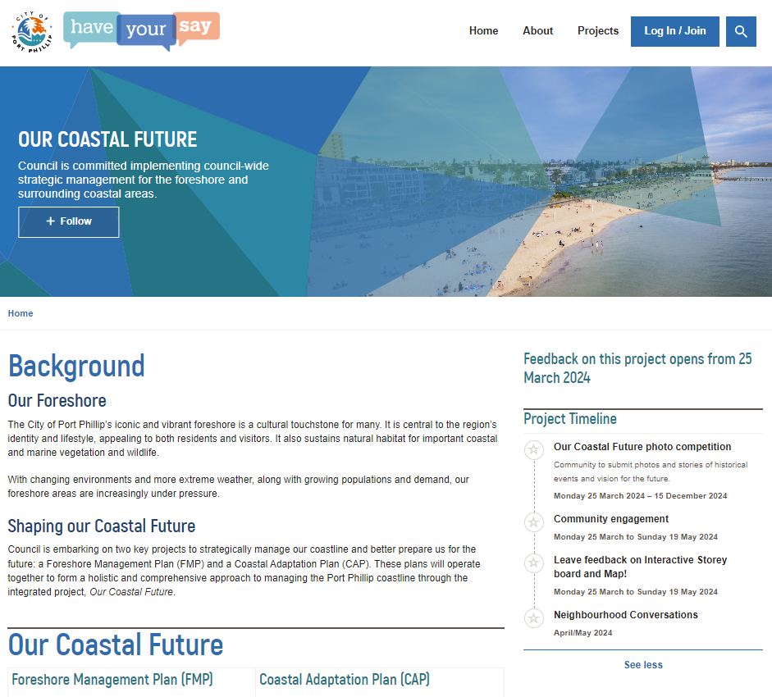

**On our page you can:**

* **Learn more** about the project, coastal hazards and our coastal communities
* **Have your say** and complete the online survey on what you love about the coast and any concerns or challenges
* **Sign up** so that you receive progress updates and notifications
* **Take part** in our interactive activities, such as our photo competition and interactive map.

**Ask us a question** – email our team at

[ourcoastalfuture@portphillip.vic.gov.au](mailto:ourcoastalfuture@portphillip.vic.gov.au)

|  |
| --- |
| References and useful links |
| Marine and Coastal Policy (DEECA 2020) |
| [Marine and Coastal Strategy (DEECA, 2022)](https://www.marineandcoasts.vic.gov.au/marine-coastal-management/marine-and-coastal-strategy) |
| [Victoria’s Resilient Coast – Adapting for 2100+](https://www.marineandcoasts.vic.gov.au/marine-coastal-management/victorias-resilient-coast-adapting-for-2100)  [Victoria's Resilient Coast Guidelines (VRC Guidelines)](https://www.marineandcoasts.vic.gov.au/__data/assets/pdf_file/0022/662503/Victorias-Resilient-Coast-Guidelines-.pdf)  [Coastal and Marine Management Plan guidelines](chrome-extension://efaidnbmnnnibpcajpcglclefindmkaj/https:/www.marineandcoasts.vic.gov.au/__data/assets/pdf_file/0033/683196/Coastal-and-Marine-Management-Plan-Guidelines.pdf) |
| [Victoria's Marine and Coastal Council (VMaCC)](https://www.marineandcoastalcouncil.vic.gov.au/) |
| CoastAdapt Glossary  [coastadapt.com.au/resource-centre](https://coastadapt.com.au/resource-centre) |
|  |