Burnett Gray play space

Engagement Summary Report

February 2026

Acknowledgement of Country
Council respectfully acknowledges the Traditional Owners of this land, the people of the Kulin Nations. We pay our respects to Elders past and present. We acknowledge and uphold their continuing relationship to this land.

Postal Address  City of Port Phillip, Private Bag 3, PO St Kilda, VIC 3182  If you require a large-print version, please contact ASSIST on 03 9209 6777.   | Language assistance  Русский (Russian): 03 9679 9813  Polski (Polish): 03 9679 9812  Ελληνικά (Greek): 03 9679 9811  廣東話 (Cantonese): 03 9679 9810  普通話 (Mandarin): 03 9679 9858  Italiano (Italian): 03 9679 9814  For other languages not listed, please phone 03 9679 9814.

If you are deaf or have a hearing or a speech impairment, you can phone us through the National Relay Service (NRS):
- TTY users dial 133677, then ask for 03 9209 6777
- Speak and listen users phone 1300 555 727, then ask for 03 9209 6777
For more information - accesshub.gov.au

Contents

Table of Contents
Introduction 4
Project background 4
What we did 7
Who we heard from 10
What we heard 14
Next steps 22

Introduction

Project background
We are planning upgrades to the Burnett Gray Gardens play space to make it an even better place for play, relaxation and connection. The aim of this project is to improve the play space and surrounding open space by creating more opportunities for fun, adding shade, and ensuring easy access for everyone. While enhancing these features, we also want to maintain the park’s special character and the qualities the community already values.

What we set out to achieve
Through this engagement, we set out to understand what matters most to the community when it comes to the future design of the play space. We wanted to learn which features - such as playground equipment, nature‑play elements, colours, greening or seating - are most important to you. This feedback will help shape the design and make sure it responds to local needs, supports a range of play opportunities, and creates a welcoming and accessible space for everyone.

About this report
This report is a record of the planned engagement process we undertook. It outlines the methodology, presents participant demographics (where available), and summarises the feedback received through the process.

Before reading this report
The following should be considered in reading this report:
- This project happened alongside another project - Ripponlea Place Plan (called publicly ‘Help shape public places and spaces in Ripponlea’). A separate Engagement Summary Report is available for this project.
- The information in this report is based on qualitative research and does not necessarily reflect the views of a statistically representative sample of the community.
- Participants attending the community events were self-selecting. As such, the key themes of conversations at these events may reflect only a limited proportion of the local community.
- Council strives to include diverse voices in our engagement activities. We acknowledge, however, that some people are likely to have experienced barriers to participation in the activities that are outlined in this report – including people with disability, multicultural communities, older people, Aboriginal and Torres Strait Islander people and others.
- The word ‘participants’ is used to describe the total group of community members and stakeholders who contributed to this engagement process. The terms ‘respondents’ is used to talk about the sub-group of total participants who responded to a specific question or engagement activity.
- The information and views presented in this report are a summary of the feedback heard from the engagement activities. As such, some information maybe factually incorrect, unfeasible or outside of the scope of this project.
- The report summarises the feedback from engagement activities. While every effort is made to include the full breadth of feedback provided, not all comments, views or advice are shown in the findings of this report. Where appropriate, a mix of quotes, themes and metrics are used to convey community feedback.
- We acknowledge that, while efforts are taken to manage duplication, there is potential for double counting where participants have attended multiple events, and/or completed online activities via the Have Your Say website.
- Detailed participant demographic data was not collected or mandatory across all engagement events and activities. This may affect the weight of findings about community participation. Where appropriate, response numbers for each question are displayed or acknowledged.
- This report focuses on the communication and engagement activities delivered by Council in a planned engagement process. It does not necessarily include events, meetings, surveys, petitions, or communications organised by the community or third parties.
- This report was developed through a combination of human analysis and artificial intelligence (AI). Human analysts conducted the primary data analysis. AI tools were used to process and analyse large datasets, identify trends, and generate some preliminary findings. Any AI-generated findings were subsequently reviewed, validated, and interpreted by human analysts with expertise in the subject matter. The final conclusions and interpretations presented in this report represent the considered judgment of these human analysts, even where AI contributed to the data processing.

Acknowledgement and thanks
We would like to acknowledge and thank the community members who contributed feedback.

What we did
Between Monday, 17 November and Friday, 19 December 2025, we let the community know about this project alongside another project - Ripponlea Place Plan (called publicly ‘Help shape public places and spaces in Ripponlea’) - and collected feedback through a mix of engagement activities.
To increase awareness of the engagement process, we did the following:
 | Posters in the area x 8 | Posters about the engagement process and the opportunity to provide feedback were placed around Glen Eira Road.
 | Social media posts x2 | Social media posts were used to promote engagement via the City of Port Phillip’s social media accounts:  - Facebook post 4600 views; 107 reactions, link clicks 27.  - Instagram story 3500 views, 71 likes.
 | Information flyers x 1694 | Flyers notifying the community about the project and the opportunity to give feedback about the plan
 | Newsletters x 2 | Project information and an invitation to engage was included in two newsletters during the engagement period: the Community News and DiverCity newsletters with a reach of 4,315.
 | ‘Have your say’ website | Council’s dedicated engagement website, ‘Have your say’ included a page for this project, with information on the process, a timeline, contact details, and opportunities to engage with a reach of 904.

Engagement activities
To collect feedback from the community we did the following activities:
  Survey x31  (Available online) | This survey collected demographic details about participants, and asked for community feedback on:  - Priorities for play equipment.
  Pop-ups x3 | We conducted 3 pop-ups along Ripponlea Village, Burnett Gray Gardens and Elwood Market during the engagement period where community members could ask questions to council officers and answers three questions about the project.
  School workshops x2 | We ran an interactive workshop with Ripponlea Primary School and Sholem Aleichem students to inform improvements to Ripponlea Village. Students took part in a craft activity of their preferred play equipment for the playground space. Students also played charades where they acted out their favourite style of play. Materials and observations from all activities were recorded to inform future design outcomes.
  Email and uploaded feedback x5 | Community members or groups were able to send written submissions to the project team via email. This included long-form responses. We were able to receive and review these alongside the engagement process.

Participation

Participation by engagement activity
Approximately 100 community members participated in this engagement process. This was spread across the engagement activities below:
Activity | Number of participants | Insights
Survey (online) | 31 | - People identifying as female (women or girls) aged 35 to 49 years were the most likely to complete the survey.
Pop-ups | 21 | - We conducted three pop-ups along Ripponlea Village, Burnett Gray Gardens and Elwood Market during the engagement period where community members could ask questions to council officers and answers three questions about the project.
School workshops | 110 | - We ran an interactive workshop with Ripponlea Primary School and Sholem Aleichem students to inform improvements to Ripponlea Village and Burnett Gray Gardens.
‘Have your say’ website | 904  visitors | - Most visitors came from direct link (53%).  - 31% of visitors were from social media.  - 11% of visitors were from search engine.

Who we heard from

Participant demographics
When we asked for community feedback, we also asked for some demographic information from participants. This helps us understand which parts of the community we have heard from.

Suburb
15 participants told us which suburb they live in, with an additional five participants living in suburbs outside of Port Phillip. The most common suburb was Ripponlea, representing 61.3% (19 participants) of all responses. Balaclava (22.6%, 7 responses), and Elwood (6.5%, 2 participants).

Age
In total, 31 participants told us their age group. The higher proportion of ages 35 to 49 followed by 60 to 69.

Gender
In total, 31 participants provided an answer to this question 74% (23 people) identified as ‘female’, and 26% (8 people) identified as ‘male’.

Diversity statements
We asked participants if they identified with any of a range of statements, to help us understand if feedback had been collected from different groups within community.
- ‘None of these apply to me’ (25 participants)
- ‘I identify as LGBTIQA+’ (2 participants)
- ‘I am from a non-English-speaking background’ (2 participants)
- ‘I prefer not to say’ (2 participants)

Household
We asked participants if they identified with any of a range of statements, to help us understand if feedback had been collected from different groups within community.
- ‘Couple with children’ (20 participants)
- ‘Couple without children’ (3 participants)
- ‘Group household’ (2 participants)
- ‘One-person household’ (2 participants)

Age of children
For participants with children, we asked how old their children are, to help us understand if feedback had been collected from different groups within community.
- ‘Infant / toddler age (aged 0-3)’ (14 participants)
- ‘Pre-school age (aged 4-5)’ (9 participants)
- ‘Primary school age (aged 6-12)’ (13 participants)
- ‘Secondary school age (aged 13)’ (4 participants)
- ‘Adult age (aged 18)’ (3 participants)

What we heard

From the survey
How do they like to spend time at play spaces best?

Survey participants were asked how their children play at playgrounds. Most respondents said swinging (71%, 22 people) followed by climbing (61.3%, 19 people) and nature play (25.8%, 8 people).

What do you/they love about the current play space, and why?

Of the 30 comments the most common response (13 comments) was ‘natural balance/climbing’ elements like logs, stepping stones, rocks, beams, and ropes to support active and “risky” play.
‘Balancing logs and stepping stones would be great’
‘Logs to step on’
‘Plant Native Trees and Habitats’ was the second most common them (7 comments). People want more nature-based planting especially native vegetation, shade trees, sensory planting, and habitats.

‘Would be nice to see native vegetation used in this area’
‘Native plantings that promote sensory play… shade trees’

‘Add Water Play Features’ was third most common with six comments. Many respondents want water-based nature play like a creek, pumps, or water features.

‘We love the water play creek at Harleston Park’
‘Water pumps’

Support the Nature Play Concept came fourth (5 comments). Some responses support the nature direction generally.

‘I like the nature play elements the best of the plan’
‘A mix of rocks and logs to climb on’

Other comments (10 comments) included things like Create Hideouts & Exploration Spots, Keep Open Grass for Sport and Sand Play.

What play equipment or features would you love to see in the Burnett Gray play space design?

Of the 31 comments the most common response (13) was ‘add swings’. Many respondents want more swings (including different types) as a key feature for a broad age range.

‘Swings and 1.2 climber’
‘More swings’
‘Build Climbing Structures’ was the second most common them (12 comments). People strongly want climbing options—frames, towers, monkey bars, and challenge play for different ages.

‘Climbing frame… great play equipment examples at Elsternwick Park playground north’
‘Climbing equipment’

‘Add Slides’ ranked third with six comments. Respondents want more slides and variety (different heights/lengths) to suit younger and older children.

‘A few slides of differing lengths and heights’
‘multiple slides suitable for both younger and older children’

‘Install Fencing & Improve Safety (dogs/road/station)’ was fourth most common (6 comments). Safety is a major concern—people want fencing to keep kids contained and prevent dogs entering, particularly near the station and road edges.

‘Off leash dogs… is an issue, and would like to see improved fencing’
‘Fences to enclose the park so the kids can’t run to the station’

Other comments (14 comments) included things like Add Trampolines & Bounce Play, Add Shade & Weather Protection and Improve Accessibility & Inclusive Design.

School student feedback

Over the engagement period we visited two schools Ripponlea Primary School and Sholem Aleichem College where we engaged with approximately 110 students across multiple sessions. As part of these sessions we facilitated activities outlined below.

Charades style activity

As part of our school engagement sessions we facilitated a Charades style activity designed to understand how students most enjoy playing in a playground setting.

Each student selected one preferred play action in their head, such as climbing, swinging, nature play, sliding, running, without revealing their choice to anyone.

One by one, students came forward to act out their chosen play style silently, following traditional Charades rules.
- No talking was allowed
- Each student had a maximum of 30 seconds to perform their action
- The rest of the group attempted to guess the play method being demonstrated
This approach encouraged creativity, movement, and discussion, while giving facilitators insight into the play behaviours students value most.

Charades style activity results

Through the Charades activity, students showed us their favourite ways to play. Climbing was the most popular activity by a clear margin, followed by Nature Play, Imagination Games, and Gymnastics/Dancing. Mid-range preferences included Jumping and Swinging, while Hiding and Exploring, Spinning, and especially Ball Sports were chosen less often. Overall, students showed a strong preference for active, creative, and exploratory play.

Note formula: Participants ranked all nine ideas from 1 (most important) to 9 (least important), and we calculated each idea’s score by adding up all the ranking numbers it received. The ideas with the lowest total scores were considered the highest priorities because they were consistently ranked closer to the top by most people.

Collage Play Space Design Activity

To further understand students’ play preferences and encourage creative expression, we facilitated a collage-based design activity where students created their ideal play space. This hands‑on task allowed students to explore different types of play equipment and communicate their ideas visually.

Each student received:
- A template sheet to design their playground
- A page containing images of various play equipment
- Access to scissors, glue sticks and coloured pencils

Students were asked to:
- Write their age on the template
- Select up to four pictures of play equipment to include in their design (with the option to use fewer)
- Use a combination of cutting, pasting and drawing to show what they would like the new play space to look like

This activity gave students the freedom to blend structured options with their own imagination, often resulting in unique layouts, additional drawn features, and personalised themes.

Collage Play Space Design Activity results

In the collage activity, students showed us what kind of playground equipment they like the most. Spin/Climb equipment was chosen the most, with Swings and Bounce/Movement equipment also popular. Nature Play (like logs or balance beams) was picked a fair bit too.
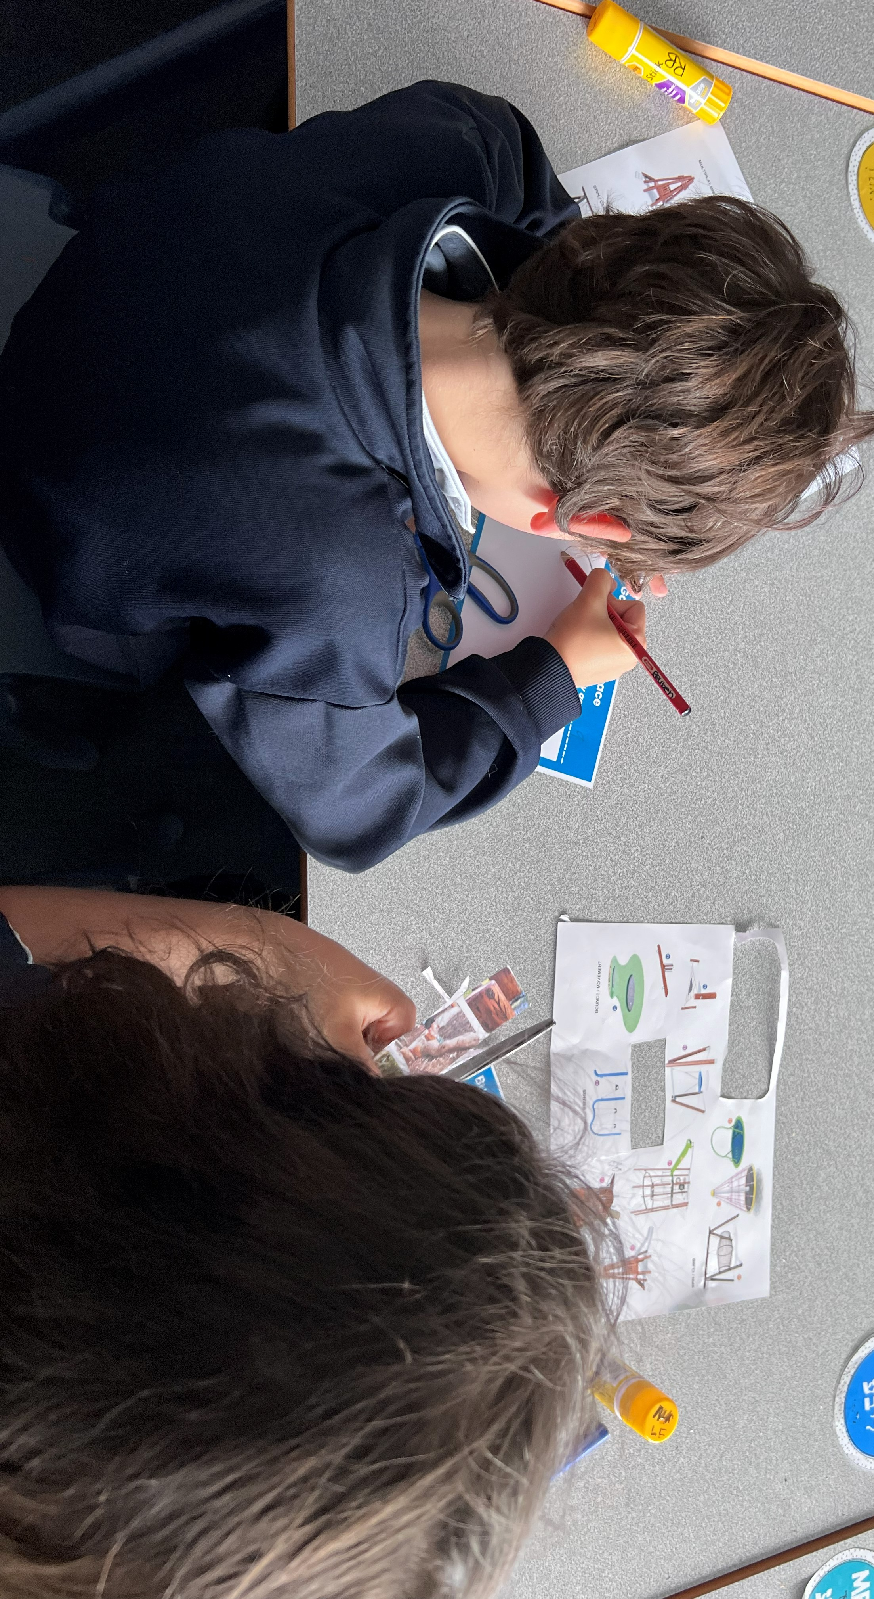

Some activities were chosen less often, like Sports equipment, and even fewer students added Monkey Bars, Flying Fox, Pond, or other features. Overall, the students clearly prefer fun, active equipment that lets them move, climb, and explore.

Note formula: Participants ranked all nine ideas from 1 (most important) to 9 (least important), and we calculated each idea’s score by adding up all the ranking numbers it received. The ideas with the lowest total scores were considered the highest priorities because they were consistently ranked closer to the top by most people.

Pop-ups
Three pop‑ups were held to collect ideas for improving Burnett Gray Gardens and together they received approximately 21 pieces of feedback from community members.
The Burnett Gray Gardens pop‑up gathered feedback from 8 people, while the Ripponlea Village pop‑up received 11 responses and an additional 2 responses were obtained from the Elwood Community Market. Although the total number of participants was small, the comments still gave helpful clues about what locals think the area needs.

The community mostly wanted the same elements included in the playspace; more shade, more places to sit, and a fully fenced playground so kids are safer and easier to watch. Feedback was also received on sightlines around the playground and train station interface with regards to the proximity of the playground to the station entrance and the commuter traffic to and from the station.

In terms of play equipment the few ideas people mentioned included swings, slides, a spinner, and a trampoline or play unit, plus some nature play like water or sand play. The community were curious on the targeted age demographic for the playground, with many stating it is currently equipped for pre-school aged children.

Overall people want the space to feel safe, comfortable, and a space for kids of different ages to enjoy.

Next steps
Thank you to everyone who contributed the engagement The findings from this round of engagement will be used to develop the final design.
We will continue to keep the community updated on the progress of the project via the dedicated project page:
https://haveyoursay.portphillip.vic.gov.au/ripponlea-place-plan

