Share your feedback on new CCTV camera locations
Survey

To ensure your feedback is considered, please ensure it is returned by Friday 4 September to:

Community Safety team
St Kilda Town Hall
99a Carlisle Street, St Kilda

Or email it to: communitysafety@portphillip.vic.gov.au

Before you tell us your feedback, take a look at the maps of proposed CCTV locations provided below.

Please be as specific as possible in your feedback, including which suburb/s and proposed camera locations you are referring to. If you would like to look in more detail at the proposed locations, visit haveyoursay.portphillip.vic.gov.au/CCTV-locations.

Balaclava precinct:
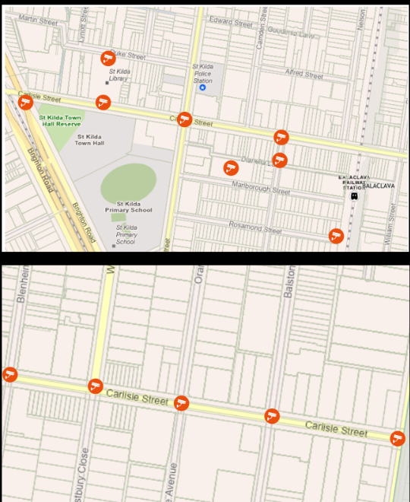

South Melbourne precinct:

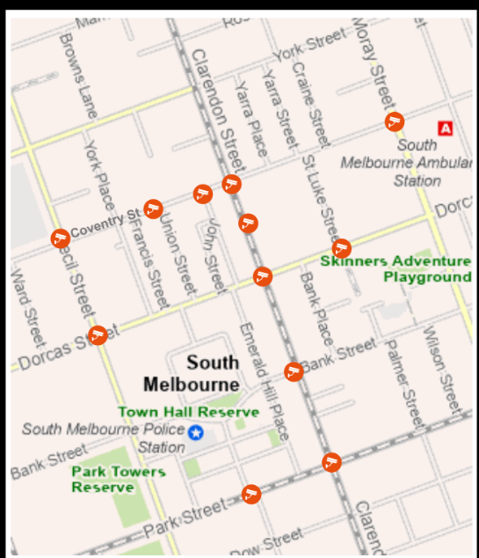

Port Melbourne Precinct:

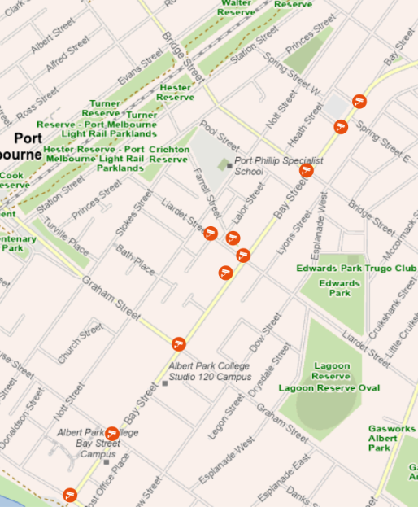

- Select what suburb/s you want to provide CCTV camera feedback for today.
Please choose one or more suburbs.
Select all that apply

Balaclava
Port Melbourne
South Melbourne
- Do you have feedback on the proposed CCTV camera locations?
Tell us your feedback below. Please be as specific as possible so we can understand which CCTV camera or location you are referring to. Where possible, include the camera name shown on the map and/or the location. This will help us accurately consider your feedback.
- Is there anything else you would like to tell us about this project?
Please share your ideas, concerns or feedback below.

About you
Please tell us a little bit about yourself so that we can understand who we're hearing from. Click here for Council's Privacy Policy to understand how your information is used.

- Are you representing a group, business or organisation? Required
Select one answer only

No, I am representing myself
Yes (Please specify). You can finish the survey here.

- Which gender do you identify with? Required
Select one answer only
Female (woman or girl)
Male (man or boy)
Non-binary
I’d prefer not to say
I use a different term (please specify)

- What is your residential suburb? Required
Select one answer only
Albert Park
Balaclava
Elwood
Melbourne
Middle Park
Port Melbourne
Ripponlea
South Melbourne
Southbank
St Kilda
St Kilda East
St Kilda West
Windsor
Prefer not to say
Other, please specify

- Please indicate your age group. Required
Select one answer only
5 - 11
12 - 14
15 - 17
18 - 24
25 - 34
35 - 49
50 - 59
60 - 69
70 - 84
85 and over
I'd prefer not to say
- Please tick any of the statements that apply to you. Required
Select as many as apply
Select all that apply
I am from an Aboriginal and/or Torres Strait Islander background
I speak a language other than English at home
I am a person with disability
I identify as LGBTIQA+
I'd prefer not to say
None of these apply to me
- Have you provided feedback on any other City of Port Phillip projects in the past 12 months? Required
Select one answer only
Yes
No
Not sure

