Domestic Animal Management Plan 2026-29

DRAFT

**Plan governance**

**Responsible Service / Department:**

City Growth and Development; Safety and Amenity

**Adoption authorised:**

**Date of adoption:**

**Date effective from:** 4 December 2025

**Content Manager folder:**

**Content Manager file:**

**Endorsed CEO or ELT member or department manager to make and approve document editorial amendments:**

General Manager City Growth and Development

Manager Safety and Amenity

**Annual desktop review date:**

2026

**Review date:**

2028

**Completion date:**

2029

**Version number:**

5

**Stakeholder review and engagement:**

Animal Management and Local Laws, Open Space Recreation and Community Resilience.

**Relevant Legislation:**

Domestic Animals Act 1994 (Victoria)

**Associated Objective:**

Liveable Port Phillip

**Associated instruments:**

Community Amenity Local Law 2023

Dog Off-Leash Guidelines 2025

Public Space Strategy 2022-2032

Council Plan 2021-2031

**Supersedes:**

Domestic Animal Management Plan 2022-2025

**Acknowledgement**

Council respectfully acknowledges the Traditional Owners and Custodians of the Kulin Nation. We acknowledge their legacy and spiritual connection to the land and waterways across the City of Port Phillip and pay our heartfelt respect to their Elders, past, present, and future.

**Mayor’s message**

To be included in final draft.

Contents

Introduction 7

Purpose 7

Statutory requirement 7

Strategic alignment 8

Process 8

Our consultation 9

How we engaged 9

Who we heard from 9

What the community told us 9

Port Phillip at a glance 10

Community 10

Dogs and cats in port phillip 10

The future 10

Local laws, orders and other domestic animal controls 12

Keeping dogs and cats 12

Animal housing 12

Animal litter 12

Dogs on / Off leash 12

Commercial dog walkers 12

Desexing cats 12

Cat curfew 12

Current programs and activities 13

Promote and encourage responsible pet ownership 15

What we currently do 15

Our Plan 2026-29 16

Reducing overpopulation and euthanasia 17

What we currently do 18

Our Plan 2026-29 18

Registration and identification 19

What we currently do 19

Our Plan 2026-29 20

Nuisance 21

What we currently do 22

Our Plan 2026-29 23

Dog attacks 24

Context and current situation 24

What we currently do 24

Our Plan 2026-29 25

Dangerous, menacing and restricted breed dogs 26

What we currently do 26

Our Plan 2026-29 26

Domestic animal businesses 27

What we currently do 27

Our Plan 2026-29 27

Training of authorised officers 29

What we currently do 29

Our Plan 2026-29 29

Other matters 30

Our Plan 2026-29 30

Review and evaluation 31

Performance monitoring and evaluation process 31

## Introduction

### Purpose

The DAMP is a four-year Plan that provides a strategic approach to promoting and encouraging responsible pet ownership, the welfare of dogs and cats and the protection of the community and environment from nuisance dogs and cats.

This document explains how Council currently manages programs and sets out actions to improve and grow the ways in which Council delivers domestic animal management programs.

These objectives and guidelines aim to create a place where pets and the community can live together, without adversely impacting on the environment or community amenity.

### Statutory requirement

Under Section 68A of the *Domestic Animals Act 1994* (Act), every Victorian local government must prepare a Plan every four years, outlining how it will manage dogs and cats within its municipal boundaries.

Every Council must review its Plan annually and publish an evaluation of its implementation in its Annual Report. The Plan must:

* Set out a method for evaluating whether animal control services provided by Council are adequate to give effect to the requirements of the Act and regulations.
* Outline programs for the training of authorised officers.
* Outline programs, services and strategies to:
* Promote and encourage responsible ownership of dogs and cats.
* Ensure that people comply with the Act, regulations and legislation.
* Minimise risk of attacks by dogs on people and animals.
* Address over-population and high euthanasia rates for dogs and cats.
* Encourage registration and identification of dogs and cats.
* Minimise potential for dogs and cats to create a nuisance.
* Effectively identify all dangerous, menacing and restricted breed dogs and ensure that these dogs are kept in compliance with Act and regulations.
* Provide for review of existing orders and Local Laws made under the Act.
* Provide for review of any other matters related to the management of dogs and cats.

### Strategic alignment

Supporting pet owners to care for their pets and be responsible pet owners enhances the safety and wellbeing of the wider community. This is an endorsed major initiative in the City of Port Phillip Council Plan 2021-31 which also incorporates the Health and Wellbeing Plan.

The DAMP aligns with the City of Port Phillip Dog Off Leash Strategic Guideline 2024. This document outlines Council’s position on the provision, distribution and management of dog facilities in public open spaces. It is used to guide decisions on the planning for all dog off-leash areas and parks.

### Process

This new DAMP builds on the current DAMP that has successfully guided the delivery of animal management services across Port Phillip.

It was developed in consultation with Council’s Animal Management Team, and informed by community consultation, research and benchmarking. It seeks to balance community and stakeholder needs, whilst ensuring compliance with requirements of the Act.

## Our consultation

### How we engaged

To be completed after consultation on draft.

### Who we heard from

To be completed after consultation on draft.

### What the community told us

To be completed after consultation on draft.

## Port Phillip at a glance

### Community

Port Phillip is located between 2 and 8km from the Melbourne CBD and covers an area of 21km2. It has over 178 hectares of public open space available, including 11km of foreshore, 10 hectares of indigenous vegetation, 24 significant parks, 70 neighbourhood parks, 54 playgrounds and 15 sporting ovals. Open spaces are highly valued and highly utilised by pet owners and non-pet owners alike. 91% of the estimated 109,515[1] people live in medium to high density housing.

Port Phillip is home to people from over 163 birthplaces, with our residents speaking 114 different languages. While there is no typical resident, about three in five are aged 18 to 49 years. It is likely our community will continue to feature many people aged 18 to 49 years; however, the largest growth is expected to be in those aged over 60, suggesting many residents will retire and age within our community. Forty-one per cent of households belong to singles and there is a high proportion of renters.

### Dogs and cats in port phillip

The following table provides a snapshot of dogs and cats across Port Phillip. Further details are provided in the body of the DAMP.

|  |  |  |  |
| --- | --- | --- | --- |
| **Key Data** | **2016-17** | **2020-21** | **2023-24** |
| Population | 109,523 | 103,438 | 109,515 |
| Complaints or requests annually | 3,532 | 2,643 | 3,626 |
| Registered dogs | 6,772 | 7,901 | 8,254 |
| Registered declared dogs  (dangerous, menacing or restricted breed) | 0 | 1 | 4 |
| Dog attack or rush | 100 | 108 | 160 |
| Registered cats | 2,906 | 3,659 | 4,031 |
| Registered Domestic Animal Businesses | 12 | 6 | 9 |
| Keeping of animals / excess animals permits issued | 86 | 49 | 8 |
| Number of infringements | 121 | 54 | 143 |
| Number of successful prosecutions | 2 | 33 | 13 |
| Dogs impounded | 120 | 69 | 91 |
| Cats impounded | 159 | 90 | 134 |

### The future

Port Phillip’s population is forecast to grow by more than 60,000 residents by 2041. Increased resident population has a flow on effect on the number of pets in Port Phillip. This impacts the number of animal registrations, dogs being walked in public open spaces, cats needing to be contained to properties, dogs potentially barking, and much more.

Our parks and waterfront will need to be welcoming to all members of the community, including pet owners, and cater for various and increased use as they become residents’ ‘backyards’.

This includes responding to an increased number of domestic animals residing in the municipality and living in apartments, as well as providing a balanced approach to ensuring that our limited open spaces are well managed and shared between dog owners and non-dog owners.

Liveable environments, and sharing our lives with pets, create a foundation for good health and wellbeing for everyone. This includes well-designed places that have safe access to quality open spaces, amenities and services.

Although mandatory cat desexing and night-time curfew regulations are already in place, unowned and feral cats will continue to be both a nuisance for the community and an environmental problem without adequate management. Council will focus on continued promotion of responsible cat ownership.

## Local laws, orders and other domestic animal controls

In addition to The Act, Council enforces the provisions of the City of Port Phillip Community Amenity Local Law 2023 and Council Orders which relate to animal management as outlined below.

### Keeping dogs and cats

The maximum number of dogs and cats allowed to be kept in houses is three dogs and two cats. However, if you live in a unit, townhouse or flat, the maximum number allowed to be kept is two dogs and two cats.

### Animal housing

Owners are required to ensure that animal housing is appropriate for the number and type of animals, minimises noise and other nuisances, and does not adversely impact the amenity of the area.

### Animal litter

Pet owners are required to both carry a bag and remove their animals’ excrement when left in a public place.

### Dogs on / off leash

Unless designated otherwise, all public areas across Port Phillip are on-leash. There are a number of parks and beaches where dogs are permitted off leash. Some areas change at different times of the day or the year. There are also some areas where dogs are prohibited.

Dogs must also be on lead within twenty metres of an organised sporting event or training; and are prohibited within five metres of any children’s playground, public barbeque or exercise equipment.

### Commercial dog walkers

A person must not, without a permit, walk, exercise or otherwise be in control of seven or more dogs on Council land.

### Desexing cats

Newly registered cats over the age of three months must be desexed. Cats exempt from desexing include:

* Cats that have been registered with Council before 14 April 2022.
* The owner is a registered breeder and meets all the requirements under the legislation.
* The owner is a current member of an applicable organisation and the animal is registered with that organisation.
* The owner of the cat has written veterinary advice that the health of that cat would be impacted if desexed.

### Cat curfew

A Council Order is in place where cats must be confined to the owner’s premises from 9pm to 6am.

## Current programs and activities

Our current domestic animal management programs and activities.

| **Program** | **Service Level to Community** |
| --- | --- |
| Identification and Registration | * Annual registration renewal notices and follow up process. * A free initial registration incentive program for owners who register their microchipped pets within 4 weeks of taking ownership. * Refund for owners who paid full fee but have their dog or cat desexed within the first 6 months of registration. * Free transfer of registration when moving registered animals from other Victorian municipalities. * Lifetime registration tags. * Online registration forms and system for both renewals and new registrations. * Periodic cross reference of Central Animal Records (CAR) database with Council’s animal registration database. * CAR request to register letter sent to all residents who microchip a new pet. * SMS registration reminders. * Routine registration checks during patrols. |
| Dog attack (against people or animals) | * Immediate response. |
| Dangerous dog complaints | * Response within 24 hours. |
| Animal Nuisance Complaints (including barking dogs) | * Response within 24 hours. * Online help information. * Barking Dog Management Kit. * Online system for lodging complaints. |
| Patrols | * Routine patrols of parks and foreshore areas. * Proactive patrols in focused areas as required. * Extended patrols during peak / summer periods - with particular focus on foreshore areas. * Partnership with Summer Amenity Team to provide presence from 6.30am to 9.00pm. Extends to 11pm on New Year’s Eve. * Recording of all patrols in online system and collection of data to determine where resources are focused, and problem areas |
| Pound Facilities  Lost Dogs Home  2 Gracie Street  North Melbourne | * Lost Dogs Home is open to the public from 10.00am to 6.00pm, Monday to Friday and 9.00am to 12.30pm weekends (closed Christmas Day and Good Friday). * Online ‘lost dog’ and ‘lost cat’ search facility. * Community and animal welfare-based outcomes wherever possible –reuniting animals with owners as first priority. |
| Education and Promotion of Responsible Pet Ownership | Communication plan in place, including a range of activities across the year.   * Regular social media campaigns. * ‘Pets of Port Phillip’ flyer in registration renewal notices. * Registration packs for all new registrations. * Barking Dog Management Guide. * Pet registration guide * Online information on responsible cat and dog ownership through Council website * Dog Attack Reporting and Prevention Guide. * Promotion of ‘Safe Cats, Safe Wildlife’ campaign * Website information. |
| After hours services (Call 8290 1333) | * 24/7 emergency after hours service. * On-call Council Officer. |
| Animal welfare / cruelty matters | * ASAP, but no less than same day response. * Online system for lodging complaints. * Our Officers are not authorised under POCTAA (Protection of Cruelty to Animals Act) and as such we liaise with and report animal welfare / cruelty matters to the RSPCA for their investigation and action. |
| Wandering cat complaints | * Cat traps are available for the public to utilise, to confine nuisance, unowned or feral cats. * Strict protocols are in place governing the use of these traps to ensure that the welfare of the confined cats is protected. * Online system for lodging complaints. |
| Domestic animal business inspections | * Annual inspections in accordance with Act legislation. * Issue annual registration certificates. * Respond to and investigate complaints. * Actively seek and identify illegal domestic animal businesses and prosecute where appropriate. |
| Declared Dogs (dangerous / menacing or restricted breed) | * Annual inspections are undertaken in accordance with the Act legislation. |
| Prosecutions | * Council Officers prosecute breaches of the Act. |
| Dogs on / off-leash | * Orders are in place restricting dogs off-leash to designated areas and times in certain parks and foreshore areas. * Orders are in place prohibiting dogs in certain parks and foreshore areas. * Dogs must be on-leash within twenty metres of an organised sporting event or training. * Dogs are prohibited within five metres of a children’s playground, public barbeque or exercise equipment area. |

## Promote and encourage responsible pet ownership

Healthy and happy pets can bring life and vibrancy to a family, and community. They provide companionship and improve well-being through supporting physical exercise and mental wellness. These benefits rely on responsible pet ownership. Council promotes an owner onus approach to responsible ownership of dogs and cats through a range of communication and education initiatives.

We understand the increasing demand for council services to be delivered online, and for engagement through social media and other digital means. However, we also acknowledge the power behind face-to-face interactions and that successful education and communication campaigns require a multi channelled approach.

Responsible pet ownership includes animals being trained and exercised, microchipped, desexed and registered with owners who comply with regulations and signage.

Communication and education campaigns with clear and simple messaging are delivered to support responsible pet ownership, as well as increasing awareness of cat curfew requirements and dog off-leash and dog prohibited areas. Council manages signage for dog-leash regulations in public places through the Strategic Dog Off-Leash Guideline 2024.

### What we currently do

* Communication plan in place, including a range of activities across the year:
* Regular social media campaigns.
* **‘**Pets of Port Phillip’ flyer in registration renewal notices.
* Registration packs for all new registrations.
* Barking Dog Management Guide.
* Dog Attack Reporting and Prevention Guide (online or via ASSIST).
* Pet registration guide provided to apartment buildings, vets and in mailed correspondence.
* Website information.
* Use of QR codes on renewal notices as an information source.
* Proactive patrols of parks and foreshore areas.
* Extended patrols during peak / summer periods - with particular focus on foreshore areas.
* Partnership with Summer Amenity Team to provide additional support during peak times.
* Signage in parks and foreshore areas detailing dog controls.
* Education initiatives aimed at improving community awareness and reducing dog attacks.
* Information provided to promote dog off leash and dog prohibited areas including maps.
* Promotion of ‘Safe Cats, Safe Wildlife’ campaign to educate owners on their pet’s impact on wildlife.

### Our Plan 2026-29

|  |  |  |  |
| --- | --- | --- | --- |
| **Objective 1:**  Promote responsible pet ownership through strong and simple messages, delivered through multiple channels. | | | |
| **1** | **Activity** | **When** | **How we will measure** |
| 1.1 | Review and update communications and education plan targeted towards promoting responsible pet ownership. | Ongoing | Delivery of communications and education materials through multiple channels. |
| 1.2 | Advocate to primary schools to participate in free Animal Welfare Victoria dog behaviour education program. | Annual | All Port Phillip primary schools contacted and encouraged to participate. |
| 1.3 | Develop a new Council-specific pet ownership guide that combines all relevant information. | 2026 | New pet ownership guide is available for new registrations and adoptions. |
| 1.4 | Investigate the opportunity to develop a ‘Pets of Port Phillip’ portal and newsletter. | 2027 | Investigation completed with recommendations about portal and newsletter. |
| 1.5 | Investigate opportunities for educational activities at community events (e.g. annual Pet Fest event). | Ongoing | Work together with community associations and organisations to support and attend 4 events per year. |

|  |  |  |  |
| --- | --- | --- | --- |
| **Objective 2**  Promote and encourage responsible cat ownership | | | |
| **2** | **Activity** | **When** | **How we will measure** |
| 2.1 | Review and update communications and education resources that explain the welfare benefits of cat containment and how it can be achieved. | 2026 | Resources reviewed and updated. |
| 2.2 | Investigate ways Council can support the community to build or buy cat enclosures. | 2027 | Council to investigate grant opportunities and apply, or support organisations to apply, where appropriate. |
| 2.3 | Change cat curfew times to ’sunset to sunrise', in an effort to further reduce predation. Current cat curfew is 9pm to 6am. | 2027 | Council Order implemented. |

## Reducing overpopulation and euthanasia

Impoundments occur when pets escape from their properties or are dumped or surrendered by owners. Council’s priority is to achieve positive community and animal welfare outcomes and return pets to owners from the field wherever possible, without taking them to the Lost Dogs’ Home animal shelter. Council has a contract with the Lost Dogs’ Home to collect uncontained dogs and cats and assist them in being returned to their owner or where this is not possible - to be rehomed.

Dog and cat impoundments especially litters of cats have increased since the last DAMP was developed. This is likely a reflection of an increased number of surrendered animals – partially due to unwanted COVID ‘pet purchases’ in 2020-21 and increased cost of living pressures.

The Lost Dogs’ Home’s goal is to reunite healthy and treatable animals with their owners or adopt them into new homes. They rehome and reunite the majority of dogs and cats that come into their care. Animals are only euthanised as a last resort. “If the health condition is chronic and pain cannot be alleviated or quality of life is acutely impeded, it is considered humane to relieve an animals’ suffering with compassionate euthanasia.”[2]

|  |  |  |  |
| --- | --- | --- | --- |
| **Impoundments** | **2016-17** | **2020-21** | **2023-24** |
| Dogs impounded | **111 (1 surrendered)** | **69 (3 surrendered)** | **91 (21 surrendered)** |
| Dogs returned to owner | 106 (95.5%) | 63 (91.3%) | 45 |
| Dogs rehomed | 3 (2.7%) | 2 (2.9%) | 19 |
| Dogs euthanised  *Dogs being assessed at time of report* | 2 (1.8%) | 4 (5.8%) | 18  *9* |
| Cats impounded | **132 (16 surrendered)** | **90 (2 surrendered)** | **134 (34 surrendered)** |
| Cats returned to owner | 27 (20.5%) | 41 (45.5%) | 39 |
| Cats rehoused | 28 (21.2%) | 28 (31.1%) | 55 |
| Cats euthanised  *Cats being assessed at time of report* | 77 (58.3%) | 26 (28.9%) | 36  *4* |

It is Council’s aim to reduce the euthanasia rates and overpopulation levels by working with the community to increase the number of desexed, microchipped and registered animals in the municipality, with a particular emphasis on cats.

'The Lost Dogs' Home has introduced the Home Together program, which provides support to pet owners seeking alternatives to surrendering their pet. In partnership with the Lost Dogs' Home, surrendering owners are now offered the opportunity to complete a thorough questionnaire to determine any other options to that their pet is appropriately rehomed.

Council does not register pets that are not microchipped and ensures animals are registered prior to releasing them once impounded. When Council becomes aware of an unregistered cat or dog (through field patrols, owner contact to Council etc), follow up is conducted and assistance provided to ensure the pet gets registered.

### What we currently do

* Council contracts its animal collection and pound services to The Lost Dogs’ Home which is open to the public every day (except Christmas Day and Good Friday).
* Online ‘lost dog’ and ‘lost cat’ search facility through the Lost Dogs Home.
* Promotion of pets available for adoption through the Lost Dogs Home.
* Partner with Lost Dogs Home ‘Home Together’ program to provide support to owners to keep their pets and minimise surrenders; and facilitate the rehoming of pets.
* Council-loaned cat trap system to confine and impound nuisance cats.
* Liaise with and report animal welfare / cruelty matters to the RSPCA for action.
* Enforce Local Law provisions governing the number of animals that can be kept on a property without a permit.
* Enforce Local Law provisions governing the responsible breeding of dogs and cats.
* Enforce Council orders governing:
  + Mandatory desexing of newly registered cats.
  + Requirement for all cats to be contained to owners’ premises 9pm to 6am.
* Conduct investigations in response to customer requests.
* Enforcement actions include notices to comply, official warnings, infringements and court prosecutions.

### Our Plan 2026-29

|  |  |  |  |
| --- | --- | --- | --- |
| **Objective 3**  Increase Council’s capacity to improve welfare of domestic animals. | | | |
| **3** | **Activity** | **When** | **How we will measure** |
| 3.1 | Continue to partner with the Lost Dogs’ Home to support the Home Together program which focuses on helping owners keep their pets and minimise the number of surrenders. The program supports pet owners to explore options to help hem keep their pets. | Ongoing | Reduction in surrendered animals. |
| 3.2 | Facilitate pet adoption days in partnership with the Lost Dogs’ Home to promote rehoming of pets and reduce the number of animals in the shelter. | 2026, ongoing annually | Annual adoption day held. |
| 3.3 | Investigate opportunities to reward people who adopt pets from partner shelters. | 2027 | Investigation completed.  Reward opportunities implemented. |
| 3.4 | Partner with Pets of the Homeless to help keep vulnerable people and their pets together by alleviating the burden of providing essential pet care during times of hardship. | 2026 | Partnership implemented. |

## Registration and identification

The registration and identification of dogs and cats is important in demonstrating responsible pet ownership and in caring for the welfare of animals. As well as being a legal requirement, an animal found with current registration and microchip has a much higher chance of being reunited with its owner.

All dogs and cats three months and over must be microchipped and registered with Council. Newly registered cats are also required to be desexed. Registrations must be renewed annually by 10 April.

A portion of all registration fees charged goes toward funding responsible pet ownership programs, education, supporting the safe return of pets to their owners, as well as the provision dog off leash areas. Information on ‘what pet registration fees pay for’ is available on Council’s website and is also included with animal registration renewal notices.

There has been a steady increase in registrations, showing a possible trend towards increased pet ownership. The increase in registrations can also be attributed to increased resident population and the success of previous DAMP activities which focused on increasing pet registrations in the community.

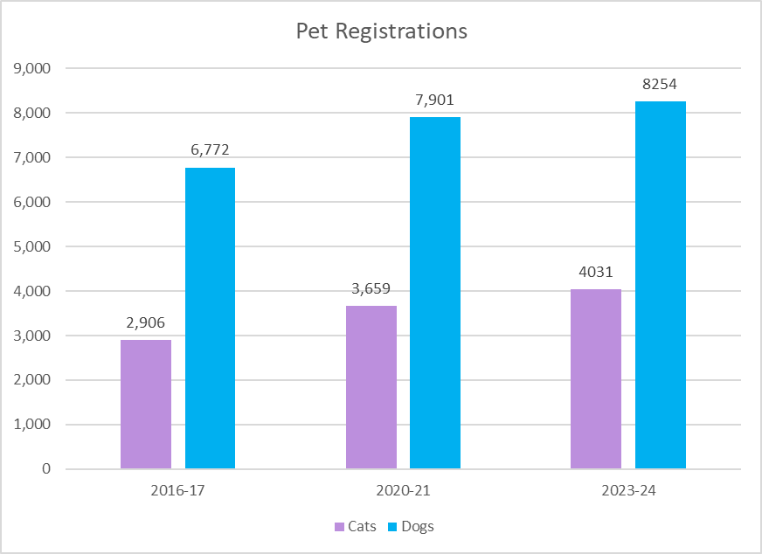

### What we currently do

* Annual registration renewal notices and follow up process.
* A free initial registration incentive program for owners who register their pets within 4 weeks of taking ownership.
* Refund for owners who paid full fee but have their dog or cat desexed within the first 6 months of the registration year.
* Free transfer of registration when moving registered animals from other Victorian municipalities.
* Lifetime registration tags.
* Online registration system for both renewals and new registrations.
* Registration packs for all new registrations.
* Periodic cross referencing of Central Animal Records (CAR) microchip database with Council’s animal registration database.
* CAR request to register letter sent to all residents who microchip a new pet.
* Council microchipping days.
* Registration door knock activities.
* Registration checks during patrols.
* Animals in the Lost Dogs’ Home must be registered prior to release.
* Proactive patrols in the community, where registration is checked and followed up for all interactions officers have with members of the public.
* Partnering with vets to ensure all reunited pets through a vet are reported to Council to ensure they are currently registered.
* Enforcement activities including notices to comply, official warnings, infringements and court prosecution.

### Our Plan 2026-29

|  |  |  |  |
| --- | --- | --- | --- |
| **Objective 4**  Animals are microchipped, desexed, registered and wearing tags. | | | |
| **4** | **Activity** | **When** | **How we will measure** |
| 4.1 | Review and simplify pet registration renewal process. | 2027 | Process efficiencies implemented |
| 4.2 | Implement staged pro rata pet registration rates. | 2027 | Additional staged pro rata pet registration rates Implemented. |
| 4.3 | Promote desexing and microchipping through the Lost Dogs’ Home mobile vet clinic. | 2026 and ongoing | Program implemented.  Number of pets desexed.  Customer feedback. |
| 4.4 | Work with local providers to develop subsidised or free desexing and microchipping programs. | 2026 and ongoing | Concession card holders can access free or subsidised microchipping and desexing. |
| 4.5 | Continue microchip audits and audits of animals adopted. | Annual | Audits complete. |
| 4.6 | Partner with shelters, vets, body corporates and breeders to promote Council registration and updating of microchip details. | Annual | Shelters, vets, body corporates and breeders contacted. |

## Nuisance

We hope to encourage people to manage their pets in a way that protects the health and welfare of the animal, maximises the companion benefits of their pet, and minimises potential for nuisance or harm to others.

In 2023-24, Animal Management Officers responded to 3,626 domestic animal requests. The most frequent animal management requests are detailed below.

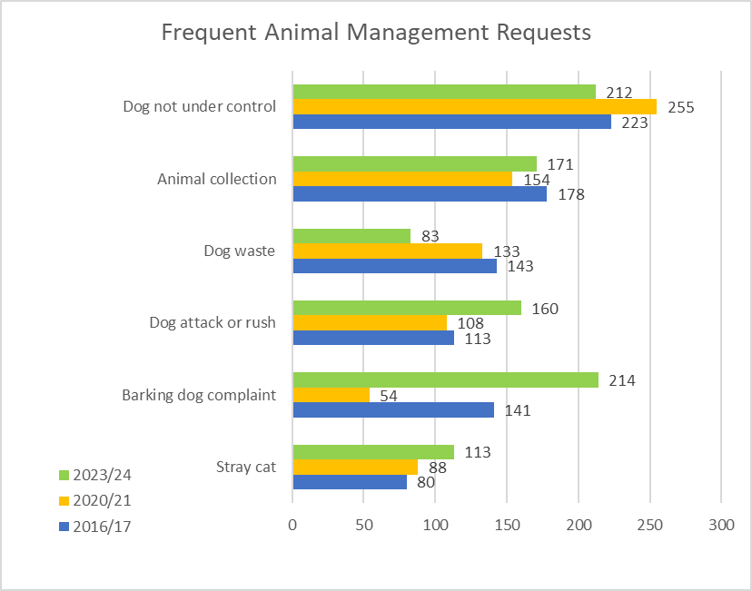

Barking dogs, dogs not under control and dog attacks are the most prevalent request types and the areas of greatest concern in the community.

Dogs not under control or on lead in areas that are required to be onlead is the other leading request. Although regular and proactive patrols are undertaken, community education and voluntary compliance are critical as only a small portion of public open space areas can be patrolled at a time.

There is an opportunity to increase community awareness and level of comfort with the dog incident reporting process, including assured anonymity.

Our Officers respond to barking dog complaints by working with the dog owner in the first instance to help them identify the root cause of the barking and suggest ways to manage this. We take an educational approach before enforcing as we find dog owners are often willing to resolve the barking issue if they become aware of its impact and are provided tools to manage it. Council has several noise recorders that can be installed, and the recordings professionally assessed to determine the severity of barking dog nuisance and provide workable information to the dog owner of where they need to make changes. When the owner is unwilling to work with us, we take enforcement action.

Dog waste that is not cleaned up by the owner is also identified as an issue. Previous suggestions to reduce the problem included the provision of dog waste bags/bins, public education and awareness, and better enforcement by Council. The suggestions to provide dog waste bags in parks and shopping strips has been considered during development, including the experiences of neighbouring Councils, and is proposed to be progressed initially as a limited 12-month trial. This is because our research indicates that it does not effectively reduce dog waste in public places, with most waste found in local streets and on nature strips. There are also concerns about the very high costs, generation of litter, theft and vandalism, and the conflict with the principle of responsible pet ownership. Further, it has been tried before in Port Phillip without success and was discontinued.

Stray cats also continue to be a concern. Domesticated cats are currently required to be confined to owners’ premises from 9pm to 6am. Unowned and feral cats will continue to be both a nuisance for the community and a negative environmental impact without adequate management into the future. Council will focus on responsible cat ownership.

### What we currently do

* Proactive patrols of parks and foreshore areas. Reactive patrols in focused areas as required.
* Extended patrols during peak / summer periods - with particular focus on foreshore areas.
* Increased patrols and attendance at events.
* Partnership with City Amenity Team to provide additional patrols.
* Partnership with the Lost Dogs’ Home to run Dogs in the Park dog training events.
* Signage in parks and foreshore areas detailing dog controls
* Signage in parks and foreshore areas notifying that there’s wildlife in the area, and to take care.
* Promotion of ‘Safe Cats, Safe Wildlife’ campaign increase education and awareness amongst pet owners on the potential impacts their cats and dogs can have upon wildlife.
* Cat traps available for the public to utilise to contain nuisance cats.
* Information provided to reduce nuisance and promote dog friendly spaces:
* Dog off leash and dog prohibited area maps
* Pets of Port Phillip flyer
* Barking dog management guide
* Dog attack reporting and prevention guide
* Online resources
* Enforce Local Law provisions governing the number of animals that can be kept on a property without a permit.
* Enforce Council orders governing:
  + Mandatory desexing of newly registered cats.
  + Requirement for all cats to be contained to owners’ premises 9pm to 6am.
* Conduct investigations in response to customer requests regarding nuisance associated with dogs and cats.
* Enforcement activities including notices to comply, official warnings, infringements and court prosecution.

### Our Plan 2026-29

|  |  |  |  |
| --- | --- | --- | --- |
| **Objective 5**  Provide a consistent approach to management of dogs in public spaces across Port Phillip. | | | |
| **5** | **Activity** | **When** | **How we will measure** |
| 5.1 | Continue to support Council’s implementation of the Dog Off-Leash Strategic Guideline 2024. | Ongoing | Work together with Open Space Council team to support implementation. |
| 5.2 | Continue to partner with local providers to promote dog training events and activities (e.g. Dogs in the Park dog training event with the Lost Dogs’ Home). | Ongoing | Facilitate four events annually.  Feedback from attendees. |

|  |  |  |  |
| --- | --- | --- | --- |
| **Objective 6**  Increase patrols, education and enforcement activities. | | | |
| **6** | **Activity** | **When** | **How we will measure** |
| 6.1 | Review patrol schedule and activities (i.e. customer requests, registrations etc) to ensure adequate resourcing for patrols, education and enforcement activities during peak periods. | 2027 | Increased patrols and officer presence. |
| 6.2 | Review and improve processes for enforcement regarding animal management including barking dog nuisance, dog attacks, dogs off leash and cat containment. | Annually | Nuisance processes revised and improved. |
| 6.3 | Continue to work with apartment buildings to help prevent nuisance by providing registration information / barking / waste / training information to their residents. | Ongoing | Reduced complaint numbers regarding dog nuisance in apartment buildings. |
| 6.4 | Review and seek to improve the way Council collects, measures and reports on domestic animal requests (including identification of ‘hotspots’). | 2027 | Review completed and any improvements implemented. |

## Dog attacks

### Context and current situation

Council continuously looks for ways to minimise dog attacks on people and animals. We do this by means of a range of proactive communication initiatives and investigation and enforcement action against offending dog owners.

There has been an increase in reports of dog attacks or rushes[3] over the last few years, some of this increase may be due to the ease of reporting through OneCouncil with a dedicated request category.

In 2023/24, Animal Management Officers investigated 160 reports of alleged dog attacks or dog rushes and Council successfully prosecuted 14 serious dog attacks and 5 dog rushes, equating to a 100% prosecution success rate.

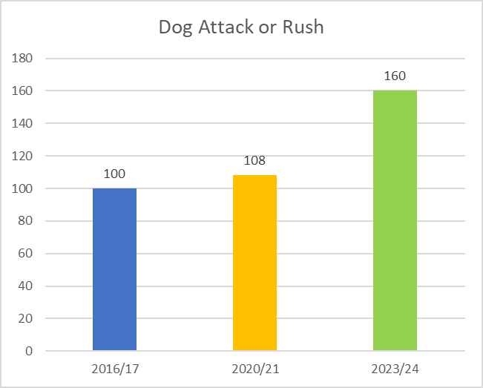

Previous community consultation identified that some people witnessed a dog-related incident but had not reported it to Council. We recognise the opportunity to increase community awareness and level of comfort with the incident reporting process, including assured anonymity.

### What we currently do

* An immediate 24/7 response to reports of dog attacks.
* Where the threat is not imminent, a response within 24 hours to reports of dangerous dogs,
* Signage in parks and foreshore areas detailing dog controls.
* Proactive patrols of parks and foreshore areas.
* Dog Attack Reporting and Prevention Guide provides improved access to information on dog regulations and Council’s investigation process.
* Information provided to reduce instances of dog aggression and promote dog friendly spaces including dog off leash and dog prohibited area maps.
* Pets of Port Phillip flyer (information on responsible pet ownership requirements in Port Phillip).
* Conduct investigations in response to customer requests regarding dog attack, rush or aggression.
* Promote effective containment, effective control and leashing, as these simple measures have a significant impact on reducing the likelihood of a dog attack. Council promotes these aspects of responsible dog ownership through educational programs, online information, community engagement from our officers in the field and educational guides.
* Enforcement activities including notices to comply, official warnings, infringements and court prosecution

### Our Plan 2026-29

|  |  |  |  |
| --- | --- | --- | --- |
| **Objective 7**  Continue to deliver best practice in management of dog attacks. | | | |
| **7** | **Activity** | **When** | **How we will measure** |
| 7.1 | Continue to develop and improve processes in the way Council manages, investigates and prosecutes dog attacks to maintain best practice. | Annually | Review completed.  Process improvements implemented where required. |
| 7.2 | Promote a strong reporting culture in the community regarding dog attacks (e.g. Council’s Dog Attack Report and Prevention Guide). | 2026 | Delivery of communications and education materials through multiple channels  (also see action 1.1). |
| 7.3 | Provide a reporting structure for vets (i.e. dog attack form) to encourage reporting. | 2026 | Reporting structure for vets developed and communicated. |
| 7.4 | Assess dogs involved in attacks to determine if a menacing or dangerous dog declaration is warranted. | Ongoing | Assessments undertaken and documented. |

## Dangerous, menacing and restricted breed dogs

Council seeks to minimise the risk to the community by administering and enforcing the provisions of the Act to identify and control dangerous, menacing and restricted breed dogs.

In 2024, Port Phillip has 4 declared dogs:

* Two declared as dangerous dogs;
* Two declared as menacing dogs; and
* Zero restricted breed dogs.

Our pet registration forms require owners to declare if their dog is a restricted breed, has been declared menacing or is a dangerous dog.

### What we currently do

* Record all declared dogs on the Victorian Declared Dog Registry and conduct annual audits of properties and leasing and housing requirements.
* Conduct investigations in response to reports of declared dogs.
* Conduct Central Animal Records microchip audits to identify potential restricted breed dogs.
* Fact sheets on website and available at Council offices.
* Enforcement activities including notices to comply, official warnings, infringements and court prosecution.

### Our Plan 2026-29

|  |  |  |  |
| --- | --- | --- | --- |
| **Objective 8**  Declared dogs in Port Phillip will be identified and appropriately managed. | | | |
| **8** | **Activity** | **When** | **How we will measure** |
| 8.1 | Conduct declared dog property inspections, ensuring compliance with the Act (e.g. security of fencing, animal housing and signage) | Annually | All declared dog property inspections undertaken annually |
| 8.2 | Continue to identify and declare dogs dangerous and menacing where required. | Ongoing | Dogs who are involved in non-compliance are declared. |

|  |  |  |  |
| --- | --- | --- | --- |
| **Objective 9**  Review Council procedures in relation to dangerous, menacing and restricted breed dogs. | | | |
| **9** | **Activity** | **When** | **How we will measure** |
| 9.1 | Review Council procedures in relation to dangerous, menacing and restricted breed dogs. | Annually | Review completed.  Process improvements implemented where required. |
| 9.2 | Review declaration process and linkage to Court outcomes to improve efficiencies and outcomes. | 2026 | Review completed.  Process improvements implemented where required. |

## Domestic animal businesses

Council works in partnership with Domestic Animal Businesses to make sure businesses are registered and complying with relevant regulations.

Port Phillip has nine registered Domestic Animal Businesses:

* Four boarding establishments / day care;
* Four dog training establishments.
* One pet shop (sells pet accessories only); and

Animal Management Officers inspect these facilities annually to ensure compliance with the relevant Code of Practice under the Act, prior to registration renewal.

Council has the ability to issue notices to comply, warnings, infringements, or to prosecute businesses that fail to comply with work plans and the relevant Code of Practice.

We actively seek to identify, investigate and prosecute any illegal Domestic Animal Businesses operating in Port Phillip.

### What we currently do

* Fact sheets on website and available at Council offices.
* Provide all Domestic Animal Businesses with relevant Code of Practice.
* Conduct annual property inspections of registered Domestic Animal Businesses for compliance with legislation.
* Conduct investigations in response to complaints to ensure compliance.
* Enforcement activities including notices to comply, official warnings, infringements and court prosecution.
* Actively seek and identify illegal domestic animal businesses and prosecute where appropriate.

### Our Plan 2026-29

|  |  |  |  |
| --- | --- | --- | --- |
| **Objective 10**  Domestic animal businesses in Port Phillip will be identified and registered. | | | |
| **10** | **Activity** | **When** | **How we will measure** |
| 10.1 | Monitor for businesses that should be registered Domestic Animal Businesses by reviewing advertisements, social media, local notice boards, etc and ensure they are compliant with legislation. | Annually | Annual monitoring completed. |

|  |  |  |  |
| --- | --- | --- | --- |
| **Objective 11**  Registered businesses are compliant with current legislation and relevant code of practice. | | | |
| **11** | **Activity** | **When** | **How we will measure** |
| 11.1 | Audit Domestic Animal Businesses in Port Phillip for compliance. | Annually | Annual audits completed. |

|  |  |  |  |
| --- | --- | --- | --- |
| **Objective 12**  Reduce community safety risks associated with walking multiple dogs at a time. | | | |
| **12** | **Activity** | **When** | **How we will measure** |
| 12.1 | Reduce the number of dogs that can be walked without a permit from six to four – to support dog walkers being able to have effective control of their animals in public places and improve community safety outcomes. | 2027 | Council Order implemented. |

## Training of authorised officers

Council’s Animal Management Team are part of the Safety and Amenity department. The Team regularly works with key partners and stakeholders including Victoria Police and aim to build relationships with these partners and the community by providing advice, support and regulatory services.

Council employs four Animal Management Officers, who during 2023-24 responded to 3,626 requests. Animal Management services are provided 8.30am to 5.00pm Monday to Friday. An emergency 24/7 after-hours telephone service operates via the Council’s main telephone number. On-call rostered Animal Management Officers responds to urgent requests. Council’s Summer Amenity program provides seasonal support and a presence in our parks and foreshore areas of an evening during Summer.

### What we currently do

Animal Management Officers are required to have a Certificate IV in Animal Control and Regulation or equally appropriate and applicable qualifications and experience.

New staff are required to complete specific training including a Council induction on policies and standard operating safety procedures and introduction to Council’s Animal Management procedures and programs. Regular team training and refresher courses and ongoing on the job training and coaching is provided.

Staff are encouraged to represent Port Phillip on industry bodies and committees where appropriate. Internal procedures and processes are regularly reviewed and updated.

The Team maintains a training register, detailing all the qualifications and training courses completed by each team member. Performance reviews and professional development plans are also undertaken annually. Team members currently receive on average 29 hours of animal management training per year.

### Our Plan 2026-29

|  |  |  |  |
| --- | --- | --- | --- |
| **Objective 13**  Ensure that Animal Management Officers have the knowledge and skills to administer their role. | | | |
| **13** | **Activity** | **When** | **How we will measure** |
| 13.1 | Support Animal Management Officers to further develop their skills as part of the annual performance development process. Including:   * Animal handling * Animal behaviour * Restricted breed identification * Customer interactions | Ongoing | Training incorporated into individual employee plans. |
| 13.2 | Partner with the Lost Dogs’ Home to provide training support and real-life animal handing experience. | 2026 and ongoing | Training partnership implemented. |
| 13.3 | Animal Management Officer attendance at conferences, industry training and networking. | Ongoing | Attendance / participation at major conferences and training. |
| 13.4 | Continue to review and update Animal Management processes. | Annually | Processes reviewed and updated. |

## Other matters

Actions in this section address The Act by providing for the review of any other matters related to the management of dogs and cats in Port Phillip

### Our Plan 2026-29

|  |  |  |  |
| --- | --- | --- | --- |
| **Objective 14**  Seek funding opportunities to support domestic animal management programs. | | | |
| **14** | **Activity** | **When** | **How we will measure** |
| 14.1 | Investigate opportunities for external funding towards the development of domestic animal management programs. | Ongoing | Grant opportunities identified and, where appropriate, applications submitted. |

|  |  |  |  |
| --- | --- | --- | --- |
| **Objective 15**  Leverage new technology to continuously improve council services. | | | |
| **15** | **Activity** | **When** | **How we will measure** |
| 15.1 | Investigate and incorporate new technologies to provide improvements in Council’s Domestic Animal Management services and communications materials. | Ongoing | Review undertaken and new technologies implemented if appropriate. |

## Review and evaluation

Section 68A(3) of The Act requires that every Council must:

1. review its Domestic Animal Management Plan annually and, if appropriate, amend the Plan;
2. provide the Secretary with a copy of the Plan and any amendments to the plan; and
3. publish an evaluation of its implementation of the Plan in its annual report.

### Performance monitoring and evaluation process

Council will monitor performance of the objectives that are detailed throughout the DAMP by reporting annually through Council’s established reporting systems, in accordance with the requirements of The Act and the Local Government Performance Reporting Framework.

A new DAMP will be completed on or before 30 October 2029.

City of Port Phillip

99a Carlisle Street

St Kilda VIC 3182

Phone: ASSIST 03 9209 6777

Email: [portphillip.vic.gov.au/contact-us](mailto:portphillip.vic.gov.au/contact-us)

Website: [portphillip.vic.gov.au](https://www.portphillip.vic.gov.au/)

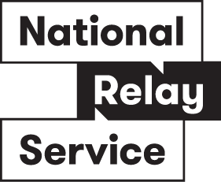

##### National Relay Service

If you are deaf or hard of hearing, you can phone us through the National Relay Service (NRS):

TTY users, dial 133677, ask for 03 9209 6777

Voice Relay users, phone 1300 555 727,

then ask for 03 9209 6777.

[relayservice.gov.au](https://www.infrastructure.gov.au/media-communications-arts/phone/services-people-disability/accesshub" \o "relayservice.gov.au)

1. ABS resident population 2023.
2. L[ost Dogs Home – Our Goals – Alleviating Suffering](https://roadmap.dogshome.com/commitment-5/alleviating-suffering#:~:text=If%20the%20health%20condition%20is,moment%20to%20say%20goodbye%20approaches.)
3. A dog attack is a bite or injury to a person, whereas a rush is where a dog has approached a person within 3 metres displaying aggressive behaviour (e.g. snarling, growling, barking, raising hackles).