Shaping Bay Street

Engagement Summary Report
October 2025

Acknowledgement of Country
Council respectfully acknowledges the Traditional Owners of this land, the people of the Kulin Nations. We pay our respects to Elders past and present. We acknowledge and uphold their continuing relationship to this land.

Postal Address  City of Port Phillip, Private Bag 3, PO St Kilda, VIC 3182  If you require a large-print version, please contact ASSIST on 03 9209 6777.   | Language assistance  Русский (Russian): 03 9679 9813  Polski (Polish): 03 9679 9812  Ελληνικά (Greek): 03 9679 9811  廣東話 (Cantonese): 03 9679 9810  普通話 (Mandarin): 03 9679 9858  Italiano (Italian): 03 9679 9814  For other languages not listed, please phone 03 9679 9814.

Contents
Introduction 4
What we set out to achieve 4
About this report 4
What we did 6
Who we heard from 10
What we heard 15
Next steps 36
Appendices 37

Introduction
Project background

Bay Street in Port Melbourne is a much-loved shopping strip in our City. We’re committed to ensuring it continues to offer a diverse and vibrant mix of businesses that our community enjoys, now and into the future.

To support this vision, we undertook a research project to gather insights that will guide potential businesses, landlords, and real estate agents on the most suitable types of tenants for Bay Street. These findings will help shape our ongoing efforts to strengthen the street’s unique character and will inform a new webpage designed to provide prospective businesses with the information they need to get started.

What we set out to achieve
Our objectives for this project were to:
- Better understand current users of the Bay Street shopping precinct
- Determine types of service and retail businesses community members think are missing or would like more of in Bay Street

About this report
The purpose of this report is to provide an overview of engagement findings, including who we heard from, what we heard and next steps in the project.
The following should be considered in reading this report:
- This report does not reflect a statistically representative community sample.
- We aim to include diverse voices but acknowledge that some groups—such as people with disability, multicultural communities, older and younger people, and Aboriginal and Torres Strait Islander peoples—may have faced participation barriers.
- ‘Participants’ refers to all community members and stakeholders involved; ‘respondents’ refers to those who answered specific questions or activities.
- The report summarises opinions, perceptions and feedback from all engagement activities. This input is not independently verified and may include inaccuracies or suggestions beyond the project's scope.
- It highlights key themes but does not replace original community feedback, which the project team may also consider.
- Not all feedback is shown. Quotes, themes and metrics are used selectively to reflect input across activities.
- Some duplication may occur where individuals took part in multiple engagement activities (i.e. online and in-person).
- Demographic data was not consistently collected (for example for emailed submissions), which may impact interpretation. Response numbers are shown where relevant.
- The report covers Council-led engagement only and excludes community or third party-run activities.
- This report was developed through a combination of human analysis and
artificial intelligence (AI). Human analysts conducted the primary data analysis. AI tools were used to process and analyse large datasets, identify trends, and generate some preliminary findings. Any AI-generated findings were subsequently reviewed, validated, and interpreted by human analysts with expertise in the subject matter. The final conclusions and interpretations presented in this report represent the considered judgment of these human analysts, even where AI contributed to the data processing.

What we did
Communications activities

Between Friday 27 June and Friday 8 August 2025, we conducted a range of communication activities to inform the community about the project. These are outlined below.
Method | Details | Reach
Postcards  | Postcards with details about the project (including a link and QR code to the engagement webpage) were distributed to nearby residents via Australia Post approx. 4 July 2025 | 2,173
Core-flute signage   | 8 x core-flute signs about the project (including a link and QR code to the engagement webpage) were installed along Bay Street. | N/A
Emails & posters   | Emails were sent to the Port Melbourne Business Association on 27 June and 15 July 2025 requesting an article in their Trader Memo asking traders to put up posters in their windows and encourage people to undertake the online survey. | Approx. 230
Newsletters | Project information and an invitation to engage was included in:  - Business e-newsletter on Friday 27 June 2025  - Help Shape our City engagement newsletter on Wednesday 16 July 2025  - Divercity newsletter on 31 July 2025 | Approx. 25,400
Social media  | Social media posts were included on Instagram and Facebook to promote the engagement process.  - 2 x Instagram posts (28 June & 5 August 2025)  - 2 x Instagram stories (3 July & 18 July 2025)  - 2 x Facebook posts (28 June & 5 August 2025) | Instagram posts + stories: 6,110  Facebook posts: 2,021
‘Have your say’ website   | Our dedicated engagement website, ‘Have your say’ included a page for this project, with information on the process, a timeline, contact details, and opportunities to engage. | 1,716 views  1,530 visits  75 followers

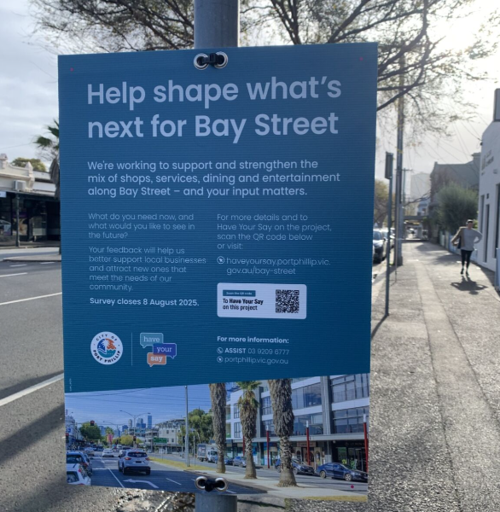
Core-flute sign on Bay Street
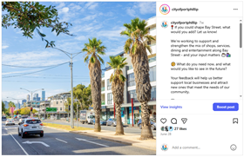
Instagram post 26 June 2025
Engagement activities

Between Friday 27 June and Friday 8 August 2025, we conducted a range of engagement activities to collect community ideas and feedback. These are outlined below.
Method | Details | Reach
Online survey   | Our survey collected information from participants about:  - How often they visit Bay Street  - What they do when they visit Bay Street  - What they have visited on Bay Street in the past 12 months  - What they think is missing or would like to see more of on Bay Street  - Other experiences of Bay Street they would like to share  We also collected a range of demographic data from those who participated.  The survey was available in hard copy on request.  View a copy of the survey at Appendix 1 (page 37). | 571
In person surveys  | We undertook in person surveys on Bay Street on Friday 4 July, and again on Saturday 12 July. Community members were invited to undertake a survey with Council staff either on a tablet or hard copy. | 33
Email submissions | We received an email submission on 1 July from a community member outlining their views and ideas for Bay Street. Note: this information has been analysed alongside the surveys collected. | 1

Who we heard from

Demographics
Our survey invited participants to share demographic details such as their suburb, gender identity, age range, household type, diversity indicators, and any previous experience engaging with us. In total, 604 people provided this information, explored below.

Suburb
We asked people what suburb they live in. Of the 604 people who responded, most people (539 / 89.2%) said Port Melbourne.

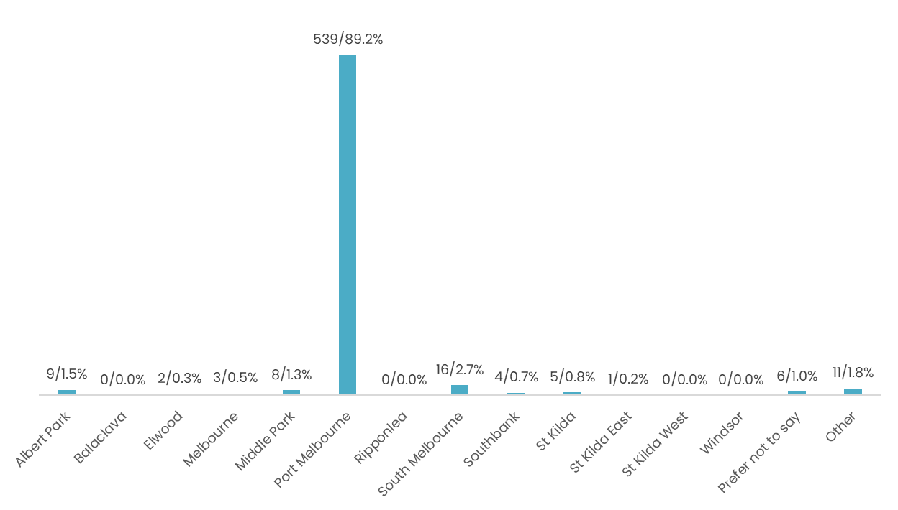

Gender

We asked people to indicate the gender with which they identify. Of the 604 people who responded, 394 people (65.2%) said they identify as female (woman or girl), 197 people (32.6%) said male (man or boy), 1 person (0.2%) said non-binary, 11 (1.8%) preferred not to say and 1 (0.2%) said they used a different term.

Age
We asked people their age range. Of the 604 people who responded, the largest group (205 people/33.9%) said they were aged 35-49. The next largest group (155 / 25.7%) said 50-59.

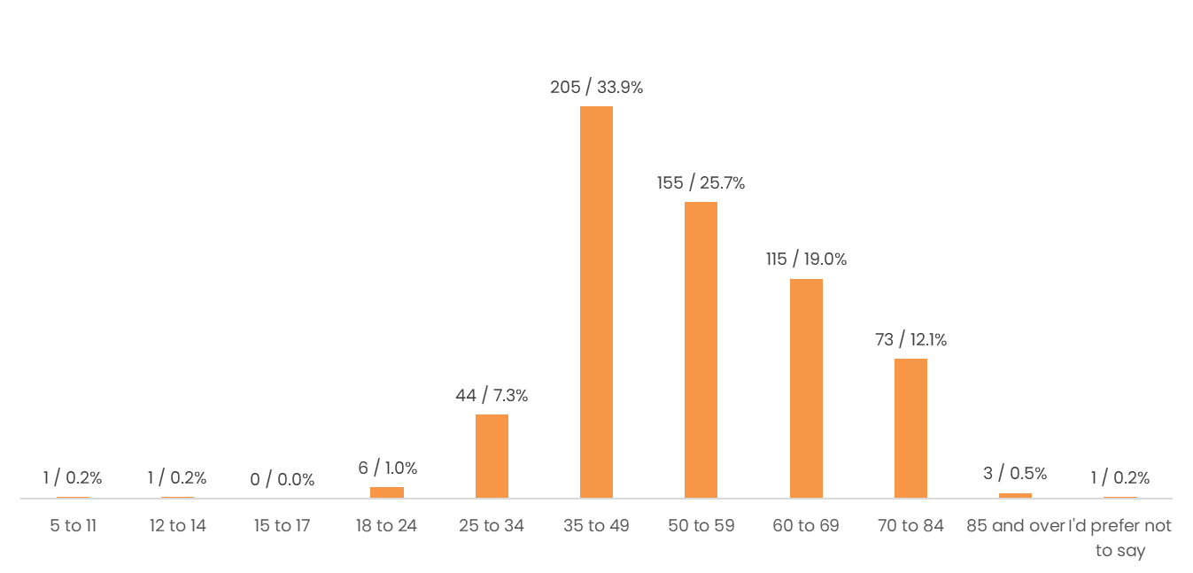

Household
We asked people about the type of household they live in. Of the 604 people who responded, the largest number of respondents (221 people / 36.6%) said they were a couple without children. The next largest (172 people / 28.5%) said they were a couple with children and the third largest (146 people / 24.2%) said they were a one-person household.
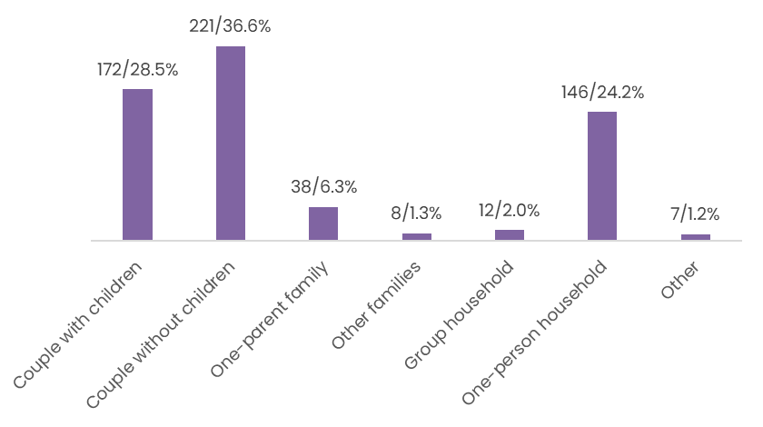

Diversity
We asked people if they identified with any of the following statements. Below is a summary of the number of responses to each of these statements:
- ‘I speak a language other than English at home’ (58 responses).
- ‘I identify as LGBTIQA+’ (41 responses).
- ‘I am a person with disability’ (20 responses).
- ‘I am from an Aboriginal and/or Torres Strait Islander background’ (6 responses).
- ‘I’d prefer not to say’ (30 responses)
- ‘None of these apply to me’ (468 responses)

Previous engagement
To help us understand if we were engaging with new community members, we asked if participants had provided feedback on any other Council projects in the past 12 months. Of the 604 people who responded, most people (325 / 53.8%) had said they had not, 222 people (36.8%) said they had, and 57 people (9.4%) said they were not sure.
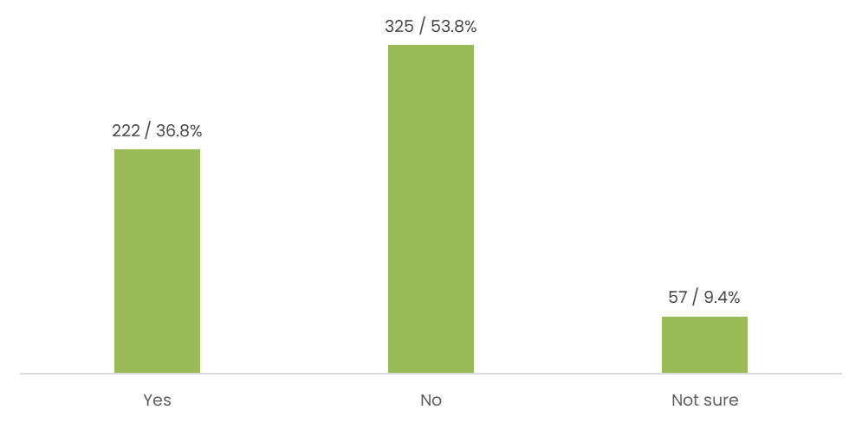

What we heard
Between 27 June and 8 August 2025, we invited people to share their views on Bay Street through a range of engagement activities, as outlined in the previous ‘What we did’ section. Please note that information in the submission we received was analysed alongside the survey data.

How often do you visit Bay Street in Port Melbourne?
We asked participants how often they visit Bay Street in Port Melbourne. Of the 600 people who responded to this question, the largest number of people (299 / 49.8%) said every day, 217 (36.2%) said more than once a week, 41 (6.8%) said once a week, 19 (3.2%) said once a fortnight, 10 (1.7%) said once a month, 7 (1.2%) said a few times a year and 2 (0.3%) said they don’t visit Bay Street. Five people (0.8%) chose the option of ‘other’.
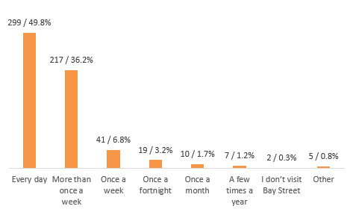
‘Other’ responses are listed below:
“5 times a week.”
“To attend appointments, not for shopping”.
“I’m currently overseas, but normally once a week”.
“Randomly- but I live close. We don’t feel safe and it’s dirty.”
“It used to be daily; I now avoid it as much as I possibly can 😩”.

Which of the following activities do you typically do when visiting Bay Street?
We asked participants what activities they typically do when visiting Bay Street. Of the 598 people who responded to this question, the largest number of people (537 / 89.8%) said shopping, 435 (72.7%) said eating/drinking at restaurants, bars or cafes, 177 (29.6%) said socialising, 110 (18.4%) said enjoying the public space and 34 (5.7%) said attending work. 68 people (11.4%) chose the option of ‘other’.

Below is a summary of the 68 ‘other’ responses received, which have been themed into eight categories.
Theme | Number and % of responses | Sample of responses
- Health & Fitness | 25 responses  4.2% of participants | “Part of regular walk”  “Going to the gym”  “Dog walking”  “Meditation”  “Pilates”
- Shopping & Errands | 15 responses  2.5% of participants | “Beauty salon/hairdressing”  “Visit bank”  “Going to the post office”  “Nail salon”
- Transport & Commuting | 14 responses  2.3% of participants | “I live on Bay Street”  “Bus access to travel to work”
- Medical & Health Services | 8 responses  1.3% of participants | “Pharmacy”  “Podiatrist. GP”  “Dentist”
- Childcare & Family | 6 responses  1% of participants | “Daycare”  “Childcare”  “Weekly playgroup”  “Getting to school”
- Volunteering | 3 responses  0.5% of participants | “Voluntary work with Historical Society”
- Visit Library | 3 responses  0.5% of participants | “Visit the library”
- Food & Beverage | 2 responses  0.3% of participants | “Getting a quick takeaway coffee”  “Eating and heading to the beach”

Which of the following places on Bay Street have you visited in the past 12 months?
We asked participants what places on Bay Street they have visited in the past 12 months. Participants were able to select multiple options. Of the 597 people who responded to this question, the largest number of people (548 / 91.7%) said supermarket and grocery, 481 (80.6%) said pharmacy, 478 (80.1%) said café, 454 (76.1%) said bakery, 451 (75.5%) said post office and 402 (67.3%) said restaurant. Sport and activity retail with 21 (3.5%) responses, accommodation (18 / 3%) and childcare (6 / 1%) received the lowest number of responses. 50 people (8.4%) chose the option of ‘other’.
Below is a detailed graph showing of responses received.

Below is a summary of the 50 ‘other’ responses received, summarised into nine themes.
Theme | Number and % of responses | Places identified
- Discount & Bargain Retail | 19 responses  3.2% of participants | Opportunity shops  Discounts stores
- Financial & Professional Services | 9 responses  1.5% of participants | Real estate  Lawyer  Bank, ATMs
- Community & Civic Services | 9 responses  1.5% of participants | Library  Port Melbourne Town Hall  Albert Park College  Parks  Post office
- Food & Beverage Retail | 8 responses  1.3% of participants | Pubs  Frozen yoghurt  Takeaway coffee
- Health & Allied Services | 6 responses  1% of participants | Podiatrist  Doctor
- Specialty & Utility Retail | 6 responses  1% of participants | Paint store  Florist  Smoke store  Photo shop  Phone repairs  Dry cleaning
- Books & Stationery | 5 responses  0.8% of participants | Newsagent  Bookshop  Tattslotto store
- Personal Care & Beauty Services | 4 responses  0.7% of participants | Beauty therapy  Massage
- Pet Services | 3 responses  0.5% of participants | Vet  Dog grooming  Pet shop

People who identified as female most visited places like supermarkets, pharmacies, cafes, and hair and beauty services. Those who identified as male showed slightly more engagement with leisure and hospitality venues, as well as frequently visiting supermarkets, restaurants, and liquor stores.

Would you like to tell us why you don't visit Bay Street in Port Melbourne?
If people indicated that they do not visit Bay Street, we asked why this was the case. We also asked which shopping precinct they prefer to go to instead of Bay Street.
The two responses received we included:
Albert Park - great selection of shops both retail and bakery (trendy, not just cheap chain stores), food, books etc. Where we regularly shop and I love to take visitors to for a lovely village feel”.
“Anywhere but. It doesn’t feel safe, it feels run down. It doesn’t offer anything. Most businesses have left, it feels like an abandoned no man’s land”

What would you like to see more of on Bay Street?
We asked people what they would like to see more of on Bay Street. Participants were able to select multiple options. Of the 565 people who responded to this question, the largest number of people (319 / 56.5%) said retail, 315 (55.8%) said clothing store, 307 (54.3%) said restaurant, 239 (42.3%) said entertainment, 209 (37%) said cafe and 179 (31.7%) said supermarket and grocery. 126 people (22.3%) chose the option of ‘other’.
Laundry and drycleaning service with 7 (3.5%) responses, accommodation (18 / 3%) and childcare (6 / 1%) received the lowest number of responses.
On the next page is a graph of the responses received.

Below is a summary of the 126 ‘other’ responses received, summarised into 12 themes. Responses have been further categorised into sub-themes to help understand the feedback more effectively. Note that some of the responses fall within the category of ‘retail’ even though they selected ‘other’.
Theme | Number and % of responses (categorised into sub-themes) | Sample of responses
- Food & Beverage | Butcher  - 37 responses  - 6.5% of participants  Deli  - 16 responses  - 2.8% of participants  Wine Bar/Pub/Bar/Club  - 13 responses  - 2.3% of participants  Grocer  - 12 responses  - 2.1% of participants  Fruit & Vegetable  - 10 responses  - 1.8% of participants  Fishmonger  - 6 responses  - 1.1% of participants  Formal dining  - 2 responses  - 0.4% of participants  Pizza  - 2 responses  - 0.4% of participants  Each of the following received 1 response, 0.2% of participants:  - Chicken shop  - Food truck  - Pet cafe  - Korean  - Craft café  - Discount supermarket | “Fresh food market including a butcher and fishmonger.”  “Great chicken shop, fresh fruit grocer”  “Providore, Italian deli, butcher, prepared meals”  “Gourmet food store”  “Specialty food like a delicatessen”  “Cheese and wine bar”  “Wine bars, not pubs”  “Higher end food restaurants”  “Family pizza shop”  “Great chicken shop”  “Food truck precinct with seating where the old cinema is”  “Korean restaurant”  “Craft cafe (e.g. pottery)”  “Discount supermarket”  “Cheaper Buy Miles, etc.”
- Fashion & Apparel | General clothing & fashion  - 9 responses  - 1.6% of participants  Shoe store  - 3 responses  - 0.5% of participants  Women’s clothing  - 2 responses  - 0.4% of participants  Fashion boutique  - 2 responses  - 0.4% of participants  Men’s clothing  - 1 response  - 0.2% of participants  Children’s clothing  - 1 response  - 0.2% of participants | “Country Road, clothes stores”  “More clothing”  “Better clothes shops”  “Children’s wear, more clothing shops”  “More clothing store suitable for the area”  “Shoe retail shops selling all brands of runners”  “Men’s retail clothing”  “Children’s wear”
- Home & Gifts | Gift shop  - 19 responses  - 3.4% of participants  Homewares  - 11 responses  - 1.9% of participants  Bookshop  - 6 responses  - 1.1% of participants  Furniture  - 3 responses  - 0.5% of participants  Toy shop  - 3 responses  - 0.5% of participants | “Gift shops where good quality gifts for weddings/birthdays etc could be purchased”  “Furniture/homewares shop”  “Home décor/decorating”  “Furniture or furnishings store”  “Household goods”  “Toy shop”
- Entertainment & Leisure | Cinema/Theatre  - 15 responses  - 2.7% of participants  Markets  - 6 responses  - 1.1% of participants  Festival  - 4 responses  - 0.7% of participants  Kid friendly café/play area  - 4 responses  - 0.7% of participants  Live music venue  - 3 responses  - 0.5% of participants  Dance studio  - 2 responses  - 0.4% of participants  Event space  - 2 responses  - 0.4% of participants  Free entertainment  - 1 response  - 0.2% of participants  Autism friendly spaces  - 1 response  - 0.2% of participants  Outdoor social spaces  - 1 response  - 0.2% of participants | “A boutique cinema to encourage a sense of community like Yarraville”  “Cinema or entertainment complex to attract more visitors”  “Boutique movie theatre”  “Gourmet markets  “Weekend markets”  “More festivals”  “Community events’  “Softplay or child entertainment”  “Kids play/party venue”  “Live music”  “Adult dance studios”  “More street life after 5 or 6pm”  “Free entertainment”  “Autism friendly spaces”  “Outdoor social spaces”
- Health & Services | Bank  - 6 responses  - 1.1% of participants  Health food store  - 6 responses  - 1.1% of participants  Public toilets  - 3 responses  - 0.5% of participants  Each of the following received 1 response, 0.2% of participants:  - Podiatrist  - Beauty salon  - Pilates studio  - Police station  - Community services | “Bring back the 2 banks that have closed”  “More bank branches, particularly NAB”  “Organic health store”  “Health food shop”  “Clean public toilets”  “Podiatrist”  “Beauty parlour for spray tan”  “Upmarket Pilates and yoga studios”  “Police station”  “Community services”
- Speciality Retail | Art gallery  - 4 responses  - 0.7% of participants  Electronics  - 3 responses  - 0.5% of participants  Sporting  - 3 responses  - 0.5% of participants  Appliances  - 2 responses  - 0.4% of participants  Kmart  - 2 responses  - 0.4% of participants  Each of the following received 1 response, 0.2% of participants:  - Hardware  - Shoe repair  - Plant nursey  - Florist  - Pet retailer  - Opportunity shop | “Art galleries”  “Electronics and appliances”  “Shops such as bike shops, sporting gear shops”  “Sports shoe store”  “A Kmart would be nice”  “Hardware”  “A shoe repairer”  “Plant nursery”  “A quality florist”  “Pet retailers”  “Op shops!”
- Diversity & Quality | - 24 responses  - 4.2% of participants | “More quality stores like Albert Park”  “Much more variety of stores”  “Better cafes with quality produce”  “More interesting shops, innovative businesses”  “Independent retail”  “Variety of services as long as they are well presented”  “Up market clothing stores and quality florist”  “High quality independent retailers, grocers, artisans, gifts, and pet retailers”
- Safety & Security | - 2 responses  - 0.4% of participants | “Police station”
- Amenity | - 2 responses  - 0.4% of participants | “Clean Public Toilets, Art work, a cleaner street”  “More activity near the beach/retail…more street life”
- Mall | - 1 response  - 0.2% of participants | “Turn Bay St into a mall”
- Recycling bins | - 1 response  - 0.2% of participants | “More disposal bins for battery and plastic bottles”
- Parking | - 1 response  - 0.2% of participants | “Better car parking”

Across gender identities, there was a strong desire to see more food and beverage options, including cafes, restaurants, and specialty food retailers. Respondents who identified as female frequently expressed interest in fashion and apparel, home and gift stores, and health and personal services. Those identifying as male showed interest in entertainment and leisure venues, such as bars and live music spaces, alongside specialty retail and health services.

Is there anything else you’d like to share about your experience of Bay Street in Port Melbourne?
We asked participants if they would like to share anything else about their experience of Bay Street. The 470 responses have been categorised below into 12 themes, from most to least popular. Responses submitted via email were also incorporated into the analysis of this question.
Theme | Number & % of responses | Sample of responses
- Retail mix | 263 responses  56% of participants | “In the past 27 years of living in Port Melbourne, we have seen a growing lack of diversity in the businesses that are available. Many businesses are repeated: nail salons, barbers, beauty/aesthetic clinics, Op shops (there were 5 up until recently).”  “I love port Melbourne, but it really needs more bars and restaurants, there’s not enough variety for when you want to socialise with friends.”  “It would be wonderful to have a mix of quality shops, charming cafés, and outdoor dining spaces that invite people to linger and connect.”  “There needs to be more stores for children as there is a high number of young families in the area.”  “More clothing stores, variety of retail, better standard of hospitality.”
- Aesthetics | 149 responses  31.7% of participants | “Remove centre medium strip and widen footpaths.”  “Bay Street is tired and needs a complete overhaul.”  “Make businesses keep their shop fronts nice and neat and clean and inviting.”  “We need more flowers and nice trees.”  “Increase public space. I firmly believe that there is scope for several road closures in and around Bay Street that can significantly improve the amenity of the area.”
- Safety | 121 responses  25.7% of participants | “We feel crime is increasing in Bay Street, which is a great worry.”  “The strip feels much less safe than it used to when we bought here in 2018.”  ‘I'm guilty of not shopping here beyond the basics because I either don't feel safe or there is nothing to entice me to come here to shop.”  “It is sometimes scary to walk down the street after hours and I’m a grown woman.”
- Cleanliness | 115 responses  24.5% of participants | “The shop fronts and sidewalks are filthy. Especially on Western side”  “Clean it up. The streets are often dirty, the gutters are old, when it rains it drips everywhere, there’s bird crap everywhere.”  “I think Bay Street footpaths need to be cleaned overnight. They are stained with dog urine, chewing gum which make it unpleasant and unhygienic.’  “The public bins are not cleaned often enough.”  “There is always rubbish on the ground and shopkeepers take no responsibility for maintaining the area in front of their shops.”
- Nightlife & Atmosphere | 101 responses  21.5% of participants | “The street has lost its luxury feel. It gives shoppers no reason to stay, socialise and enjoy the various other opportunities. Instead it’s just grab and go. We’re losing connection and community because of this.”  “The street feels run down and daggy.”  “For most of the year, Bay Street after 8.00pm is a badly lit, poorly patronised and uninviting wasteland.”  “Need better outside seating options that are not related to businesses.”  “Many port Melbourne residents go to Albert Park to have a relaxing dinner and some nice bars”
- Business support | 91 responses  19.4% of participants | “It seems to me that the rent is too expensive for potential business tenants to start a business therefore some sort of rent control needs to be brought in.”  “Young people should be encouraged to open businesses. No doubt very high rents are a hindrance to young, fresh ideas. You can’t force the market but maybe subsidies, rebates or other incentives could assist?”  “Facade Improvement Scheme…Offer grants or matched funding to landlords/businesses to repaint, restore, or modernise shopfronts. Provide Facade Design Guidelines: Provide templates or visual guides for desirable shopfront upgrades.”  “We need meaningful and sustained support from council to revitalise the precinct and protect the cultural and economic value small businesses bring to the community.”
- Comparison to other areas | 68 responses  14.5% of participants | “I head to Glen Huntly Road for specialist foods or to South Melbourne Market. I also use Victoria Ave for household goods and special clothing stores.”  “Bay Street has lost its vibrancy and charm. Just take a look at Albert Park - it has maintained its character and pride.”  “Although we’d much rather stay in Port, sometimes we go to Bridport St where the atmosphere is much nicer.”  “Bay St should aim to have the same shops/ good cafes like Chapel St.”  “We need more retail shops like Albert Park does. More clothing, shoes & make-up stores.”
- 222 Bay Street | 65 responses  13.8% of participants | “The building on corner of Bay and Liardet has been an eye sore for way too long.”  “DO SOMETHING about that ugly building that was burnt - how can that still be standing in a place like Bay Street”  “The shell of the burnt out building on the corner of Liardet and Bay is appalling. It’s been there for years and brings a feeling of deterioration and degradation which pervades and impacts the surrounding area.”  “Burnt out building screams derelict.”
- Parking & Access | 45 responses  9.6% of participants | “A roundabout on the bay and Liardet street corner makes the most sense.”  “Would very much appreciate traffic lights at the corner of Liardet and Bay Sts”  “Parking is difficult and there are no EV charging stations.”  “Pavements are very busy, I would like to see one side of parking removed, introduce bike lanes and expand the pavements, encourage more people and less cars.”  “Parking is also unhelpful, with spaces along Bay St only permitting 1 hour, which is generally not long enough for anything, especially appointments.”
- Hoon driving | 18 responses  3.8% of participants | “Speeding on Bay St is a huge problem, hoons are daily occurrence”
- Dogs | 14 responses  3% of participants | “It’s great to have people walking their dogs but cleaning up after them needs to be better.”  “Pet cafe’s - there are a lot of dog owners in port Melbourne so somewhere they could take their pets would be great.”
- Toilets | 4 responses  0.9% of participants | “There is a problem with public toilet access, the only one being adjacent to Coles, with limitations on opening times.”

Next steps
Insights from this engagement project will be available to potential businesses who are looking to start a business on Bay Street, including the development of a new Bay Street Precinct Prospective Business Hub webpage. The insights will guide potential businesses, landlords and real estate agents on what businesses and services the community is seeking.

Appendices

Appendix 1. Survey
- How often do you visit Bay Street in Port Melbourne?
Please choose an option from the list below. If you are unsure or would prefer not to say, you can skip this question.
Select one answer only

Every day
More than once a week
Once a week
Once a fortnight
Once a month
A few times a year
I don’t visit Bay Street [Please skip to question 4]
Other

- Which of the following activities do you typically do when visiting Bay Street?
Please select all that apply to you. If you are unsure or would prefer not to say, you can skip this question.
Select all that apply

Attending work
Eating/drinking at restaurants, bars or cafes
Enjoying the public space
Shopping
Socialising
Other

- Which of the following places on Bay Street have you visited in the past 12 months?
Please select all that apply to you. If you are unsure or would prefer not to say, you can skip this question.
Select all that apply
Accommodation
Allied Health Services
Bakery
Cafe
Childcare
Clothing Store
Convenience store
Dental
Entertainment
Retail
Florist
Hairdressing and Beauty
Health and Fitness Centre
Jewellery Store
Laundry and Drycleaning Service
Liquor Store
Medical Service
Optometry
Pharmacy
Physiotherapy & Osteopathy
Post Office
Restaurant
Sport and Activity Retail
Supermarket and Grocery
Other

- Would you like to tell us why you don't visit Bay Street in Port Melbourne? [Please skip if not applicable]
Please select as many as apply to you. You can skip this question if you'd prefer.
Select one answer only
I don't live in the area
It doesn't have the kind of places (i.e. shops, restaurants, businesses) I'm looking for
It's not a convenient location for me
Other

- Which shopping precinct do you prefer to go to instead of Bay Street? [Please skip if not applicable]
Write your answer below. You can skip this question if you prefer.

- What would you like to see more of on Bay Street?
Please select all that you think apply. If you are unsure or would prefer not to say, you can skip this question.
Select all that apply
Accommodation
Allied Health Services
Bakery
Cafe
Childcare
Clothing store
Convenience store
Dental
Entertainment
Retail
Florist
Hairdressing and beauty
Health and Fitness Centre
Jewellery Store
Laundry and Drycleaning Service
Liquor Store
Medical Service
Optometry
Pharmacy
Physiotherapy & Osteopathy
Post Office
Restaurant
Sport and Activity Retail
Supermarket and Grocery
Other

- Is there anything else you’d like to share about your experience of Bay Street in Port Melbourne?
Please tell us below.

Please tell us a little bit about yourself so that we can understand who we're hearing from. Click here for Council's Privacy Policy to understand how your information is used.
- Please indicate your age group. ^{Required}
Select one answer only
5 - 11
12 - 14
15 - 17
18 - 24
25 - 34
35 - 49
50 - 59
60 - 69
70 - 84
85 and over
I'd prefer not to say
- What is your residential suburb? ^{Required}
Select one answer only
Albert Park
Balaclava
Elwood
Melbourne
Middle Park
Port Melbourne
Ripponlea
South Melbourne
Southbank
St Kilda
St Kilda East
St Kilda West
Windsor
Prefer not to say
Other, please specify

- Which gender do you identify with? ^{Required}
Select one answer only
Female (woman or girl)
Male (man or boy)
Non-binary
I’d prefer not to say
I use a different term (please specify)

- Which of the following best describes your current household? ^{Required}
Select one answer only
Couple with children
Couple without children
One-parent family
Other families
Group household
One-person household
Other

- Please tick any of the statements that apply to you. ^{Required}
Select as many as apply
Select all that apply
I am from an Aboriginal and/or Torres Strait Islander background
I speak a language other than English at home
I am a person with disability
I identify as LGBTIQA+
I'd prefer not to say
None of these apply to me
- Have you provided feedback on any other City of Port Phillip projects in the past 12 months? ^{Required}
Select one answer only
Yes
No
Not sure

Thank you for completing this survey. Please return your survey by 5pm on Friday 8 August to:

Economic Development team
St Kilda Town Hall
99A Carlisle St, St Kilda 3182
Or email a copy to: helpdeskabbp@portphillip.vic.gov.au

