Multicultural strategy

Engagement Summary Report
March 2026

Acknowledgement of Country
Wominjeka. Council respectfully acknowledges the Traditional Owners and Custodians of the Kulin Nation. We acknowledge their legacy and spiritual connection to the land and waterways across the City of Port Phillip and pay our heartfelt respect to their Elders, past, present, and emerging.

Postal Address  City of Port Phillip, Private Bag 3, PO St Kilda, VIC 3182  If you require a large-print version, please contact ASSIST on 03 9209 6777.  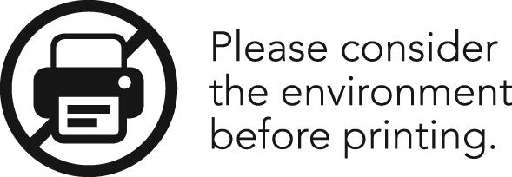 | Language assistance  Русский (Russian): 03 9679 9813  Polski (Polish): 03 9679 9812  Ελληνικά (Greek): 03 9679 9811  廣東話 (Cantonese): 03 9679 9810  普通話 (Mandarin): 03 9679 9858  Italiano (Italian): 03 9679 9814  For other languages not listed, please phone 03 9679 9814.
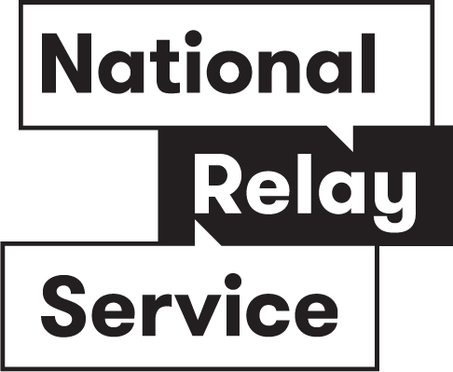
If you are deaf or have a hearing or a speech impairment, you can phone us through the National Relay Service (NRS):
- TTY users dial 133677, then ask for 03 9209 6777
- Speak and listen users phone 1300 555 727, then ask for 03 9209 6777
For more information - accesshub.gov.au

Contents
Introduction 4
What we did 8
Communications activities 8
Engagement activities 11
Who we heard from 14
Community demographics 14
Cultural background 14
Suburb 16
Age 17
Gender identity 18
Diversity and inclusion 18
Past engagement 18
Targeted groups 19
What we heard 23
Community feedback 23
Codesign Sessions 37
Differences in feedback across genders 50
Next steps 52
Appendix 1. Multicultural Strategy Survey 53
(English, hard copy version) 53
Appendix 2. Organisations that received direct invitations 58

Introduction

Project background
City of Port Phillip is committed to creating a city where people of all cultural and religious backgrounds feel respected, valued, and safe. For this reason, we are developing a Multicultural Strategy to strengthen inclusion, belonging, and cultural safety across our diverse community. The strategy will be grounded in the enduring presence and cultures of First Nations peoples, whose sovereignty and histories span over 65,000 years, and will guide Council’s actions to:
- Celebrate and promote our cultural diversity
- Build stronger social connection
- Address ethnic, religious and race-based discrimination
- Make services easier to access for all residents
The community consultation for this strategy was open from 10 November to 14 December 2025. It is acknowledged that the day the engagement closed coincided with the tragic Bondi Beach shooting in Sydney, an event that deeply impacted communities across Australia and reinforced the importance of fostering safety, inclusion, and resilience in our local context.

What we set out to achieve
Through this engagement project, we wanted to learn from our community about what matters most for multicultural inclusion. We aimed to find out:
- What future goals Council should work towards to better support multicultural communities.
- Which priorities are most important for the next four years.
- What actions Council can take to strengthen inclusion and participation.
- Which cultural events and significant dates Council should celebrate and acknowledge.
- What should be included in Council’s new commitment to people from cultural and religious backgrounds.
We especially wanted to hear from people with diverse cultural and religious backgrounds to ensure these insights reflect the voices of our community.

About this report
This report provides an overview of the community engagement process. It explains:
- What we did: the activities and methods used to gather input.
- Who we heard from: the people and groups who shared their views.
- What we heard: the key themes and insights from the community.

Before reading this report
- The findings are based on qualitative feedback from people who chose to take part. This means the views shared are not statistically representative of the whole community and may only reflect a portion of local voices.
- While we aim to include diverse perspectives, some community members may have faced barriers to participation, including people with disability, multicultural communities, older people, and Aboriginal and Torres Strait Islander people.
- ‘Participants’ refers to everyone involved in the engagement; ‘respondents’ refers to those who answered a specific question or activity.
- The report summarises what we heard. Feedback has not been independently verified, so some comments may be incorrect, unachievable or outside the project scope. Not all individual comments are shown; themes, quotes and numbers are used to reflect the range of views.
- Some people may have contributed more than once across different activities, which may result in unintentional double‑counting.
- Demographic data was not collected consistently across all activities, which limits our ability to analyse differences between groups.
- The report covers Council‑led engagement activities only and does not include community‑run or third‑party events, surveys or petitions.
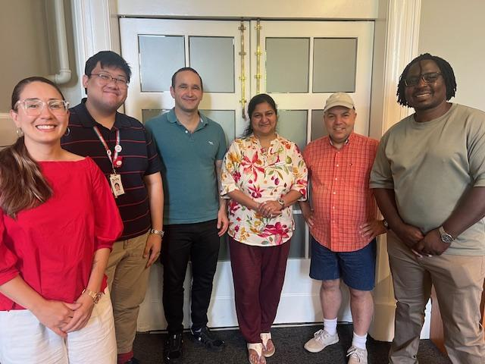
- This report was developed through a combination of human analysis and artificial intelligence (AI). Human analysts conducted the primary data analysis. AI tools were used to process and analyse large datasets, identify trends, and generate some preliminary findings. Any AI-generated findings were subsequently reviewed, validated, and interpreted by human analysts with expertise in the subject matter. The final conclusions and interpretations presented in this report represent the considered judgment of these human analysts, even where AI contributed to the data processing.
Figure 1: This picture shows participants of the second stakeholder codesign workshop facilitated by Think HQ

What we did
Between 10 November and 14 December 2025, we delivered a range of communications activities to let the community know about this engagement project and collected feedback through a mix of engagement activities.

Communications activities
To increase awareness of the engagement process, we did the following:
Method | Details | Reach
‘Have your say’ webpage | Council’s dedicated engagement webpage, ‘Have your say’ included a page for this project, with information on the process, a timeline, contact details, and opportunities to engage.  Responses could be submitted in video or audio format, and in any preferred language.  Translations were provided in Arabic, Simplified Chinese, Greek, Hindi, Portuguese, Russian and Spanish. | 1,060 views  849 visits  484 visitors
Postcards | Postcards were distributed to the local community, explaining the engagement process and inviting people to provide feedback.  Translations are provided in simplified Chinese, Hindi, Spanish, Greek, and Russian. | 50 distributed via the library
Newsletters | Project information and an invitation to engage was included in multiple Council newsletters, including:  - Community Sector News (19 November, 9 December  - Youth E-bulletin (3 December)  - Business news (24 November)  - South Melbourne Market Trader e-newsletter (24 November)  - What’s on at libraries (21 November)  - Divercity (28 November)  - Help shape Our City (18 November)  Several non-Council organisations also shared the information in their newsletters and networks, including:  - City of Port Phillip Multifaith Network  - Council of Christians and Jews Victoria newsletter  - Elwood Primary newsletter  - Glen Eira Interfaith Network  - Inner South Multicultural Network  - Jewish Care — social media  - Jewish Community Council — social media and Sunday message  - Port Melbourne Primary newsletter  - Port Phillip Zero  - St Mary’s Catholic Primary newsletter  - St Mary’s School newsletter | Community Sector News) – 1,261 recipients  Youth e-bulletin– 443 recipients  Business News (2905 recipients)  South Melbourne Market Trader e-newsletter (213 recipients)  What’s on at the Libraries e-newsletter– 6,938 recipients  Divercity e-newsletter– 15103 recipients  Help Shape Our City engagement e-newsletter– 4,280 recipients
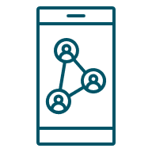Social media posts | Social media posts were included on Facebook and Instagram to promote the engagement opportunity. | Stand-alone posts (Collaboration with Libraries):  Instagram: 1,071 reach, 55 likes, 3 comments  Facebook: 1,195 views, 7 reactions, 1 comment, 9 link clicks  Broader engagement-related posts:  Instagram: 611 reach, 14 likes, 1 share  Facebook: 654 reach, 8 likes, 1 comment  South Melbourne Market Facebook post (21 November): 1,557 views
Emails to networks & Stakeholder packs   | We sent emails to many stakeholders relevant to the project.  This included ‘Stakeholder packs’ that were developed and distributed, containing translated materials, culturally appropriate images, and inclusive messaging to ensure accessibility and resonance across diverse communities.  Translations were provided in simplified Chinese, Hindi, Spanish, Greek, Russian and Portuguese.  Stakeholders were encouraged to amplify the reach of this information by sharing it through their networks, including social media platforms, translated posters and WhatsApp groups.  This included:  - Participants of previous related engagement who had indicated interest, such as the Plan for Port Phillip  - Toy libraries, playgroups and community managed children and family services  - Community Grants recipients (400 plus grant recipients)  - Former Multicultural Advisory Committee members  - Multicultural Senior Groups (18 groups)  - Members of the Port Phillip Multifaith network (65 members)  - Inner South Multicultural Network (90 members)  - Direct invitations were issued to key organisations (see Appendix 2 for the full list).  - Port Phillip Councillors  - Participants in Co‑design Sessions for Multicultural Strategy | N/A
Map installation   | A large world map was displayed at the St Kilda and Emerald Hill libraries for people to mark their cultural background and share ideas. The map was also used at targeted activities, South Melbourne Primary School, citizenship ceremonies, and library installations, to capture cultural background information and link people to the survey via QR code. | Approx. 506

Engagement activities
To collect feedback from the community we did the following activities:
 | Method | Details | Participation
 |   Survey | Our survey collected ideas and priorities for the Multicultural Strategy, as well as demographic information from participants.  It was available online via the Have Your Say webpage, could be downloaded in hard copy, and was also available from ASSIST customer service desks and at the libraries.  It was available in English, Arabic, Chinese, Greek, Hindi, Portuguese, Russian and Spanish.  A copy of the survey in English can be found at Appendix 1 on page 53 | Online survey: 69  Hard copy survey: 31 (including 30 Russian and 1 Spanish)
 |   Targeted conversations, interviews & activities | Targeted engagement activities occurred to capture the ideas of diverse groups who may not participate in other engagement activities. This included:  - Citizenship Ceremony at St Kilda Town Hall  - Hindi Storytime at St Kilda Library  - Mandarin Storytime at Port Melbourne library  - Multicultural senior groups at Betty Day Centre at Betty Day Centre (Polish, Russian and Jewish groups)  - Multicultural senior groups from Greek background in Port Melbourne  - Park Towers Management  - Port Phillip’s Multifaith Network  - Port Phillip’s Youth Advisory Committee  - Skinner’s Playground  - South Melbourne Primary school (68 percent of students are born overseas)  - Space2B  - St Kilda Library ESL groups  Targeted engagement activities were designed around priority populations who experience barriers to accessing Council information for example, residents in public housing, people with low digital literacy, and groups requiring gender-specific engagement.  At targeted engagement activities, we also shared information about the role of local government and how feedback would be used, with all materials available in multiple languages. | Approx. 250
 |   Submissions, emails and uploads | Community and organisational submissions were received via email and through uploads on the Have Your Say webpage. | 2
  Codesign Sessions |  | We invited people from diverse cultural backgrounds, and local organisations/groups to participate in four interactive sessions to help shape key elements of the strategy. Community members received a $50 Coles Myer voucher per hour for sessions they attended. | Community session 1: 13 participants  Community session 2: 6 participants  Group and organisational session 1: 10 participants.  Group and organisational session 1: 6 participants.

Who we heard from

Community participants
Through our survey and some other engagement activities we asked questions about community participants demographic details. Of the total participants (approx. 375), 53 people shared all or some of their demographic information with us. Demographics were not collected from all participants as it was not considered appropriate or feasible to do so in all settings. The following explores the demographic information that we collected.

Cultural background
We asked participants of our online survey and Have Your Say webpage uploads to describe their cultural background. The 50 people who told us are represented in the word cloud below. The larger the word appears, the more times it was mentioned.
There were also many targeted activities (listed in the ‘what we did section page 8) were we did not ask specifically for peoples’ cultural background.
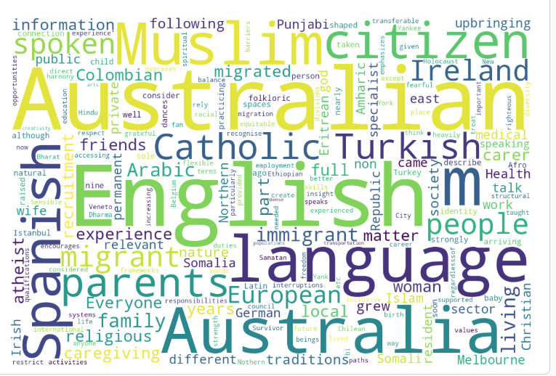
At some of our activities, we also invited participants to mark their cultural background on a large world map. We then counted the dots as accurately as possible to understand where people identify their cultural background. Please note that the numbers below are our best approximation, as some areas of the map were difficult to count.
Across the three maps, Africa accounts for 74 dots, the Americas continents for 104, and Asia records the highest total with 179. Europe contributes 111 dots, while Oceania adds 38, bringing the combined total across all maps to 506 dots.
At the country level (excluding Australia), the highest counts come from Indonesia with 27 dots, followed by India with 22, the United States with 21, China with 19, and Brazil with 17. This is par with ABS statistics data. Pictures of these are included below.
It is important to note that not all participants provided verbal or written feedback, with some accessing other engagement opportunities via a QR code. The map raised awareness of the project and provided Council with a broad snapshot of the demographic groups who interacted with it. For example, students at South Melbourne Primary School placed dots on the map as they walked into school, and attendees at a citizenship ceremony also participated in this way.

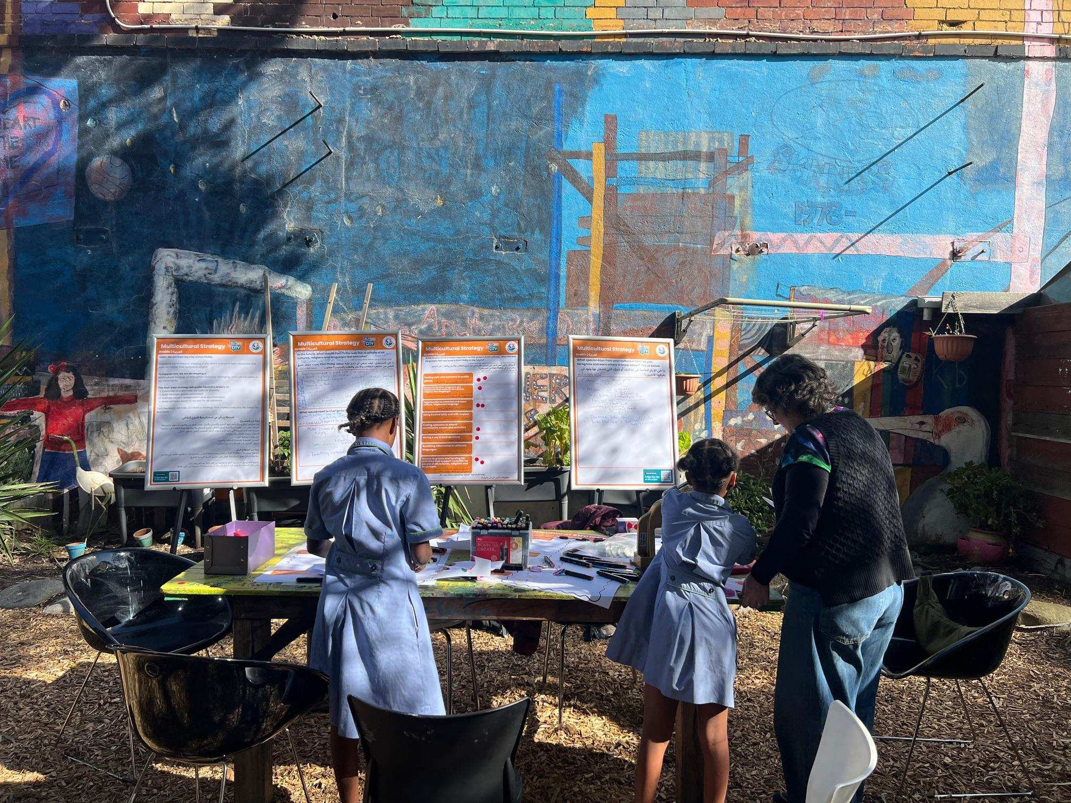
Figure 2: This picture shows families participating in a targeted session at Skinners playground, families mainly reside at local housing estates.

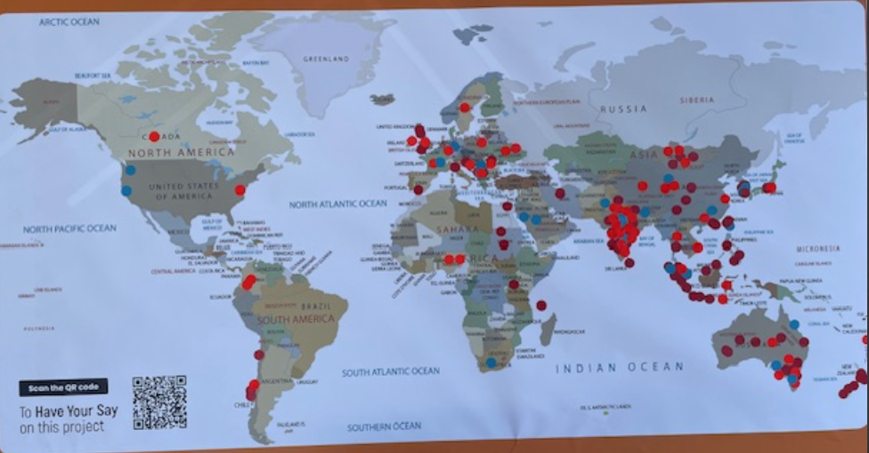
Figure 3 (below): This photo shows the world‑map exercise where residents were invited to mark their cultural background. This map is from our targeted outreach session at South Melbourne Primary School, where 68% of students are born overseas.
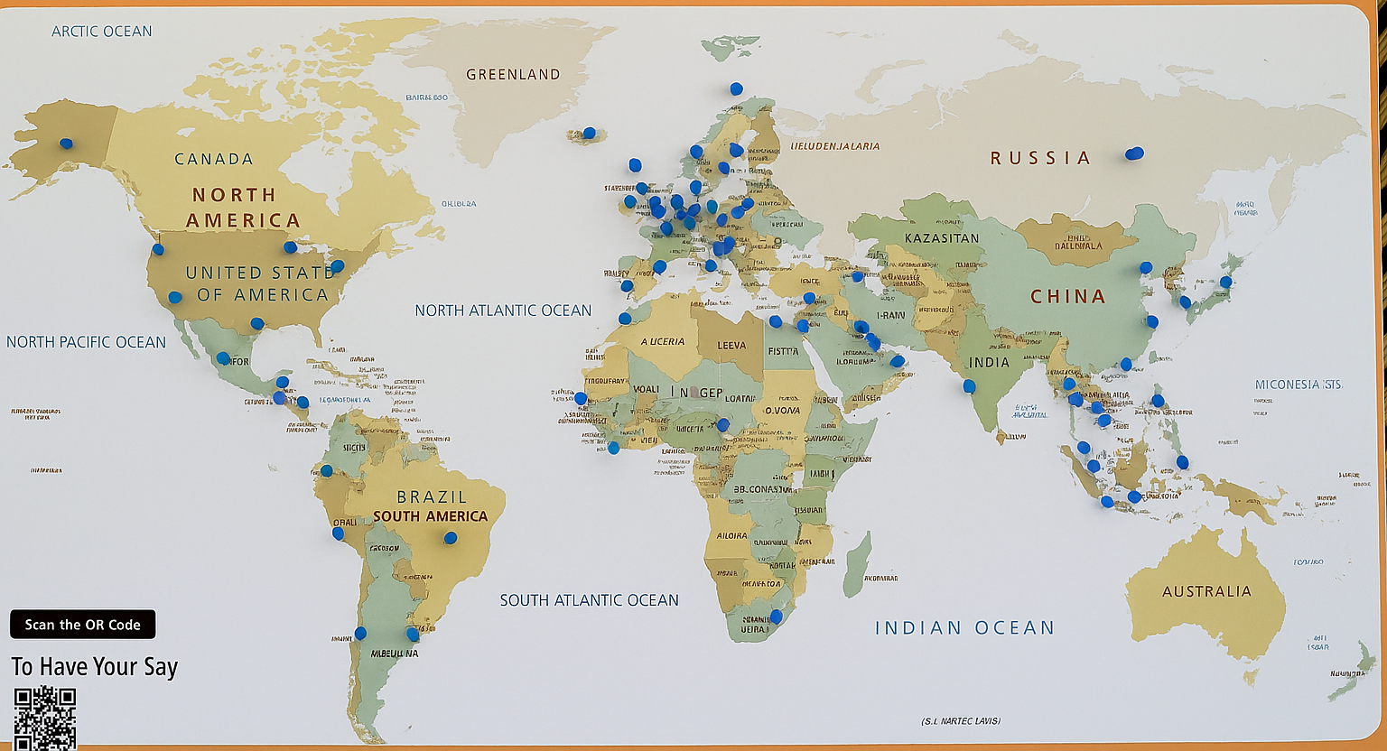
Figure 4: This photo shows the world‑map exercise where residents were invited to mark their cultural background. This map was created at the Australian Citizenship Ceremony, where more than 200 people took part on the day
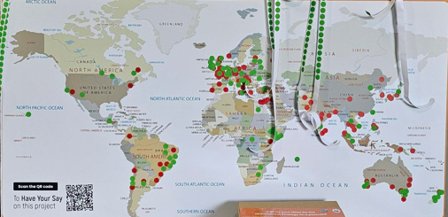
Figure 5: This photo shows the world‑map exercise where residents were invited to mark their cultural background. This map comes from the St Kilda and Emerald Hill Libraries, where it was installed for one week.
In addition, as part of the Codesign Sessions (see page 37 for details) we engaged with community members from a range of cultural and religious identities.

Suburb
We asked people the suburb they live in. Of the 53 people who responded, the largest group (14 people/26.4%) lived in South Melbourne. The next largest were Port Melbourne (7 people / 13.2%) and St Kilda (6 people / 11.3%). No one said they lived in St Kilda West or Windsor.

Age
We asked people to identify their age group. Of the 51 people who responded, the largest proportion was aged 35–49 years (18 people, 35.3%). The next most common age groups were 70–84 years (10 people, 19.6%) and 25–34 years (9 people, 17.6%). No respondents were aged 17 or under; however, we engaged with younger people through other mechanisms, including the Youth Advisory Committee and South Melbourne Primary School.

Gender identity
We asked people their gender identity. Of the 53 people that responded, the majority (33 people/62.3%) identified as female (woman or girl). 16 people / 30.2% identified as male (man or boy). 1 person identified as non-binary and 3 people (5.7%) said they would prefer not to say.

Diversity and inclusion
We asked people if they identified with any of the following statements. These included:
- ‘I speak a language other than English at home’ (28 responses).
- ‘I am a person with disability’ (5 responses).
- ‘I identify as LGBTIQA+’ (3 responses).
- ‘I am from an Aboriginal and/or Torres Strait Islander background’ (0 response).
- I’d prefer not to say (10 responses)
- None of these apply to me (10 responses)

Past engagement
To help us understand if we were engaging with new community members, we asked participants had provided feedback on any other Council projects in the past 12 months. 27 people (50.9%) said they had not, and 21 people (39.6%) said they had. 5 people (9.4%) were not sure.

Codesign Sessions
Codesign Sessions were delivered at the end of the engagement period in order to gather in depth advice and ideas to shape key elements of the strategy. These were smaller, interactive sessions facilitated by communications agency Think HQ.
The sessions comprised of two groups, with two sessions for each group. The two groups included:
- Community representatives
- Community stakeholders (including organisations and groups)
Recruitment for these sessions took place throughout the broader engagement period. As engagement progressed, it became apparent that responses from the local Jewish community were limited despite extensive outreach. To address this gap and ensure equitable representation, additional targeted recruitment efforts were undertaken, particularly for the stakeholder session. These efforts helped secure strong participation from Jewish community representatives, ensuring that the voices, experiences, and priorities of all parts of the community were reflected in the development of the strategy.

Community representatives
These sessions brought together a highly diverse group of community members with cultural backgrounds including Polish, Somali, Chilean, Indian, Bulgarian‑Greek, Japanese, Sri Lankan, French, Singaporean and mixed heritage. Participants shared a range of religious and cultural identities, including Jewish, Muslim and Christian backgrounds. This diversity provided a rich foundation for exploring how residents from different cultural communities’ experience life in Port Phillip and what they need to feel safe, included and connected.
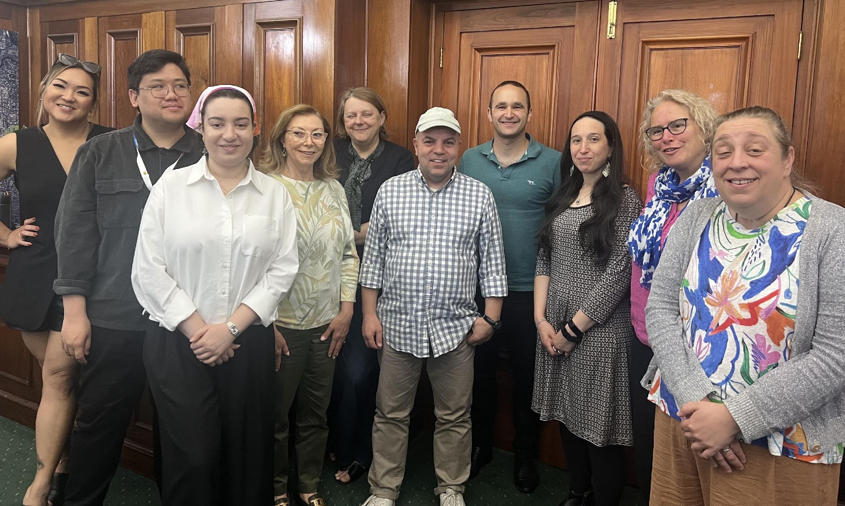
Residents primarily lived in St Kilda and Balaclava, with others travelling from South Melbourne. Their time in Australia ranged from more than 30 years to just a few months, and many shared complex migration journeys spanning multiple countries. The group included parents, retirees, volunteers, workers and recently arrived migrants, providing a broad cross‑section of community perspectives. Participants also spoke a wide range of languages including Polish, Somali, Arabic, Hindi, Spanish, Greek, Bulgarian, Japanese, French and Russian.
Figure 6: This picture shows participants from the first stakeholder codesign workshop
Figure SEQ Figure \* ARABIC 6: Targeted session at South Melbourne Primary

Group and organisational sessions
These two sessions brought together representatives from a wide range of community organisations, service providers and advocacy groups. These included Alfred Health – Mental and Addiction Health, Australian Jewish News, Better Health Network, Council of Christians and Jews, Elevate Voices for Change (Women’s Health in the Southeast), Jewish Community Council of Victoria, the Jewish Museum, Polaron Translations and Interpreting, and Women’s Health in the Southeast.
Figure SEQ Figure \* ARABIC 7: Participants of the first stakeholder codesign workshop

Other groups and organisations
A total of 40 survey participants listed the organisations they were representing. In addition to this, we also had a range of community groups attend the different targeted engagement activities, including
These included:
- ABRISA – Brazilian Association
- Alfred Health – Mental and Addiction Health
- Association of Former Inmates of Nazi Concentration Camps and Ghettos from the Former Soviet Union
- Australian Jewish News
- Better Health Network
- Council of Christians and Jews
- Elevate Voices for Change (Women’s Health in the Southeast)
- Galini Greek Senior Citizens Club
- Jewish Community Council of Victoria
- Jewish Museum
- Kastellorizian Association of Victoria Inc.
- Polaron - Translations, Interpreting & EU Citizenship
- Polish Australian Port Melbourne community (member of)
- Polish Senior Citizens Club of St Kilda ‘Astry’
- Port Melbourne Greek Community Senior Citizens Club
- Port Phillip Multifaith Network (65 faith organisations are represented, including Christian (Catholic, Anglican, Salvation Army, Pentecostal and Baptist), Hindu, Buddhist and Jewish groups)
- Rawcus Theatre Company Inc.
- Sephardi Association of Victoria
- Share & Swap Shop (community group run by people from multicultural backgrounds)
- South Melbourne Greek Women’s Club ‘Olympia’
- Space2b Social Design
- Women’s Health in the Southeast

What we heard

Community feedback
Below is an overview of what we heard through our engagement activities including our survey, targeted conversations, interviews & activities and submissions/emails.

In the future, what should Port Phillip be like so people of all cultures, religions and languages feel welcome?
We asked people what they thought Port Phillip should be like so people of all cultures, religions and languages feel welcome. We received 294 comments, from which the following themes and sub-themes emerged from most to least comments received.
Theme | Participant quotes
Create welcoming spaces and hubs (48 comments)  Sub-themes:  - Community hubs & neutral drop‑ins  - Youth‑friendly spaces  - Outdoor & coastal activation  - Safety‑by‑design & access  - Inclusive facilities & prayer spaces  - Digital‑ready places | “Creating safe spaces for young people…spaces you can be loud, talk to friends and be with friends is central.” (Source: Targeted outreach)  “Muslim prayer space is needed; we travel to the city to pray.” (Source: Targeted outreach)  “Welcoming spaces must explicitly address discrimination.” (Source: interview)  “Multiple small, local nodes (not just a single central hub) make participation feasible for isolated groups and families without transport.”  (Source: interview)
Accessible information, services access and language support (46 comments)  Sub-themes:  - Multilingual access & formats  - Library hubs & collections  - Digital inclusion & literacy  - Human connectors & help desks  - Regional partnerships & channels | “Provide information in multiple languages, including Farsi.” (Source: Targeted outreach)  “Libraries could serve as community hubs… provide translated materials for early childhood, health, and education.” (Source: Targeted outreach)  “Printed materials and digital literacy training… many seniors struggle to access online info.” (Source: Targeted outreach)
Understanding, Respect & Social Cohesion (33 comments)  Sub-themes:  - Dialogue & learning  - Shared identity & non‑divisive messaging  - Counting all voices (incl. non‑religious)  - Fairness between groups  - Trust‑building practices | “We need open conversations… spaces where people can ask questions to build understanding and respect.”  (Source: Targeted outreach)  “Make people feel like we are all Australian… embrace our similarities not our differences.” (Source: Online survey)  Participants need to know they will be respected regardless of identity, faith, or language, and that unwelcoming behaviours are not tolerated. (Source: Interview)
Support for families and carers (31 comments)  Sub-themes:  - Citizenship & settlement supports  - Homework & learning support  - Early childhood access & affordability  - Parenting & life skills  - Maternal & child health | “The cost of childcare for non-residents is a barrier, and it prevents mothers accessing employment and social connection” (Source: targeted outreach)  “Maternal health is central for families, but it would be good if they were upskilled in cultural competency be culturally informed and understand cultural needs.” (Source: targeted outreach)
Celebrate cultures and diversity (27 comments)  Sub-themes:  - Cultural content in schools & libraries  - Inclusive celebration calendar  - Arts and culture for inclusion  - Equitable representation & messaging  - Decorations & place‑making | “More multicultural events and celebrations—want to learn more about other culture.”  (Source: Targeted outreach)  Culture on display creates home: when residents share their cultural practices publicly and see appreciation, belonging accelerates. (Source: interview)  Community-led events are pivotal: hosting and teaching the broader community fosters pride and mutual understanding. (Source: interview)
Social Connection and Informal Networks (26 comments)  Sub-themes:  - Multilingual access & formats  - Library hubs & collections  - Digital inclusion & literacy  - Human connectors & help desks  - Regional partnerships & channels | “Word-of-mouth remains a key channel for migrants.” (Source: Targeted outreach)  “More social groups for new residents so they can get information.”  (Source: Targeted outreach)  “Connection is the core outcome. People must feel safe, seen, heard, and not judged the moment they enter a space.” (Source: interview)
Council-supported cultural programs (23 comments)  Sub-themes:  - Grants & resourcing  - Volunteer & succession support  - Food/event compliance support  - Partnerships & logistics  - Program transparency & reporting | “Shift from short grants to strategic partnerships… multi-year agreements where Council and organisations co-plan annual programs aligned to the Strategy.”  (Source: Interview)  “Support community groups’ volunteers to run the community led activities… simplify process for using community spaces.”  (Source: Targeted outreach)  “Access to grants for community groups… funding currently barely covers meals—need more resources for meaningful activities.” (Source: Targeted outreach)
Participation and belonging (21 comments)  Sub-themes:  - Advisory & local decision groups  - Civic pathways  - Orientation & connectors  - Co‑design & governance posture  - Transparency & feedback loop | “Getting new migrants involved in local decision making can we create a local decision group?” (Source: Targeted outreach)  “Run a ‘Welcome to Port Phillip’ tour for newcomers.” (Source: Targeted outreach)  “Can we create a local decision group that can plan out activities for the local community?” (Source: Targeted outreach)
Stand against racism and hate (18 comments)  Sub-themes:  - Community safety & incident response  - Anti‑racism standards  - Psychological safety norms  - Design for safety  - Community education | “Schools have a big role to play around anti-racism education… the library is a great place of education.” (Source: Online survey)  “Our children see a lot of things that are scary. How do we deal with it? How do we build their skills and resilience to deal with it?” (Source: targeted outreach)  “I am deeply concerned about young men and sons and their safety as young people of colour”  (Source: targeted outreach)  “You stop wearing things that show your identity because you feel afraid.” (Source: targeted outreach)
Fair job opportunities for everyone (9 comments)  Sub-themes:  - Job‑seeking orientation & norms  - Inclusive recruitment & recognition of experience  - Entry pathways & temporary roles  - Workplace multilingualism & inclusion  - Bridging skills & English for work | “Recruitment should value international experience, not just local experience.” (Source: Online survey)  “We need mentoring and help with CVs because job-seeking norms here are very different.” (Source: Targeted outreach)  “Temporary jobs should be advertised in one central place for newcomers.” (Source: Targeted outreach)
Respect and recognition for First Nations people (7 comments)  Sub-themes:  - Treaty & multilingual education  - On‑Country learning & environment  - Active visibility in civic life  - Co‑design & leadership | “First Nations people are not just another group in a multicultural society. They are the Traditional Owners of unceded lands. Council should develop educational material that draws on the Victorian Treaty and distribute it in all languages present in our community” (Source: Online survey)  “Celebrate First Nation culture and history actively in public spaces, events, storytelling, and decision-making.” (Source: Online survey)

A small number of survey participants were not supportive of the question: ‘In the future, what should Port Phillip be like so people of all cultures, religions and languages feel welcome?

What would need to change to make this happen?
Following on from the previous question, we asked people what they thought Port Phillip should be like so people of all cultures, religions and languages feel welcome. We received 210 comments, and from which the following themes and sub-themes emerged.
Theme | Participant quotes
Programs, Funding & Strategic Partnerships (31 comments)  Sub-themes:  - Simplified Funding Processes  - Commissioning Model for Multi-Year Partnerships  - Regional Collaboration across other LGAs  - Capacity Building to support leadership succession and community led activities | “Partner with neighbouring LGAs (e.g., Stonnington) to co-fund and scale programs that mirror real community flows across borders.” (Source: Interview)  “More funding for multicultural education and activities.” (Source: Online survey)  “Shift from short grants to strategic partnerships: multi-year agreements where Council and organisations co-plan annual programs aligned to the Strategy.” (Source: Interview)
Information Access, Navigation & Digital Inclusion (29 comments)  Sub-themes:  - Multilingual and multiformat information delivery  - Digital Literacy Support  - Trusted Community Connectors  - Innovative Technology Solutions  - Orientation & Welcome Programs | “Establish a trusted community connectors to share accurate information and support residents.” (Source: Targeted outreach)  “Better communication so all residents know what is happening in the area”. (Source: Online survey)
Welcoming Places and Accessible Spaces (23 comments)  Sub-themes:  - Neighbourhood hubs within walking distance  - Inclusive Design  - Accessible amenities and simplified venue access & booking  - Corridors specific outreach to areas such as St Kilda Road, South Melbourne etc.  - Safe Youth Spaces  - Activation of green & public Spaces for multicultural events | “Ensure community facilities have adequate amenities, tables, chairs, setup assistance—and are fully accessible, especially for older members (70+), as physical setup is becoming increasingly challenging.” (Source: targeted outreach)  “Expand services along St Kilda Road by providing Council-led outreach, including a toy library and other community programs.” (Source: targeted outreach)  Community programs in libraries and schools can create spaces for shared learning and cultural exchange. (Source: Online survey)
Safety, Inclusion & Social Cohesion (20 comments)  Sub-themes:  - Anti-Discrimination Policies  - Community Education:  - Positive Messaging: Council-led campaigns promoting diversity and harmony.  - Intercultural/interfaith dialogue  - Visible Anti-Racism Messaging in Public Spaces  - Clear Reporting Channels for Discrimination | Publishing success stories of newcomers in local media promotes cultural pride and community celebration, (Source: Online survey)  Teach respect and inclusion in the community. Have clear rules against racism and inappropriate comments. (Source: Online survey)  Council should show strong commitment to anti‑vilification. Share policies publicly and make sure they are followed. (Source: Online survey)  Anti-racism education in schools promotes inclusion and reduces discrimination. (Source: Online survey)  “Organise information sessions/tours that are headed by appropriate representatives to better understand a specific religion, culture and/or language.” (Source: Online survey)
Leadership, Commitment & Advocacy (20 comments)  Sub-themes:  - Cultural competency for councillors and staff.  - First Nations Recognition  - Advocacy for Equity:  - Stand again racism and hate  - Monitoring & Reporting on Strategy Progress  - Diverse representation in leadership/workforce; advisory committees (incl. youth); transparent sponsorships/decision making | Council to advocate for groups to State Government. (Source: targeted outreach)  A welcoming slogan for Port Phillip. A welcoming statement. E.g. "City that welcomes everyone" (Source: targeted outreach)  Promote awareness about traditional custodians of the land. Provide easy-to-understand guides on respect and inclusion. (Source: Online survey  Advocates for systemic change in recruitment practices to ensure equity and inclusion. (Source: Online survey
Community Voice & Local Decision-Making (19 comments)  Sub-themes:  - Advisory groups and local decision groups and structured feedback loops.  - Codesign process  - Youth representation  - Transparency & Feedback  - Capacity building for governance and advocacy | ““Can we create a local decision group that can plan out activities for the local community?” (Source: Targeted outreach)  “Strengthen community capacity in governance, safety, and resilience.” (Source: Targeted outreach)  “Regular consultations with new migrants about what they want” (Source: Targeted outreach)  “Stop treating us as if we are not smart, remember it took many years of organising, coordination and advocacy to come and live in Australia.” (Source: Online survey)
Cultural Calendar, Events & Celebration (19 comments)  Sub-themes:  - Annual Cultural Calendar  - Community-Led Celebration  - Inclusive Programming  - Promotion & Visibility: Marketing campaigns to raise awareness of events  - Heritage recognition | Run programs and events that celebrate cultural diversity. Focus on what brings people together. (Source: Online survey)  Street decorations in all suburbs' shopping strips. (Source: Online survey)
Belonging Through Social Connection (16 comments)  Sub-themes:  - Buddy Systems  - Interest-Based Groups  - Intergenerational Activities  - Low-Barrier Social Events | “Language practice woven into activities (craft, lunch, retail/market prep, studio tasks) reduces anxiety and builds confidence. (Source: Interview)  “Facilitate environments for organic connection”. (Source: Interview)
Employment Pathways & Economic Participation (10 comments)  Sub-themes:  - Inclusive Recruitment Policies  - Skill Development Programs:  - Support for Migrant Entrepreneurs  - Fair Access to Job | Creative social enterprise opportunities (craft/food markets, micro-commissions) provide purpose, routine, and self-worth, even if income is modest. (Source: Interview)  Environmental volunteering and cultural programs can lead to skill-building and community-based employment opportunities (Source: Online survey)  More people from different backgrounds working together at the Council, because they
Families, Early Years & Parenting Support (10 comments)  Sub-themes:  - Childcare affordability & access  - Parenting skills & family resilience  - Early years navigation  - Cultural Competency  - Culturally appropriate activities for families | “Intergenerational programs that include families and children in cultural and environmental activities.”- (Source: Online survey)  Clear info on schools, kindergartens, after-school programs. (Source: Targeted outreach)

A small number of survey participants who completed the survey were not supportive of Council taking steps to ensure people of all cultures, religions and languages feel welcome.

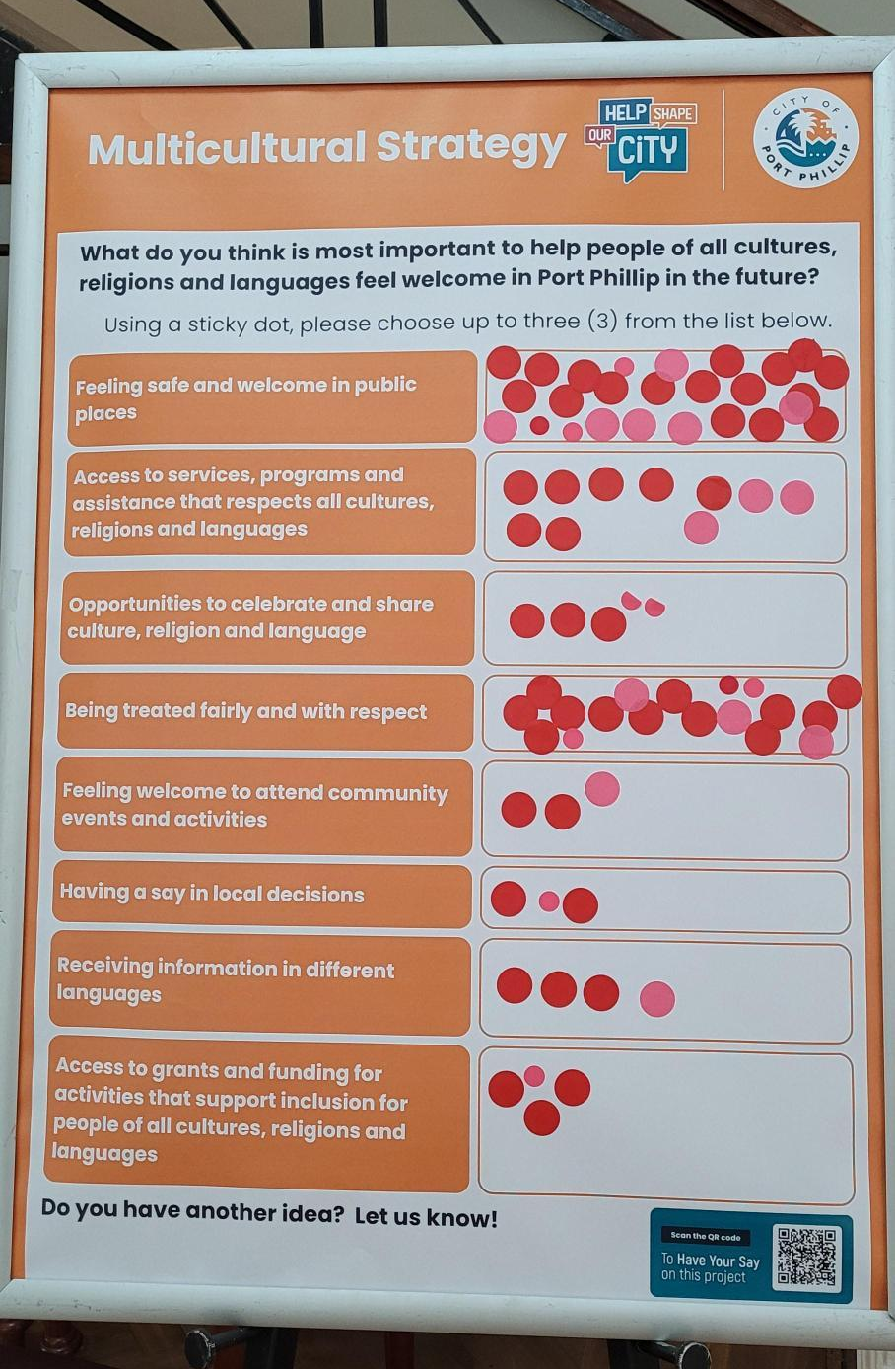
What do you think is most important to help people of all cultures, religions and languages feel welcome in Port Phillip in the future?
Figure 7: This picture shows an engagement activity from the Citizenship ceremony
Through many of our engagement activities, we asked people to choose 3 of the options they thought was most important.
People were also offered an opportunity to provide a different response to those listed. We received 514 responses to this question.

Theme | Number of dots
Feeling safe and welcome in public places | 162
Being treated fairly and with respect | 91
Having a say in local decisions | 58
Access to services, programs and assistance that respects all cultures, religions and languages | 53
Opportunities celebrate and share culture, religion and language | 52
Feeling welcome to attend community events and activities | 42
Access to grants and funding for activities that support inclusion for people of all cultures, religions and languages | 39
Receiving information in different languages | 17

What special days from your culture or faith do you recognise and want others to know about?

For many of our engagement activities, we asked people what they thought Port Phillip should be like so people of all cultures, religions and languages feel welcome. We received 134 comments, and from which the following themes and sub themes emerged.
Theme | Subthemes
Religious and Spiritual Observances (55 comments) | Islamic: Ramadan (month of fasting), Eid al-Fitr (end of Ramadan), Eid al-Adha (Festival of Sacrifice), Muharram (Islamic New Year), Hajj (pilgrimage).  Hindu: Diwali (Festival of Lights), Holi (Festival of Colours), Dussehra (victory of good over evil), Onam (harvest festival), Ugadi (New Year for Telugu/Kannada communities).  Jewish: Passover, Purim, Hanukkah, Sukkot.  Sikh: Vaisakhi/Baisakhi (harvest and Khalsa foundation), Gurpurab (birth anniversary of Guru Nanak).  Christian: Christmas (birth of Jesus), Easter (resurrection), Advent (season of hope), Pentecost (40 days after Easter), Orthodox Christmas/Easter (observed by Eastern churches).
Cultural & Heritage Festivals (by region) (37 comments) | East Asia: Lunar/Chinese New Year (family reunions, travel), Dragon Boat Festival (boat races), Mid-Autumn Festival (mooncakes, lanterns), Tomb Sweeping Day.  South Asia: Diwali and Holi (also cultural), Onam (Kerala harvest), Ugadi, Baisakhi, Indian Festival Day.  Middle East/Central Asia: Nowruz (Persian New Year), Nauryz (Kazakhstan spring festival).  Europe: St Patrick’s Day (Irish heritage), Italian Festival Day, Guy Fawkes Day (UK), Oxi Day (Greece), Greek Independence Day (Greece)  Americas: Brazilian Carnival (parades, samba), Thanksgiving (USA).  Oceania: Matariki (Māori New Year)
Community Priorities, Participation and Access (10 comments) | Learning & Recognition: Interest in learning about other cultures and Australian traditions.  Inclusive Practices: Open invitations (e.g., Ramadan/Eid), inclusive days vs private celebrations.  Safety & Accessibility  Education: Teach cultural/religious stories in schools (e.g., Christmas roots).  Visibility & Data Equity: “No data on Muslim population” → feelings of invisibility.  Small Community Recognition: Japanese community wants acknowledgment despite size.  Operational Needs: Micro-grants, logistics, promotion, multiple neighbourhood touchpoints.
Local & First Nations Observances (8 comments) | Local: Australia Day (Jan 26), ANZAC Day (Apr 25).  Aboriginal & Torres Strait Islander: Day of Mourning (Jan 26), Reconciliation Week (May), National Sorry Day (May 26), NAIDOC Week (July).  Māori: Matariki (New Year)
Community and Family Days (8 comments) | Family Roles: Mother’s Day, Father’s Day, Parents’ Day, Children’s Day.  New Year
Awareness & Inclusive Days (7 comments) | Gender Equality: International Women’s Day (Mar 8).  Cultural Diversity & Anti-Racism: Harmony Week / Cultural Diversity Week (around Mar 21).  Age Inclusion: Seniors Week.  Migration & Inclusion: International Migrants Day (Dec 18).  Peace & Cohesion: International Day of Peace (Sep 21)
National Days & Independence Celebrations (6 comments) | Global Independence Days: USA (Jul 4), Greece (Mar 25), France (Bastille Day, Jul 14), Chile (Dec 18), South Sudan Independence Day.  Victory Day (9 May), World War II Remembrance (11 November)
Seasonal & Nature-Based Observances (3 comments) | Solar Markers: Solstices (summer/winter), Equinoxes (spring/autumn).  Harvest: Baisakhi, Onam.  Lunar Phases: Holi (full moon of Phalguna).  Light & Lanterns: Diwali, local light festivals.

Codesign Sessions
Figure SEQ Figure \* ARABIC 9: Participants of the community codesign session
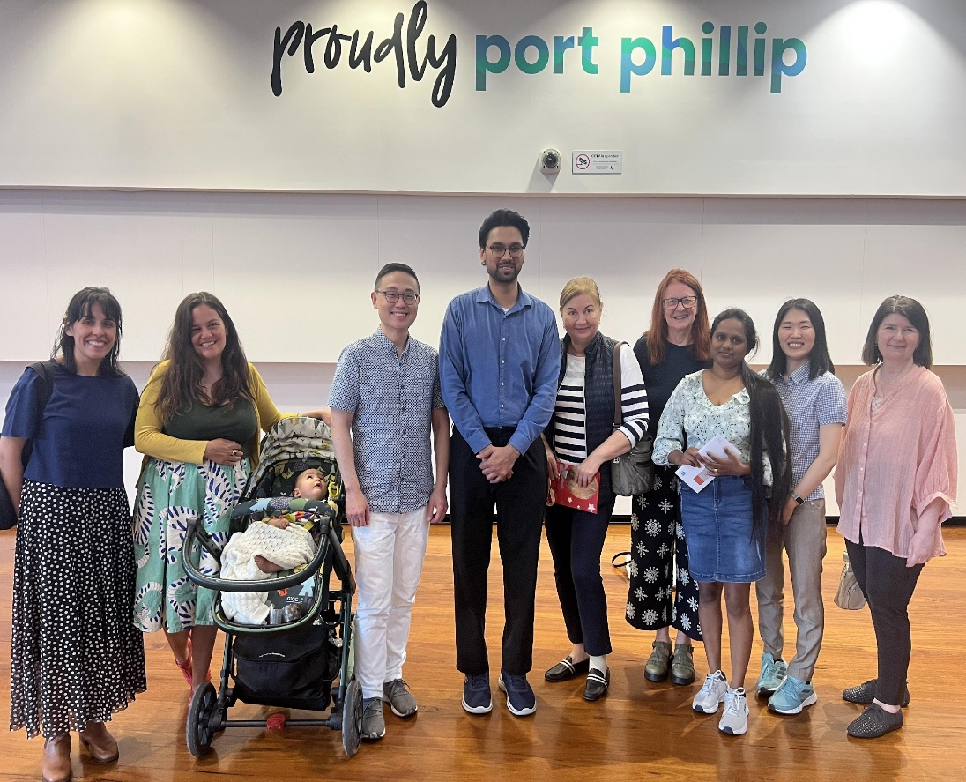
This section brings together the outcomes of four collaborative sessions facilitated by communications agency Think HQ. Thirteen local residents and ten stakeholders participated. Central to this process was a codesign approach, which moved beyond traditional consultations to actively partner with the community in building the strategy’s foundation. By engaging both stakeholders and community members, this ensures that future actions are not just informed by the community but created with them.
Figure 8: This picture shows participants from the first co-design workshop with community members

Workshops 1 and 2 (Strategy Consultation Phase)
Throughout both sessions, discussion questions were used as a launch pad to facilitate conversation and unpack the themes and key areas for the Multicultural Strategy.
Discussion 1: What does multiculturalism mean to you?
Key themes
- From acceptance to greater understanding
True multiculturalism is a shift from passively coexisting with others to actively valuing, respecting and celebrating the richness that diversity brings.
- Beyond the minimum by moving past baseline tolerance or ‘tick box’ exercises towards genuine appreciation and celebration of the diverse community.
- Validating cultures that have historically faced exclusion and moving beyond occasional festivities to daily respect.
- A paradox of unity stating, ‘we are all the same because we are all different,’ suggesting that the shared humanity is found within our unique differences.
- Providing opportunities to learn about other cultures to build genuine respect for people in the community, facilitating meaningful interactions.
- Identity, safety and belonging
The discussion explored elements of Multiculturalism highlighting the right to be oneself without fear.
- Ensuring psychological and physical safety in public spaces.
- The freedom to define one’s own identity and stay connected to heritage without assumptions or discrimination.
- Creating ‘third’ spaces where people feel seen, celebrated and safe to express their authentic selves.
- The search for belonging and inclusion within the community whilst balancing the desire to maintain a unique cultural distinctiveness.
- Power dynamics and systemic awareness
A significant portion of the discussion focused on the work that needs to be done to celebrate multiculturalism and the structures that hold it back.
- Analysing the power and responsibility of the ‘mainstream’ culture to create space for others.
- Using an anti-racist lens to address systemic inequalities and the social structures that perpetuate racism.
- Recognising that multiculturalism is intersectional with culture overlapping with age, class, gender and ability, requiring a nuanced approach to meeting community needs.
- Shared values and intercultural growth
Multiculturalism is defined by diverse communities who can learn from one another.
- Approaching different cultures with curiosity and love to learn.
- Finding common ground and shared values with neighbours to create a ‘shared culture’ whilst respecting each other's differences.
- Shifting from living side-by-side to interacting and influencing one another through daily experiences.
- Practical commitment
For multiculturalism to thrive, it must be embedded in how people live.
- Ensuring commitment to diversity is reflected in policies and community capabilities.
- Having the courage to engage in difficult dialogues that lead to community growth and deeper understanding.
- Acknowledging that the definition of multiculturalism changes based on a person’s peer group, needs, and lived experience.
- Interculturalism in relation to multiculturalism
The concept of interculturalism was explored as closely connected to, but distinct from, multiculturalism. Participants discussed interculturalism primarily as a practice or approach, rather than as a direct replacement for multiculturalism.
- Interculturalism was seen as building on multiculturalism, moving from recognition of diversity to active interaction, relationship building and mutual learning between cultures.
- Participants described multiculturalism as the foundation (who is here), with interculturalism focusing on how people live, connect and problem solve together in everyday life.
- Interculturalism was viewed as addressing the limitations of multiculturalism when it remains symbolic, event based or surface level, without deeper engagement or structural change.
- Unlike multiculturalism, interculturalism places stronger emphasis on shared responsibility, including the role of mainstream culture, active engagement across communities and shifting power dynamics to foster genuine belonging.

Discussion 2: What does success look like in 10 years for a truly inclusive Council?
Key themes
- Representation in Council
Success is a council that mirrors the community it serves, both in its workforce and its decision-makers/process.
- Council composition and leadership genuinely reflect the diversity of residents in the Port Phillip Community.
- A whole-of-council approach that applies an intersectional lens to all the work.
- Utilising community demographic data to upskill staff and reduce bureaucratic barriers, ensuring policy is respective to everyday needs.
- Establishing strong trust-based relationships that eliminate us vs them dynamics.
- Safety and accessible infrastructure
A successful council ensures that the physical environment removes barriers rather than creating them.
- Services function as a ‘one-stop shop’ where language, disability, age, and gender are never barriers to participation or support.
- A community with reduced crime and discrimination, where safe housing and public spaces allow all residents to thrive.
- High visibility for diverse languages through signage and communication, signalling a sense of welcoming.
- Addressing the inequalities that prevent stable accommodation and access to council-led opportunities.
- Belonging and cultural strength
In 10 years, multiculturalism has moved from the periphery to the centre of Port Phillip’s identity.
- A genuine sense of belonging for everyone, specifically centring those who traditionally lack a voice, such as youth and older people.
- Cultural diversity is positioned as a reason Port Phillip is a desirable place to live.
- Moving from one-off events to consistent, year-round platforms for communities to showcase heritage and engage in cross-cultural learning.
- A community connected to culture that honours its history while moving forward in harmony.
- Community spaces
Success is defined by how people interact in the ‘third spaces’ of Port Phillip.
- Public spaces, local businesses, and beachfronts are better utilised to encourage gathering and interaction.
- Policy and programming are created using codesign principles, ensuring community voices and needs are at the heart of every initiative.
- Collaboration with schools and local partners to promote cultural understanding from a young age.
- Active efforts to bridge social and geographic divides within the Council area to foster true harmony.
- Collaborative leadership
The Council acts as a facilitator for knowledge and power-sharing.
- Creating greater knowledge-sharing loops between diverse groups, stakeholders, and community partners.
- Council takes the lead on inclusivity initiatives to ensure the burden of change does not fall solely on minority communities.
- A visual identity for the City of Port Phillip that actively makes all people feel included and valued.
Discussion 3: What should the council prioritise over the next 4 years?
Key themes
By bringing together the stakeholder and community priorities, there are key themes that can create a focus for a four-year plan. This combined vision balances the community’s desire for visible, local belonging with the stakeholders' focus on evidence-based, structural safety.
- Safety and protection: Implement comprehensive anti-racism strategies and education to ensure physical, emotional, and cultural safety in all public and private spaces. This includes intersectional approaches to preventing gender-based violence and protecting the rights of all religious and ethnic groups.
- Accessible and inclusive spaces: Transform libraries and public spaces into accessible, ‘walkable’ community hubs (both physical and online) that serve as ‘one-stop shops’ for services, cultural activities, and hearing community voices.
- Visibility through arts and education: Activate local precincts and commercial areas through public art, storytelling, and high-profile festivals that increase the visibility of diverse communities and foster cross-cultural understanding.
- Targeted support: Provide specialised outreach and guidance for new migrants, international arrivals, and isolated individuals to build independence and a sense of belonging.
- Evidence-based communication and access: Improve services to have inclusive navigation through centralised information hubs and community boards that are translated. Use data collection and consultation that values lived experience to ensure policies reflect the specific needs of underserved communities.
- Cultural recognition: Create and protect dedicated spaces for daily cultural practices and workshops where family traditions and norms can be shared and respected as a community strength.

Workshops 3 and 4 (Strategy Feedback and Validation Phase)
Key elements of the draft Multicultural Strategy (Including themes, strategic Intents and actions based on input from community engagement and the first two co-design sessions) were presented in these sessions for feedback. The elements were interrogated using a traffic-light system, allowing participants to share what they supported, flag areas for improvement and propose new ideas.

Workshop 3 (Stakeholders)
Theme | Feedback on Name & Strategic Intent | Feedback on Proposed Actions
Theme 1: Safe & Cohesive Port Phillip | - Language and definitions:  - Need to shift to action-focus language.  - Too broad and needs to be connected to current progress.  - Request for a glossary to define what safety and cohesive means.  - Responsibility:  - Questioned the accountability of the intent. | - Framing:  - Need to apply an intersectional lens, taking diverse lived experience into account.  - Highlighting the importance of community-led and co-designed approaches.  - Identifying the most effective anti-racism mechanism (framework, roadmap etc).  - Transparency:  - Need for explanation on how these actions will be addressed.
Theme 2: Belonging & Community Connection | - Language and framing:  - Suggestion to update the term ‘empower’ to ‘amplify’.  - Need for further clarity  - Suggestions for language such as ‘build’.  - Suggestion for title: Belonging, connection and community.  - Taking an intersectional lens to participation.  - Tone:  - Positive feedback about aspirational tone. | - Relevance:  - Feedback that Action 3 does not align with the theme.  - Identification of crossover between Theme 1 and 2.  - Language and framing:  - Replace ‘accessible’ with ‘low barrier.’
Theme 3: Accessible Information & Trusted Support | - Scope and definitions:  - Need for clarification of key terms.  - Participants questioned the core focus.  - Interconnection:  - Note that Themes 1, 2 and 3 are interconnected rather than stand-alone issues.  - Tone:  - Suggestion that strategic intent should be ‘positive’ and strengths-based. | - Hub Locations (Action 2):  - Challenged limiting hubs to libraries.  - Orientation Content (Action 4):  - Suggested the "Welcome to Port Phillip" program should be broader than just services, potentially including "cultural info about their new community.”  - Methodology:  - Request to use trauma-informed approaches and ensure initiatives are co-designed and community-led.  - Accessibility:  - A strong call for "more in-person options, especially for elder accessibility," rather than relying on online pathways.
Theme 4: Diverse Port Phillip | - Language and framing:  - Some wording (specifically "Activate") suggested the community is passive. Language should reflect working "with and for" communities.  - Suggestions included renaming the theme to Strong/Enabling Diverse Communities or Celebrating Diversity to be more outcome based. | - Language and definitions:  - Need to define what is meant by neighbourhood. Specific request to change the word Fund to Support regarding community-led cultural events.  - Highlighting that the promise of simplified processes for events needs to be ‘looked at further’ due to its high importance.  - Identification that Themes 1, 2 and 3 are highly interconnected and interdependent.
Theme 5: Representation & Opportunity | - Language and framing:  - Requested a specific change to the strategic intent, replacing filled with opportunity with filled with opportunities for personal and professional growth.  - Suggested the current name was "not fitting" and proposed alternatives like "Inclusive / enabling Participation and Opportunity." | - Inclusive language:  - There was a request to remove migrants from the text (specifically regarding economic participation).  - Governance:  - Focus on accountability, calling for a "MEAL Framework" (Monitoring, Evaluation, Assessment, and Learning) and "Continuous improvement" mechanisms.  - Correction of phrasing "Advocate on Council," suggesting it be replaced with "Championing" priorities. New Action:  - A new action was proposed to explicitly state: "The local economy reflects the diversity of the community."

Prioritisation
In an additional activity, stakeholders reviewed the proposed themes to prioritise them. It is noted that Theme 2 (Belonging & Community Connection) received the highest level of support, while Theme 5 (Representation & Opportunity) received the lowest during the stakeholder voting session.
• Theme 1 (Safe & Cohesive): 2 votes
• Theme 2 (Belonging & Connection): 6 votes
• Theme 3 (Accessible Information): 2 votes
• Theme 4 (Diverse Port Phillip): 3 votes
• Theme 5 (Representation & Opportunity): 0 vote

Workshop 4 (Community members)
NOTE: Slight adjustments to language were made based on feedback from Workshop 3.
Theme | Feedback on Name & Strategic Intent | Feedback on Proposed Actions
Theme 1: Safe & Cohesive Port Phillip | - Language and definitions  - Request for glossary of terms to define safety.  - Suggestion to incorporate the word ‘foster’ to take a proactive, strength-based approach.  - Responsibility  - Questioned the accountability of the intent.  - Clarity  - Some felt the strategic intent was not clear how to action it.  - Requested that ‘racism’ be addressed alongside ‘discrimination.’ | - Transparency (Action 1)  - Request to "promote transparency around the anti-racism strategy".  - Question around the correct anti-racism mechanism to use as a first step (strategy, road map, statement etc).  - Holistic Safety (Action 2):  - Recognition that safety must be paired with cultural & community activity, not just enforcement.  - Suggestion to highlight welcoming spaces for newcomers.  - Definitions (Action 4)  - Requested more detail on what partnership entails.
Theme 2: Belonging & Community Connection | - Renaming for impact  - Suggestion to expand the name to ‘Belonging & Community Emotional Connection’ to link with social cohesion.  - Strength-Based Language  - Challenged the word "isolation" in the intent, suggesting to "take a strengths-based approach instead" and warning the intent should "not [be] too idealistic."  - Target Demographics:  - The intent specifically mentions "ethnic minorities" and "stressing new arrivals & their needs."  - Year-Round Visibility  - Emphasised that "year-round cultural visibility is needed, not just festivals" and should focus on "Flourishing communities built on a rich history & data." | - Accountability (Action 1)  - Strong demand to "Sharpen the relationship between advice given & advice enacted" and "Increase accountability & make transparent the impact of advice on council."  - Representation (Action 1 and Action 4)  - Some noted the current advisory structure is "Not representative.”  - Called for "Agility and more input from diverse communities."  - Request to interrogate "why certain groups haven't been consulted? who's missing?" and "Build connections between unrepresented gaps."  - Intersectionality (Action 3)  - Specifically requested adding "women" to the target groups and urged Council to account for intersectionality.  - Evaluating Feedback (Action 4):  - Dislike of the term ‘feedback loops’, suggestion for a clearer framework such as "PDCA (plan, do, act, check)" as a positive, constructive alternative.  - Participants heavily emphasised measurement.
Theme 3: Accessible Information & Trusted Support | - Inclusivity  - Request to explicitly add "for everyone” to the theme name.  - Promoting Awareness:  - Suggestion to expand the strategic intent to actively "Promote awareness" alongside ensuring services are barrier-free. | - Strong support for Hub Locations and Language Access Policy (Action 1 and 2)  - Emphasis on identifying "what the first places new arrivals go to engage.”  - Request that hubs be "multilingual / accessible (IT) hubs" catering to those of non-English speaking background.  - A specific addition was made to Action 1 to ensure "professional" translation and interpreting across Council services.  - Orientation Phrasing (Action 4):  - The language "orientation programme" was flagged as potentially "off putting."  - Participants also questioned target definitions, asking who ‘new residents’ refers to.  - Refining Programs (Action 3):  - This action was noted as "Too vague."  - Feedback suggested shifting the focus from addressing the "risk of exclusion" to actively asking to "facilitate inclusion?" through "tailored funded programs + facilities" for "specific communities."
Theme 4: Enabling Diverse communities | - Positioning  - Preference from one resident that this be the first theme.  - Language  - Some critique of the word ‘enabling’, challenging this by stating “But I already feel enabled.”  - Suggestions for alternatives included empowering. Suggestion to incorporate ‘life-long learning community.  - Refining Intent  - Edits were made directly to the text to include "participation" (alongside celebration) and "decision-making" (alongside education and events).  - Notes also emphasised "Making cultures visible for the benefit of all" and building "flourishing communities." | - Calendar Visibility (Action 1):  - Participants added that Council must "Develop and maintain" the calendar.  - There was a strong call for offline promotion, suggesting "Printed versions of the calendar in key locations e.g. at shopping centres" and "Increasing awareness”  - Grant Transparency & Tokenism (Action 2):  - Participants asked for a clear "Framework for deciding," questioning "How are grants allocated? By whom?"  - They also explicitly warned against reducing multiculturalism to "'spaghetti & polka' i.e. tokenistic cliche events."  - Storytelling & Coordination (Action 3):  - Participants added "oral histories" to the list of multicultural programming and called for a plan that co-ordinates key actions e.g. grants & storytelling.  - Library Inclusion (Action 4):  - A specific request was made to "emphasise small minorities". Practical suggestions included a "Book sharing programme for small language groups.  - Suggestion for intergenerational connection.
Theme 5: Enabling Participation & Opportunity | - Renaming  - Participants suggested adding "Decision-making" to the title.  - Refining Intent  - Direct edits were made to the text to explicitly include removing barriers to "decision-making" and ensuring the local economy "and services" reflect the diverse community.  - Advocacy Role:  - Participants questioned the boundaries of Council's role. | - Awareness & Support (new action):  - Suggestions included a focus on "1:1 peer support," building "awareness of existing programs," and creating "hubs in every city centre drop-in --> using available spaces".  - Council Recruitment (Action 1):  - Request for a "Recruitment policy for CoPP to be representative of its community."  - Grant Models & Jargon (Action 2):  - The wording was heavily criticised as "too much jargon."  - Participants warned that multi-year partnerships could be potentially exclusive and favour more experienced groups.  - Suggestion for a model including short & long-term grants depending on project.  - Employment (Action 3):  - Edits shifted the focus to "strong employment" specifically for "CoPP residents."  - Civic Participation (Action 5):  - Desire for "Educating for involvement in council decision making & allocating seats at the table."  - Practical ideas included: starting small with committees, counsellor mentoring opportunities, open day etc.  - A "service navigator" role was again highlighted to bridge the gap between federal and local levels.

Differences in feedback across genders
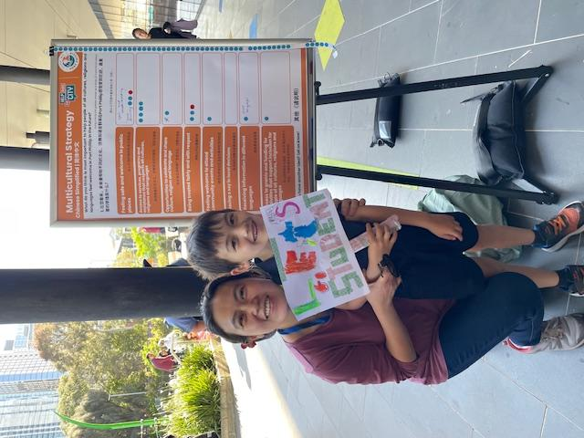
Across gender identities, respondents consistently highlighted the importance of feeling safe, respected, and welcomed in public spaces. Safety concerns featured prominently, including issues such as street crime, antisocial behaviour, discrimination, and racial or religious harassment. Respondents across all genders also expressed a strong desire for inclusive services, clearer communication from Council, and more opportunities to celebrate and connect across cultures. These shared priorities reflect a broad, cross-gender emphasis on belonging, visibility, and everyday safety in Port Phillip.
Figure 9: This picture shows a family who provided feedback at South Melbourne Primary School
Figure SEQ Figure \* ARABIC 10: Participant from South Melbourne Primary School
Female respondents
Respondents who identified as female frequently raised themes relating to family wellbeing, children’s education, and access to culturally safe services. Many women described needing support with early childhood education, maternal and child health, homework help, and language inclusive programs. Female respondents also raised the importance of community connection, including women’s groups, cultural activities, festivals, and social spaces where they could meet others from similar backgrounds. A number of women emphasised the value of representation, noting that seeing people from their background in Council or community leadership would improve trust and inclusion.
Male respondents
Respondents identifying as male often focused on issues relating to public safety, social cohesion, and fairness. Several male respondents emphasised concerns about rising hate-based behaviour, street crime, and the need for stronger Policing or community protective measures. Many men expressed a desire for equal treatment across cultural and religious groups, voicing concerns about bias or “overemphasis” on certain groups, and calling for a balanced approach to inclusion initiatives. This reflects a gendered pattern in the data: male respondents tended to frame inclusion through the lenses of security, equity, and social order rather than family service-oriented needs.
Non-binary respondents/preferred not to state gender
Respondents who identified as nonbinary, preferred not to state their gender, or used other identities frequently emphasised inclusion, equitable access, and the need for Council to recognise diverse worldviews. Several highlighted the importance of ensuring that people across religious and nonreligious identities feel seen particularly humanists, atheists, or those who felt overlooked in multicultural frameworks. Their comments focused strongly on equal recognition, transparent communication, fair representation in decision making, and ensuring that services do not privilege one belief system or cultural group over another. These respondents tended to frame inclusion through respect, fairness, and the removal of structural or symbolic barriers.

Next steps
Information from this report will be used to inform the development of the final Multicultural Strategy, which will be presented to Council for adoption in October 2026.
We would like to thank all participants who have contributed to the development of the Multicultural Strategy.
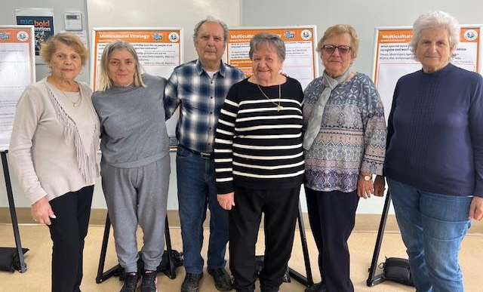
Figure 10: This picture shows participants from a targeted sessions with community leaders from Greek background.

Appendix 1. Multicultural Strategy Survey

(English, hard copy version)
About the project

We are committed to creating a city where everyone feels respected and safe, no matter their culture or religion. To support this, we are developing a Multicultural Strategy to strengthen inclusion, belonging, and cultural safety in our community.
This four-year strategy will guide Council’s actions to:

- Celebrate and promote our cultural diversity
- Build stronger social connection
- Address ethnic, religious and race-based discrimination
- Make services easier to access for all residents

About the survey
This plan will reflect the real experiences and needs of people across Port Phillip’s diverse community. Your feedback will help us create a strategy that makes everyday life better for everyone.
Share your ideas for the Multicultural Strategy by completing this survey.
Return your completed form by 5pm, Friday 12 December 2025:

- Take it or mail to: Diversity, Equity & Inclusion team, St Kilda Town Hall, 99A Carlisle St, St Kilda 3182
- Email to: diversity@portphillip.vic.gov.au
- Upload it in the ‘Upload your feedback’ section at haveyoursay.portphillip.vic.gov.au/multicultural-strategy

We can assist with translation or help you complete the survey.
To ask questions or request a copy of the survey, contact us:
(03) 9209 6777 (ask for the Diversity, Equity and Inclusion team)
diversity@portphillip.vic.gov.au.

Find out about workshops and other ways to participate, go to haveyoursay.portphillip.vic.gov.au/multicultural-strategy.

Survey

- In the future, what should Port Phillip look like so people of all cultures, religions and languages feel welcome? ^{Required}
Tell us your ideas below.

- What would need to change to make this happen? ^{Required}
Tell us your ideas below.

- What do you think is most important to help people of all cultures, religions and languages feel welcome in Port Phillip in the future?
Choose up to three (3) options from the list below.
Feeling safe and welcome in public places
Access to services, programs and assistance that respects all cultures, religions and languages
Opportunities to celebrate and share culture, religion and language
Being treated fairly and with respect
Feeling welcome to attend community events and activities
Having a say in local decisions
Receiving information in different languages
Access to grants and funding for activities that support inclusion for people of all cultures, religions and languages
Something else (Please tell us)

About you
Visit haveyoursay.portphillip.vic.gov.au/privacy-policy to learn how your information will be used.
- Are you representing a group or organisation?
Please tell us the name of your group or organisation below.

- How would you describe your cultural background?
You may like to include information such as where you were born, your religion, the language you speak at home, or anything else you feel is important.

- Which gender do you identify with? ^{Required}
Select one answer only
Female (woman or girl)
Male (man or boy)
Non-binary
I’d prefer not to say
I use a different term (please specify)

- What is your residential suburb?
Select one answer only
Albert Park
Balaclava
Elwood
Melbourne
Middle Park
Port Melbourne
Ripponlea
South Melbourne
Southbank
St Kilda
St Kilda East
St Kilda West
Windsor
Prefer not to say
Other, please specify

- Please indicate your age group. ^{Required}
Select one answer only
5 - 11
12 - 14
15 - 17
18 - 24
25 - 34
35 - 49
50 - 59
60 - 69
70 - 84
85 and over
I'd prefer not to say

- Please tick any of the statements that apply to you. ^{Required}
Select as many as apply
Select all that apply
I am from an Aboriginal and/or Torres Strait Islander background
I speak a language other than English at home
I am a person with disability
I identify as LGBTIQA+
I'd prefer not to say
None of these apply to me

- Have you provided feedback on any other City of Port Phillip projects in the past 12 months? ^{Required}
Select one answer only
Yes
No
Not sure

- Are you happy for us to include quotes from your survey in Council reports or other public facing content?

Select one answer only
Yes
No

- Would you like a copy of your responses posted or emailed to you?

If yes, write your email or postal address below.

Thank you for taking this survey. Please return your completed form by 5pm, Friday 12 December 2025:

- Take it or mail to: Diversity, Equity & Inclusion team, St Kilda Town Hall, 99A Carlisle St, St Kilda 3182
- Email to: diversity@portphillip.vic.gov.au
- Upload it in the ‘Upload your feedback’ section at haveyoursay.portphillip.vic.gov.au/multicultural-strategy

Appendix 2. Organisations that received direct invitations
Organisation | Category
ABRISA Brazilian Association | Cultural Associations
Action on Disability within Ethnic Communities | Disability & Inclusion
Adass Israel | Faith-Based / Multifaith
Alfred Health – Mental and Addiction Health | Health & Mental Health
Artbus | Arts, Culture & Social Enterprise
Australian GLBTIQ Multicultural Council | Multicultural Peak & Advocacy
Australasian Zionist Youth Council | Multicultural Peak & Advocacy
Better Health Network | Health & Mental Health
Brigidine Asylum Seekers Project | Housing, Asylum & Community Services
C Care | Food Relief & Social Support
Catholic Parish of Sacred Heart and St Columba | Housing, Asylum & Community Services
Chabad St Kilda | Faith-Based / Multifaith
Council of Christians and Jews | Faith-Based / Multifaith
Department of Families, Fairness and Housing (Park Towers) | Government & Agencies
Elwood + St Kilda Neighbourhood Learning Centre | Housing, Asylum & Community Services
FoodFilled | Food Relief & Social Support
Glen Eira Adult Learning Centre | Education & Training
Hare Krishna Temple | Faith-Based / Multifaith
Jewish Care | Jewish Community Organisations & Museums
Jewish Community Council of Victoria | Jewish Community Organisations & Museums
Jewish Museum | Jewish Community Organisations & Museums
Launch Housing | Housing, Asylum & Community Services
Melbourne Holocaust Museum | Jewish Community Organisations & Museums
Melbourne Polytechnic (Adult Migrant Program) | Education & Training
Mount Scopus Memorial College | Schools
OneBall | Sports & Health Promotion
Polaron | Migration / Language / Multilingual Services
Sassoon Yehuda Sephardi Synagogue | Faith-Based / Multifaith
See Yup Society | Faith-Based / Multifaith
Services Australia (Multicultural Unit) | Government & Agencies
South Melbourne Primary School | Schools
Southport Community Centre | Housing, Asylum & Community Services
Space2b | Arts, Culture & Social Enterprise
St Kilda Shule | Faith-Based / Multifaith
Temple Beth Israel | Faith-Based / Multifaith
The King David School | Schools
Victoria Police – Multicultural Unit | Government & Agencies
Women’s Health in the South East | Health & Mental Health

