WOODSTOCK STREET TREE RENEWAL

Engagement Summary Report
Woodstock Street Tree Renewal
March 2023

Introduction 3
Project background 3
What we set out to achieve 3
Engagement questions 4
What we did 5
Engagement activities 5
Participation 6
Who we heard from 6
What we heard 8
What we heard at Woodstock Street Drop-in session Tuesday 15 March 2023 10
What we heard via Have Your Say - Online Engagement Platform 11
What we heard at Neighbourhood Conversations 22 March 2023 12
How this report will be used 13
How to find out more 13
Next steps 13



Introduction

Project background
Woodstock Street, Balaclava has a low level of canopy cover, to improve this Council is planting new trees. The trees are being planted within in-road tree plots, as the footpaths are narrow and do not provide enough underground growing space for tree-roots to grow and establish a large canopy.
Two tree species, Red Ironbark and Wallangarra White Gum, were proposed for planting in the large tree plots along the street based on their suitability to the site, we asked the community to tell us which of two trees they'd like to see planted along Woodstock Street.
The selected tree will be complemented by a smaller flowering eucalypt, Eucalyptus macrandra which will be planted in smaller in-road plots to avoid impact to overhead powerlines or underground services.
We understand that maintaining car parking spaces is important to residents in the area, the tree plots have been placed at sites which avoid any reduction in the total number of available car parks on the street.

What we set out to achieve
The addition of 30 in-road tree plots along Woodstock St will be a change to the Woodstock Street streetscape.

The purpose of the engagement project was:
- Give our community a voice on what tree they’d like to see planted in Woodstock Street.
- Inform and reassure the community that the project will not impact on car parking spaces.
- Inform our community, including the traders along Carlisle Street about the tree planting options and upcoming disruptions to access during construction.
- Inform our community about the benefits of including trees as part of the built environment for mental, physical, and environmental health.

(Note 20 in-road tree plots will be delivered in this phase of the project. Delivery of a further 10 plots will depend on the condition of underground infrastructure assets, which are being assessed in the coming year.)

Engagement questions
We asked participants to register to provide feedback via Council’s Have Your Say platform, this was to ensure the people who participated in this survey only provided one response.
We asked:
- Which Street do you live in?
- We’ve selected two tree species for planting based on their suitability to the site, we’d like you to choose which one of two trees you'd like to see planted. Options: Eucalyptus sideroxylon (Red Ironbark) or Eucalyptus scoparia (Wallangarra White Gum)
- Do you have any feedback on the plan?

What we did

Engagement activities
From March 6 to March 26, 2023, we engaged with the Balaclava community, consultation activities included:
Online Consultation
A dedicated project page was launched on Have Your Say including:
- An online survey for tree selection and feedback on the plan
- Supporting information, including a proposed tree planting site plan, photographs of the proposed tree species, and FAQs.
- Email responses to be sent to openspace@portphillip.vic.gov.au
In-person consultations
Woodstock street drop-in session - Tuesday 15 March 2023
Council’s Arborist/Project Manager and Engagement Advisor answered questions and collected feedback.
Neighbourhood engagement program – Wednesday 22 March 2023
Council’s Arborist/Project Manager and Engagement Team members answered questions and collected feedback.
Postcards
Postcards with a QR code and project information were delivered to residential homes in Balaclava in Woodstock Street and surrounding streets.
Signage located along Woodstock Street
Signage was erected in six locations along Woodstock Street to notify residents of their opportunity to have a say.
Engagement Newsletter – sent to 2,412 subscribers on Wednesday 21 March 2023
Feedback was sought from Balaclava residents.

Participation

Total participation
During this project, we heard from 69 participants.
Activity | Number of participants
Have Your Say survey | 21
Woodstock street drop-in | 29
Neighbourhood engagement program | 19

Who we heard from
Gender
Gender identification | Number of respondents (54 total) | Proportion  of  respondents
Woman or female | 41 | 2%
Man or male | 31 | 57%
Non-binary | 1 | 2%
Prefer not to say | 0 | 0

Age Group
 | Woodstock street drop-in | HYS | NEP | Woodstock street drop-in | HYS | NEP | NEP | Proportion  of  respondents  (54 respondents)
Under 18 | 1 |  |  |  |  |  |  | 2% (1)
18 - 25 |  |  |  |  |  |  |  | 0% (0)
26 - 35 | 2 |  | 1 | 2 | 1 | 1 |  | 13% (7)
36 - 45 | 5 | 2 | 3 | 3 | 1 |  |  | 26% (14)
46 - 55 | 4 | 3 |  | 1 | 2 |  |  | 19% (10)
56 - 65 | 2 | 2 | 2 | 3 | 2 |  | 1 | 22% (12)
Over 65 | 2 |  | 2 | 4 | 1 | 1 |  | 19% (10)

Suburb
 | Woodstock street drop-in | HYS | NEP | Proportion  of  respondents  (54 respondents)
Balaclava | 29 | 18 | 7 | 87% (47)
South Melbourne |  |  | 1 | 2% (1)
St Kilda |  | 2 | 5 | 13% (7)
St Kilda East |  | 1 |  | 2% (1)

What we heard
The response to the project has been positive, receiving broad support from residents.
Sixty-one responses were received. Participants provided feedback via the Have your Say platform and two in-person consultation sessions, held in the Woodstock Street Park and at the Carlisle Street Neighbourhood Conversations session.

We asked: Which tree would you like see planted along Woodstock Street?
Participants voted on their preferred tree choice.
Eucalyptus sideroxylon (Red Ironbark) | OR | Eucalyptus scoparia (Wallangarra White Gum)
A classic ironbark with almost black,  fissured bark, grey green leaves and  red to pink ornamental flowers.  (Flowers in May to August) |  | A white trunked eucalypt with smooth,  pale bark and a rounded crown of fine,  green, pendulous leaves.  Flowers are small and white.  (Flowers in December).

Voting results:
Engagement Activity | Red Ironbark (Eucalyptus sideroxylon) | Wallangarra White Gum (Eucalyptus scoparia)
Have Your Say | 10 | 11
Woodstock Street drop-in | 12 | 9
Neighbourhood conversation | 9 | 10
Total | 31 | 30

What we heard at Woodstock Street Drop-in session Tuesday 15 March 2023

We asked | What we heard
Which Tree would you like see planted along Woodstock Street? | Twenty-one people participated in a dotmocracy.  The Red Ironbark received the most votes 57% (12)  Wallangarra White Gum received 43% (9)
What we heard:
Participants that provided feedback on the dotmocracy, also provided general feedback. Feedback provided is not themed.
- Leaf litter gets blown around which is messy and looks bad.
- Canopy coverage is shading solar panels.
- Concern that Crepe Myrtles are being removed (council staff advised they were not).
- That existing underground infrastructure is in poor condition, particular gas mains.
- Existing Tree plantings have not been maintained/formatively pruned.
- Cars would find it difficult to pass each other in Woodstock Street with proposed tree plots.
- Woodstock Street should be one direction only, it’s currently used as a rat run to get to Brighton Road.
- Marlborough Street is difficult to walk down because of the tree plots and they haven’t been maintained for years.
- We need more trees in Grosvenor Street.
- Rubbish dumping needs more attention, particularly along the Sandringham Line Rail Reserve.
- Local councillors do not have a presence in the area/are not available to hear residents’ concerns.

What we heard via Have Your Say - Online Engagement Platform

We asked: | What we heard
Which Street do you live in? | Most respondents 83% (18) live in Balaclava.  Over half of participants 55% (16) stated they live in streets surrounding Woodstock Street (Grosvenor Street, Nightingale Street, Rosamond Street).

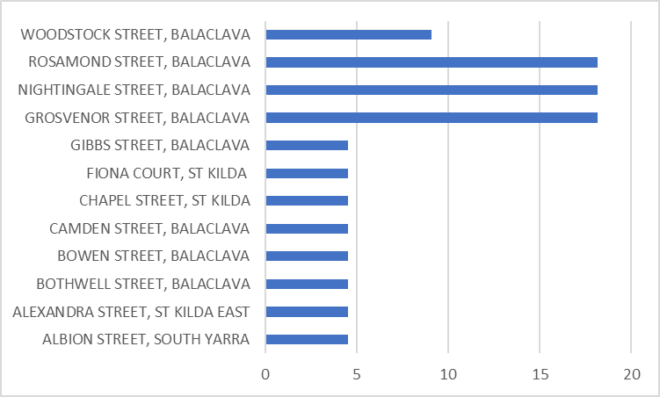

We asked: | What we heard
Do you have any feedback on the plan? | 13 respondents provided feedback.  5 respondents support of the project, happy about more trees being planted, creating more canopy coverage and positive sentiment about the plan “looks great”.  3 respondents were concerned about tree selection, stating they’re not a local native tree. The trees would create leaf litter and birds’ droppings would create mess.  1 respondent was concerned about the effects of plots on street parking.  4 respondents provided general comments. Comments included: Crepe Myrtles look terrible most of the year and they're not native.  Leaves are causing problems with the drains. Some more frequent/thorough street sweeping would be appreciated.

What we heard at Neighbourhood Conversations 22 March 2023
We asked | What we heard
Which Tree would you like see planted along Woodstock Street? | Nineteen people participated in a dotmocracy at the Balaclava Neighbourhood Conversation drop in event.  Wallangarra White Gum received 52% (10)  The Red Ironbark received the most votes 48% (9)
What we heard:
Participants that provided feedback on the dotmocracy, also provided general feedback. Feedback provided is not themed
We were asked why a deciduous tree wasn’t an option (Council officers explained that it would create too much leaf litter and wouldn’t compliment the native tree palette in the area)
Resident were concern that the tree species may create too much leaf litter.
Participants wanted reassurance that the proposed tee plots wouldn’t affect parking bay numbers on Woodstock Street.

How this report will be used
The information in this report was used to choose the large tree species to be planted on Woodstock Street, Balaclava.

How to find out more
You can stay up to date on this project by visiting https://haveyoursay.portphillip.vic.gov.au/woodstock-street-tree-renewal

Next steps
Construction commences week starting Monday 15 May 2023.

